Fig. S1
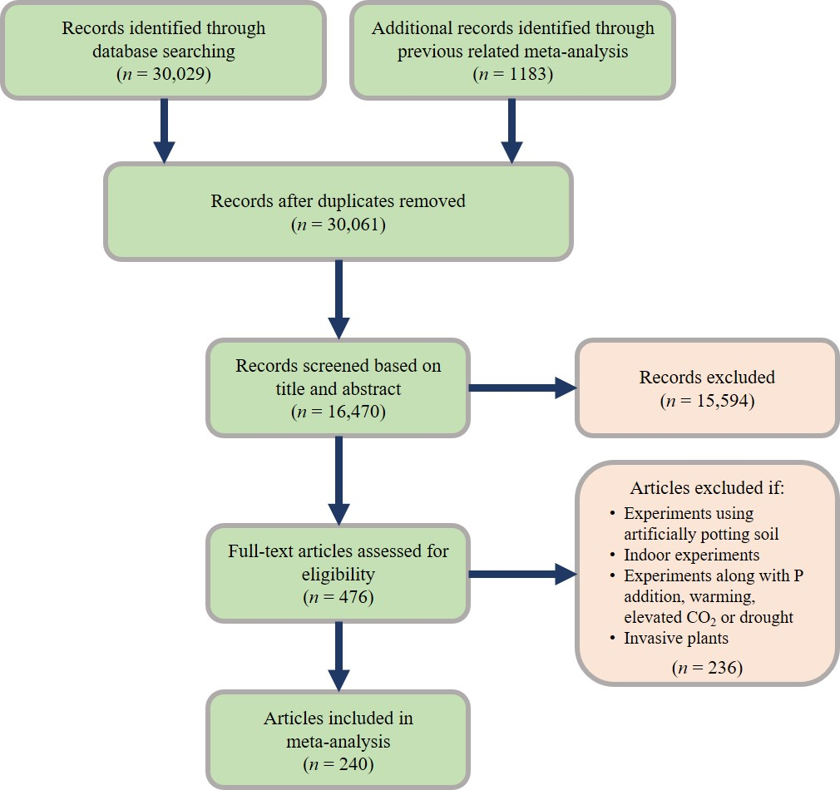
FIGURE S1 PRISMA flow diagram depicting the literature search and study selection process.

Fig. S2
FIGURE S2 Study sites included in this meta-analysis. Each point represents a single site, with some points obscured.

Fig. S3
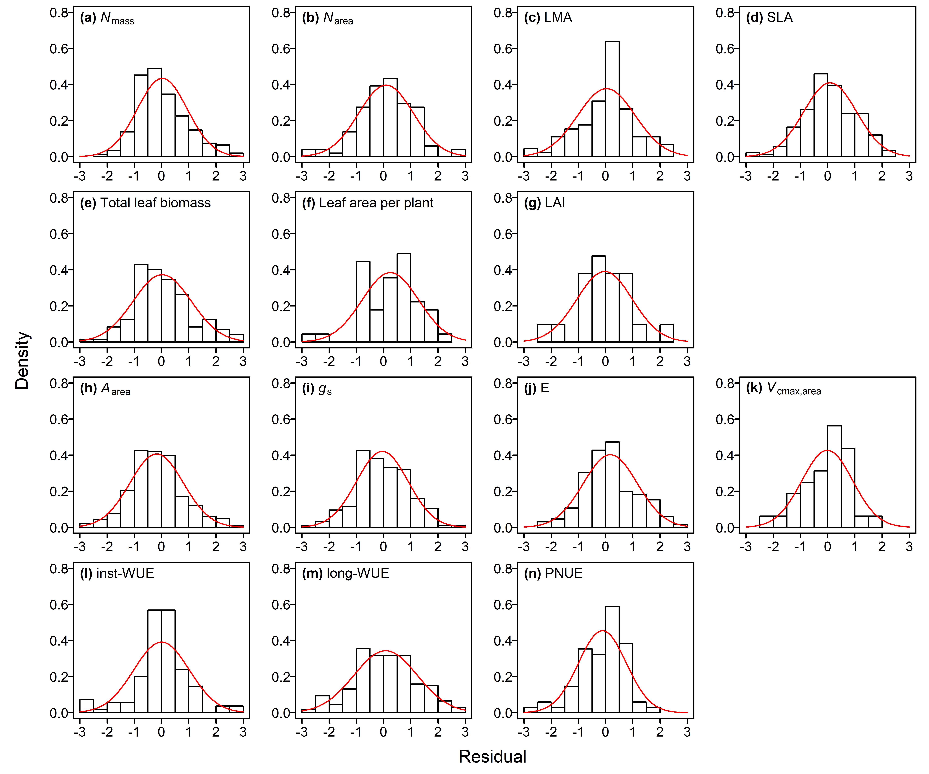
FIGURE S3 Histograms of standard residuals of the studied traits. Red lines show the curves fitted by normal distributions. See Table S3 for tests of skew and kurtosis.

Fig. S4
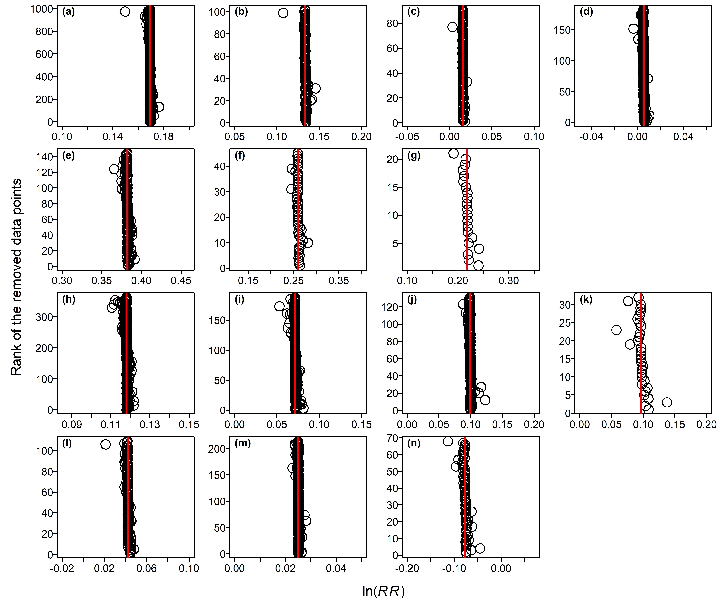
FIGURE S4 Sensitivity analysis for responses to N addition of the 14 photosynthesis-related traits: (a) N_{mass}, (b) N_{area}, (c) SLA, (d) LMA, (e) Total leaf biomass, (f) Leaf area per plant, (g) LAI, (h) A_{area}, (i) V_{cmax,area}, (j) E, (k) g_{s}, (l) inst-WUE, (m) long-WUE, (n) PNUE. The red line represents the mean ln(RR) using all data. Circles show estimates of mean ln(RR) when one data point is removed.

Fig. S5
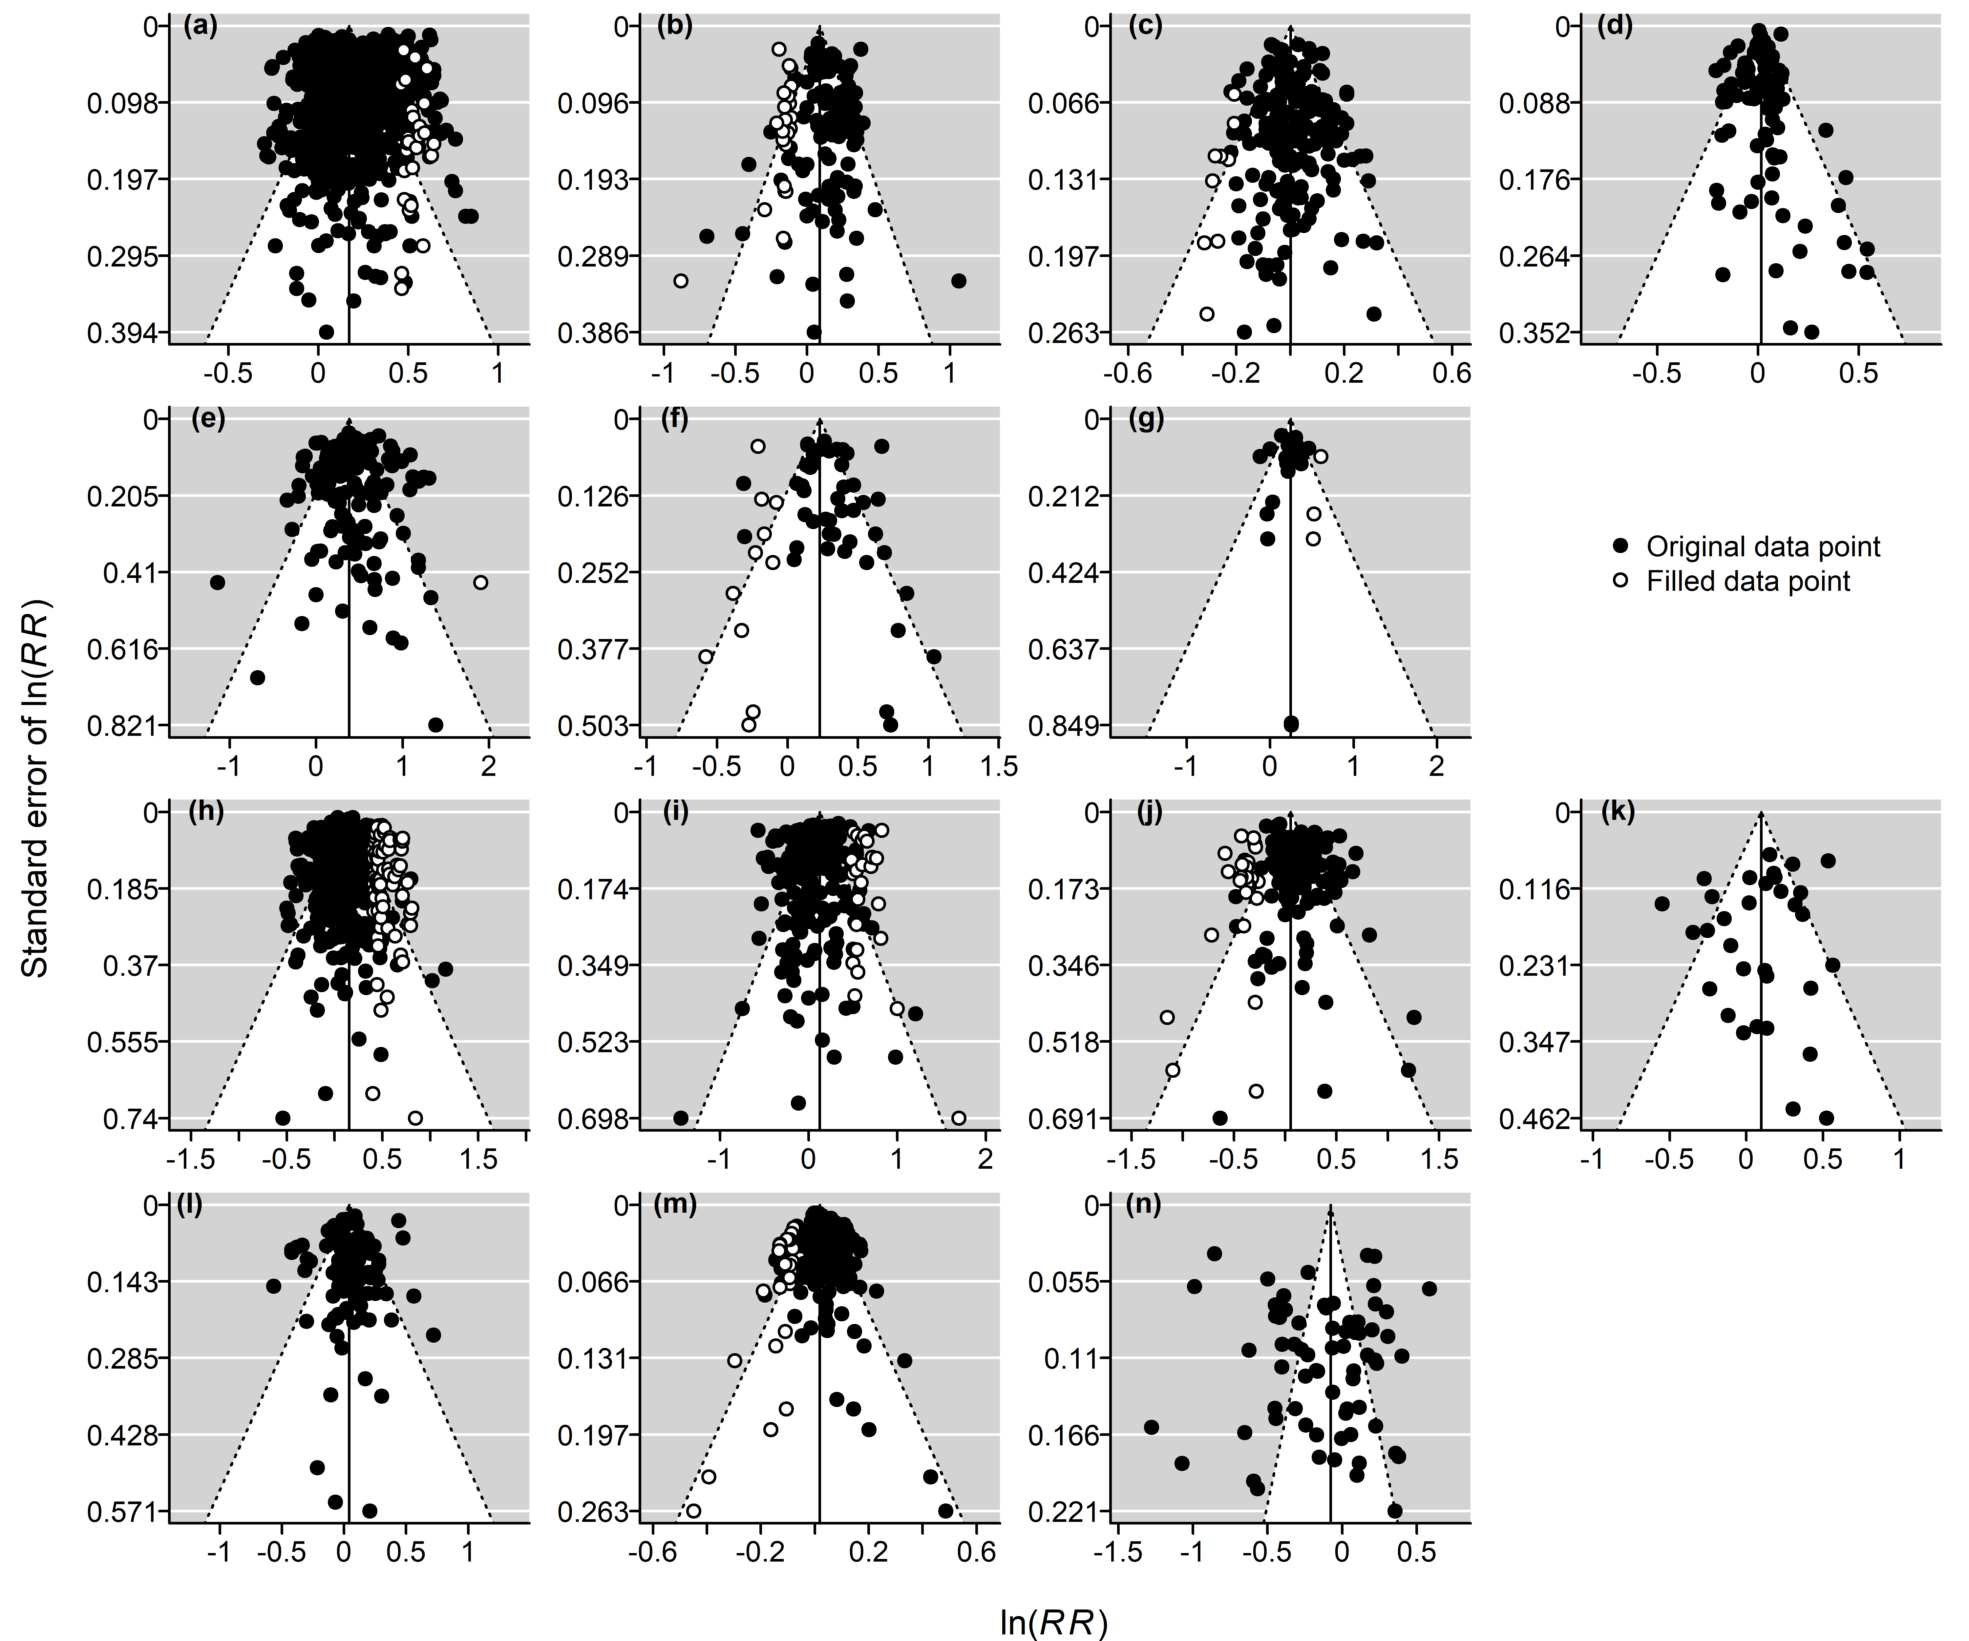
FIGURE S5 Results of a publication bias analysis done using the trim and fill method. (a) N_{mass}, (b) N_{area}, (c) SLA, (d) LMA, (e) Total leaf biomass, (f) Leaf area per plant, (g) LAI, (h) A_{area}, (i) V_{cmax,area}, (j) E, (k) g_{s}, (l) inst-WUE, (m) long-WUE, (n) PNUE. See Table S5 for more details.

