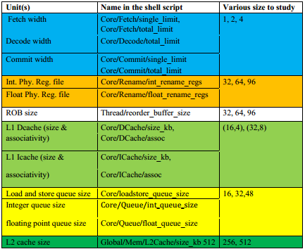

The colors in the graphs refer to the colors of the parameters in the table above and also refer to the parameter that is being varied.

The following values are for when the parameters are minimum

|  |  |  |  |  |  |  |  |  |  |
| --- | --- | --- | --- | --- | --- | --- | --- | --- | --- |
| |  |  | | --- | --- | | Blue set = 1 | 0.06 | | Blue set = 2 | 0.061 | | Blue set = 4 | 0.061 | |  |  |  |

|  |  |
| --- | --- |
| Amber set=32 | 0.06 |
| Amber set=64 | 0.06 |
| Amber set=96 | 0.061 |
|  | | |  |  |  |
| White Set = 32 | 0.06 |
| White Set = 64 | 0.084 |
| White Set = 96 | 0.084 |

|  |  |
| --- | --- |
| Olive Set = (16,4) | 0.06 |
| Olive Set = (32,8) | 0.06 |

|  |  |
| --- | --- |
| Yellow Set = 16 | 0.06 |
| Yellow Set = 32 | 0.06 |
| Yellow Set = 48 | 0.06 |

|  |  |
| --- | --- |
| Green Set = 256 | 0.06 |
| Green Set = 512 | 0.06 |

|  |  |
| --- | --- |
| Blue set = 1 | 0.278 |
| Blue set = 2 | 0.448 |
| Blue set = 4 | 0.669 |

|  |  |
| --- | --- |
| Amber set=32 | 0.278 |
| Amber set=64 | 0.278 |
| Amber set=96 | 0.278 |

|  |  |
| --- | --- |
| Olive Set = (16,4) | 0.278 |
| Olive Set = (32,8) | 0.278 |

|  |  |
| --- | --- |
| Yellow = 16 | 0.278 |
| Yellow = 32 | 0.278 |
| Yellow = 48 | 0.278 |

|  |  |
| --- | --- |
| Green Set = 256 | 0.278 |
| Green Set = 512 | 0.278 |

|  |  |
| --- | --- |
| White Set = 32 | 0.278 |
| White Set = 64 | 0.279 |
| White Set = 96 | 0.279 |

The following values are for when the parameters have maximum values.

|  |  |
| --- | --- |
| Blue set = 1 | 0.103 |
| Blue set = 2 | 0.107 |
| Blue set = 4 | 0.108 |

|  |  |
| --- | --- |
| Amber set=32 | 0.089 |
| Amber set=64 | 0.108 |
| Amber set=96 | 0.061 |

|  |  |
| --- | --- |
| Olive Set = (16,4) | 0.108 |
| Olive Set = (32,8) | 0.108 |

|  |  |
| --- | --- |
| Yellow = 16 | 0.089 |
| Yellow = 32 | 0.108 |
| Yellow = 48 | 0.108 |

|  |  |
| --- | --- |
| Green Set = 256 | 0.108 |
| Green Set = 512 | 0.108 |

|  |  |
| --- | --- |
| White Set = 32 | 0.061 |
| White Set = 64 | 0.091 |
| White Set = 96 | 0.108 |

|  |  |
| --- | --- |
| Blue set = 1 | 0.286 |
| Blue set = 2 | 0.448 |
| Blue set = 4 | 0.669 |

|  |  |
| --- | --- |
| Amber set=32 | 0.671 |
| Amber set=64 | 0.681 |
| Amber set=96 | 0.669 |

|  |  |
| --- | --- |
| White Set = 32 | 0.669 |
| White Set = 64 | 0.677 |
| White Set = 96 | 0.681 |

|  |  |
| --- | --- |
| Olive Set = (16,4) | 0.681 |
| Olive Set = (32,8) | 0.686 |

|  |  |
| --- | --- |
| Yellow = 16 | 0.677 |
| Yellow = 32 | 0.686 |
| Yellow = 48 | 0.686 |

|  |  |
| --- | --- |
| Green Set = 256 | 0.686 |
| Green Set = 512 | 0.686 |

When the sizes of the parameter are increased the IPC values also increase in the case of bzip2_source benchmarking for the Blue, Amber and White parameters when everything else is constant. However, in the case of craft only the values of the Blue parameter increase with the increase in the value of the parameter, while the rest remain constant. The maximum difference can be seen in the values of Amber parameters when the everything else is minimum and cache is 256 kb. A significant difference can also be see when the cache is 512kb and all other parameters are maximum for the White parameter for the crafty benchmark.