Volunteers (4):
- Volunteer 1: Adult with expertise in woodworking
- Volunteer 2: Adult with experience in woodworking
- Volunteer 3: Youth with experience in construction
- Volunteer 4: Youth with experience in construction & painting
Note: When rounding with a router, using the quarter rounding setting.

Denver attachment:
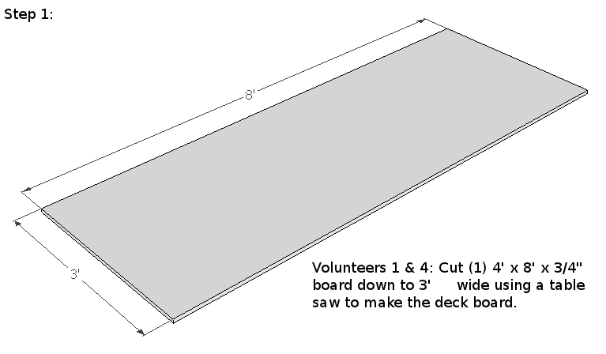
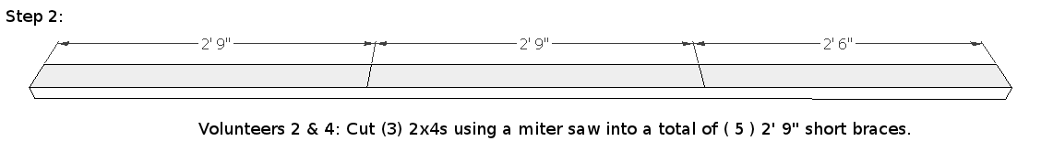
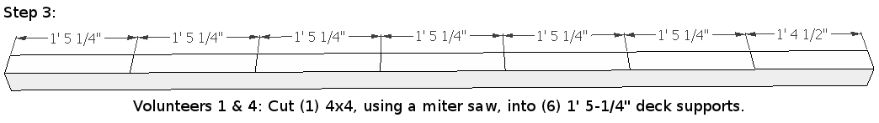
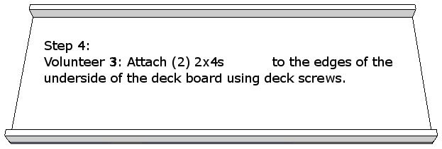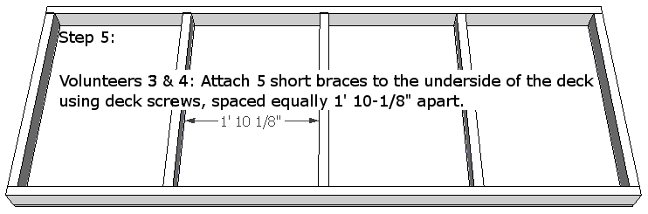
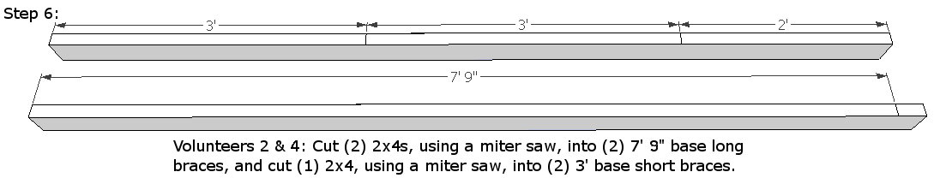

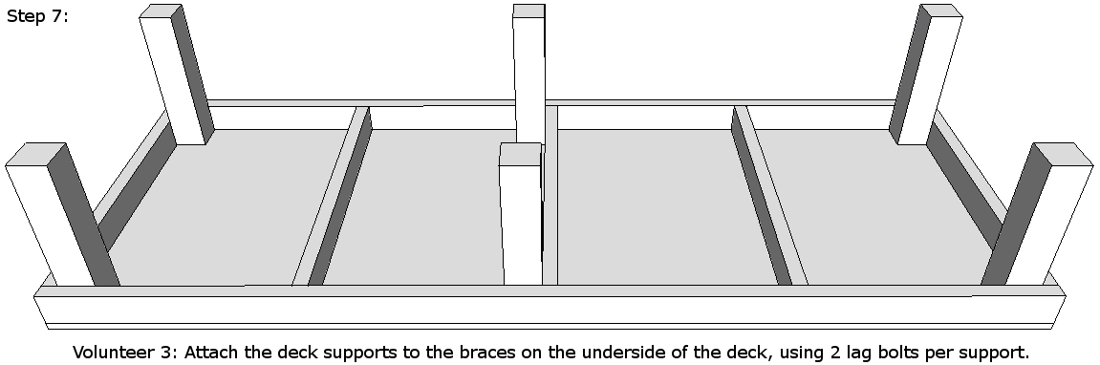

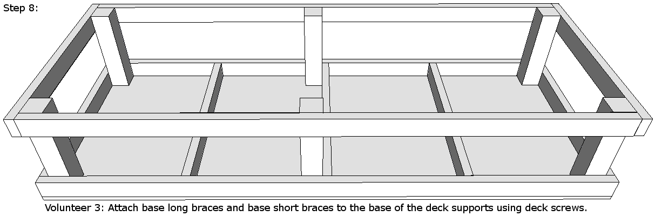

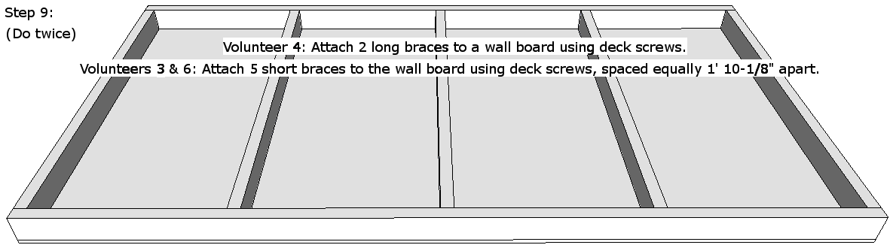

Volunteers 2 & 3: Using a router and a sander, round the outer edges of both walls.
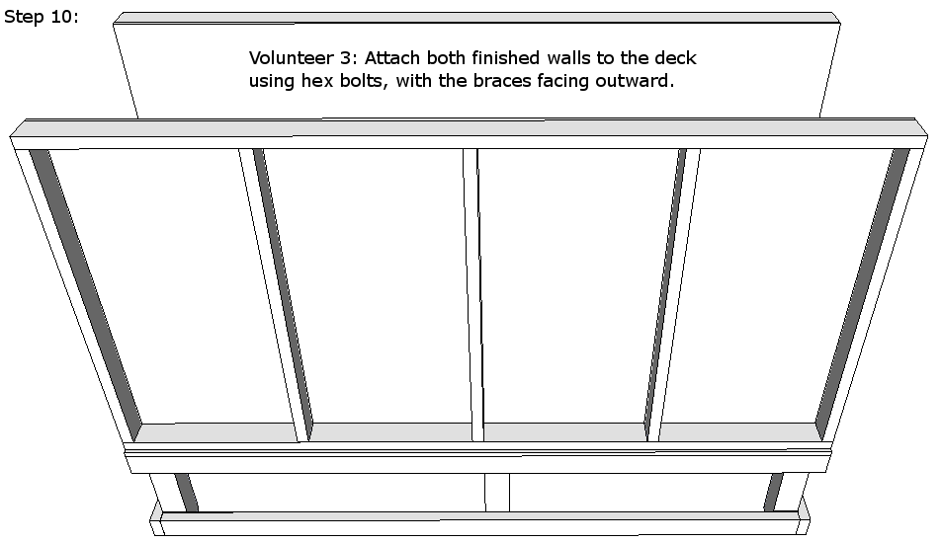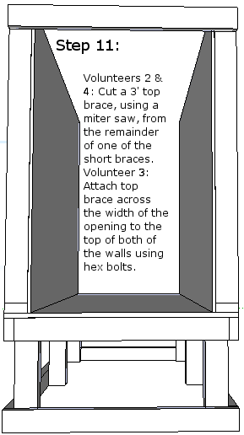

Volunteer 3: Remove the walls from the deck and the top brace from the walls.
Volunteers 3 & 4: Apply varnish to the inner faces & the outer edges of both walls & to the top & sides of the deck.

Main wall:
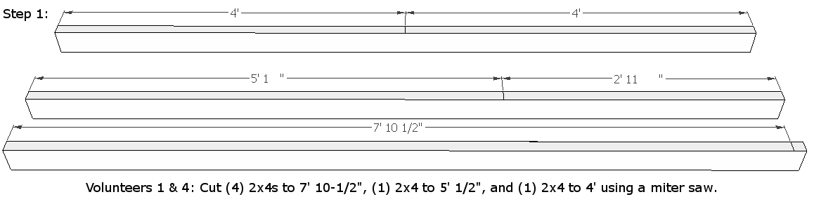

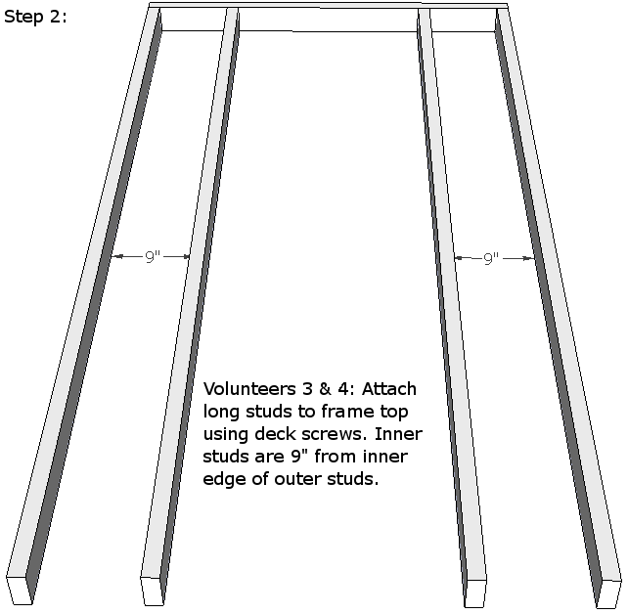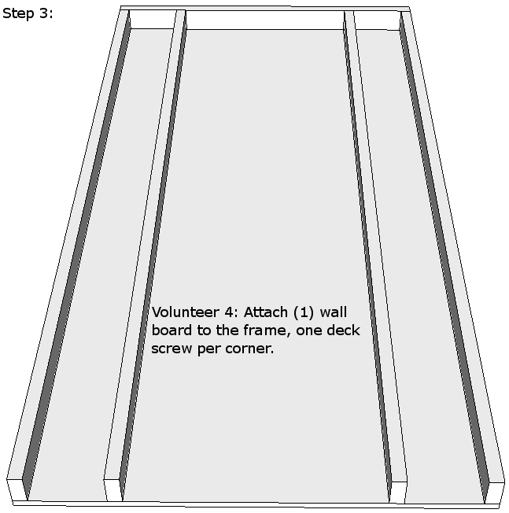
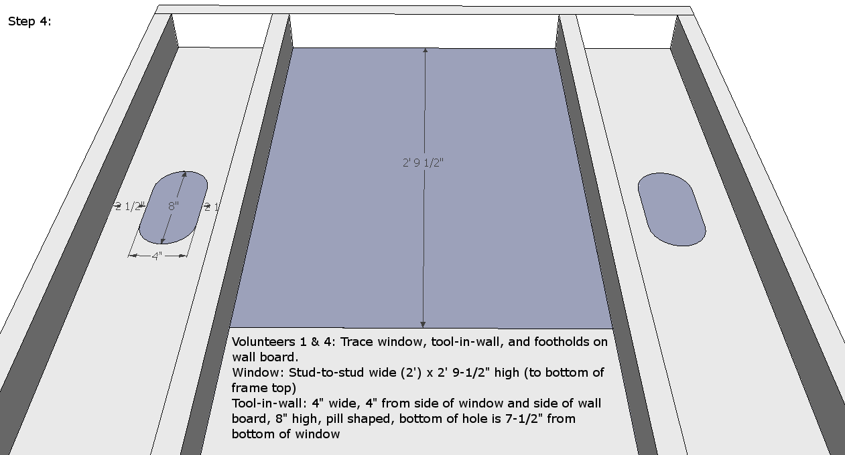

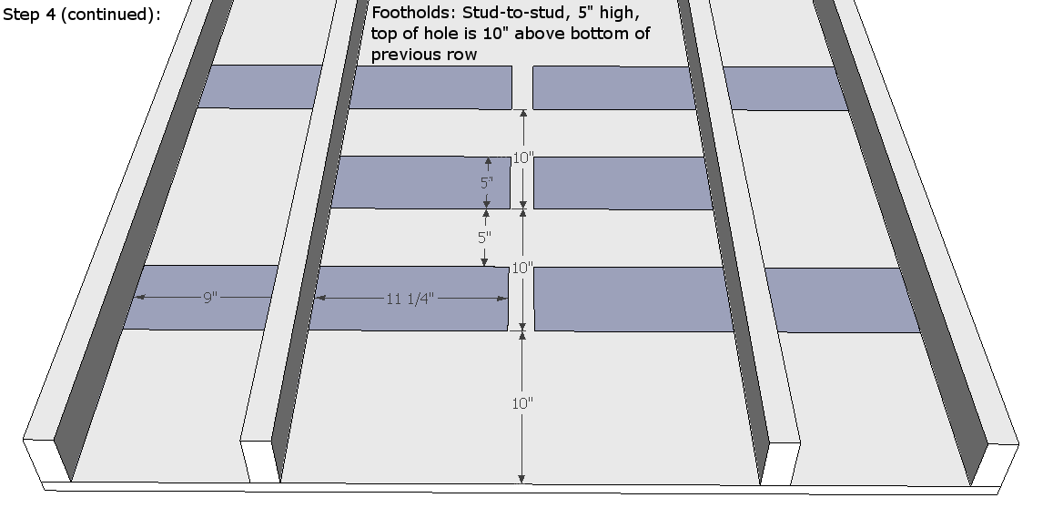
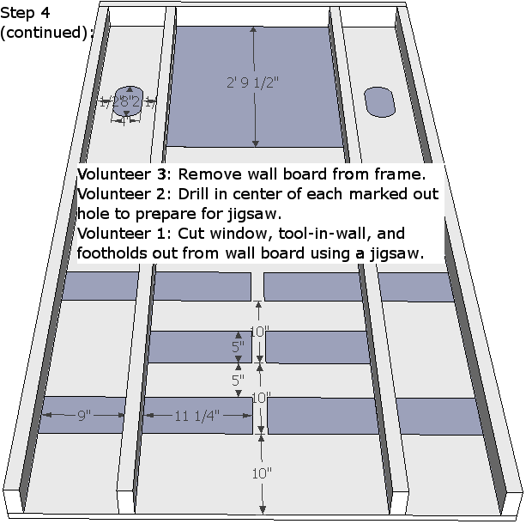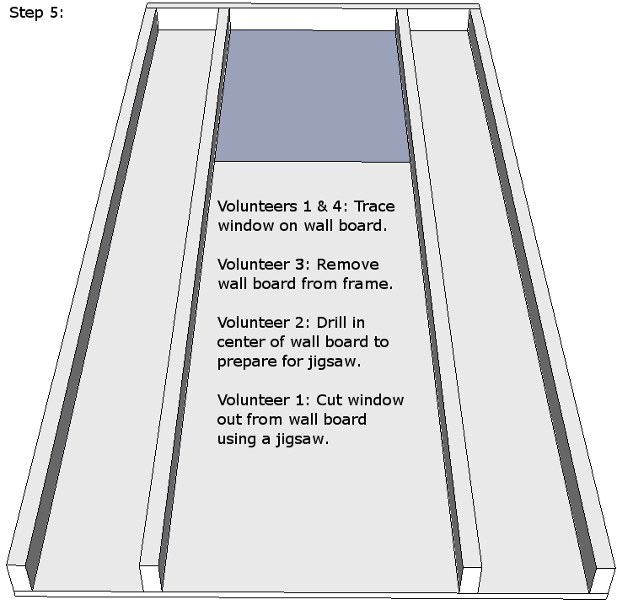

Volunteers 2 & 3: Using a router and a sander, round the edges of each cutout.

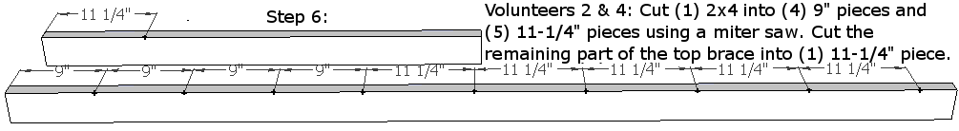

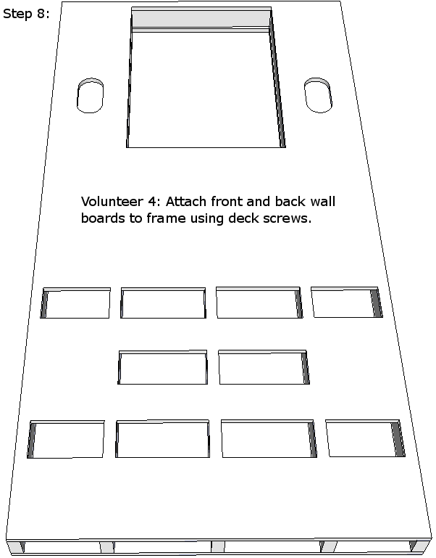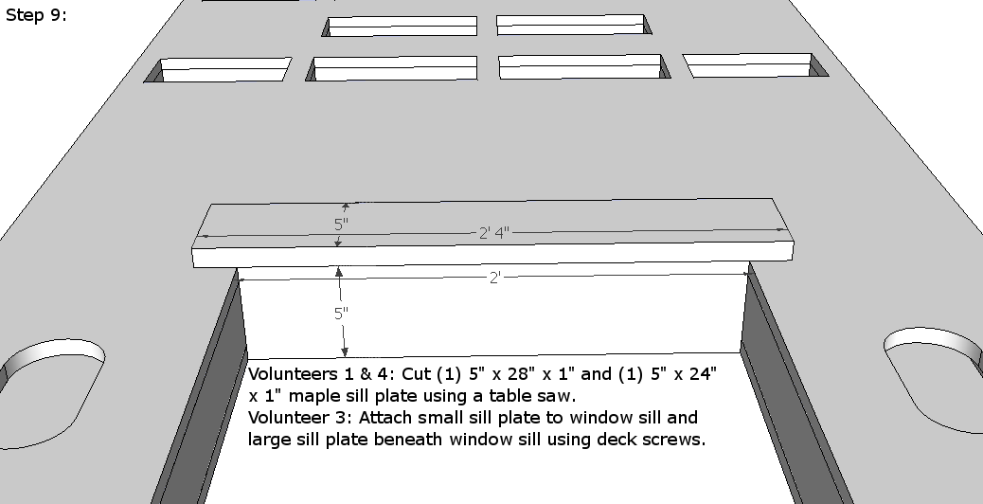
Step 9: Volunteers 1 & 4: Cut (1) 5” x 28” x 1” and (1) 5” x 24” x 1” maple sill plates using a table saw. Volunteer 3: Attach small sill plate to window sill & large sill plate beneath window sill using deck screws.
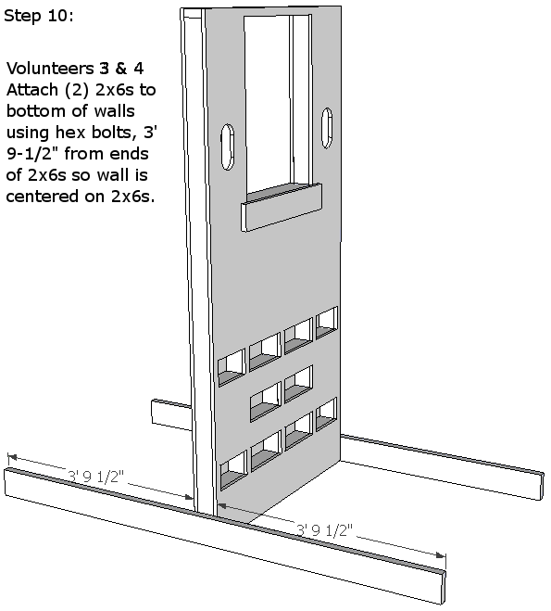

Volunteers 2 & 3: Using a router and a sander, round all remaining edges of the wall, the top edges of the base supports, and the angle braces.

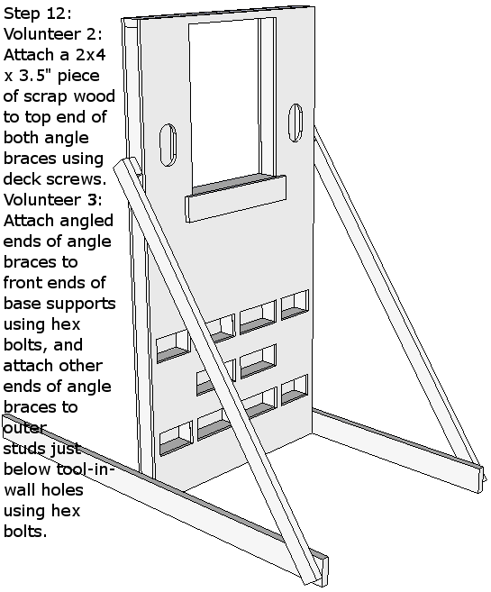

Volunteer 3: Remove all the braces from the wall and from each other.
Volunteers 3 & 4: Apply varnish to all surfaces of the wall and to each brace.

Deck:
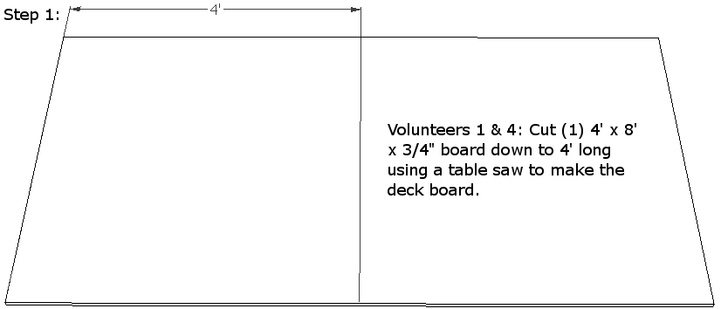

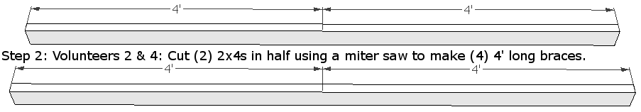

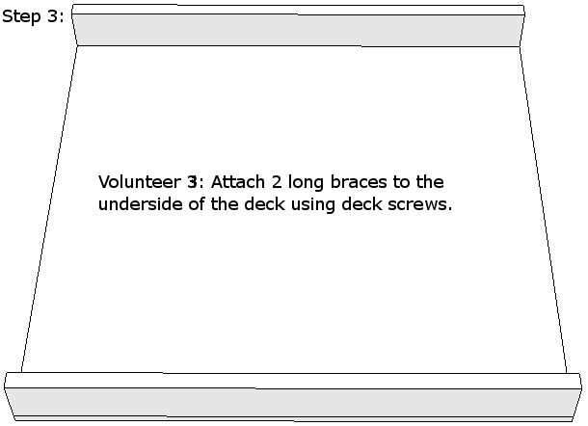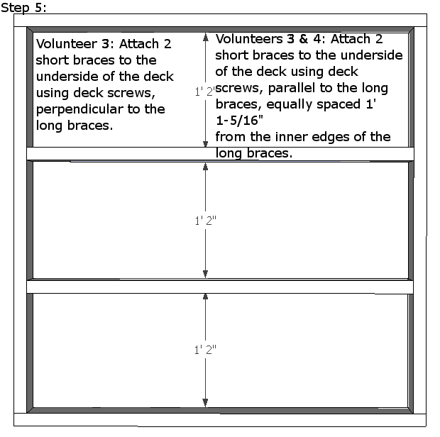

Volunteers 2 & 3: Using a router and a sander, round the top edges of the deck.

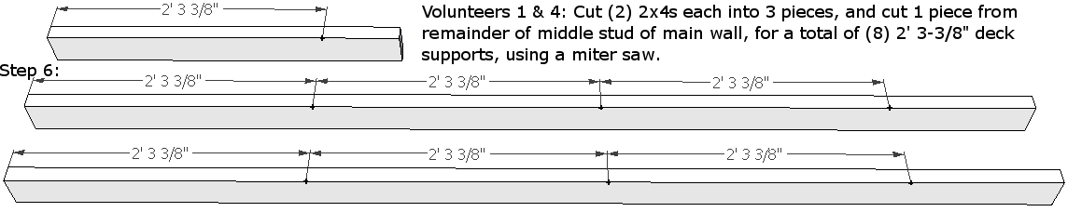
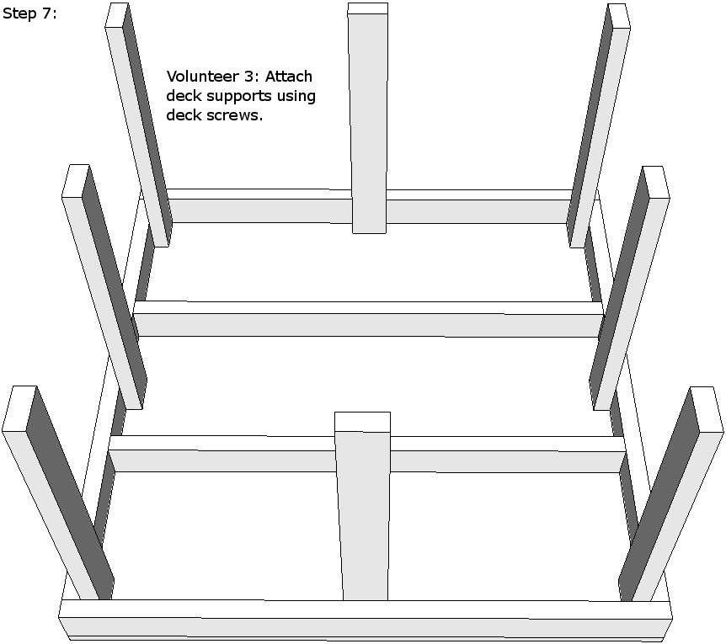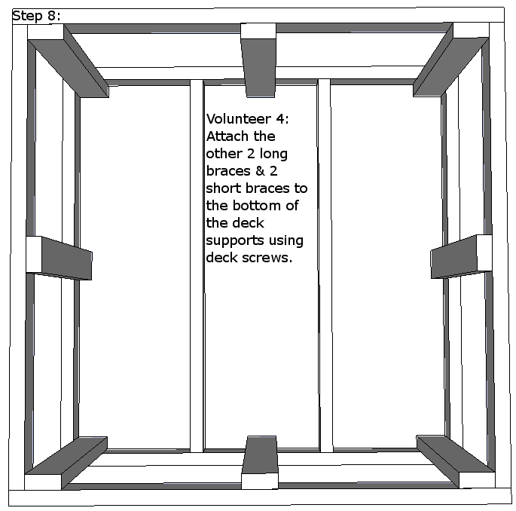
Volunteers 3 & 4: Apply varnish to the top and to the top edges of the deck.

Extras:

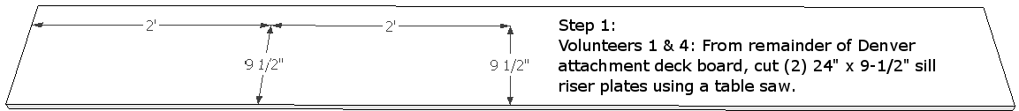

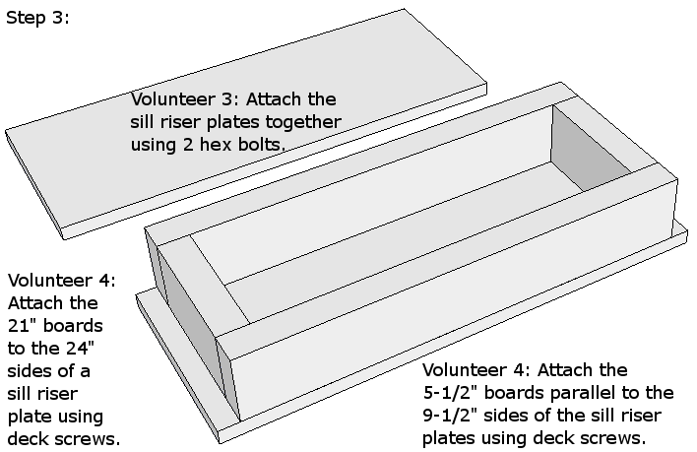

Volunteer 3: Remove the sill riser plates.

Volunteers 2 & 3: Using a router and a sander, round the edges of both sill riser plates.
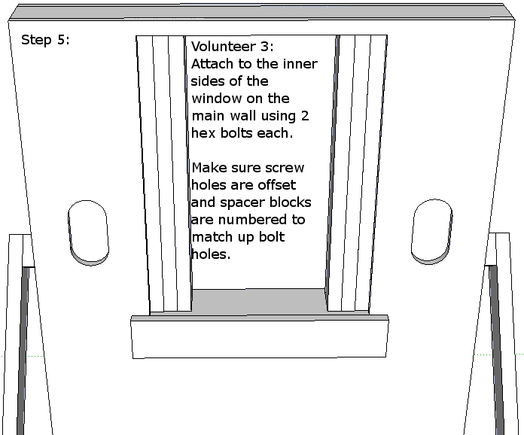

Volunteer 3: Remove the spacer blocks from the wall.

Volunteers 2 & 3: Using a router and a sander, round the long edges of the spacer blocks.

Volunteers 3 & 4: Apply varnish to each spacer block.

