**SOFTWARE VERIFICATION, VALIDATION AND TESTING**

TESTING DOCUMENTATION

PROJECT NAME

Prepared by:

**Student 1**

**Student 2**

Proposed to:

**Samed Jukić, Assist. Prof. Dr.**

**Aldin Kovačević, Teaching Assistant**

Date of submission

TABLE OF CONTENTS

Generate your table of contents here.

# 1. Introduction

## 1.1. About the Project

Describe the project/application you are testing in a few sentences and provide a link to its homepage.

## 1.2. Project Functionalities and Screenshots

Describe or list the main features of the project and provide a few screenshots of those features.

# 2. Test Plan

## 2.1. Scope

Describe what you are planning to test on the project: are you testing the entire application, or only focusing on some parts/features of it? Is there something you are not planning to test, etc?

## 2.2. Testing Environment and Tools

Describe what kind of tools and/or frameworks are you going use during your testing, what programming language you are using, etc.

# 3. Test Execution

In the “Test Execution” section, you need to list your **test scenarios** and **test cases**. *Test scenario* is a statement whose purpose is to inform what particular area of the application will be tested. Test scenarios consist of multiple *test cases*, which test specific parts of an application. You can use the following template approach for test scenarios and test cases, but you can also use a custom template or your own “design”, as long as you have all the necessary information.

## 3.1. Test Scenario Name

Give a brief one-two sentence description of the test scenario. Afterwards, list the test cases in that test scenario. You can use the following table.

|  |  |  |  |  |
| --- | --- | --- | --- | --- |
| **Test Name:** Short test name | | | | |
| **Description:**  Test description | | | | |
| **Pre-condition(s):** Are there any conditions or other tests that need to be executed before this test; are there any test fixtures? If not, leave this blank. | | | | |
| **Test Steps:**  1. Number the steps needed to execute this test case.  2. Like this. | **Test Data:**  - is there any specific input data you are using for this test (e.g. some input field values, credentials, etc.) | **Expected Result:**  What was the expected result of this test? | **Actual Result:**  What was the actual result of this test, once you executed it? | **Status:**  PASS or FAIL (you can color code them) |
| **Notes:** Are there any notes about this test you would like to add? If not, leave this blank. | | | | |

Provide a screenshot of your test code after the test case table.

The following section will be one test scenario example for you, with two tests.

## 3.2. Example Scenario: Visit the Home Page

Users want to be able to visit the home page, and get a quick glance at the most important features it has to offer.

|  |  |  |  |  |
| --- | --- | --- | --- | --- |
| **Test Name:** Test sidebar links | | | | |
| **Description:**  Check if all sidebar items are clickable and lead to their respective page | | | | |
| **Pre-condition(s):** | | | | |
| **Test Steps:**  1. Go to the landing page  2. Check if all links have been rendered  3. Click on each link individually  4. Check if the URL of the opened page corresponds to the link in the sidebar | **Test Data:** | **Expected Result:**  The user is taken to the correct new page when clicking on the link. | **Actual Result:**  The user is taken to the correct new page when clicking on the link. | **Status:**  PASS |
| **Notes:** | | | | |

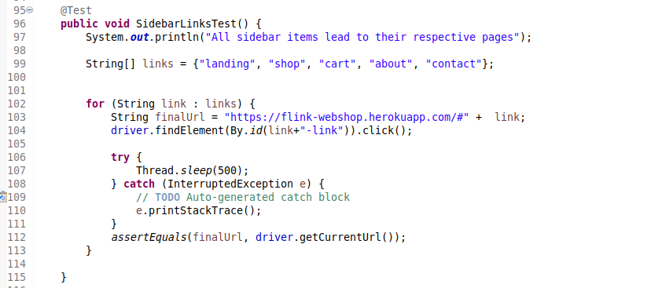

|  |  |  |  |  |
| --- | --- | --- | --- | --- |
| **Test Name:** Test “Find out more” button | | | | |
| **Description:**  Check if “Find out more” button works and leads to proper page (either a product page, or an “About us” page) | | | | |
| **Pre-condition(s):** | | | | |
| **Test Steps:**  1. Wait until “Find out more” button is loaded  2. Click on the button  3. Check if it leads to the expected page | **Test Data:** | **Expected Result:**  The user is taken to a new page. | **Actual Result:**  The page gives a 404 error because the requested page does not exist. | **Status:**  FAIL |
| **Notes:** | | | | |

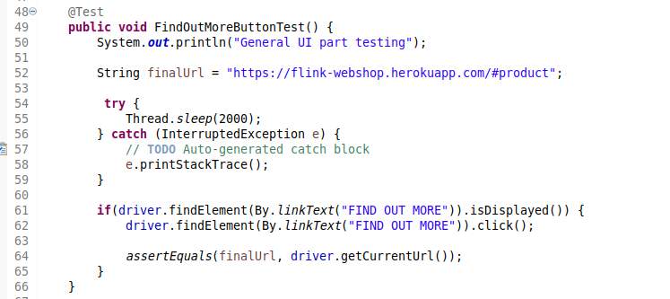

...

# 9. Conclusion

## 9.1. Testing Summary

Provide a summary of all your executed tests. Something like this would be alright:

|  |  |  |  |
| --- | --- | --- | --- |
| **Testing Tool** | **Total Tests** | **Passed Tests** | **Failed Tests** |
| Framework or tool(s) used for testing. If you wrote tests in multiple different tools, create a row with the number of tests for each of them. | total number of tests | # of passing tests | # of failing tests |

If there are failing tests, provide a list of their names. Ideally, you can also create bookmarks in the document and make links to those failing test cases.

## 9.2. Final Thoughts

Provide some closing statements or your final thoughts about the project you tested. Did you find that it was implemented well? Did you notice any obvious mistakes or flaws in it? Are there some recommendations or observations you would note for the site?