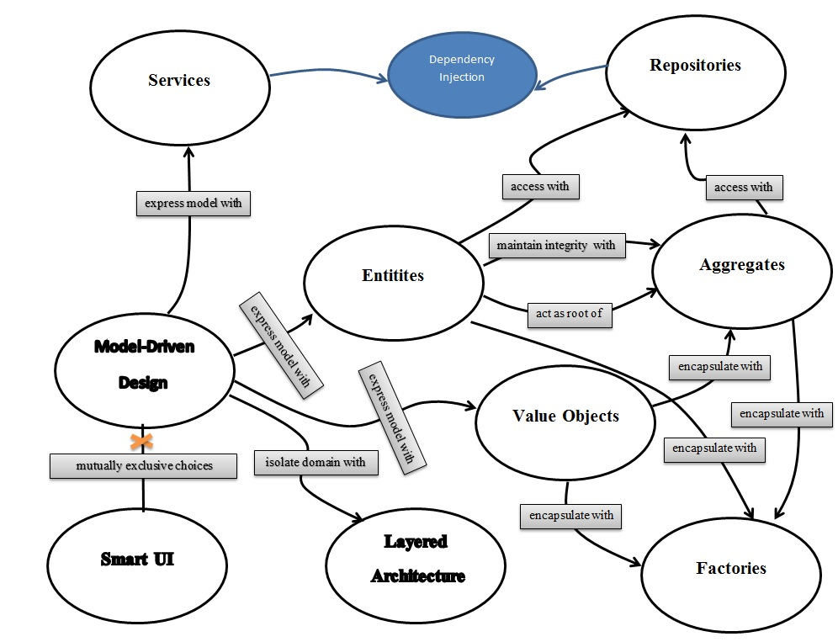

l

a

y

e

r

a

p

p

l

i

c

a

t

o

n

application layer

application layer