Sprint #3

Group members: Sagar Tailor, Andrew Edillo, Chad Schulte, Evan Kennedy, Kip Tucker, Richard Clemence

**Items to present**

* This Sprint accomplishments
  + User stories to be completed in next sprint
  + UI/UX to be implemented in next sprint
  + QA test cases report of pass/failed test cases executed on this sprint work
  + Progress on hardware (Raspberry Pi cameras)

**Project Requirements**

Customer behavior monitoring is rapidly catching eye of large chain retailers. How many customers are there in the store at any given time and where they are spending their time is of interest for intelligent scheduling of employees and product displays. As part of this project, you will implement a retail IoT solution which accomplishes above mentioned goals using ceiling mounted cameras. You will assume that cameras are mounted in each aisle. Your system will provide store owners following functionality:

* Ability to create store and its layout (aisle and length of aisle)
* Specify area of interest in a video stream coming from aisle video
* Ability to register IoT camera with specific aisle
* View various statistics generated camera measurements
* Customer counts in entire store by time, day, week, month
* Customer count in various aisle by time, day, week, month
* Time spent by customers at different location in aisle

You will work with my research assistant to build intelligent model that can perform image/video analysis to detect people and track them through the store. Such information will be sent to server in minimalistic data and further analysis will be performed by servers to provide above stated business intelligence to the store manager. To support multi-store chain adaptation, you will implement required grouping schema such that a store can belong to a chain.

**Project Plan (Sprint-by-Sprint)**

Sprint #3

* Web interface with hardware setup
* User access stories
* Store Layout user submission software
  + possibly drag and drop user interface
  + simple shapes for aisles, registers, cameras, doors

Sprint #4

* Customer/individual recognition software finished

Sprint #5

* Continuing development, additional features (statistics, etc.)

Sprint #6

* Documentation
* Feature polishing/UI setup

Sprint #7

* Project demonstration

Sprint #8

* Judged demonstration

**Risks and Challenges**

* Getting everyone to meet in person (conflicting schedules, etc.)
* Networking issues
* Learning how to use the Django framework, which needs knowledge of Python

**Actors**

1. Store Owner
2. Customer
3. Camera
4. Raspberry Pi module
5. Website

**User Access Permissions**

* Store Owner
  + Ability to create and edit floor plans
  + Ability to add cameras or change camera placement
  + Can view statistics based on the information captured by the cameras
* Administrator
  + Creates accounts for store owners
  + Can view statistics based on the information captured by the cameras
  + In charge of overall website maintenance
* Customer
  + Can view general statistics based on the information captured by the cameras

**Functional Requirements**

1. Website shall allow Store/Business owner to create profile of their business.
2. Website shall allow Store Owner to add different stores to their profile.
3. Website shall allow Store Owner to create layout of store.
4. Website shall allow labelling of aisles.
5. Website shall allow associating aisle to camera.
6. Website shall allow addition of camera module to interested area of surveillance on layout plan.
7. Website shall allow Owner to specify area of interest within camera capture
8. Website shall show area and distance of camera capture.
9. Camera modules shall be set up at designated areas
10. Camera module will capture video to be manipulated by Raspberry Pi module.
11. Raspberry Pi Module shall identify each individual customer entering/leaving store.
12. IoT camera module shall track movement of each identified individual customer within store and camera capture area.
13. Website will present different statistics based on information collected by IoT camera.

**User Stories**

* As a customer, I can access the website with my account to view the general statistics and data based on the information captured by the store cameras.
* As a store owner, I can create and edit store floor plans that reflect my own store.
* As a store owner, I can register cameras with specific locations/aisles.
* As a store owner, I can use the in-store cameras to count the number of customers my store sees per day.
* As a store owner, I can use the store cameras to monitor customer behavior and to better understand where customers spend their time the most.
* As a store owner, I can view the in-store camera stream.
* As a store owner, I use use the data from the image/video analysis to determine which items are the most popular.
* As an administrator, I can view and customize the statistics and data based on the information captured by the store cameras.
* As an administrator, I can choose what data is shown on the website for customers/store owners to view.

**Use Cases/Diagrams**

|  |  |
| --- | --- |
| **USE CASE NAME** | **Create floor plans** |
| **ACTORS** | * **Store Owner** * **Website** |
| **DESCRIPTION** | **Store Owner is able to create the floor plan for their store.** |
| **PRECONDITION** | * **Store Owner visits website** |
| **TRIGGER** | **Visiting website and clicking “Create/Edit Floor Plan”** |
| **STEPS** | 1. **Store Owner visits website** 2. **Store Owner selects “Create/Edit Floor Plan”** 3. **Store Owner is able to customize their store’s floor plan** |
| **EXCEPTION FLOW** | **Store Owner attempts to edit a non-existent floor plan.** |
| **EXIT CONDITION** | **Edits to the floor plan are saved.** |
|  | |

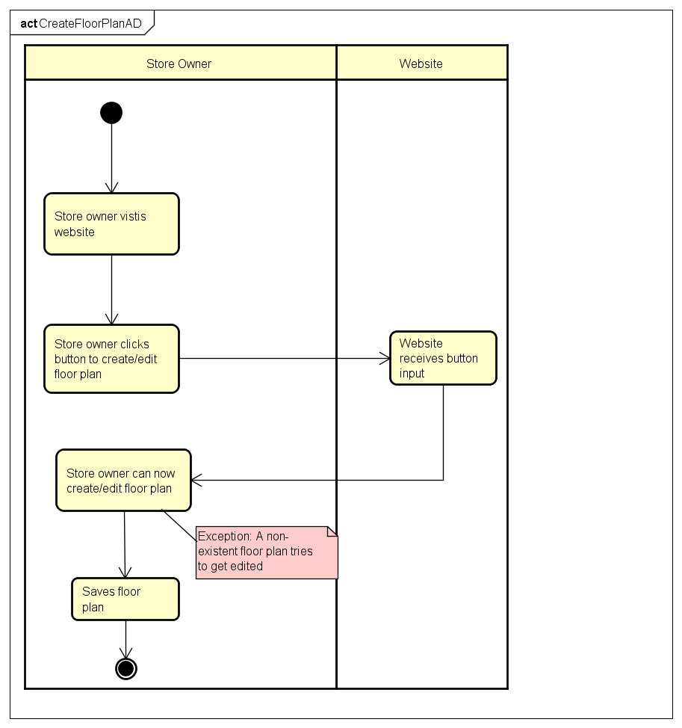

|  |  |
| --- | --- |
| **USE CASE NAME** | **Sign up/Create account** |
| **ACTORS** | * **Store Owner (SO)** * **Customer (C)** * **Website administrator (A)** |
| **DESCRIPTION** | **SO/C/A can sign up and create a personal account to enter the website.** |
| **PRECONDITION** | * **SO/C/A visits website for the first time** |
| **TRIGGER** | **Visiting website and clicking “Sign Up”** |
| **STEPS** | 1. **SO/C/A visits website and clicks “Sign Up”** 2. **SO/C/A is taken to another page to create their username and password** 3. **SO/C/A has successfully signed up and created an account** |
| **EXCEPTION FLOW** | **SO/C/A attempts to login without an existing account.** |
| **EXIT CONDITION** | **New account information is saved and the user has successfully signed up.** |
|  | |

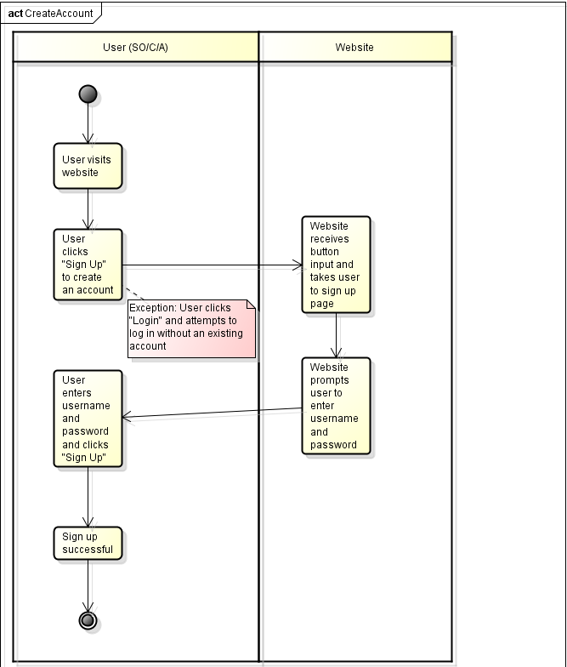

|  |  |
| --- | --- |
| **USE CASE NAME** | **Register camera/Set area of interest** |
| **ACTORS** | * **Store Owner** * **Website** * **Camera** |
| **DESCRIPTION** | **Store owner can determine where to position camera in store and specify area of interest (in aisle or entrance).** |
| **PRECONDITION** | * **Store owner has an account** * **Store owner has functional cameras** * **Cameras are set up throughout the store** |
| **TRIGGER** | **Visiting website and clicking “Camera Options”.** |
| **STEPS** | 1. **Store owner logs into website** 2. **Store owner clicks “Camera Options”** 3. **Store owner clicks “Register Camera”** 4. **Store owner can specify and register camera position in the website (which entrance, aisle number, etc.)** |
| **EXCEPTION FLOW** | **Cameras are not up and running in the store.** |
| **EXIT CONDITION** | **Camera positions and areas of interest are registered and saved.** |
|  | |