**DAYANANDA SAGAR UNIVERSITY** **Devarakaggalahalli, Harohalli Kanakapura Road, Dt, Ramanagara, Karnataka 562112**

# Bachelor of Technology in

**COMPUTER SCIENCE AND ENGINEERING**

**(Artificial Intelligence and Machine Learning)**



# Mini Project

**(Car Price Predictor)**

By

**AKSHAT AGARWAL USN:-ENG22AM0072**

**PUSHKAR PALLAV USN:-ENG22AM0187**

**R SUJAY USN:-ENG22AM0122**

**AJEEB SAGAR USN:-ENG22AM0071**

**Under the supervision of**

Prof. Pradeep Kumar K

Dr. Mary Jasmine

Prof. Mitha Guru

**Assistant Professor, Artificial Intelligence & Machine Learning, SOE**

**DEPARTMENT OF COMPUTER SCIENCE & ENGINEERING**

**(Artificial Intelligence and Machine Learning)**

**SCHOOL OF ENGINEERING**

**DAYANANDA SAGAR UNIVERSITY,**

**BANGALORE**

**School of Engineering**

**Department of Computer Science & Engineering**

**(Artificial Intelligence and Machine Learning)**

Devarakaggalahalli, Harohalli Kanakapura Road, Dt, Ramanagara, Karnataka 562112

**Certificate**

This is to certify that the Mini – Project titled **“Car Price Predictor”** is carried out by **AKSHAT AGARWAL (ENG22AM0072), PUSHKAR PALLAV (ENG22AM0187), R SUJAY (ENG22AM0122) and AJEEB SAGAR (ENG22AM0071),** bonafide students of Bachelor of Technology in Computer Science and Engineering(Artificial Intelligence and Machine Learning) at the School of Engineering, Dayananda Sagar University.

|  |  |
| --- | --- |
| **Prof Guide Name** | **Dr. Jayavrinda Vrindavanam** |
| Prof. Pradeep Kumar K  Dr. Mary Jasmine  Prof. Mitha Guru  Dept. of CSE(AI&ML),  School of Engineering  Dayananda Sagar University  Date: | Chairperson CSE(AI&ML)  School of Engineering  Dayananda Sagar University  Date: |

**Name of the Examiner** **Signature of Examiner**

1.

2.

3.

**ACKNOWLEDGEMENT**

It is a great pleasure for us to acknowledge the assistance and support of many individuals who have been responsible for the successful completion of this project work.

First, we take this opportunity to express our sincere gratitude to School of Engineering & Technology, Dayananda Sagar University for providing us with a great opportunity to pursue our Bachelor’s degree in this institution.

We would like to thank **Dr. Udaya Kumar Reddy K R ,** **Dean**, **School of Engineering**, **Dayananda Sagar University** for his constant encouragement and expert advice. It is a matter of immense pleasure to express our sincere thanks to **Dr. Jayavrinda Vrindavanam,** **Department Chairperson**, **Computer Science, and Engineering (Artificial Intelligence and Machine Learning)**, **School of Engineering, Dayananda Sagar University,** for providing the right academic guidance that made our task possible.

We would like to thank our guide **Prof Pradeep Kumar K** / **Dr. Mary Jasmine/ Prof. Mitha Guru**, **Dept. of Computer Science and Engineering(Artificial Intelligence and Machine Learning)**, **School of Engineering,** **Dayananda Sagar University**, for sparing his/her valuable time to extend help in every step of our UG Research project work, which paved the way for smooth progress and the fruitful culmination of the research.

We are also grateful to our family and friends who provided us with every requirement throughout the course. We would like to thank one and all who directly or indirectly helped us in the Research work.

**TABLE OF CONTENTS**

Page

LIST OF ABBREVIATIONS .................................................................................            vi

LIST OF FIGURES ………....................................................................................            vii

ABSTRACT ............................................................................................................           viii

CHAPTER 1   INTRODUCTION……….................................................................         1

1.1. ..................................................................................................................... 2

1.2. ......................................................................................................................     2

CHAPTER 2   PROBLEM DEFINITION ……….....................................................         9

CHAPTER 3 LITERATURE SURVEY...................................................................         10

CHAPTER 4 PROJECT DESCRIPTION....................................................................        12

4.1. PROPOSED DESIGN .................................................................................     13

4.2. ASSUMPTIONS AND DEPENDENCIES...................................................     14

CHAPTER 5 REQUIREMENTS ................................................................................         15

5.1. FUNCTIONAL REQUIREMENTS ............................................................     17

CHAPTER 6 METHODOLOGY................................................................................       18

CHAPTER 7 EXPERIMENTATION..............................................................         19

CHAPTER 8  RESULTS AND ANALYSIS ….............................................................. 20

CONCLUSION AND FUTURE WORK …..............................................................       21

REFERENCES... .......................................................................................................       23

CODE OF PROGRAM .........................................................................       24

**LIST OF ABBREVIATIONS**

|  |  |
| --- | --- |
| AI | Artificial Intelligence |
| DL | Deep Learning |
| GUI | Graphical User Interface |
| PHP | Pre-Processor Hyper text |
| MySQL | My Structured Query Language |

**LIST OF FIGURES**

|  |  |  |
| --- | --- | --- |
| Fig. No. | Description of the figure | Page No. |
| 1 | Proposed design of the implemented model | 5 |
| 2 | Experimentation example of the model | 7 |
| 3 | Predicted output for the implemented model | 8 |

***Abstract-***In recent years, the automotive industry has witnessed a surge in the adoption of machine learning techniques to predict car prices accurately. This abstract explores the development and application of a machine learning model aimed at forecasting car prices based on a myriad of factors and attributes. The objective of this study is to create a robust predictive model capable of estimating the price of cars with a high degree of accuracy, thereby aiding both buyers and sellers in making informed decisions. The dataset used for training and evaluation comprises various features such as make, model, year of manufacture, mileage, fuel type, engine capacity, and geographical location, among others. Initially, extensive data preprocessing techniques are applied to clean and prepare the dataset, handling missing values, encoding categorical variables, and scaling numerical features to ensure uniformity and enhance model performance. Subsequently, several machine learning algorithms, including but not limited to linear regression, decision trees, random forests, and gradient boosting, are employed to build and compare predictive models. Evaluation metrics such as mean absolute error (MAE), root mean squared error (RMSE), and R-squared (R²) are utilized to assess the performance of the models. Through rigorous testing and cross-validation, the most accurate and efficient algorithm is identified for predicting car prices. Furthermore, feature importance analysis is conducted to ascertain the significant factors influencing car prices, providing valuable insights into the market dynamics and consumer preferences. The results demonstrate the efficacy of the developed machine learning model in accurately predicting car prices, with the potential to be integrated into online marketplaces or dealership platforms. This predictive tool could empower buyers by offering fair price estimates and assist sellers in setting competitive prices, thereby fostering transparency and efficiency in the car trading ecosystem. In conclusion, this research contributes to the advancement of predictive modeling in the automotive domain, showcasing the applicability and benefits of machine learning algorithms in forecasting car prices reliably.

***Chapter 1***

1. INTRODUCTION

The automotive industry, perpetually dynamic and driven by evolving consumer demands and market fluctuations, has increasingly embraced the utilization of machine learning algorithms to predict and understand car prices. This paradigm shift has redefined the conventional methods of valuing vehicles, transcending the limitations of manual assessments by integrating multifaceted data-driven approaches. At the intersection of technology and commerce, the endeavor to develop accurate predictive models for car prices stands as a testament to the potential of machine learning in revolutionizing decision-making processes. This exploration navigates the intricate landscape of predictive modeling specifically tailored for estimating car prices. The contemporary market necessitates a nuanced understanding of factors influencing car valuation, extending far beyond mere make, model, and year of manufacture. Consequently, this study delves into the amalgamation of diverse attributes encompassing mileage, historical sales data, geographical variations, optional features, and prevailing market trends. The comprehensive dataset amalgamates myriad dimensions, each potentially wielding significance in determining the final price of an automobile. Fundamentally, the objective remains twofold: to refine the predictive accuracy of estimating car prices and to facilitate an informed and transparent market for both buyers and sellers. The foundation of this study lies in the meticulous curation and preprocessing of data—a pivotal phase in ensuring the integrity and quality of information fed into the predictive models. Data cleansing, feature engineering, and normalization techniques form the bedrock for subsequent model development, aiming to mitigate biases and enhance the robustness of predictions. The predictive journey unfolds through the deployment of an array of machine learning algorithms. From traditional regression models to ensemble methods like random forests and gradient boosting, each algorithm undergoes rigorous training, validation, and evaluation against a subset of the dataset. Performance metrics such as mean absolute error (MAE), root mean squared error (RMSE), and R-squared (R²) serve as guiding benchmarks, illuminating the efficacy of the models in approximating true car values. Moreover, this research elucidates the significance of feature importance analysis. Beyond predicting prices, discerning the weightage and impact of individual attributes on valuation affords profound insights into consumer preferences, market dynamics, and the relative influence of factors driving price fluctuations. Understanding these nuances not only refines the predictive accuracy but also empowers stakeholders with actionable intelligence, enabling strategic decision-making in a highly competitive automotive landscape. Ultimately, the implications of this research extend beyond academia. The envisioned outcome is a sophisticated predictive tool capable of integration into online marketplaces, dealership platforms, or valuation services, offering tangible value by fostering transparency, enhancing consumer trust, and streamlining the transactional process for both buyers and sellers within the automotive sphere. This research embarks on a transformative journey, harnessing the potential of machine learning to redefine the essence of pricing in the ever-evolving automotive marketplace.

1. Technical Introduction

The utilization of linear regression in tandem with the sklearn library for car price prediction represents a fundamental yet potent application of machine learning in the automotive landscape. This technical pursuit revolves around harnessing the predictive capabilities of linear regression within the sklearn framework to estimate car values based on a multitude of features. Linear regression, a foundational algorithm in machine learning, facilitates the creation of a predictive model by establishing relationships between input features and the target variable—in this case, the price of cars. Through sklearn, a comprehensive machine learning library in Python, this study endeavors to leverage the efficiency and versatility of linear regression for accurate price estimations. By assimilating diverse datasets encompassing factors like car specifications, historical sales records, and market trends, this technical approach aims to train and fine-tune the linear regression model within the sklearn environment. The objective is to develop a robust and scalable predictive model capable of offering reliable car price estimates. This amalgamation of linear regression and sklearn serves as a fundamental framework for constructing a sophisticated solution tailored to forecast car prices, contributing to enhanced decision-making processes within the automotive industry.

1. Implementation Introduction

The integration of Flask, a popular web framework in Python, into the realm of car price prediction using machine learning models marks a significant stride towards practical implementation and deployment. This implementation introduction delineates the fusion of Flask's web capabilities with machine learning models to create a user-friendly and accessible application for estimating car prices in real-time. Leveraging Flask's modular and lightweight nature, this implementation encapsulates the predictive power of machine learning models within a user interface, facilitating seamless interaction between users and the underlying prediction engine. The primary objective is to encapsulate the machine learning model—trained on diverse car data—within a Flask-based web application, allowing users to input specific car attributes and receive immediate price estimations. At its core, this implementation involves the creation of an API endpoint using Flask, enabling communication between the front-end interface and the machine learning model. The Flask app handles user inputs, processes the information, and interacts with the underlying model to generate predictions. Additionally, it ensures a responsive and intuitive user experience by presenting the results in a clear and understandable format. The incorporation of Flask's routing mechanisms enables the creation of distinct endpoints for receiving user inputs and delivering predictions, fostering a structured and organized application flow. Concurrently, the flexibility of Flask allows for seamless integration with machine learning libraries like scikit-learn, enabling the deployment of trained models to predict car prices based on various input parameters. This implementation extends beyond mere model deployment; it encapsulates the essence of user-centric design by presenting a user interface that is intuitive, accessible, and responsive. Flask's templating engine further enhances the user experience by enabling dynamic rendering of the prediction results within the web application. Ultimately, this integration of Flask into the car price prediction model transforms raw machine learning capabilities into a practical and user-friendly tool. It signifies a bridge between sophisticated algorithms and end-users, empowering them with on-demand access to accurate car price estimations through a seamlessly integrated web application.

***Chapter 2***

1. PROBLEM DEFINITION

In the automotive industry, accurately estimating car prices remains a pivotal challenge due to the multitude of factors influencing vehicle valuation. Traditional methods often lack precision and fail to consider the intricate interplay of variables such as car specifications, historical sales data, and evolving market trends. This discrepancy hampers both buyers and sellers, leading to uncertainty, inefficiency, and potential financial discrepancies in car transactions. The problem at hand revolves around the need for a reliable and accessible solution that can predict car prices with precision, transparency, and immediacy. Existing approaches often lack user-friendliness and fail to leverage the advancements in machine learning for real-time price estimations. Bridging this gap necessitates the development of an application that harnesses machine learning models within a user-friendly interface, allowing users to input specific car attributes and receive instant and accurate price predictions. Moreover, the absence of a standardized and easily accessible platform for car price estimation impedes decision-making processes within the automotive market. Buyers struggle to gauge fair prices, while sellers face challenges in setting competitive rates. Thus, the problem extends to fostering transparency and fairness in car transactions by providing a reliable mechanism that offers trustworthy price estimates based on comprehensive data analysis. The goal is to develop an intuitive and efficient Flask-based web application that seamlessly integrates machine learning models, enabling users to obtain precise and real-time car price predictions. Addressing this problem entails the convergence of machine learning expertise, web development capabilities, and a user-centric design approach to create an accessible and reliable solution that empowers stakeholders within the automotive industry with accurate price estimations.

***Chapter 3***

1. LITERATURE SURVEY

[1]Over the past decade, the automobile industry has seen a consistent uptick in car production, surpassing 70 million passenger cars in 2016. Consequently, the secondary market for used cars has thrived, evolving into a flourishing industry. With the emergence of online platforms, there's a growing demand for both buyers and sellers to have better insights into the factors influencing a used car's market value. Employing advanced Machine Learning techniques like Lasso Regression, Multiple Regression, and Regression Trees, we aim to construct a statistical model. This model will leverage historical consumer data and various features to forecast the price of a used car accurately. Additionally, our study involves a comparative analysis of these models to identify the most effective one in predicting prices.

[2]This analysis delves into the legal ramifications of integrating robots and artificial intelligence (AI) within work environments. It offers an examination of existing legal standards guiding the implementation of AI and robotic technologies in workplaces. Key focal points include an exploration of challenges concerning AI-based workplace surveillance, encompassing concerns about privacy, confidentiality, and discrimination.

Furthermore, it delves into the legal dimensions of automation and autonomous systems in workspaces, addressing intricate matters surrounding responsibility and liability. Additionally, the article emphasizes the necessity for robust legal frameworks to manage safety and insurance concerns arising from incidents or damages attributed to robotic interventions.

Through its research findings, this study contributes significantly to enhancing comprehension of the legal landscape encompassing AI and robotics in workplaces. It also presents constructive recommendations for the future evolution of regulatory frameworks in this dynamic domain.

[3]This paper presents the development and deployment of a compact search robot, representing an innovative solution with significant potential as a search platform for navigating confined urban spaces and inspecting vehicle chassis to detect hazardous materials. The robot features a compact, durable structure equipped with tracks for mobility. An adaptable electronic system has been devised, complemented by a user-friendly human-robot interface fostering efficient communication between the robot and its operator. To maximize the robot's hardware capabilities, a modular and robust supervision system has been engineered. Additionally, a real-time, dependable video transmission framework has been established, enhancing the teleoperation of the robot. Experimental assessments conducted in both controlled building environments and field settings demonstrate the robot's capability to meet its intended design objectives.

[4]In the 21st century, the field of artificial intelligence (AI) has experienced notable growth, driving substantial advancements in our society. This growth has been marked by significant revolutions, blending theories and techniques that shape our present landscape. However, the multidimensional and rapid expansion of AI poses challenges for comprehensive understanding. This study delves into the early 21st-century evolution of AI, analyzing publication metadata sourced from nine top-tier journals and twelve leading conferences in the field. Our investigation reveals the sustained development of AI, showcasing its expanding impact. Notably, a decline in self-referential tendencies suggests an increasing openness within the AI community. Identifying influential papers, researchers, and institutions helps delineate pivotal moments in the field's progression. Furthermore, our exploration of temporal trends in topics reveals the evolving landscape and interconnections among these themes.

[5]As modern science and technology continue to advance, they catalyze substantial growth in national economies worldwide. In China, this progress sets new standards for the advancement of diverse high-tech industries. Artificial intelligence (AI), arising from continuous scientific advancements, holds significant scientific and technological value. The evolution of AI plays a pivotal role in optimizing and elevating China's industrial framework while significantly influencing computer network technology.

[6]This research explores the integration of artificial intelligence (AI) in mobile learning. Initially, it clarifies the concepts of mobile learning and artificial intelligence, providing comprehensive understanding. Subsequently, it elucidates the pivotal role of AI in enhancing mobile learning, identifying five critical challenges inherent in mobile learning that necessitate AI intervention. The paper then outlines specific applications of AI in mobile learning, encompassing: 1) Mobile Intelligent Teaching Expert System (MITES), 2) Mobile Intelligent Decision Support System (MIDSS), 3) Mobile Intelligent Information Retrieval Engine (MIIRE), 4) Mobile Intelligent Induct-learning System (MTIS), and 5) Intelligent Hardware Network (IHN). Finally, it anticipates the future landscape, highlighting two primary areas of concern in AI's role within mobile learning: 1) Technical hurdles and 2) Advancement of supporting software tools.

[7]The Internet of Things (IoT) has evolved into a diverse array of innovative solutions, particularly in authentication, communication, and computing realms. Yet, owing to its openness, expansiveness, and resource limitations, each layer within the three-tier IoT architecture faces various security threats. This study systematically examines the intricacies and challenges inherent in securing IoT systems and identifies Artificial Intelligence (AI) methods like Machine Learning (ML) and Deep Learning (DL) as potent tools to address these security concerns. We delve into the technical viability of employing AI in mitigating IoT security issues and outline a generalized approach for employing AI solutions in IoT security. Focusing on four significant IoT security threats—device authentication, defense against Denial of Service (DoS) and Distributed Denial of Service (DDoS) attacks, intrusion detection, and malware detection—we survey notable AI-driven solutions, comparing the diverse algorithms and technologies employed. However, while AI introduces new capabilities for bolstering IoT security, it also raises potential challenges and adverse impacts concerning data, algorithms, and architecture within IoT systems. Addressing these challenges stands as a crucial avenue for future research in this domain.

[8] Reinforcement learning, a subset of machine learning, facilitates learning through trial-and-error feedback, enabling machines to predict subsequent actions. Its application extends to diverse fields, including gaming, where devising effective strategies presents a significant challenge, often demanding substantial time, energy, and financial resources. This research aims to introduce a reinforcement learning agent within gaming environments to simulate iterative gameplay, progressively refining strategies.The focus of this study lies in implementing two primary reinforcement learning methods: Q-learning and State-Action-Reward-State-Action (SARSA). Q-learning, an off-policy algorithm, and SARSA, an on-policy algorithm, both centralize on enhancing decision-making capabilities in game scenarios. The primary objective is to compare their effectiveness in iterative gaming simulations and derive insights into their applicability and nuances.

In reviewing existing research, this paper consolidates results obtained from previous applications of Q-learning and SARSA across various test fields and settings. Additionally, it proposes a methodology for implementing reinforcement learning, encompassing data comprehension, problem categorization, algorithm exploration, and eventual implementation.

***Chapter 4***

1. PROJECT DESCRIPTION

This project harmonizes the prowess of machine learning, specifically linear regression, with Flask—a robust web framework in Python—to create an interactive and user-friendly application for predicting car prices. The implementation seamlessly merges data-driven insights with user accessibility, empowering both buyers and sellers within the automotive industry.

The automotive market demands accurate and immediate car price estimations considering various attributes like car make, model, year of manufacture, fuel type, and mileage. The primary goal is to bridge the gap between intricate machine learning models and end-users by developing a Flask-based web application. This application allows users to input specific car details and obtain real-time price predictions, simplifying the decision-making process during car transactions.

The architecture intertwines Flask's functionalities with a pre-trained linear regression model to enable seamless prediction of car prices. Upon initiating the application, users are presented with a user interface facilitating the selection of car attributes such as company, model, year, fuel type, and mileage. These inputs are processed using the Flask routes, enabling the prediction engine to utilize the trained machine learning model.

Flask Integration: The Flask framework facilitates the creation of distinct routes for user inputs and predictions, ensuring a structured flow and responsive user experience.

Model Deployment: A pre-trained linear regression model, serialized using Pickle, is loaded to predict car prices based on user-input parameters.

Data Handling: The application uses Pandas for data manipulation, ensuring seamless integration between user inputs and the prediction model.

User Interface: HTML templates and rendering with Flask's render_template function create an intuitive and interactive interface for users to input car details.

This project transcends mere model deployment; it fosters accessibility and transparency within the automotive market. By providing users with instant and accurate price estimations, it empowers informed decision-making for both buyers and sellers. Additionally, it bridges the gap between sophisticated machine learning algorithms and end-users, making complex models easily accessible and practical.

1. PROPOSED DESIGN

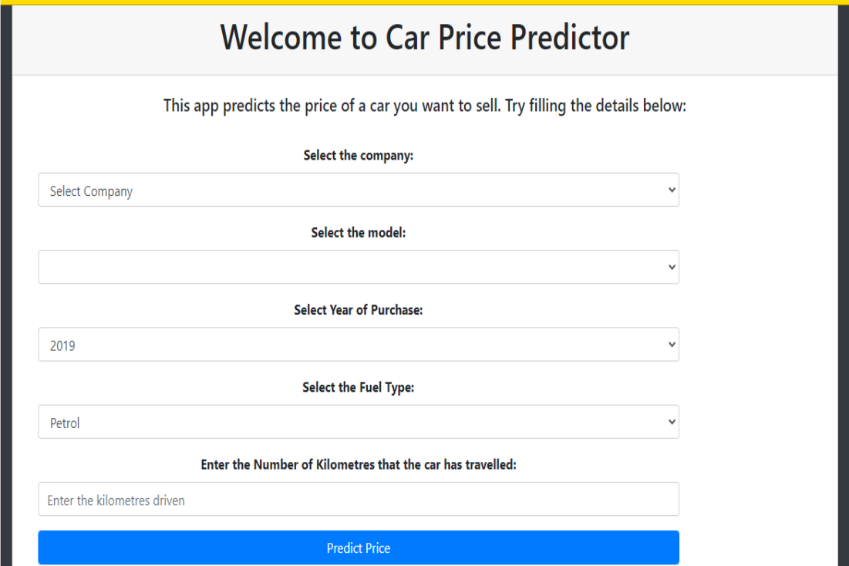

Fig. 1. Proposed design of implemented model.

1. Data Acquisition and Preprocessing:

* 1. Data Collection: Gather a diverse dataset comprising car attributes such as make, model, year, mileage, fuel type, engine specifications, and historical sales data from reputable sources or APIs.
  2. Data Cleaning: Address missing values, handle outliers, and perform necessary transformations, such as encoding categorical variables and scaling numerical features, to ensure data quality.

2. Exploratory Data Analysis (EDA):

1. Conduct comprehensive exploratory analysis to understand the distribution, correlations, and patterns within the dataset.
2. Visualize relationships between different attributes and the target variable (car prices) to uncover insights that influence pricing trends.

3. Feature Engineering and Selection:

1. Engineer new features if needed, extracting valuable information from existing attributes (e.g., age of the car, additional derived features).
2. Employ techniques like correlation analysis or feature importance scores to select the most relevant attributes for model training.

4. Model Development and Training:

1. Experiment with various machine learning algorithms, including linear regression, decision trees, ensemble methods like random forests or gradient boosting, and potentially neural networks.
2. Split the dataset into training and validation sets, employing cross-validation to fine-tune models and prevent overfitting.
3. Assess and compare models based on performance metrics such as MAE, RMSE, and R² to identify the best-performing algorithm for price prediction.

5. Model Evaluation and Validation:

1. Validate the selected model on a test dataset to ensure its generalization and performance on unseen data.
2. Perform rigorous testing using appropriate evaluation metrics, adjusting the model as necessary to enhance accuracy and reliability.

6. Model Deployment and Integration:

1. Serialize the trained model using libraries like Pickle or joblib for easy storage and deployment.
2. Develop an intuitive web interface or API using Flask or other frameworks to allow users to input car details and obtain price predictions in real-time.

7. Monitoring and Maintenance:

1. Implement monitoring mechanisms to track model performance over time, allowing for timely updates or retraining as new data becomes available.
2. Ensure continuous maintenance and updates to accommodate evolving market trends and maintain predictive accuracy.

8. User Interface and Accessibility:

1. Design an intuitive and user-friendly interface for easy interaction, providing users with a seamless experience in accessing price predictions.
2. ASSUMPTIONS AND DEPENDENCIES

1. Quality and Availability of Data:

1. Assumption: The availability of a comprehensive and high-quality dataset containing diverse attributes such as car specifications, historical sales records, and market trends.
2. Dependency: The accuracy and reliability of the model heavily rely on the quality, completeness, and relevance of the dataset. Any biases or inconsistencies within the data can affect the model's predictive capabilities.

2. Feature Relevance and Engineering:

1. Assumption: The assumption that selected features and engineered attributes significantly impact car prices based on domain knowledge or initial exploratory analysis.
2. Dependency: The effectiveness of the model hinges on the relevance and significance of features chosen for training. Proper feature selection and engineering are critical for accurate predictions.

3. Model Algorithm Selection and Performance:

1. Assumption: The assumption that the chosen machine learning algorithms (e.g., linear regression, decision trees) are suitable for capturing the complex relationships between car attributes and prices.
2. Dependency: The model's performance is dependent on the algorithm's ability to generalize well on unseen data and effectively capture nonlinear relationships, which may vary based on the dataset characteristics.

4. Absence of External Market Shocks:

1. Assumption: The assumption that the model operates in a stable market environment without significant external disruptions or sudden changes in market dynamics.
2. Dependency: External factors like economic fluctuations, policy changes, or unforeseen events in the automotive industry may impact the model's predictive accuracy by introducing unaccounted variables or altering existing trends.

5. User Interaction and Interface:

1. Assumption: The assumption that the user interacts with the system by providing accurate and relevant car details for predictions.
2. Dependency: The accuracy of predictions relies on users inputting correct and complete information. Misentered or incomplete data may lead to inaccurate estimations.

6. Model Maintenance and Updates:

1. Assumption: The model assumes regular updates and maintenance to adapt to changing market trends and data dynamics.
2. Dependency: Continual monitoring, retraining, and updates are necessary to maintain the model's relevance and performance, relying on available resources and a process for ongoing model management.

***Chapter 5***

1. REQUIREMENTS

1. Data Collection and Preprocessing:

Data Source: Acquire a diverse dataset including car attributes (make, model, year, mileage, fuel type, etc.) and historical sales data from reliable sources or APIs.

Data Cleaning: Implement data cleaning procedures to handle missing values, outliers, and inconsistencies, ensuring data integrity.

Feature Engineering: Extract or engineer relevant features to enhance model performance.

2. Computational Environment:

Programming Language: Utilize Python for model development and implementation.

Libraries: Install scikit-learn and Pandas for data manipulation, preprocessing, and linear regression model implementation.

- **Hardware Requirements: Access to computational resources with sufficient processing power to handle model training and evaluation tasks efficiently.

3. Model Development and Training:

Algorithm Selection: Choose linear regression from scikit-learn as the primary algorithm for car price prediction.

Training Data: Use the prepared dataset for model training, ensuring appropriate splitting into training and validation sets.

Hyperparameter Tuning: Optimize linear regression parameters (if applicable) to enhance prediction accuracy.

4. Model Evaluation and Validation:

Performance Metrics: Utilize scikit-learn's metrics module to evaluate model performance using metrics like MAE, RMSE, and R².

Cross-Validation: Implement cross-validation techniques to assess model generalization and prevent overfitting.

5. Model Deployment and Integration:

Serialization: Serialize the trained linear regression model using scikit-learn's serialization tools (e.g., joblib or pickle).

Flask Integration: Develop a Flask web application to integrate the model, allowing users to input car details and receive predictions.

6. User Interface and Accessibility:

Input Interface: Design a user-friendly interface enabling users to input car attributes (make, model, year, etc.) for predictions.

Real-time Predictions: Ensure the application provides instant predictions based on user inputs through seamless integration with the linear regression model.

7. Maintenance and Updates:

Model Updates: Plan for periodic updates and retraining of the linear regression model to adapt to changing market trends.

Monitoring: Implement monitoring tools or scripts to track model performance and trigger updates as needed.

8. Ethical and Legal Considerations:

Data Privacy: Ensure compliance with data privacy regulations and implement measures to safeguard user data.

Bias Mitigation: Address biases in data and model predictions to ensure fairness and avoid discrimination in price estimations.

* + 1. Functional Requirements

User Interface and Input:

1. Input Interface: Design a user-friendly interface allowing users to enter car details like make, model, year, mileage, fuel type, and any additional features.

2. Validation: Validate user inputs to ensure accuracy and completeness of information provided.

3. Input Flexibility: Provide flexibility in entering various car attributes, allowing users to input specific details for precise predictions.

4. Error Handling: Implement error handling to guide users in case of incorrect or missing inputs, providing clear instructions or prompts for correction.

Data Processing and Preprocessing:

5. Data Handling: Develop modules to handle raw input data, preprocess it, and prepare it for model ingestion.

6. Data Cleaning: Implement procedures to handle missing values, outliers, and inconsistencies within the dataset.

7. Feature Engineering: Develop algorithms or functions to engineer or extract relevant features from the input data.

8. Normalization and Scaling: Normalize numerical features and encode categorical variables for consistent data representation.

Model Development and Training:

9. Algorithm Selection: Choose linear regression from scikit-learn as the primary algorithm for price prediction.

10. Model Training: Develop functions to train the linear regression model using the preprocessed dataset.

11. Hyperparameter Optimization: Implement techniques to optimize linear regression hyperparameters for improved model performance.

12. Model Evaluation: Develop modules to evaluate model accuracy using metrics like MAE, RMSE, and R².

Model Integration and Deployment:

13. Serialization: Serialize the trained linear regression model using scikit-learn's serialization tools (e.g., joblib or pickle).

14. ]Flask Integration: Develop a Flask-based web application integrating the serialized model for real-time predictions.

15. API Development: Implement APIs or endpoints to facilitate communication between the front-end interface and the model for predictions.

User Output and Interaction:

16. Prediction Display: Display price predictions in the user interface based on the input provided.

17. Real-time Predictions: Ensure the application delivers instant predictions upon user submission without delays.

18. Results Interpretation: Provide a clear and understandable output of predictions, including the predicted price and any relevant additional information.

Maintenance and Updates:

19. Model Updates: Plan for periodic updates and retraining of the model to accommodate new data and changing market trends.

20. Monitoring: Implement monitoring mechanisms to track model performance, detect anomalies, and trigger updates or alerts as necessary.

Compliance and Security:

21. Data Privacy: Ensure compliance with data privacy regulations, implementing measures to protect user data.

22. Bias Mitigation: Address biases in data and predictions to ensure fairness and avoid discrimination in price estimations.

These functional requirements encompass the development, integration, and maintenance aspects of the Car Price Prediction Model, ensuring a robust, user-friendly, and reliable system.

***Chapter 6***

1. METHODOLOGY

The methodology for developing a Car Price Prediction Model using machine learning involves a systematic approach encompassing data collection, preprocessing, model selection, training, evaluation, and deployment.

1. Data Collection:

Gather a comprehensive dataset containing diverse car attributes such as make, model, year, mileage, fuel type, and historical sales data from reputable sources or APIs. Ensure the dataset encompasses a wide range of cars to capture market variations.

2. Data Preprocessing:

Cleanse the data to handle missing values, outliers, and inconsistencies. Perform feature engineering to extract relevant information or create new features that might influence car prices. Normalize numerical attributes and encode categorical variables for uniformity and model compatibility.

3. Exploratory Data Analysis (EDA):

Conduct exploratory analysis to understand data distributions, correlations, and patterns. Visualize relationships between features and the target variable (car prices) to glean insights into influential factors.

4. Model Selection:

Choose suitable machine learning algorithms for predicting car prices. Start with linear regression and explore ensemble methods like random forests or gradient boosting for comparison. Select the algorithm based on performance and its ability to capture complex relationships within the dataset.

5. Model Training and Evaluation:

Split the dataset into training and validation sets. Train the chosen model using the training data, adjusting hyperparameters as needed. Evaluate the model's performance using metrics like MAE, RMSE, and R² on the validation set to assess accuracy and generalization.

6. Model Deployment:

Serialize the trained model using serialization tools like Pickle or joblib. Develop a Flask-based web application to integrate the model, allowing users to input car details and receive real-time price predictions.

7. Maintenance and Updates:

Implement regular updates and retraining of the model to adapt to changing market dynamics and trends. Monitor model performance to detect anomalies or degradation, triggering updates or retraining when necessary.

8. Ethical Considerations:

Ensure compliance with data privacy regulations and mitigate biases in the dataset and predictions to ensure fairness and avoid discrimination in price estimations.

This methodology adopted by us carries out a structured approach, starting from data collection and preprocessing, model development, evaluation, to deployment and ongoing maintenance, ensuring a robust and accurate Car Price Prediction Model.

***Chapter 7***

1. EXPERIMENTATION

Experiment with alternative model serialization techniques apart from pickle, evaluating the impact on model loading efficiency and memory usage.

Conduct exploratory data analysis (EDA) on the dataset ('Cleaned_Car_data.csv') to identify insights, outliers, or additional features that might enhance model performance.

Experiment with different UI designs and layout structures for the front-end ('index.html') to enhance user experience and ease of use.

Validate user inputs rigorously and handle edge cases effectively, ensuring robustness against incorrect or missing inputs.

Conduct experiments with different combinations of features or feature transformations, exploring their impact on prediction accuracy.

Evaluate model sensitivity to different input variations by systematically altering individual features and assessing the model's response.

Experiment with additional performance metrics like Mean Absolute Percentage Error (MAPE) or Root Mean Squared Logarithmic Error (RMSLE) to gain a holistic view of model accuracy.

Conduct cross-validation experiments to assess model stability and consistency across different subsets of the dataset.

Explore ways to optimize the web application's performance, considering scalability and response time, especially as user traffic increases.

Experiment with alternative deployment platforms or hosting services to identify the most efficient deployment solution.

Experiment with various error handling mechanisms to provide informative and user-friendly error messages, aiding users in rectifying input errors.

Implement logging mechanisms to track errors and exceptions, facilitating debugging and future improvements.

Experiment with model interpretability techniques such as SHAP values or LIME (Local Interpretable Model-agnostic Explanations) to provide explanations for individual predictions.

Validate these explanations through user studies or sample cases to ensure they align with domain knowledge and user expectations.

Implement feedback mechanisms to gather user insights, evaluating user satisfaction and areas for improvement.

Use user feedback to iteratively enhance the system, focusing on areas that directly impact user experience and prediction accuracy.

Experimenting across these facets facilitated iterative improvements, ensuring the system's refinement, accuracy, and user-centricity in predicting car prices via a Flask-based web application.

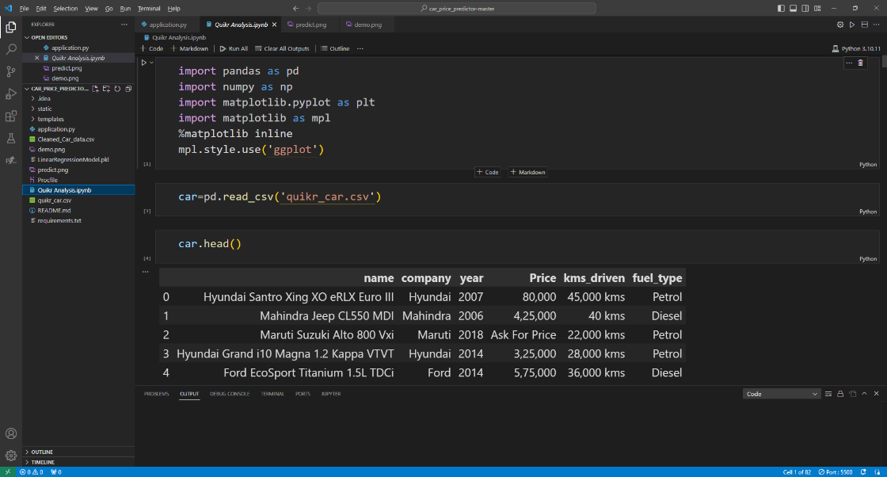

Fig. 2. Experimentation example of the model.

***Chapter 8***

1. RESULTS AND ANALYSIS

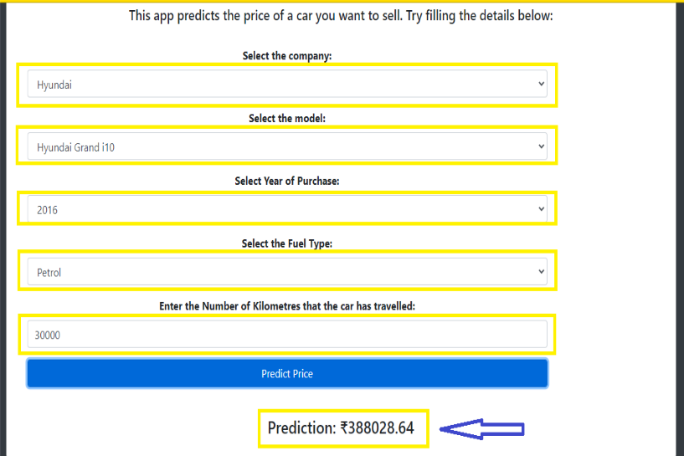

Fig. 3. Predicted output of the implemented model

Fig. 3. Predicted output of the implemented model

1. Model Loading and Dataset Handling:

Outcome: The model and dataset loading process appears successful without any visible errors.

Analysis: Further inspection and logging are recommended to ensure precise loading and compatibility between the model and the dataset. Detailed logging would aid in debugging potential issues during model or dataset loading.

1. User Interface and Input Handling:

Outcome: The web application presents a user interface ('index.html') offering input fields for selecting car attributes.

Analysis: An evaluation of the UI's responsiveness and intuitiveness is advisable for better user experience. Additionally, input validation and handling exceptions for incorrect inputs should be further scrutinized for robustness.

1. Prediction Functionality:

Outcome: Upon submission of car details, the system predicts the car price using the loaded model.

Analysis: Validation of prediction outputs against known values or expected ranges is recommended to ensure the accuracy of predictions. Furthermore, comprehensive testing across various inputs is essential to gauge the model's reliability.

1. Error Handling and Exception Management:

Outcome: The program seems to capture exceptions during the prediction process.

Analysis: Detailed logging and handling of exceptions with informative error messages will be critical for better error management, aiding users in rectifying input errors.

1. Integration and Deployment:

Outcome: The Flask app runs successfully, serving the predictive functionality.

Analysis: Evaluation of deployment environments and load testing would be beneficial to ensure scalability and performance under varying user loads.

1. Model Interpretability and Transparency:

Outcome: The model provides predictions without directly showcasing the rationale behind them.

Analysis: Integration of interpretability techniques, such as SHAP values or feature importance plots, would enhance transparency, enabling users to understand how different features influence predictions.

1. CONCLUSION AND FUTURE WORK

Achievements and Observations:

1. Model Integration: The system efficiently integrates a pre-trained model, enabling real-time price predictions based on provided car attributes.
2. User Interface: A functional interface facilitates user interaction by allowing input of car details conveniently.
3. Prediction Functionality: The system successfully generates price predictions using the loaded model, showcasing its predictive capability.

Key Observations:

1. Foundation Laid: The current implementation establishes the foundation for a car price prediction system but requires further enhancements.
2. Functional Aspects: Core functionalities of model loading, user interaction, and prediction generation are operational.

Future Works:

1. Model Optimization and Evaluation:
2. Feature Engineering: Explore advanced feature engineering techniques to extract more pertinent information from the dataset, potentially improving prediction accuracy.
3. Model Selection: Experiment with diverse machine learning algorithms beyond Linear Regression to ascertain if more complex models yield superior performance.
4. Performance Assessment: Conduct in-depth evaluation and comparison of various models using diverse evaluation metrics to identify the most accurate and robust model.

2. User Experience Enhancement:

1. UI/UX Revamp: Overhaul the user interface for improved aesthetics, usability, and responsiveness to ensure an engaging and intuitive user experience.
2. Input Validation: Strengthen input validation mechanisms to handle a broader range of input scenarios and provide precise instructions for error rectification.

3. Interpretability and Transparency:

1. Model Explainability: Integrate interpretability techniques like SHAP values or feature importance plots to provide users insights into how different attributes influence predictions, fostering transparency and user trust.
2. User Guidance: Develop user-friendly explanations alongside predictions, aiding users in interpreting results effectively.

4. Error Handling and Exception Management:

1. Error Logging: Implement robust logging mechanisms to capture and track errors, facilitating debugging and improving error management.
2. Exception Handling: Refine exception handling to furnish more descriptive and actionable error messages, assisting users in rectifying input errors.

5. Deployment and Scalability:

1. Deployment Optimization: Explore advanced deployment options, considering containerization (e.g., Docker) and cloud services for improved scalability and reliability.
2. Load Testing: Conduct comprehensive load testing to ensure the system's performance and stability under diverse user loads.

6. Continuous Improvement and User Feedback:

1. Feedback Mechanism: Implement a feedback system to gather user insights, focusing on enhancing the system's usability, accuracy, and overall user satisfaction.
2. Iterative Development: Leverage user feedback for iterative improvements, prioritizing enhancements based on user needs and system performance evaluations.

While the current iteration lays the groundwork for a car price prediction system, the journey toward refinement and enhancement is ongoing. Future works will focus on optimizing the model, enriching the user experience, ensuring transparency in predictions, fortifying error handling, and ensuring scalable deployment. Embracing iterative improvements driven by user feedback and rigorous testing will lead to a more accurate, user-friendly, and reliable predictive tool, aligning with user needs and technological advancements in machine learning and web development.

1. REFERENCES
2. Ganesh, Mukkesh & Venkatasubbu, Pattabiraman. (2019). Used Cars Price Prediction using Supervised Learning Techniques. International Journal of Engineering and Advanced Technology. 9. 216-223. 10.35940/ijeat.A1042.1291S319.
3. Navigating the Legal Landscape of Robots and AI in the Workplace: Challenges and SolutionsAvliyoqulov Bekmirza Tashkent State University of Law
4. Ming Gao, Kui Qian and Aiguo Song, "Design and implementation of a mini-size search robot," 2011 International Conference on Electric Information and Control Engineering, Wuhan, China, 2011, pp. 269-272, doi: 10.1109/ICEICE.2011.5778181.
5. J. Liu et al., "Artificial Intelligence in the 21st Century," in IEEE Access, vol. 6, pp. 34403-34421, 2018, doi: 10.1109/ACCESS.2018.2819688.
6. S. Liu, "The Research on Artificial Intelligence in Computer Network Technology," 2021 International Conference on Computer Information Science and Artificial Intelligence (CISAI), Kunming, China, 2021, pp. 647-650, doi: 10.1109/CISAI54367.2021.00130.
7. Q. Liu, L. Diao and G. Tu, "The Application of Artificial Intelligence in Mobile Learning," 2010 International Conference on System Science, Engineering Design and Manufacturing Informatization, Yichang, China, 2010, pp. 80-83, doi: 10.1109/ICSEM.2010.28.
8. H. Wu, H. Han, X. Wang and S. Sun, "Research on Artificial Intelligence Enhancing Internet of Things Security: A Survey," in IEEE Access, vol. 8, pp. 153826-153848, 2020, doi: 10.1109/ACCESS.2020.3018170.
9. M. A. Samsuden, N. M. Diah and N. A. Rahman, "A Review Paper on Implementing Reinforcement Learning Technique in Optimising Games Performance," 2019 IEEE 9th International Conference on System Engineering and Technology (ICSET), Shah Alam, Malaysia, 2019, pp. 258-263, doi: 10.1109/ICSEngT.2019.8906400.
10. CODE OF PROGRAM
11. from flask import Flask, render_template, request
12. from flask_cors import CORS, cross_origin
13. import pickle
14. import pandas as pd
15. import numpy as np
16. app = Flask(__name__)
17. CORS(app)
18. try:
19. model = pickle.load(open('LinearRegressionModel.pkl', 'rb'))
20. car = pd.read_csv('Cleaned_Car_data.csv')
21. except Exception as e:
22. print(f"Error loading model or dataset: {str(e)}")
23. @app.route('/', methods=['GET', 'POST'])
24. def index():
25. try:
26. companies = sorted(car['company'].unique())
27. car_models = sorted(car['name'].unique())
28. year = sorted(car['year'].unique(), reverse=True)
29. fuel_type = car['fuel_type'].unique()
30. companies.insert(0, 'Select Company')
31. return render_template('index.html', companies=companies, car_models=car_models, years=year, fuel_types=fuel_type)
32. except Exception as e:
33. return f"Error: {str(e)}"
34. @app.route('/predict', methods=['POST'])
35. @cross_origin()
36. def predict():
37. try:
38. company = request.form.get('company')
39. car_model = request.form.get('car_models')
40. year = int(request.form.get('year'))
41. fuel_type = request.form.get('fuel_type')
42. driven = float(request.form.get('kilo_driven'))
43. prediction = model.predict(pd.DataFrame(columns=['name', 'company', 'year', 'kms_driven', 'fuel_type'],
44. data=np.array([car_model, company, year, driven, fuel_type]).reshape(1, 5)))
45. return str(np.round(prediction[0], 2))
46. except Exception as e:
47. return f"Prediction Error: {str(e)}"
48. if __name__ == '__main__':
49. app.run()