1. Could the project icon be customised to use the actual project icon,

Yes,

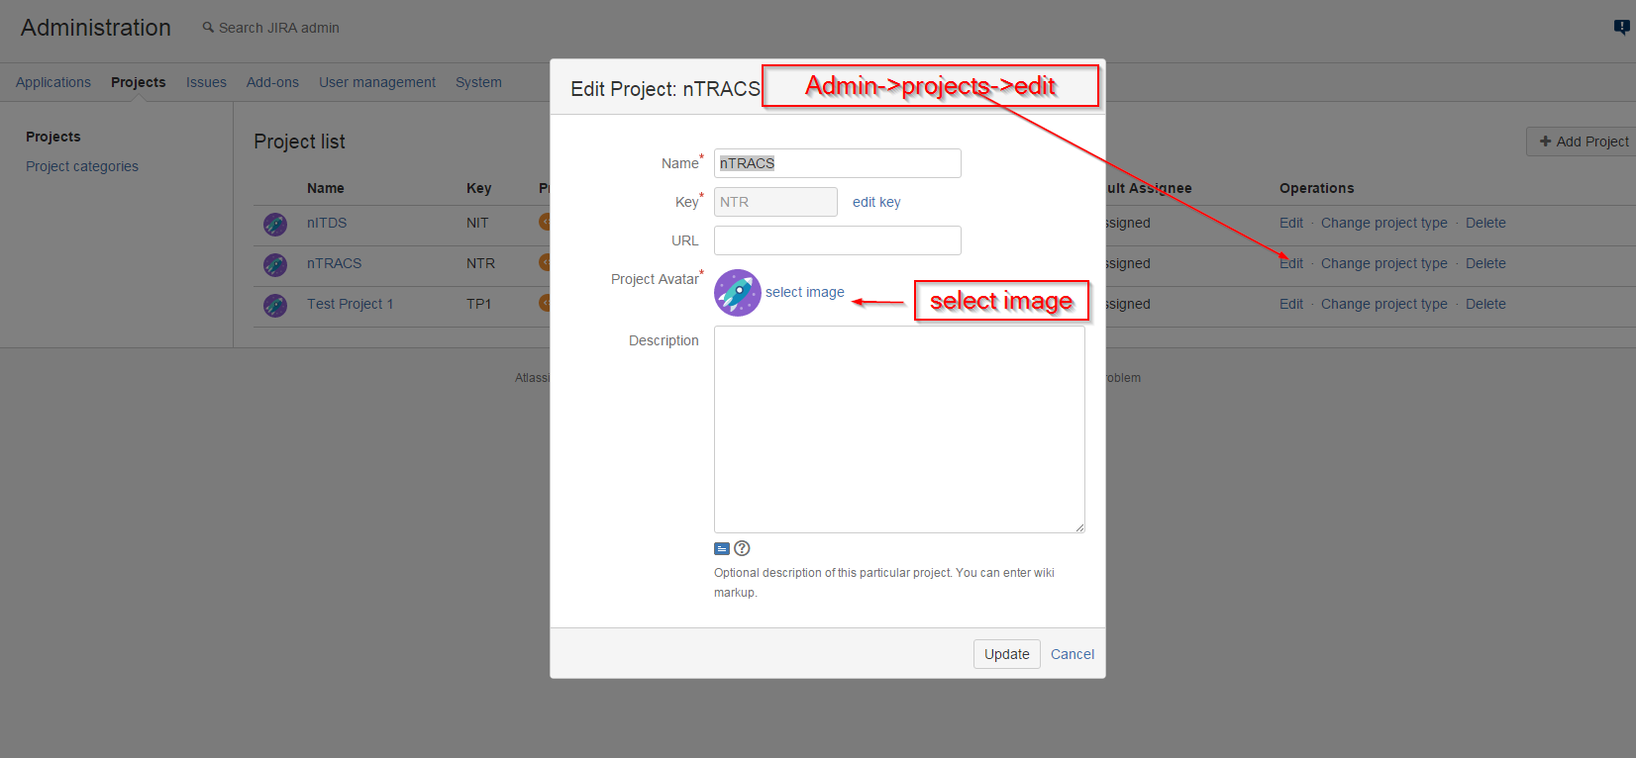

1. I found myself difficult to locate a particular sprint in the past that I want to look for.

Only completed sprint come in the report section. And all the future and current active sprint will be in scrum board.

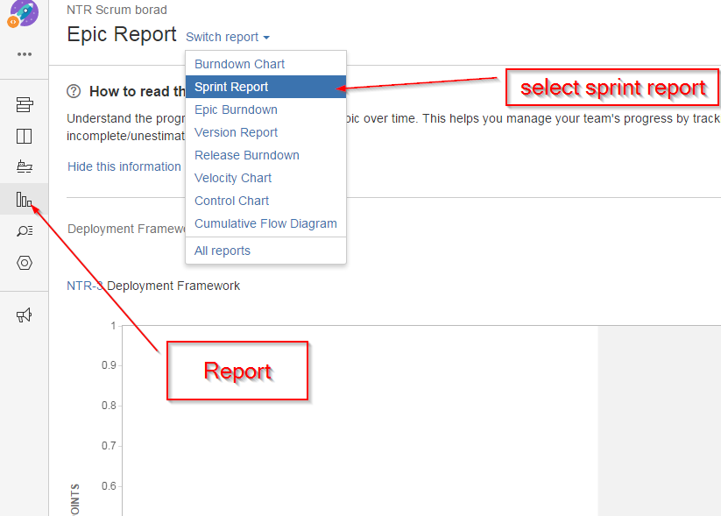

1. In release view, some Sync failed to bit bit bucket, I assume that it is normal as the source code are not.

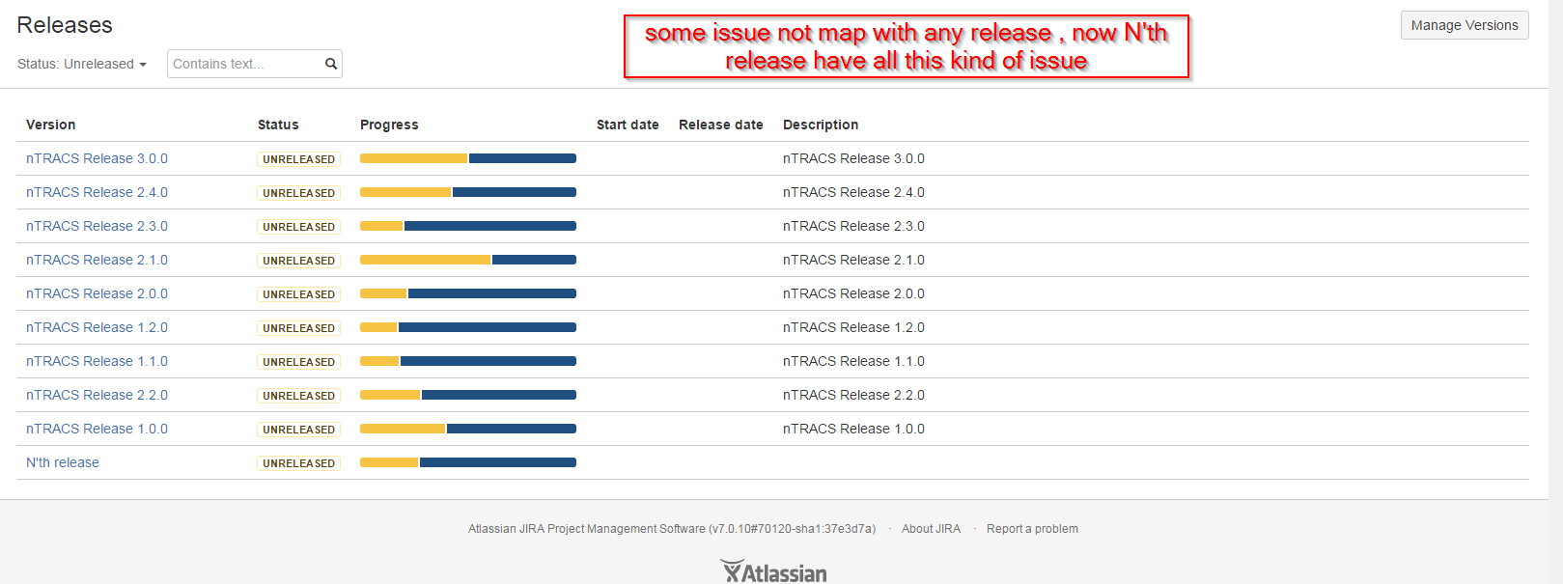

1. I have created some Epics, but I can’t find them in the Epic list when I create user Story.

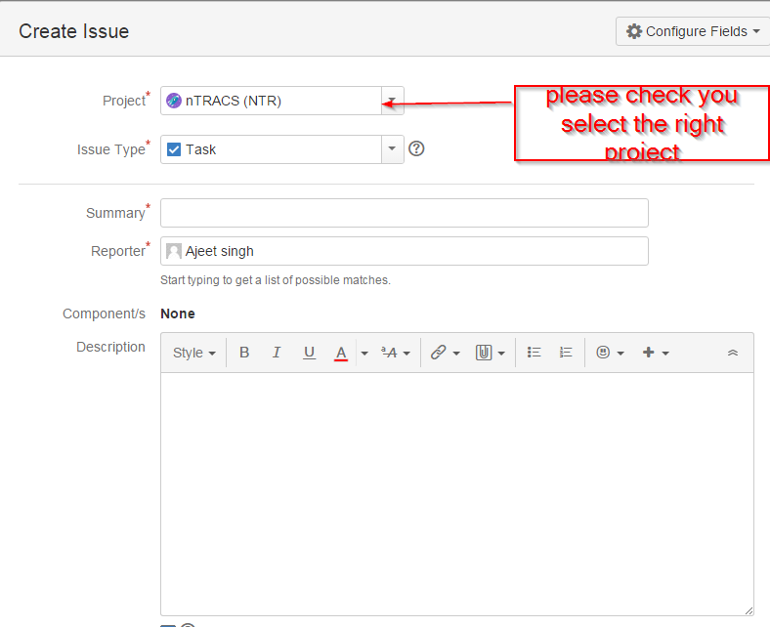

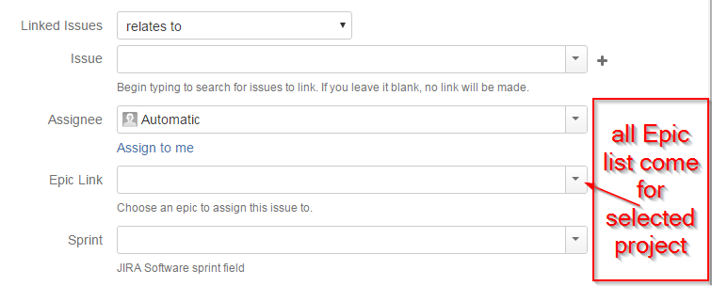

1. I don’t know where to edit the sprint info. E.g. the start and end date of the Sprint

