Oops:
Oops (Object oriented programming) is programming paradigm which is using to designed software using Object that combine data(properties) and behavior (methods).
Properties: name, age, color
Methods: talking(), saving(), running().
Core concepts of OOP:
1. Class: Class is a blueprint or template for creating object. It defines properties (data) and behavior (method).
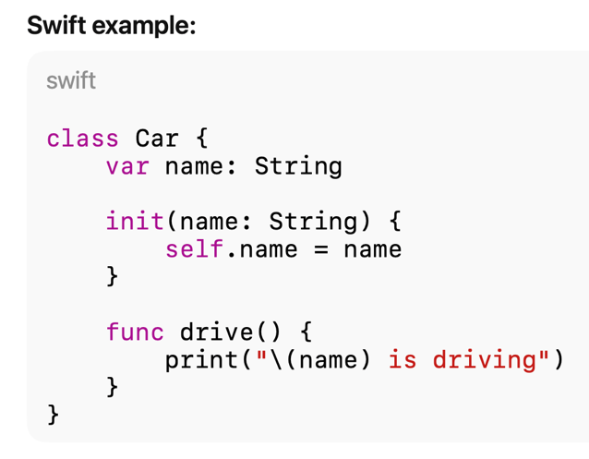
2. Object: Object is instance of any class that holds the data and perform actions on data defined by class.
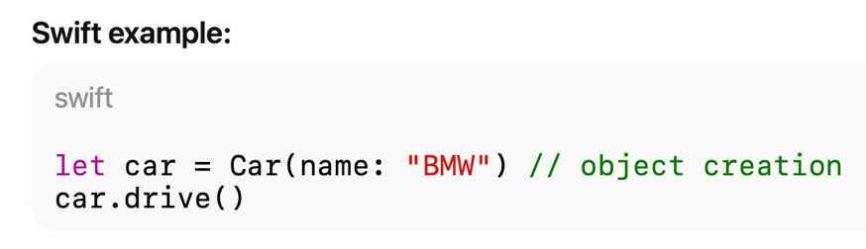
3. Encapsulation: Encapsulation is the concept of binding data and methods together, hiding internal details from outside the world and control access of data and methods using access modifier - open, public, internal, filePrivate, private.

Open | Accessible anywhere + can be subclassed/overridden outside the module
Public | Accessible anywhere + cannot be subclassed/overridden outside the module
Internal | Default: accessible only inside the module
fileprivate | Accessible only inside the same file
private | accessible only withing the same declaration.
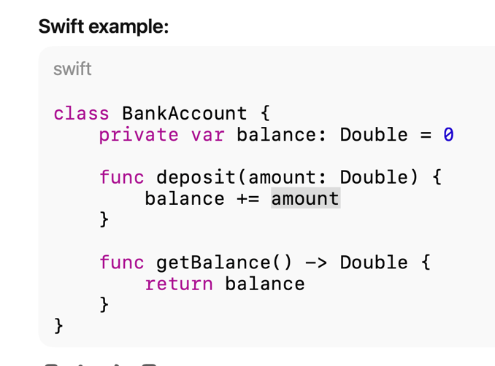
4. Inheritance:
Inheritance is mechanism where one class can access property and method from another class. Inheritance it used for code reusability.
Base class/Superclass: The class whose properties and methods are inherited by another class.
Subclass/Derived class: The class that inherits from a superclass and adds/overrides functionality.
Method overriding Subclass provides its own version of superclass method using override.
Property overriding: Subclass override computed property. (stored property can not be overridden)
Property observers override: Subclass adds willSet/didSet to inherited properties.
final: prevent a class, method and properties from being inherited or overridden.
‘super’ keyword: Used to access superclass methods, properties, or initializer.

Abstraction:
Abstraction means hiding complexity and showing only what’s needed to use something.
Abstraction focuses on what an object does, not how it does it.
In Swift, it’s commonly achieved using:
1. Protocol
2. Abstract like base class - Inheritance and method overloading.

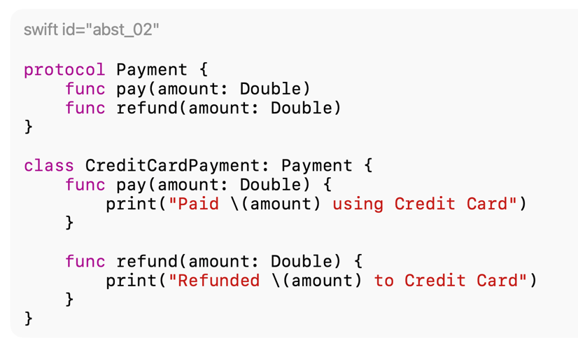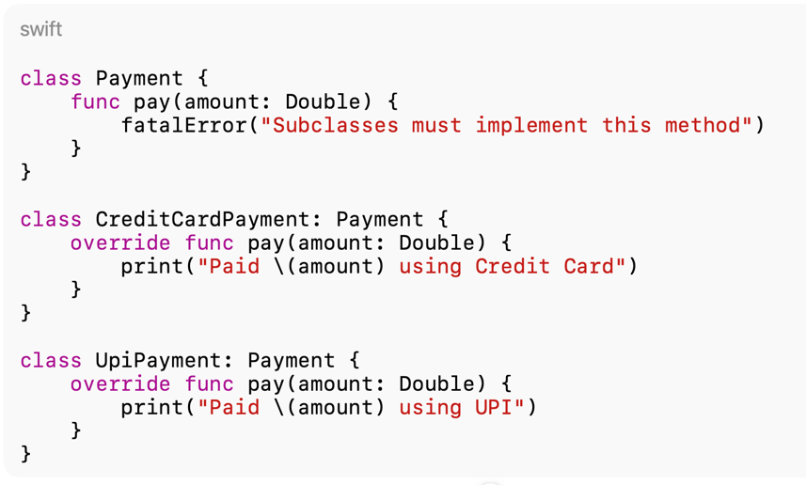

Types in Swift:
- Method Overriding (runtime polymorphism)
- Protocol-based polymorphism
Polymorphism allows different objects to respond to the same method call in their own way.
Method Overriding (Run time polymorphism):
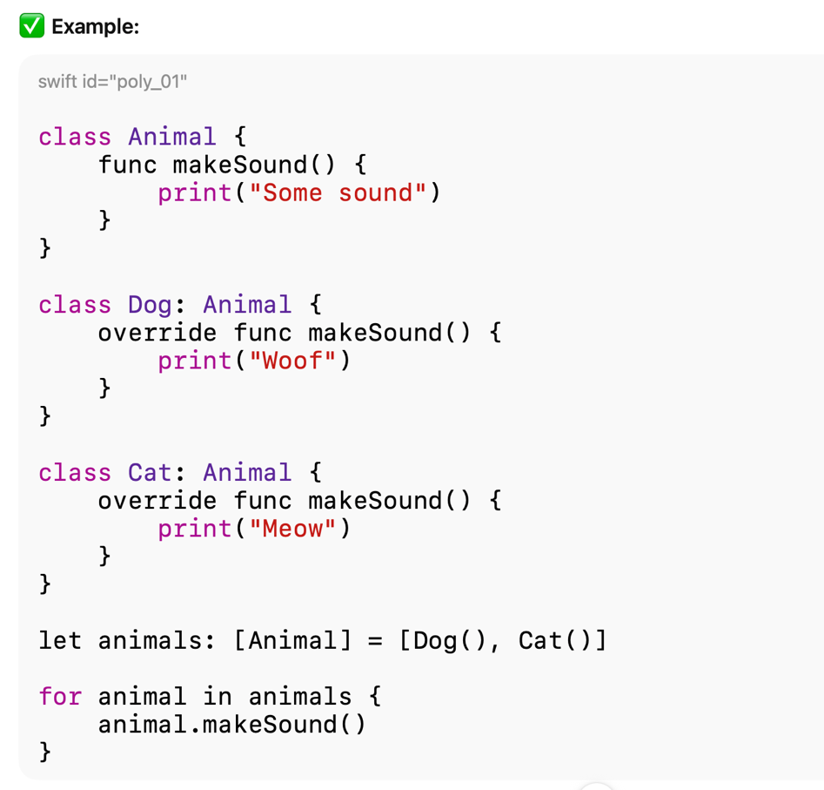
Protocol based polymorphism in Swift:
