SMART goals: Making goals meaningful

In this lesson, you are learning to define and create measurable project goals and deliverables. Now, let's focus on SMART goals.

**Specific, Measurable, Attainable, Relevant,** and **Time-bound (SMART)** goals are very helpful for ensuring project success. As you start your career in project management, you may not directly set the project goals, but you should be able to clarify and understand them. SMART goals help you see the full scope of a goal, determine its feasibility, and clearly define project success in concrete terms.

Let’s recap what we discussed in the previous video by taking a look at a breakdown of the criteria for SMART goals below:

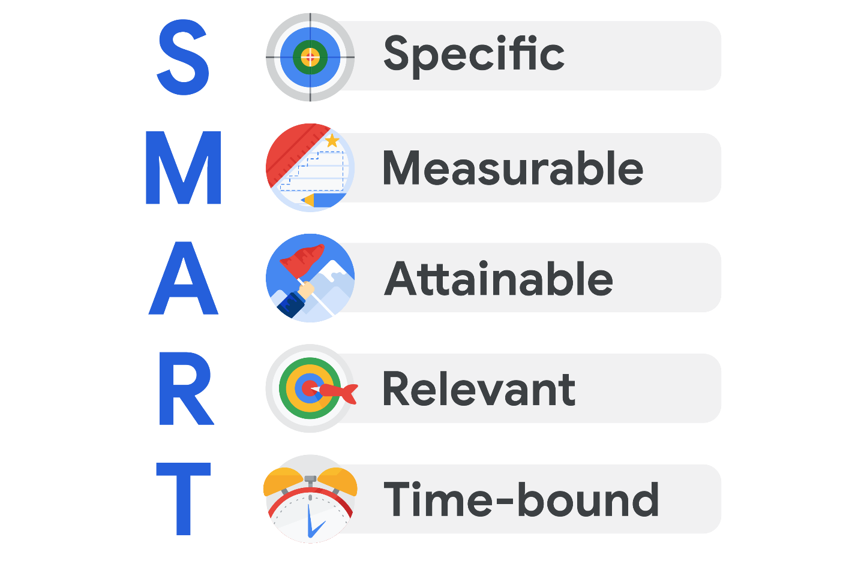

* **Specific:** The objective has no ambiguity for the project team to misinterpret.
* **Measurable:** Metrics help the project team determine when the objective is met.
* **Attainable:** The project team agrees the objective is realistic.
* **Relevant:** The goal fits the organization’s strategic plan and supports the project charter.
* **Time-bound:** The project team documents a date to achieve the goal.

You may see variations on what each letter in the “SMART” acronym stands for. (For example, you may see “actionable” or “achievable” instead of “attainable” or “realistic” instead of “relevant.”) However, the general intent of each of these terms—to make sure the goal is within reach—is always similar.

**Focusing on the "M" in SMART**

Let’s take a moment to zoom in on the **M** in SMART, which stands for **measurable**. Having measurable goals allows you to assess the success of your project based on quantifiable or tangiblemetrics, such as dollar amounts, number of outputs, quantities, etc. Measurable goals are important because they leave little room for confusion around expectations from stakeholders.

Not every metric will have value, so you will have to determine which metrics make sense for the project. For example, measuring how many meetings the software engineers on your project attend on a weekly basis may not be the most valuable metric for a productivity goal. Alternatively, you might measure other aspects of the engineers’ productivity, such as a particular number of features created per engineer or a specific number of issues flagged per day.

**Defining a SMART goal**

Let’s explore an example related to making a personal goal measurable. Imagine you are looking to make a career change, and you set a goal to complete a Google Career Certificate. You can **measure** the success of this goal because after completing the entire program, you will receive a certificate—a tangible outcome.

Now, let’s determine how to make the remaining elements of this goal SMART. In this example, your **specific** goal is to attain aGoogle Career Certificate. You can make this goal **attainable** by deciding that you will complete one course per month. This goal is **relevant** because it supports your desire to make a career change. Finally, you can make this goal **time-bound** by deciding that you will complete the program within six months.

After defining each of these components, your SMART goal then becomes: Obtain a Google Career Certificate by taking one course per month within the next six months.

**Key takeaway**

Determining metrics can be extremely helpful in capturing statuses, successes, delays, and more in a project. As a project manager, identifying meaningful metrics can help move the project toward its goal. Additionally, by defining each element of a project goal to make it SMART, you can determine what success means for that goal and how to achieve it.