Weekly Status Report
JUST UDO AVIATION PRIVATE LIMITED (Fly91)
Submitted By
Greatworx
23/09/2026
Reporting Period: 14th September – 20th September 2026

security best practices
Content | Link
Best Practices for AWS root users | https://docs.aws.amazon.com/accounts/latest/reference/best-practices-root-user.html
Best Practices for AWS Access Keys | https://docs.aws.amazon.com/accounts/latest/reference/credentials-access-keys-best-practices.html
Shared Responsibility Model | https://aws.amazon.com/compliance/shared-responsibility-model/
AWS Cloudtrail | https://aws.amazon.com/cloudtrail/
Trusted Advisor | https://aws.amazon.com/premiumsupport/trustedadvisor/
Creating Billing alarms | https://docs.aws.amazon.com/AmazonCloudWatch/latest/monitoring/gs_monitor_estimated_charges_with_cloudwatch.html#gs_creating_billing_alarm
Enable MFA | https://docs.aws.amazon.com/IAM/latest/UserGuide/id_credentials_mfa.html
GIT Secrets | https://github.com/awslabs/git-secrets

Summary
JUST UDO AVIATION PRIVATE LIMITED (Fly91) - 674351849978

Billing and Cost Overview
Total cost for the week: $1,287.44
Average Daily Cost: $183.92
Total Tax Cost: $241.59
The costs slightly decreased compared to the previous week due to the following services: EC2-Instances, EC2-Other.
No Activity performed by Greatworx in this account.

Resource Utilization & Alarms
All EC2 Server Alarms triggered between (14th September – 20th September 2026)
Server Name | Region | Memory/Disk/CPU | Alert date and no. of trigger
fly91-app-prod(i-0a1b2c3d4e5f60718) | ap-south-1 | Disk 90% [/] | September 15(2 Times)September 18(1 Time)
fly91-db-prod(i-0b2c3d4e5f6071829) | ap-south-1 | CPU 80% | September 16(3 Times)
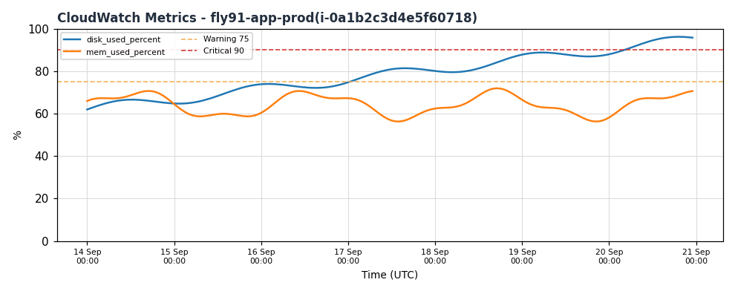
CloudWatch metrics for fly91-app-prod(i-0a1b2c3d4e5f60718) - 14th September – 20th September 2026
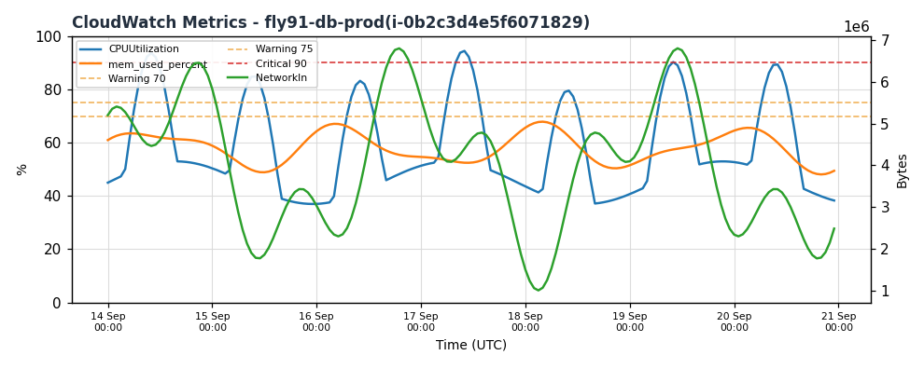
CloudWatch metrics for fly91-db-prod(i-0b2c3d4e5f6071829) - 14th September – 20th September 2026
-- End Of Document --

