
Weekly Status Report
Aptech Limited

Submitted By
Operisoft Technologies Pvt Ltd
04/10/2026


Cost Summary Difference of All AWS Accounts
No | Account Name | Account ID | Last Week Cost (21 Sep to 27 Sep) | Tax Cost | Current Week Cost (28 Sep to 04 Oct) | Services
1 | Aptrack 1.0 - DC [Aptech] | 654654548701 | $847.52 |  | $758.69 | The costs decreased by $88.83 due to usage of following services: EC2-Other, Relational Database Service, VPC.
2 | Aptrack 2.0 - NonProd UAT [MEL] | 767397805488 | $1,161.14 | $28.21 | $1,175.81 | The costs increased by $14.66 due to usage of following services: Network Firewall.
3 | Aptrack 2.0 OldManagement A/c [MEL]/Production | 015747350560 | $689.66 |  | $642.65 | The costs decreased by $47.01 due to usage of following services: EC2-Other, Relational Database Service, CloudFront.
4 | Aptrack 1.0 - DR [Aptrack5.0] | 590183710228 | $1,474.89 |  | $1,452.06 | The costs decreased by $22.83 due to usage of following services: EC2-Other, EC2-Instances, VPC.
5 | Aptrack - ProAlle | 617172754330 | $1,004.26 | $22.19 | $968.33 | The costs decreased by $35.93 due to usage of following services: Network Firewall, EC2-Other, Relational Database Service.
6 | Aptrack - 2.0 - Shared Service [MEL] | 533267037955 | $1,134.16 |  | $1,168.61 | The costs increased by $34.44 due to usage of following services: EC2-Other, Network Firewall, EC2-Instances.
7 | Aptrack-SAP-Dev and Quality | 528757792293 | $1,319.37 | $28.46 | $1,183.84 | The costs decreased by $135.53 due to usage of following services: Network Firewall, VPC, Relational Database Service.
8 | Aptrack-SAP-Production | 195275643918 | $307.51 |  | $283.14 | The costs decreased by $24.37 due to usage of following services: Network Firewall, EC2-Instances.
9 | Aptrack – LCMS | 771423618181 | $558.31 | $9.42 | $471.23 | The costs decreased by $87.07 due to usage of following services: VPC.
10 | Aptech-ProConnect | 108782065415 | $1,290.53 |  | $1,364.84 | The costs increased by $74.31 due to usage of following services: Network Firewall, VPC.
11 | Aptrack - QnA Solution | 211125374996 | $91.93 |  | $102.24 | The costs increased by $10.30 due to usage of following services: VPC, EC2-Instances, EC2-Other.
12 | Aptech-LAPA | 343218180162 | $367.70 |  | $412.98 | The costs increased by $45.29 due to usage of following services: Network Firewall, EC2-Other.
13 | Aptrack-Arena | 034362049944 | $185.36 | $4.52 | $190.24 | The costs increased by $4.88 due to usage of following services: EC2-Other, VPC.
14 | Aptech Avalon | 985539791413 | $1,074.62 |  | $969.23 | The costs decreased by $105.39 due to usage of following services: Network Firewall, VPC, EC2-Instances.
15 | Aptech AI Applications | 166185345052 | $1,080.40 |  | $913.08 | The costs decreased by $167.32 due to usage of following services: EC2-Instances, VPC, EC2-Other.
16 | Aptrack AR_VR_MAAC | 377555974222 | $1,183.31 |  | $1,226.69 | The costs increased by $43.38 due to usage of following services: EC2-Other, EC2-Instances, Relational Database Service.
17 | Aptrack - 2.0 - Log archive [MEL] | 637423329781 | $106.47 | $2.53 | $106.58 | The cost remains same.
18 | Aptech-Domains | 622050225451 | $582.14 | $14.31 | $526.40 | The costs decreased by $55.74 due to usage of following services: Network Firewall, CloudFront.
19 | Aptrack - 2.0 - Audit [MEL] | 851725245759 | $170.12 | $2.88 | $155.02 | The costs decreased by $15.10 due to usage of following services: EC2-Other, CloudWatch, EC2-Instances.
20 | Aptech International | 470684059456 | $194.71 | $4.55 | $184.64 | The costs decreased by $10.07 due to usage of following services: EC2-Other, EC2-Instances, CloudFront.
Total Cost |  |  | ⬆️$14,824.11 | $117.07 | ⬇️$14,256.30

- The billing for the current week (28 September to 04 October) has decreased compared to the previous week.
- The cost difference is $567.81.

security best practices: -
Content | Link
Best Practices for AWS root users | https://docs.aws.amazon.com/accounts/latest/reference/best-practices-root-user.html
Best Practices for AWS Access Keys | https://docs.aws.amazon.com/accounts/latest/reference/credentials-access-keys-best-practices.html
Shared Responsibility Model | https://aws.amazon.com/compliance/shared-responsibility-model/
AWS Cloudtrail | https://aws.amazon.com/cloudtrail/
Trusted Advisor | https://aws.amazon.com/premiumsupport/trustedadvisor/
Creating Billing alarms | https://docs.aws.amazon.com/AmazonCloudWatch/latest/monitoring/gs_monitor_estimated_charges_with_cloudwatch.html#gs_creating_billing_alarm
Enable MFA | https://docs.aws.amazon.com/IAM/latest/UserGuide/id_credentials_mfa.html
GIT Secrets | https://github.com/awslabs/git-secrets
-------------------------------------------- Summary --------------------------------------------
Aptrack 1.0 - DC [Aptech] – 654654548701
----------------------------------------------------------------------------------------------------
- Billing and Cost Overview
  - Total cost for the week: $758.69
  - Average Daily Cost: $108.38
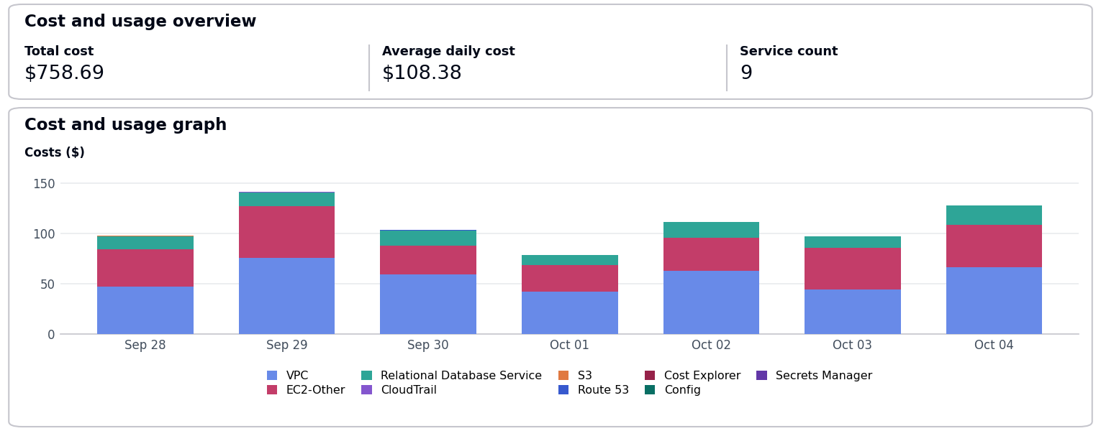
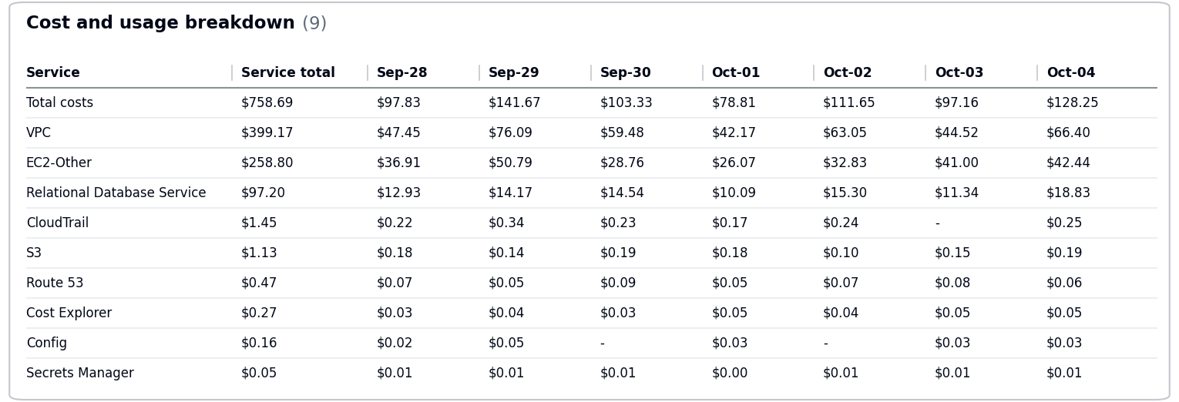
- The costs decreased by $88.83 due to usage of following services: EC2-Other, Relational Database Service, VPC.
- No Activity performed by Operisoft in this account.
Resource Utilization & Alarms
All EC2 Server Alarms triggered between (28 September 2026 to 04 October 2026)
Server Name | Region | Memory/Disk/CPU | Alert date and no. of trigger
db-server-01 (i-0fedcba9876543210) | ap-south-1 | CPU 85% | September 29(1 Time)  October 04(5 Times)
web-server-01 (i-0123456789abcdef0) | ap-south-1 | CPU 90% | October 02(6 Times)  October 03(4 Times)
-------------------------------------------- Summary --------------------------------------------
Aptrack 2.0 - NonProd UAT [MEL] – 767397805488
----------------------------------------------------------------------------------------------------
- Billing and Cost Overview
  - Total cost for the week: $1,175.81
  - Average Daily Cost: $167.97
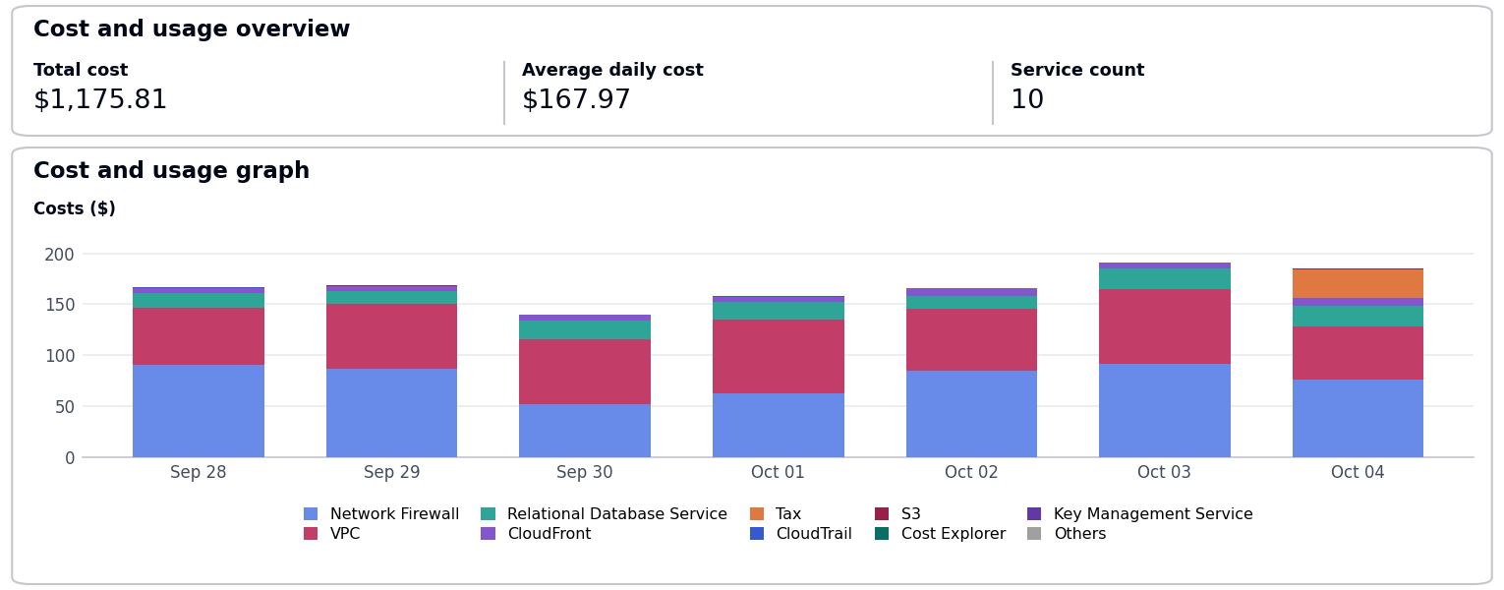
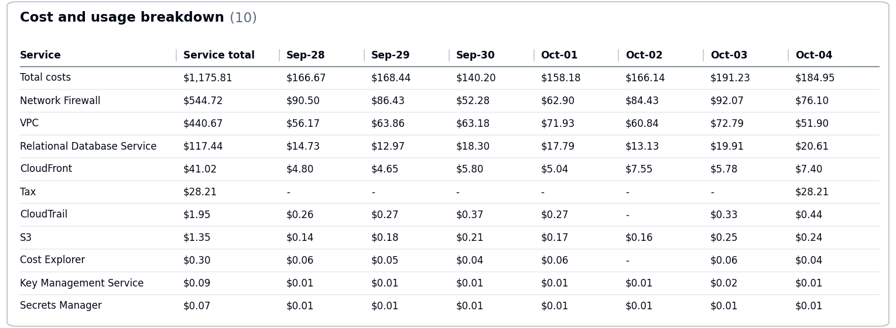
  - Total Tax Cost: $28.21
- The costs increased by $14.66 due to usage of following services: Network Firewall.
- No Activity performed by Operisoft in this account.
Resource Utilization & Alarms
All EC2 Server Alarms triggered between (28 September 2026 to 04 October 2026)
Server Name | Region | Memory/Disk/CPU | Alert date and no. of trigger
app-server-01 (i-0987654321fedcba0) | ap-south-1 | Memory 90% | October 03(4 Times)  October 04(5 Times)
db-server-01 (i-0fedcba9876543210) | ap-south-1 | CPU 85% | October 01(6 Times)  October 04(3 Times)
web-server-01 (i-0123456789abcdef0) | ap-south-1 | Disk 95% [/var] | September 29(3 Times)  October 03(3 Times)
-------------------------------------------- Summary --------------------------------------------
Aptrack 2.0 OldManagement A/c [MEL]/Production – 015747350560
----------------------------------------------------------------------------------------------------
- Billing and Cost Overview
  - Total cost for the week: $642.65
  - Average Daily Cost: $91.81
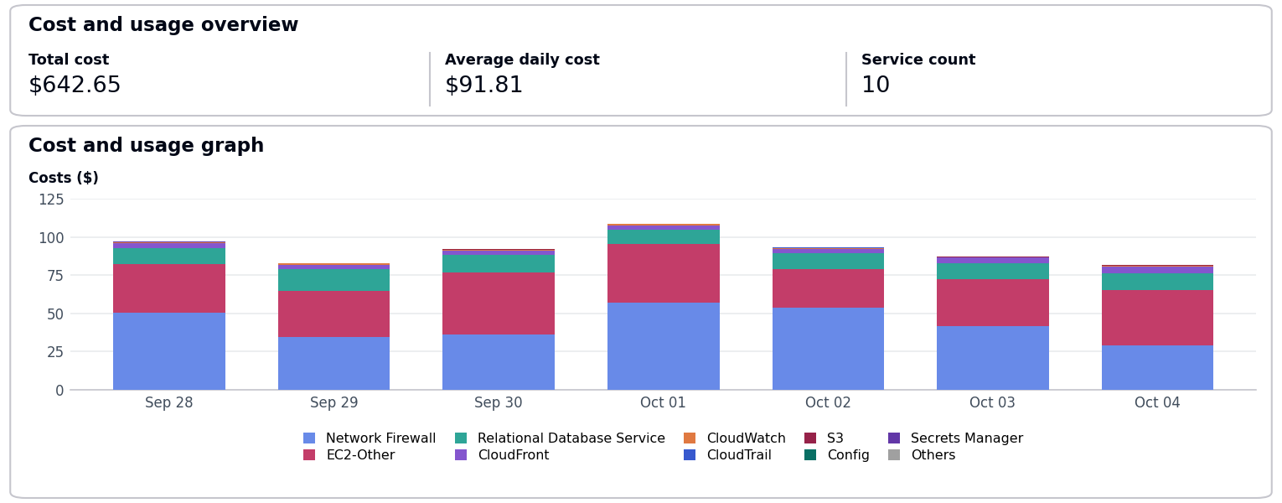
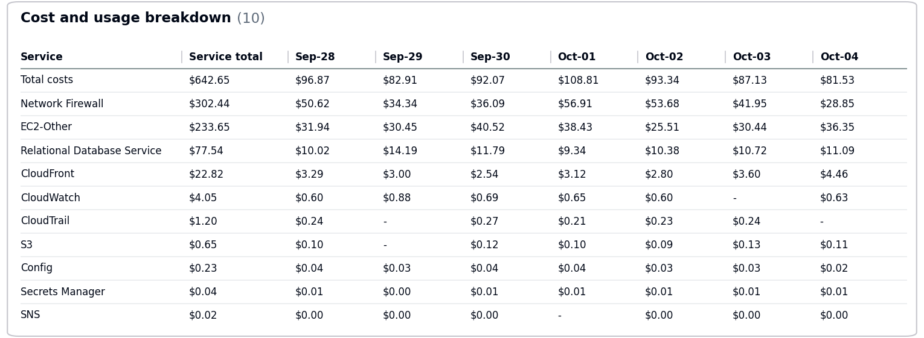
- The costs decreased by $47.01 due to usage of following services: EC2-Other, Relational Database Service, CloudFront.
- No Activity performed by Operisoft in this account.
Resource Utilization & Alarms
No Resource Utilization & Alarms.
-------------------------------------------- Summary --------------------------------------------
Aptrack 1.0 - DR [Aptrack5.0] – 590183710228
----------------------------------------------------------------------------------------------------
- Billing and Cost Overview
  - Total cost for the week: $1,452.06
  - Average Daily Cost: $207.44
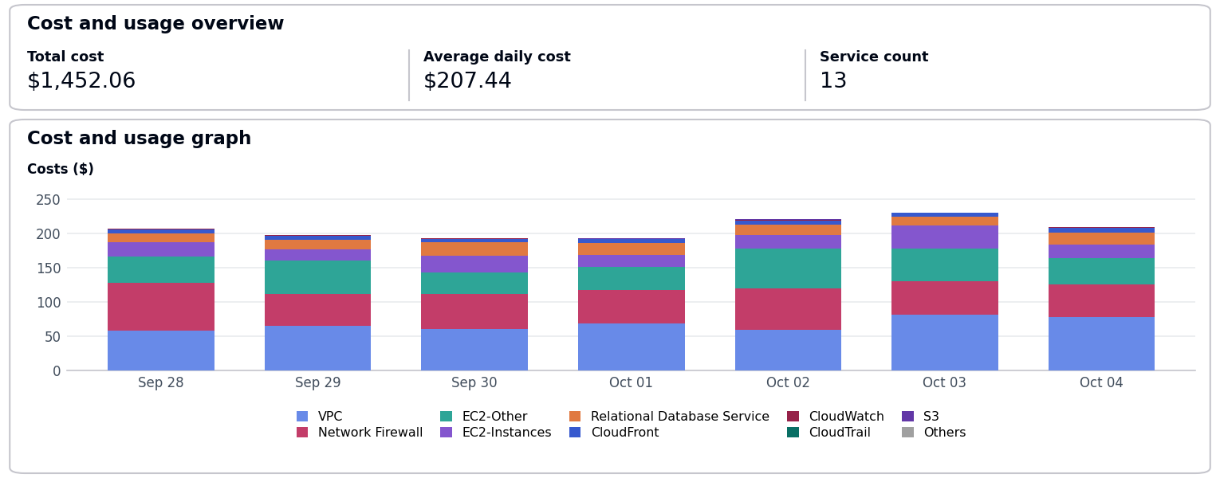
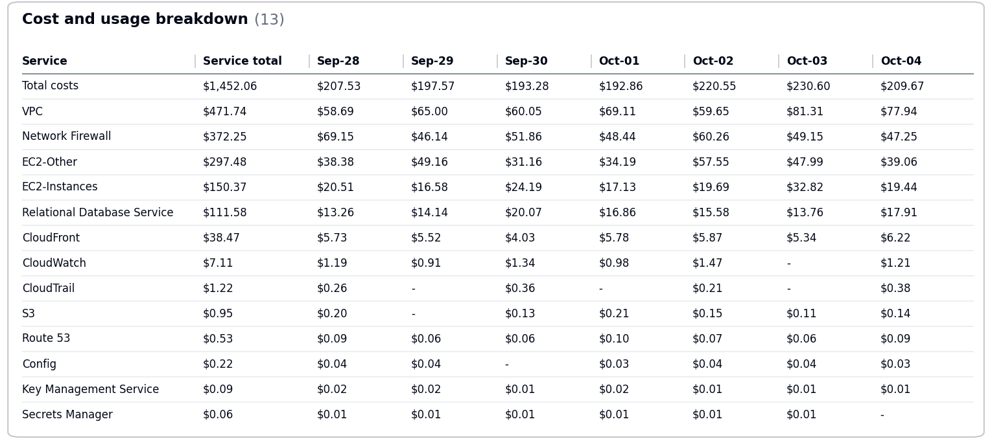
- The costs decreased by $22.83 due to usage of following services: EC2-Other, EC2-Instances, VPC.
- No Activity performed by Operisoft in this account.
Resource Utilization & Alarms
All EC2 Server Alarms triggered between (28 September 2026 to 04 October 2026)
Server Name | Region | Memory/Disk/CPU | Alert date and no. of trigger
db-server-01 (i-0fedcba9876543210) | ap-south-1 | Disk 85% [C:] | September 29(2 Times)  October 02(5 Times)
web-server-01 (i-0123456789abcdef0) | ap-south-1 | CPU 90% | September 28(2 Times)  September 30(3 Times)
-------------------------------------------- Summary --------------------------------------------
Aptrack - ProAlle – 617172754330
----------------------------------------------------------------------------------------------------
- Billing and Cost Overview
  - Total cost for the week: $968.33
  - Average Daily Cost: $138.33
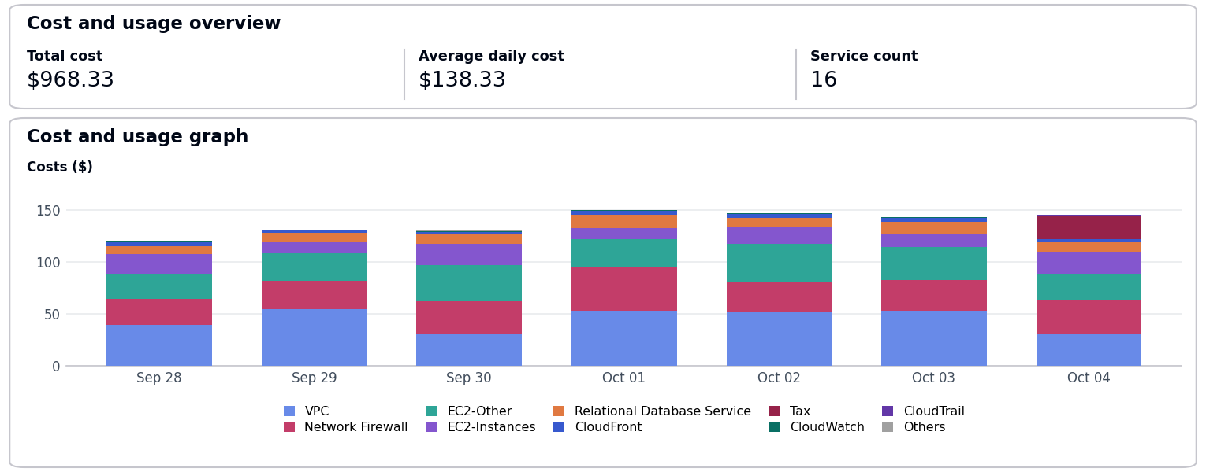
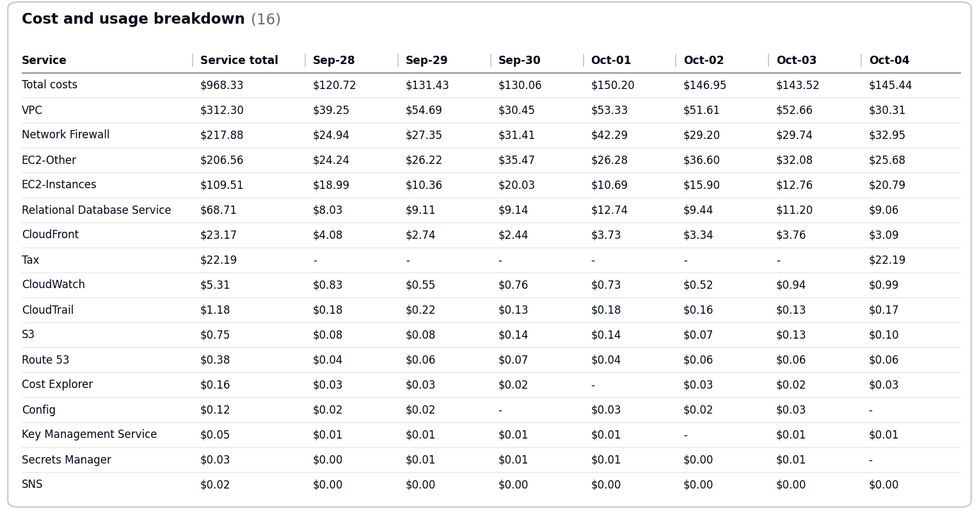
  - Total Tax Cost: $22.19
- The costs decreased by $35.93 due to usage of following services: Network Firewall, EC2-Other, Relational Database Service.
- No Activity performed by Operisoft in this account.
Resource Utilization & Alarms
All EC2 Server Alarms triggered between (28 September 2026 to 04 October 2026)
Server Name | Region | Memory/Disk/CPU | Alert date and no. of trigger
web-server-01 (i-0123456789abcdef0) | ap-south-1 | Disk 95% [/var] | September 28(3 Times)  September 29(4 Times)
-------------------------------------------- Summary --------------------------------------------
Aptrack - 2.0 - Shared Service [MEL] – 533267037955
----------------------------------------------------------------------------------------------------
- Billing and Cost Overview
  - Total cost for the week: $1,168.61
  - Average Daily Cost: $166.94
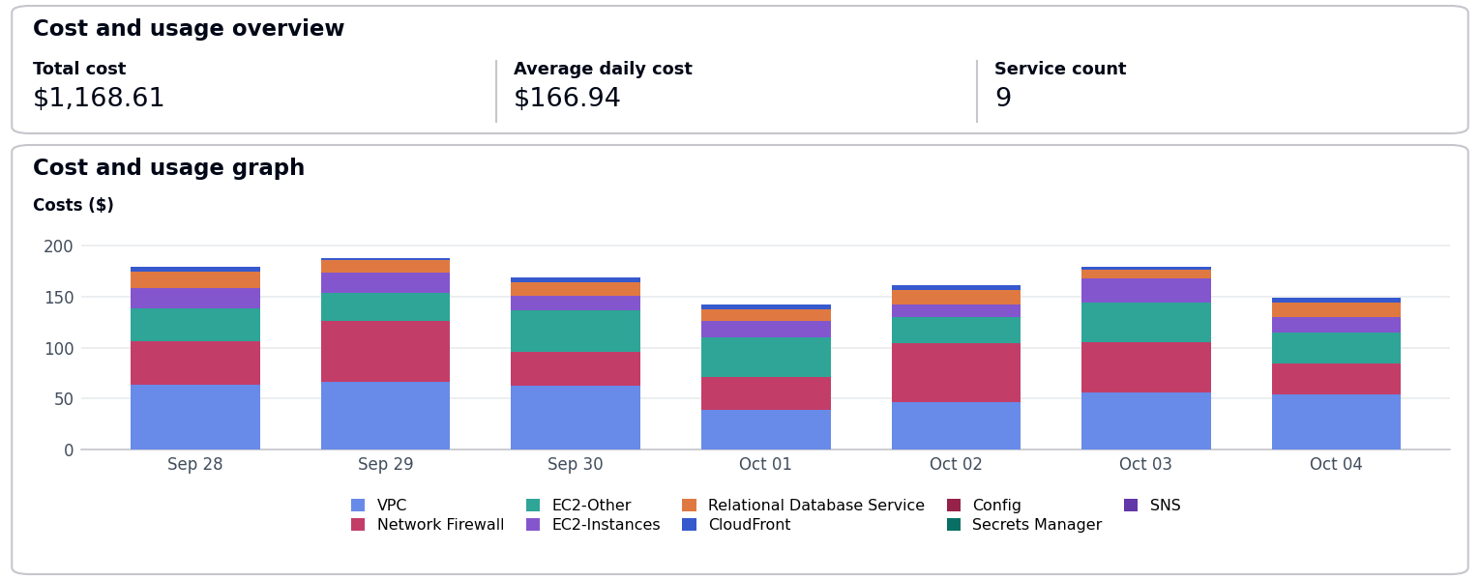
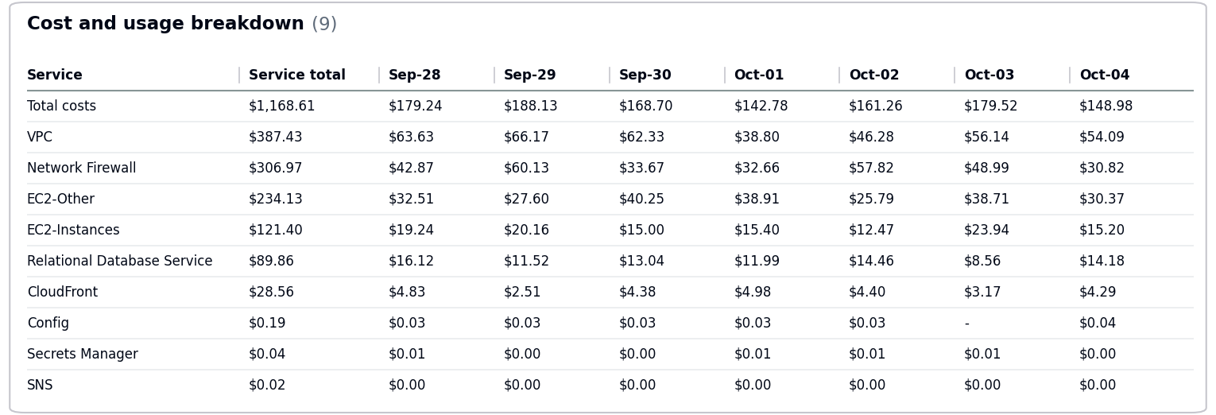
- The costs increased by $34.44 due to usage of following services: EC2-Other, Network Firewall, EC2-Instances.
- No Activity performed by Operisoft in this account.
Resource Utilization & Alarms
No Resource Utilization & Alarms.
-------------------------------------------- Summary --------------------------------------------
Aptrack-SAP-Dev and Quality – 528757792293
----------------------------------------------------------------------------------------------------
- Billing and Cost Overview
  - Total cost for the week: $1,183.84
  - Average Daily Cost: $169.12
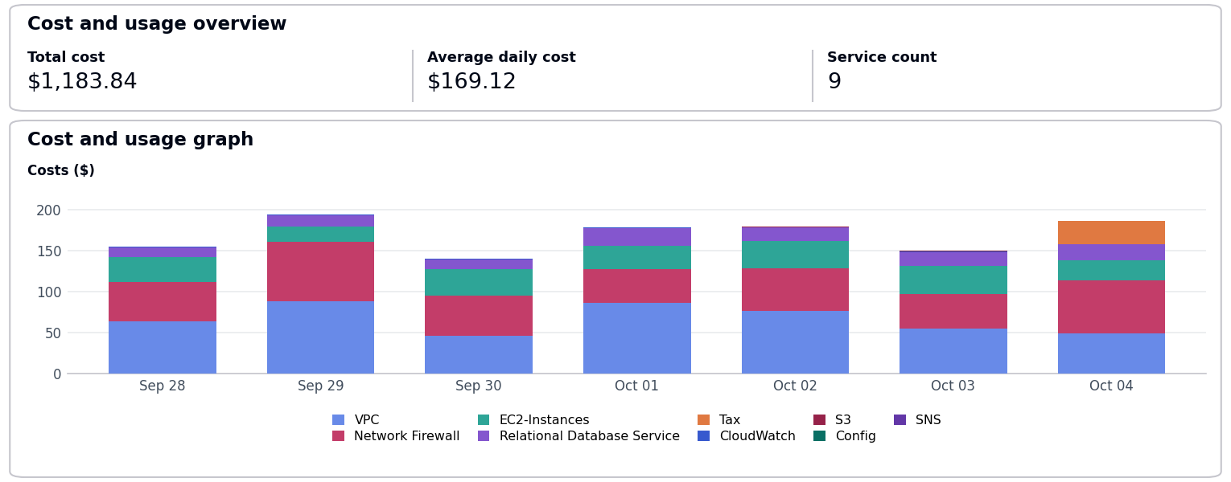
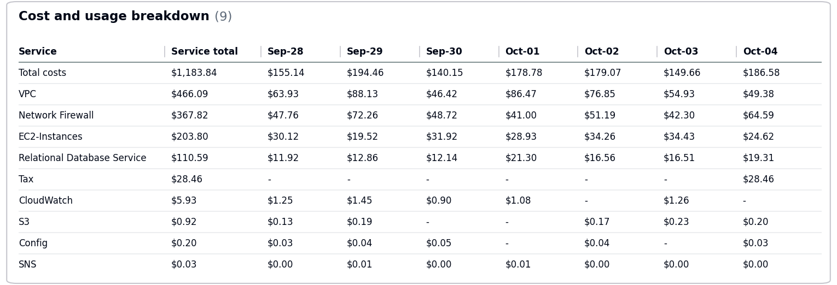
  - Total Tax Cost: $28.46
- The costs decreased by $135.53 due to usage of following services: Network Firewall, VPC, Relational Database Service.
- No Activity performed by Operisoft in this account.
Resource Utilization & Alarms
All EC2 Server Alarms triggered between (28 September 2026 to 04 October 2026)
Server Name | Region | Memory/Disk/CPU | Alert date and no. of trigger
app-server-01 (i-0987654321fedcba0) | ap-south-1 | Memory 90% | October 01(3 Times)  October 03(2 Times)
web-server-01 (i-0123456789abcdef0) | ap-south-1 | CPU 90% | September 29(3 Times)  October 04(2 Times)
-------------------------------------------- Summary --------------------------------------------
Aptrack-SAP-Production – 195275643918
----------------------------------------------------------------------------------------------------
- Billing and Cost Overview
  - Total cost for the week: $283.14
  - Average Daily Cost: $40.45
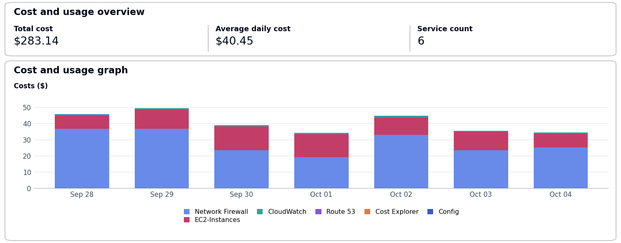
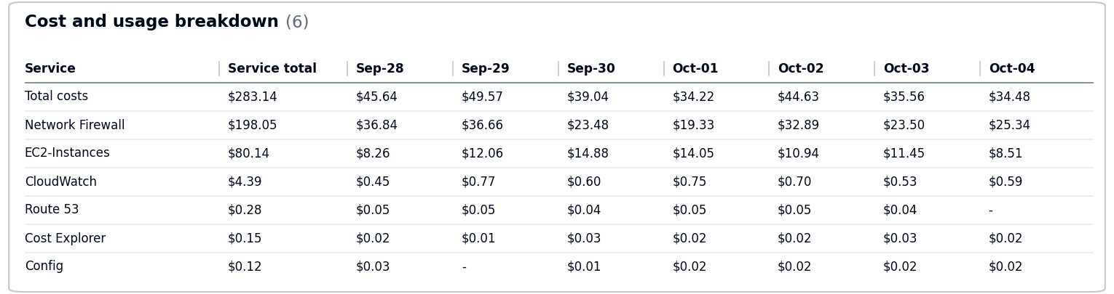
- The costs decreased by $24.37 due to usage of following services: Network Firewall, EC2-Instances.
- No Activity performed by Operisoft in this account.
Resource Utilization & Alarms
All EC2 Server Alarms triggered between (28 September 2026 to 04 October 2026)
Server Name | Region | Memory/Disk/CPU | Alert date and no. of trigger
app-server-01 (i-0987654321fedcba0) | ap-south-1 | Memory 90% | September 29(6 Times)  October 01(5 Times)
db-server-01 (i-0fedcba9876543210) | ap-south-1 | Disk 85% [C:] | September 29(6 Times)  October 01(5 Times)
web-server-01 (i-0123456789abcdef0) | ap-south-1 | Disk 95% [/var] | September 28(1 Time)  October 02(1 Time)
-------------------------------------------- Summary --------------------------------------------
Aptrack – LCMS – 771423618181
----------------------------------------------------------------------------------------------------
- Billing and Cost Overview
  - Total cost for the week: $471.23
  - Average Daily Cost: $67.32
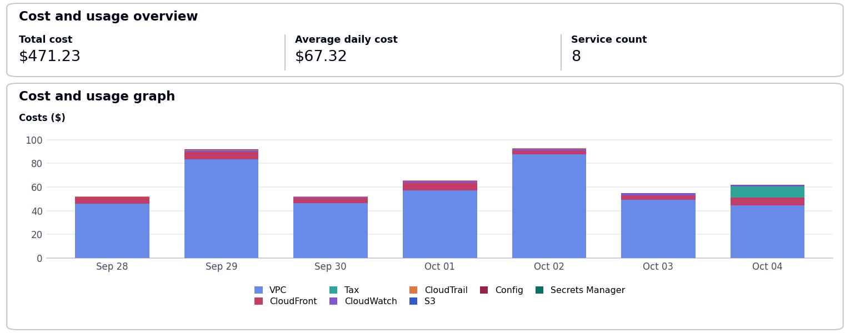
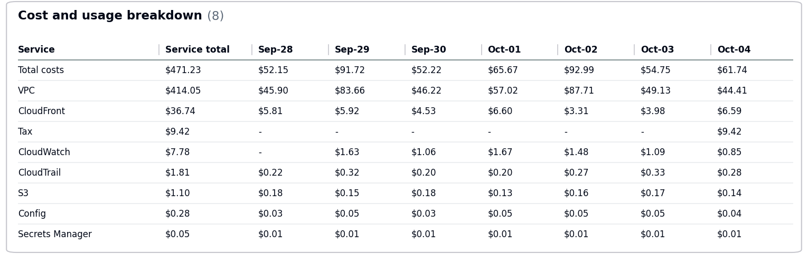
  - Total Tax Cost: $9.42
- The costs decreased by $87.07 due to usage of following services: VPC.
- No Activity performed by Operisoft in this account.
Resource Utilization & Alarms
No Resource Utilization & Alarms.
-------------------------------------------- Summary --------------------------------------------
Aptech-ProConnect – 108782065415
----------------------------------------------------------------------------------------------------
- Billing and Cost Overview
  - Total cost for the week: $1,364.84
  - Average Daily Cost: $194.98
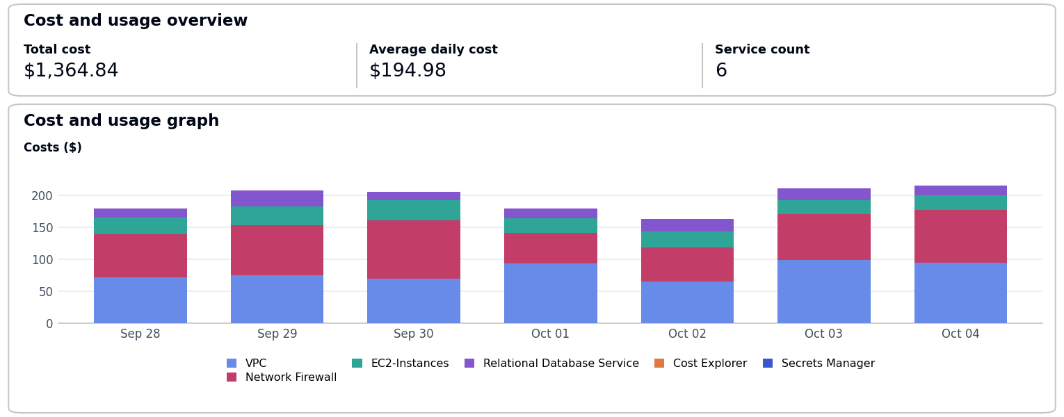
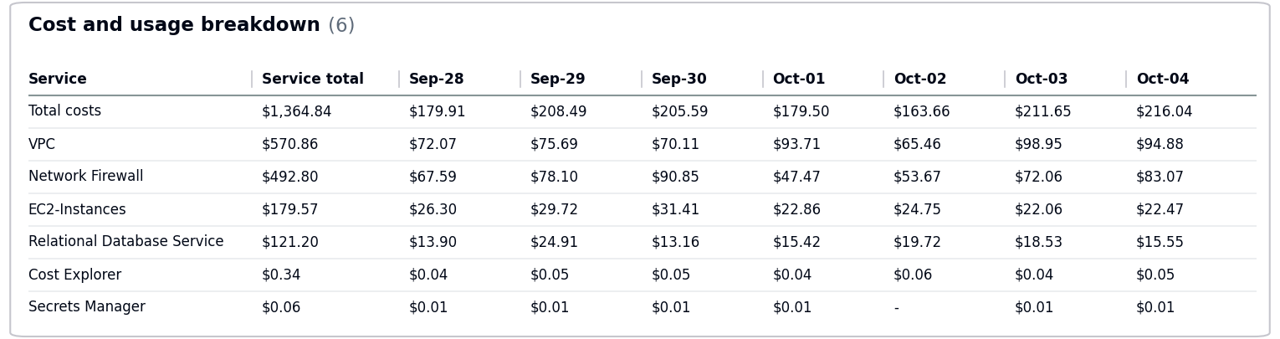
- The costs increased by $74.31 due to usage of following services: Network Firewall, VPC.
- No Activity performed by Operisoft in this account.
Resource Utilization & Alarms
All EC2 Server Alarms triggered between (28 September 2026 to 04 October 2026)
Server Name | Region | Memory/Disk/CPU | Alert date and no. of trigger
web-server-01 (i-0123456789abcdef0) | ap-south-1 | Disk 95% [/var] | September 28(2 Times)  October 01(1 Time)
-------------------------------------------- Summary --------------------------------------------
Aptrack - QnA Solution – 211125374996
----------------------------------------------------------------------------------------------------
- Billing and Cost Overview
  - Total cost for the week: $102.24
  - Average Daily Cost: $14.61
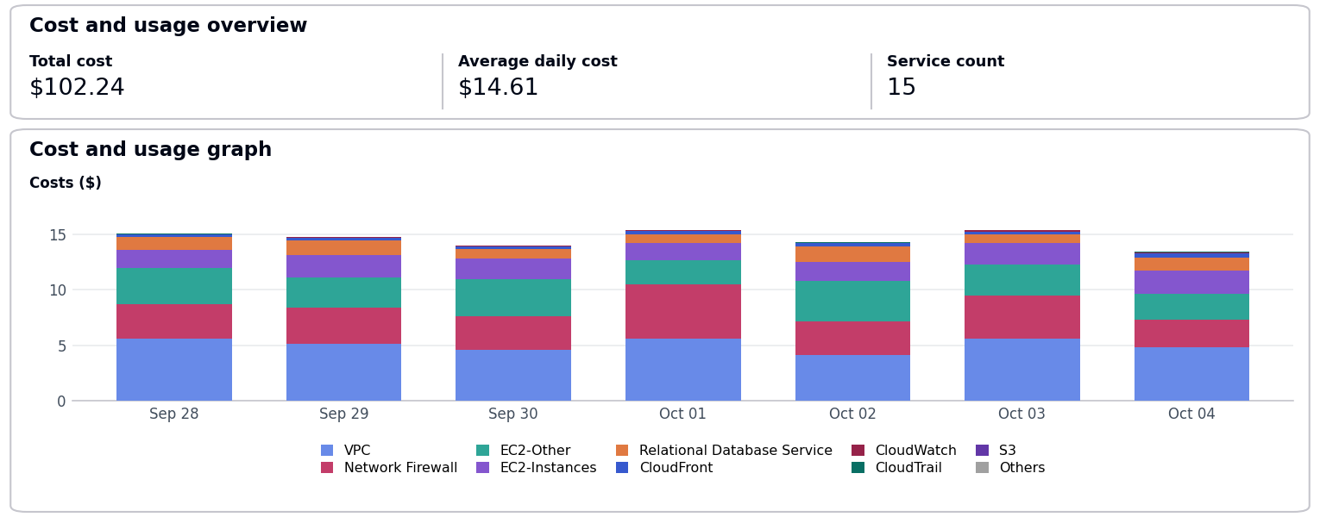
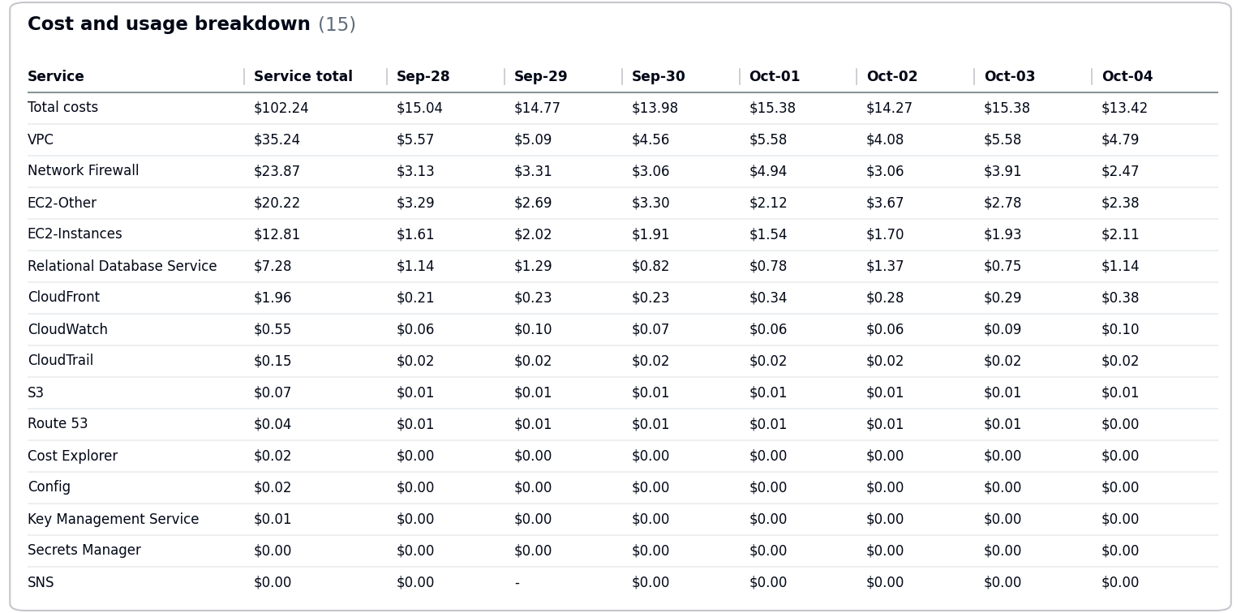
- The costs increased by $10.30 due to usage of following services: VPC, EC2-Instances, EC2-Other.
- No Activity performed by Operisoft in this account.
Resource Utilization & Alarms
All EC2 Server Alarms triggered between (28 September 2026 to 04 October 2026)
Server Name | Region | Memory/Disk/CPU | Alert date and no. of trigger
db-server-01 (i-0fedcba9876543210) | ap-south-1 | CPU 85% | October 01(2 Times)  October 04(5 Times)
web-server-01 (i-0123456789abcdef0) | ap-south-1 | Disk 95% [/var] | September 28(6 Times)  October 02(4 Times)
-------------------------------------------- Summary --------------------------------------------
Aptech-LAPA – 343218180162
----------------------------------------------------------------------------------------------------
- Billing and Cost Overview
  - Total cost for the week: $412.98
  - Average Daily Cost: $59.00
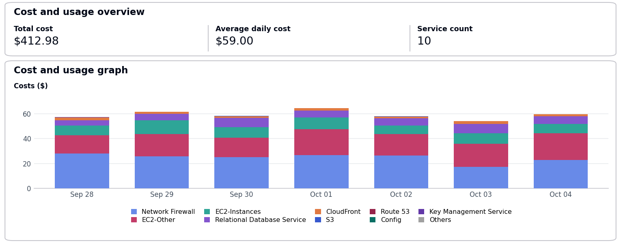
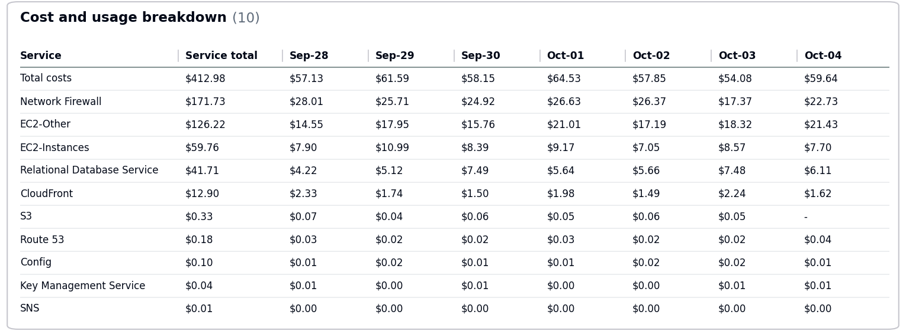
- The costs increased by $45.29 due to usage of following services: Network Firewall, EC2-Other.
- No Activity performed by Operisoft in this account.
Resource Utilization & Alarms
No Resource Utilization & Alarms.
-------------------------------------------- Summary --------------------------------------------
Aptrack-Arena – 034362049944
----------------------------------------------------------------------------------------------------
- Billing and Cost Overview
  - Total cost for the week: $190.24
  - Average Daily Cost: $27.18
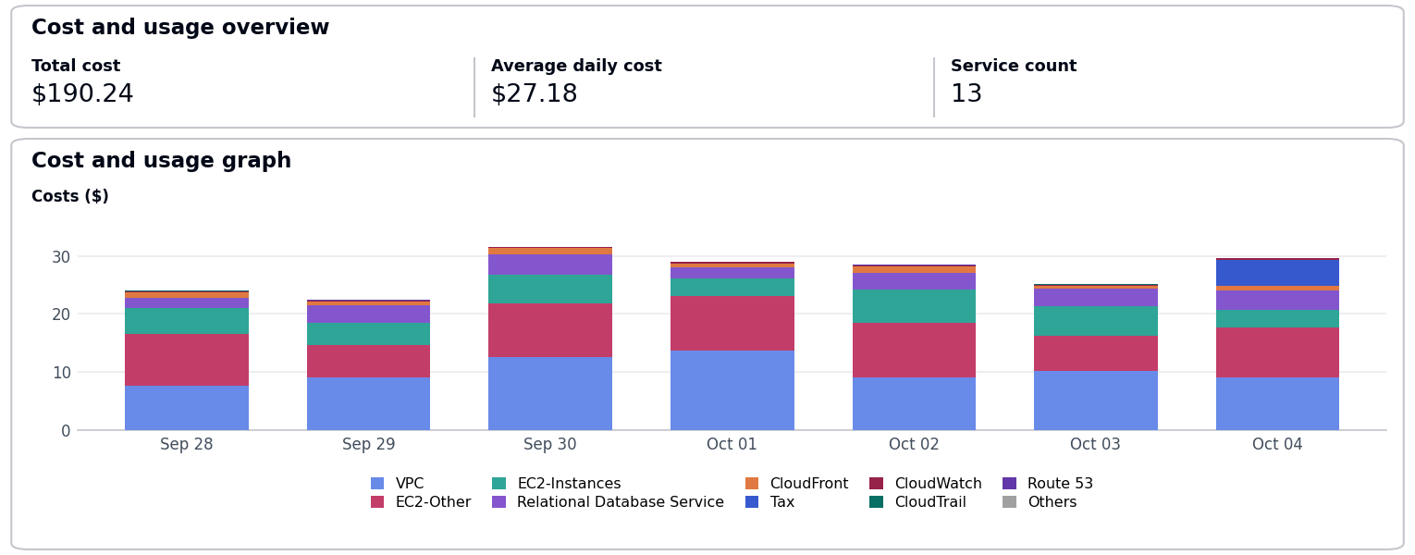
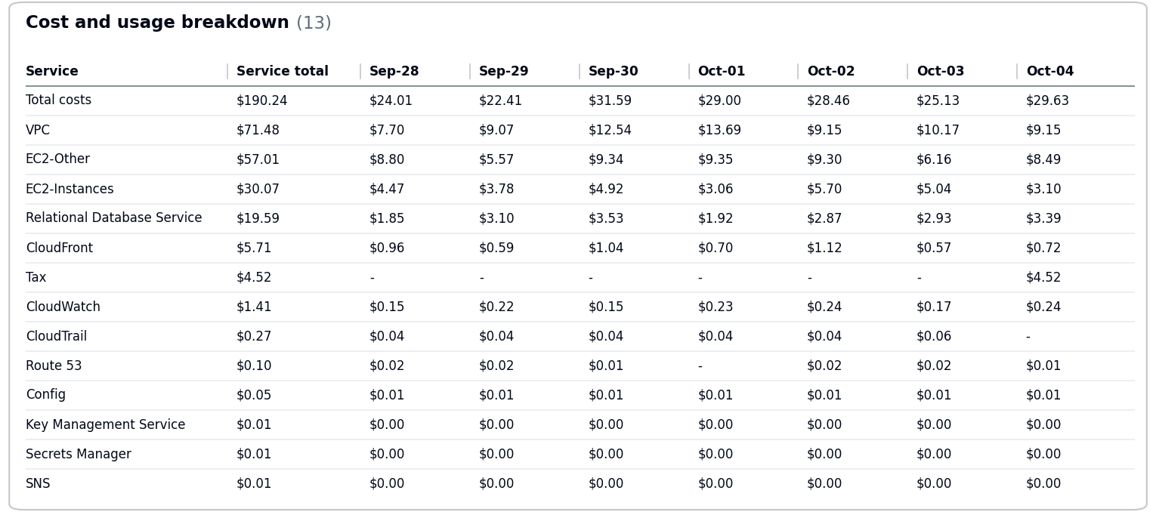
  - Total Tax Cost: $4.52
- The costs increased by $4.88 due to usage of following services: EC2-Other, VPC.
- No Activity performed by Operisoft in this account.
Resource Utilization & Alarms
All EC2 Server Alarms triggered between (28 September 2026 to 04 October 2026)
Server Name | Region | Memory/Disk/CPU | Alert date and no. of trigger
db-server-01 (i-0fedcba9876543210) | ap-south-1 | Disk 85% [C:] | October 01(4 Times)  October 03(5 Times)
web-server-01 (i-0123456789abcdef0) | ap-south-1 | Disk 95% [/var] | September 30(5 Times)  October 03(2 Times)
-------------------------------------------- Summary --------------------------------------------
Aptech Avalon – 985539791413
----------------------------------------------------------------------------------------------------
- Billing and Cost Overview
  - Total cost for the week: $969.23
  - Average Daily Cost: $138.46
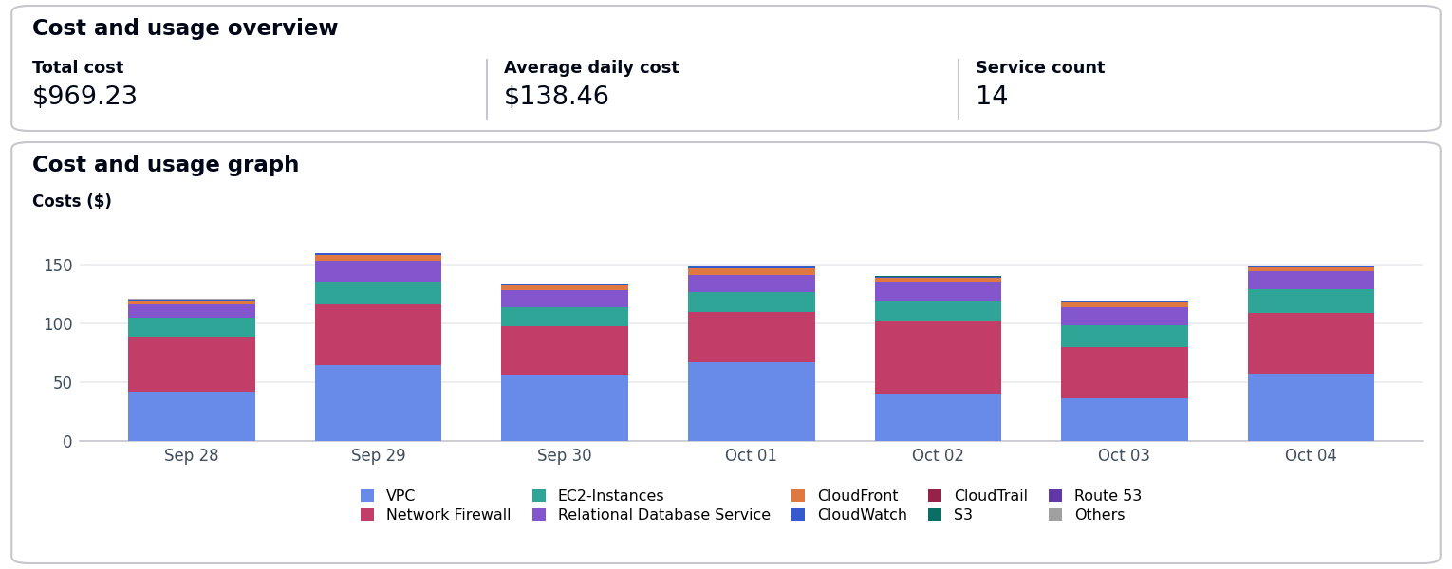
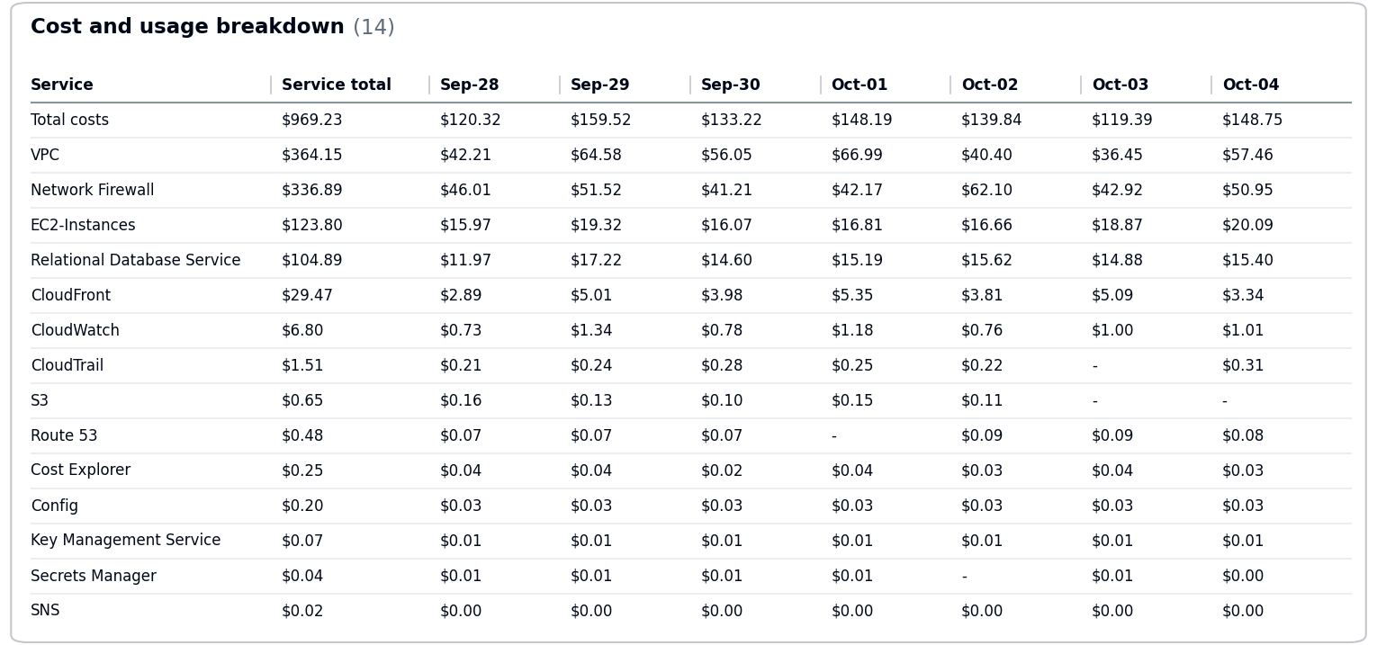
- The costs decreased by $105.39 due to usage of following services: Network Firewall, VPC, EC2-Instances.
- No Activity performed by Operisoft in this account.
Resource Utilization & Alarms
All EC2 Server Alarms triggered between (28 September 2026 to 04 October 2026)
Server Name | Region | Memory/Disk/CPU | Alert date and no. of trigger
app-server-01 (i-0987654321fedcba0) | ap-south-1 | Memory 90% | October 03(2 Times)  October 04(2 Times)
web-server-01 (i-0123456789abcdef0) | ap-south-1 | CPU 90% | September 30(1 Time)  October 02(1 Time)
-------------------------------------------- Summary --------------------------------------------
Aptech AI Applications – 166185345052
----------------------------------------------------------------------------------------------------
- Billing and Cost Overview
  - Total cost for the week: $913.08
  - Average Daily Cost: $130.44
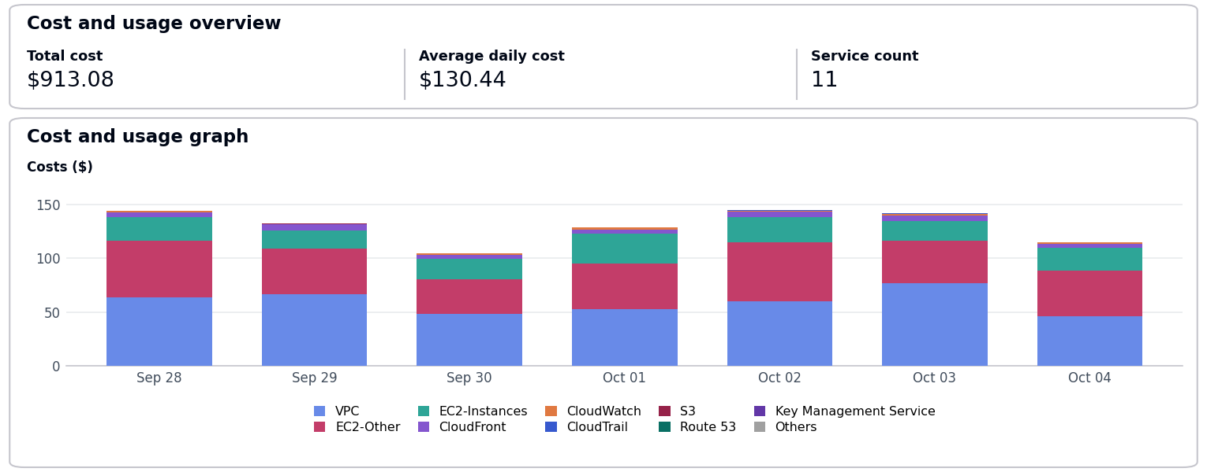
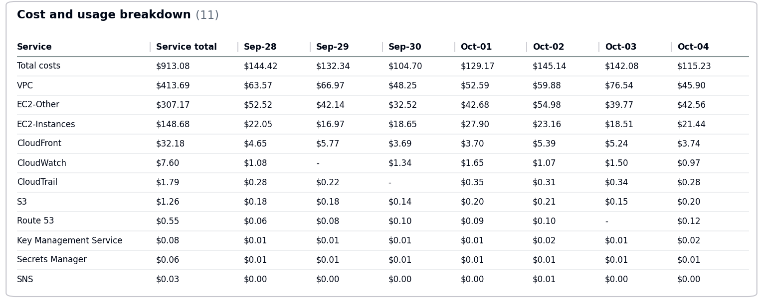
- The costs decreased by $167.32 due to usage of following services: EC2-Instances, VPC, EC2-Other.
- No Activity performed by Operisoft in this account.
Resource Utilization & Alarms
No Resource Utilization & Alarms.
-------------------------------------------- Summary --------------------------------------------
Aptrack AR_VR_MAAC – 377555974222
----------------------------------------------------------------------------------------------------
- Billing and Cost Overview
  - Total cost for the week: $1,226.69
  - Average Daily Cost: $175.24
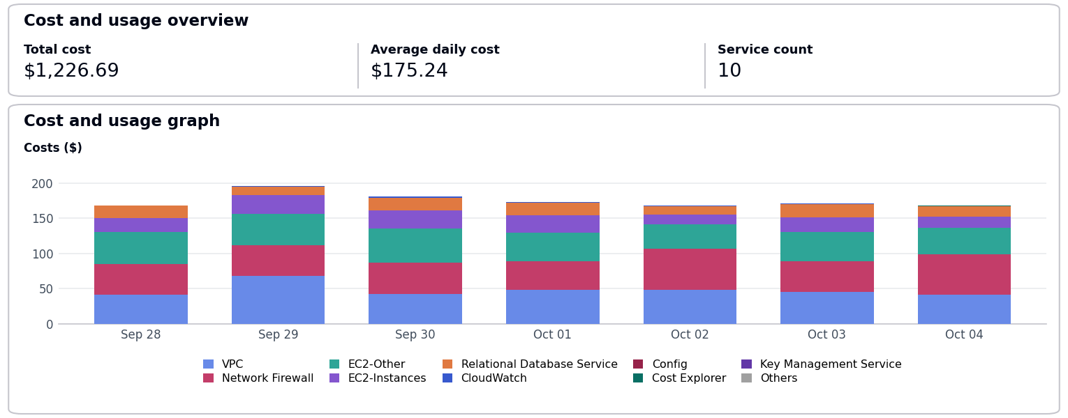
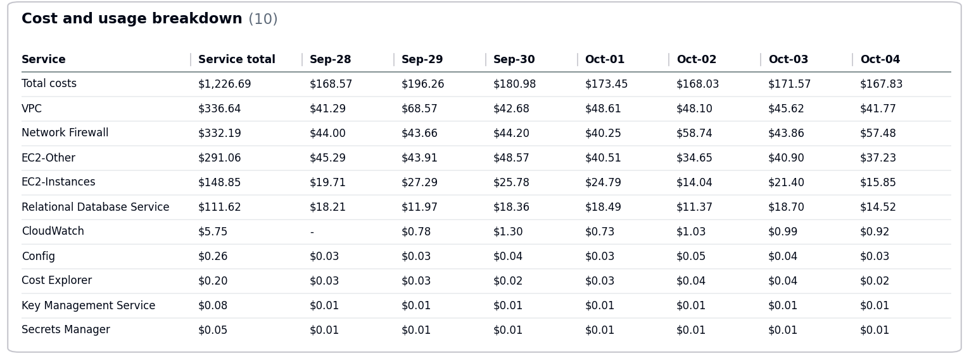
- The costs increased by $43.38 due to usage of following services: EC2-Other, EC2-Instances, Relational Database Service.
- No Activity performed by Operisoft in this account.
Resource Utilization & Alarms
All EC2 Server Alarms triggered between (28 September 2026 to 04 October 2026)
Server Name | Region | Memory/Disk/CPU | Alert date and no. of trigger
app-server-01 (i-0987654321fedcba0) | ap-south-1 | Memory 90% | September 30(6 Times)  October 04(1 Time)
db-server-01 (i-0fedcba9876543210) | ap-south-1 | Disk 85% [C:] | October 01(1 Time)  October 03(2 Times)
-------------------------------------------- Summary --------------------------------------------
Aptrack - 2.0 - Log archive [MEL] – 637423329781
----------------------------------------------------------------------------------------------------
- Billing and Cost Overview
  - Total cost for the week: $106.58
  - Average Daily Cost: $15.23
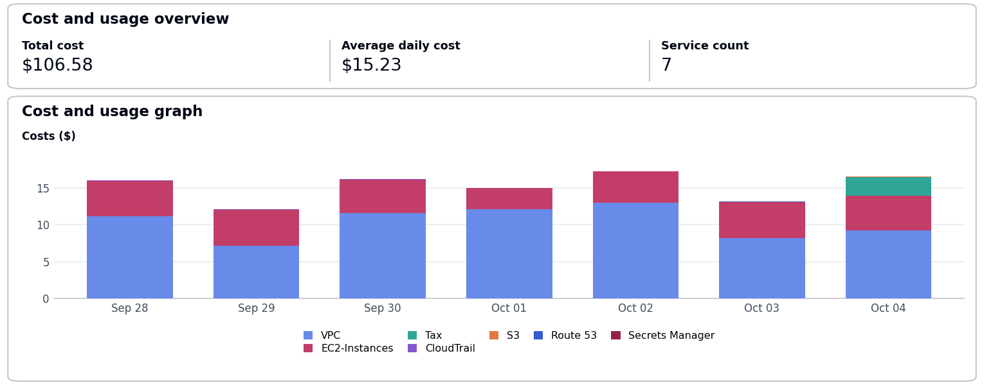
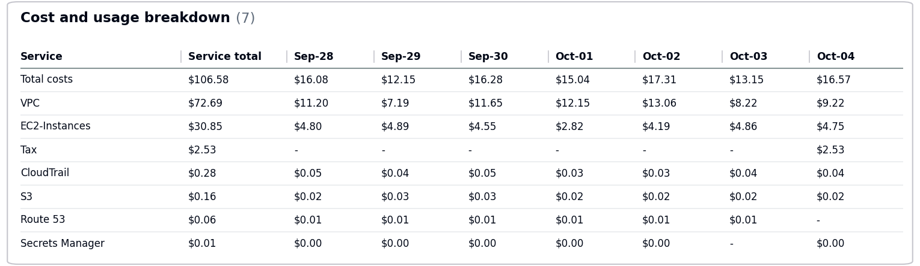
  - Total Tax Cost: $2.53
- The cost remains same.
- No Activity performed by Operisoft in this account.
Resource Utilization & Alarms
All EC2 Server Alarms triggered between (28 September 2026 to 04 October 2026)
Server Name | Region | Memory/Disk/CPU | Alert date and no. of trigger
db-server-01 (i-0fedcba9876543210) | ap-south-1 | CPU 85% | September 28(4 Times)  October 02(2 Times)
web-server-01 (i-0123456789abcdef0) | ap-south-1 | Disk 95% [/var] | September 29(3 Times)  September 30(2 Times)
-------------------------------------------- Summary --------------------------------------------
Aptech-Domains – 622050225451
----------------------------------------------------------------------------------------------------
- Billing and Cost Overview
  - Total cost for the week: $526.40
  - Average Daily Cost: $75.20
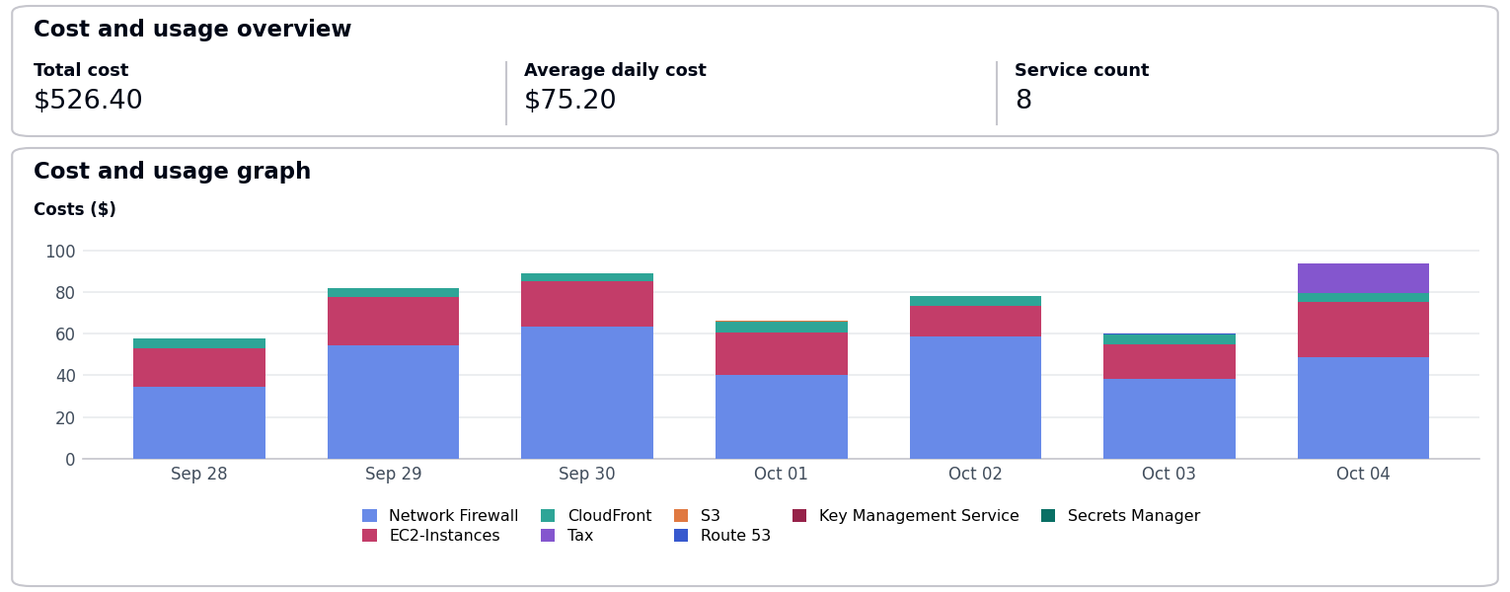
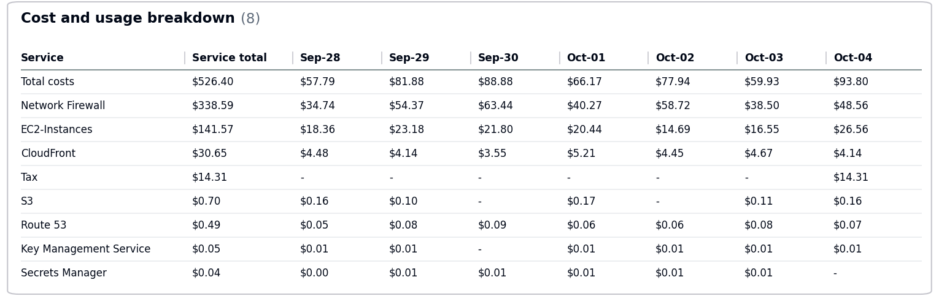
  - Total Tax Cost: $14.31
- The costs decreased by $55.74 due to usage of following services: Network Firewall, CloudFront.
- No Activity performed by Operisoft in this account.
Resource Utilization & Alarms
No Resource Utilization & Alarms.
-------------------------------------------- Summary --------------------------------------------
Aptrack - 2.0 - Audit [MEL] – 851725245759
----------------------------------------------------------------------------------------------------
- Billing and Cost Overview
  - Total cost for the week: $155.02
  - Average Daily Cost: $22.15
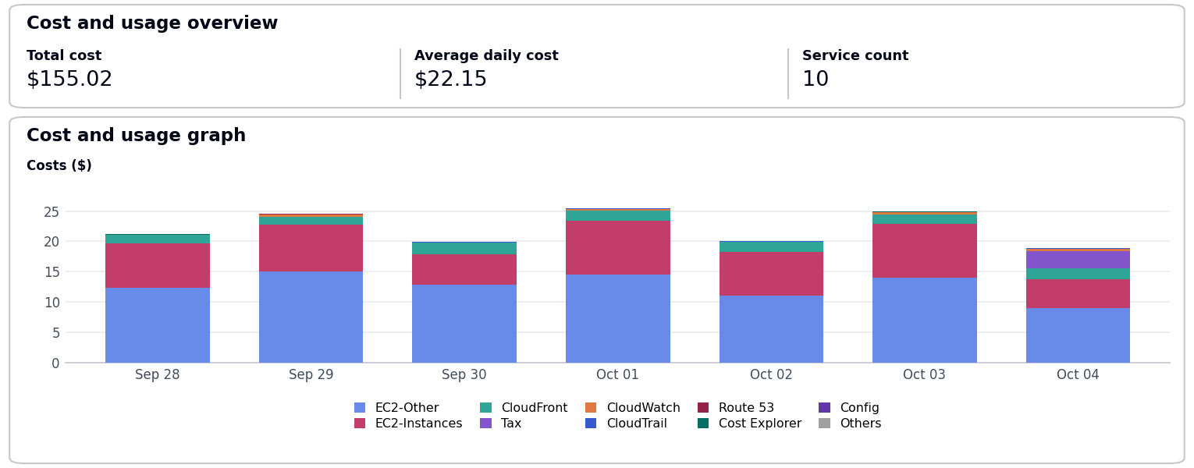
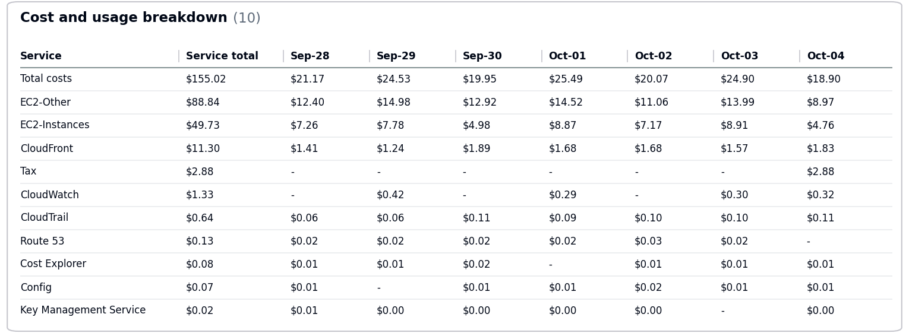
  - Total Tax Cost: $2.88
- The costs decreased by $15.10 due to usage of following services: EC2-Other, CloudWatch, EC2-Instances.
- No Activity performed by Operisoft in this account.
Resource Utilization & Alarms
All EC2 Server Alarms triggered between (28 September 2026 to 04 October 2026)
Server Name | Region | Memory/Disk/CPU | Alert date and no. of trigger
web-server-01 (i-0123456789abcdef0) | ap-south-1 | CPU 90% | September 28(4 Times)  September 29(5 Times)
-------------------------------------------- Summary --------------------------------------------
Aptech International – 470684059456
----------------------------------------------------------------------------------------------------
- Billing and Cost Overview
  - Total cost for the week: $184.64
  - Average Daily Cost: $26.38
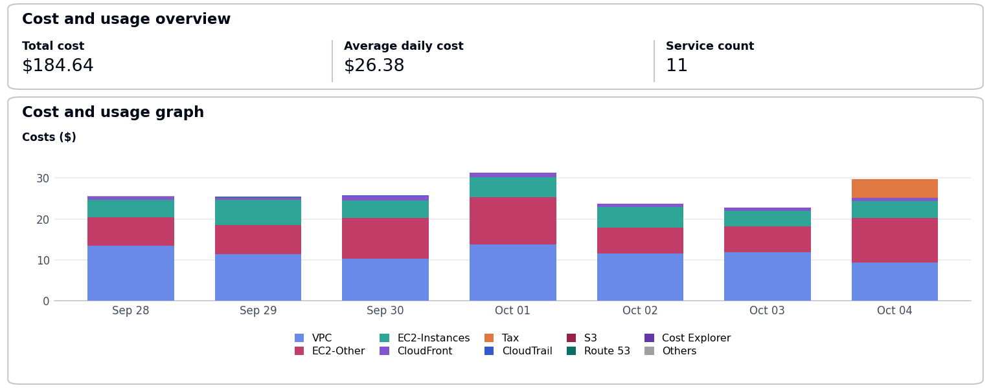
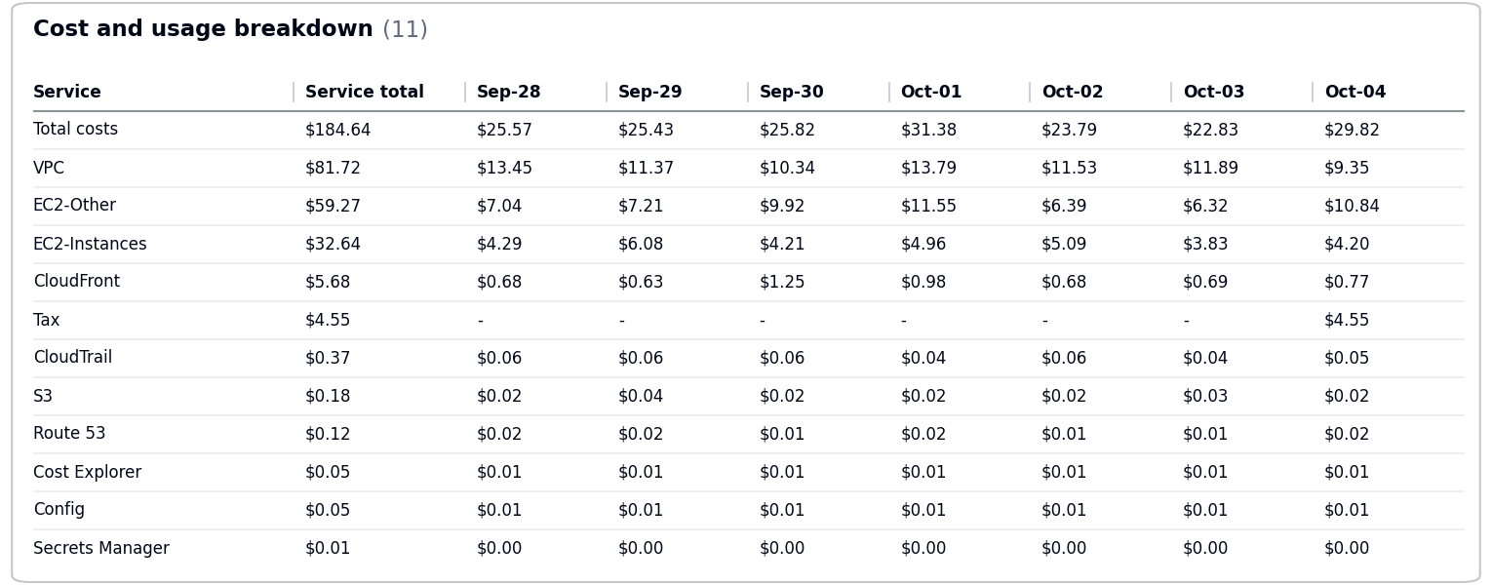
  - Total Tax Cost: $4.55
- The costs decreased by $10.07 due to usage of following services: EC2-Other, EC2-Instances, CloudFront.
- No Activity performed by Operisoft in this account.
Resource Utilization & Alarms
All EC2 Server Alarms triggered between (28 September 2026 to 04 October 2026)
Server Name | Region | Memory/Disk/CPU | Alert date and no. of trigger
db-server-01 (i-0fedcba9876543210) | ap-south-1 | Disk 85% [C:] | September 29(3 Times)  October 01(6 Times)

-- End Of Document --

