
Weekly Status Report
Aptech Limited

Submitted By
Operisoft Technologies Pvt Ltd
01/10/2026


Aptech Limited Weekly Status Report
(14 September to 20 September 2026)
Cost Summary Difference of All AWS Accounts
No | Account Name | Account ID | Last Week Cost (07 Sep to 13 Sep) | Tax Cost | Current Week Cost (14 Sep to 20 Sep) | Services
1 | Aptrack 1.0 - DC [Aptech] | 654654548701 | $841.79 |  | $745.88 | The costs decreased by $95.92 due to usage of following services: VPC, EC2-Other.
2 | Aptrack 2.0 - NonProd UAT [MEL] | 767397805488 | $1,236.55 | $26.49 | $1,297.34 | The costs increased by $60.79 due to usage of following services: Network Firewall, Relational Database Service, VPC.
3 | Aptrack 2.0 OldManagement A/c [MEL]/Production | 015747350560 | $703.39 |  | $618.21 | The costs decreased by $85.18 due to usage of following services: Network Firewall, EC2-Other, CloudWatch.
4 | Aptrack 1.0 - DR [Aptrack5.0] | 590183710228 | $1,565.99 |  | $1,539.31 | The costs decreased by $26.68 due to usage of following services: VPC, EC2-Instances.
5 | Aptrack - ProAlle | 617172754330 | $1,052.32 | $21.86 | $985.27 | The costs decreased by $67.04 due to usage of following services: EC2-Other, Network Firewall, EC2-Instances.
6 | Aptrack - 2.0 - Shared Service [MEL] | 533267037955 | $1,221.11 |  | $1,268.84 | The costs increased by $47.73 due to usage of following services: EC2-Instances, VPC, Relational Database Service.
7 | Aptrack-SAP-Dev and Quality | 528757792293 | $1,161.65 | $22.64 | $1,160.63 | The costs decreased by $1.02 due to usage of following services: Relational Database Service, EC2-Instances, CloudWatch.
8 | Aptrack-SAP-Production | 195275643918 | $312.19 |  | $295.82 | The costs decreased by $16.37 due to usage of following services: Network Firewall.
9 | Aptrack – LCMS | 771423618181 | $451.64 | $15.86 | $548.61 | The costs increased by $96.97 due to usage of following services: VPC, CloudFront.
10 | Aptech-ProConnect | 108782065415 | $1,242.63 |  | $1,387.08 | The costs increased by $144.46 due to usage of following services: VPC, Network Firewall, EC2-Instances.
11 | Aptrack - QnA Solution | 211125374996 | $89.84 |  | $99.87 | The costs increased by $10.03 due to usage of following services: EC2-Other, VPC, EC2-Instances.
12 | Aptech-LAPA | 343218180162 | $386.27 |  | $391.41 | The costs increased by $5.14 due to usage of following services: Network Firewall.
13 | Aptrack-Arena | 034362049944 | $200.55 | $5.19 | $207.78 | The costs increased by $7.23 due to usage of following services: VPC, Relational Database Service, EC2-Other.
14 | Aptech Avalon | 985539791413 | $1,009.85 |  | $997.82 | The costs decreased by $12.03 due to usage of following services: VPC, CloudFront, CloudTrail.
15 | Aptech AI Applications | 166185345052 | $1,079.95 |  | $928.71 | The costs decreased by $151.24 due to usage of following services: VPC, EC2-Other, CloudWatch.
16 | Aptrack AR_VR_MAAC | 377555974222 | $1,249.52 |  | $1,328.16 | The costs increased by $78.63 due to usage of following services: EC2-Other, Network Firewall, CloudWatch.
17 | Aptrack - 2.0 - Log archive [MEL] | 637423329781 | $98.61 | $3.15 | $90.81 | The costs decreased by $7.81 due to usage of following services: VPC.
18 | Aptech-Domains | 622050225451 | $522.10 | $11.60 | $435.62 | The costs decreased by $86.47 due to usage of following services: Network Firewall, EC2-Instances.
19 | Aptrack - 2.0 - Audit [MEL] | 851725245759 | $167.01 | $4.25 | $169.33 | The costs increased by $2.31 due to usage of following services: EC2-Other.
20 | Aptech International | 470684059456 | $181.86 | $5.36 | $196.24 | The costs increased by $14.38 due to usage of following services: VPC, EC2-Instances.
Total Cost |  |  | $14,774.84 | $116.40 | ⬇$14,692.74

- The billing for the current week (14 September to 20 September) has decreased compared to the previous week.
- The cost difference is $82.10.

Security Best Practices Links:
Content | Link
Best Practices for AWS root users | https://docs.aws.amazon.com/accounts/latest/reference/best-practices-root-user.html
Best Practices for AWS Access Keys | https://docs.aws.amazon.com/accounts/latest/reference/credentials-access-keys-best-practices.html
Shared Responsibility Model | https://aws.amazon.com/compliance/shared-responsibility-model/
AWS Cloudtrail | https://aws.amazon.com/cloudtrail/
Trusted Advisor | https://aws.amazon.com/premiumsupport/trustedadvisor/
Creating Billing alarms | https://docs.aws.amazon.com/AmazonCloudWatch/latest/monitoring/gs_monitor_estimated_charges_with_cloudwatch.html#gs_creating_billing_alarm
Enable MFA | https://docs.aws.amazon.com/IAM/latest/UserGuide/id_credentials_mfa.html
GIT Secrets | https://github.com/awslabs/git-secrets
------------------------------------------------------- Summary -------------------------------------------------------
Aptrack 1.0 - DC [Aptech] – 654654548701
--------------------------------------------------------------------------------------------------------------------------------
- Billing and Cost Overview
  - Total cost for the week: $745.88
  - Average Daily Cost: $106.55
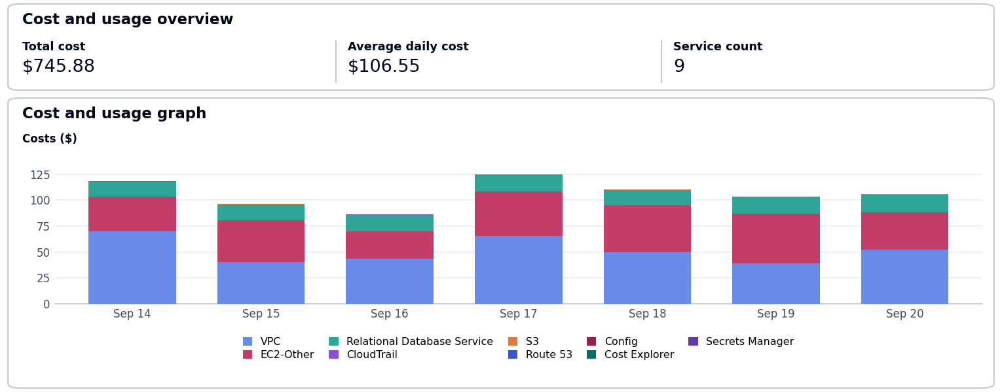
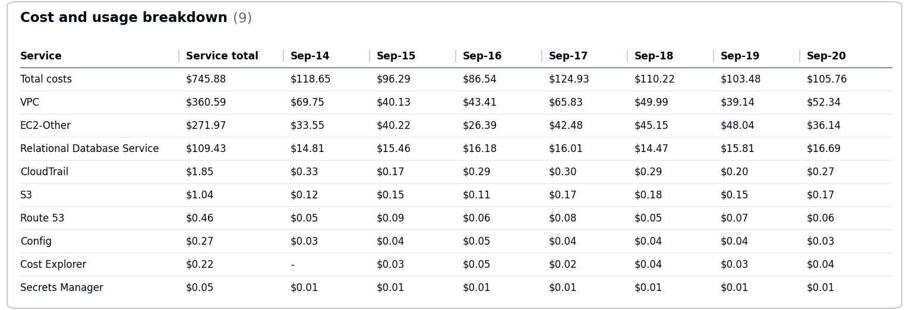
- The costs decreased by $95.92 due to usage of following services: VPC, EC2-Other.
- No Activity performed by Operisoft in this account.
Resource Utilization & Alarms
All EC2 Server Alarms triggered between (14 September 2026 to 20 September 2026)
Server Name | Region | Memory/Disk/CPU | Alert date and no. of trigger
db-server-01 (i-0fedcba9876543210) | ap-south-1 | Disk 85% [C:] | September 16(6 Times)  September 18(6 Times)
------------------------------------------------------- Summary -------------------------------------------------------
Aptrack 2.0 - NonProd UAT [MEL] – 767397805488
--------------------------------------------------------------------------------------------------------------------------------
- Billing and Cost Overview
  - Total cost for the week: $1,297.34
  - Average Daily Cost: $185.33
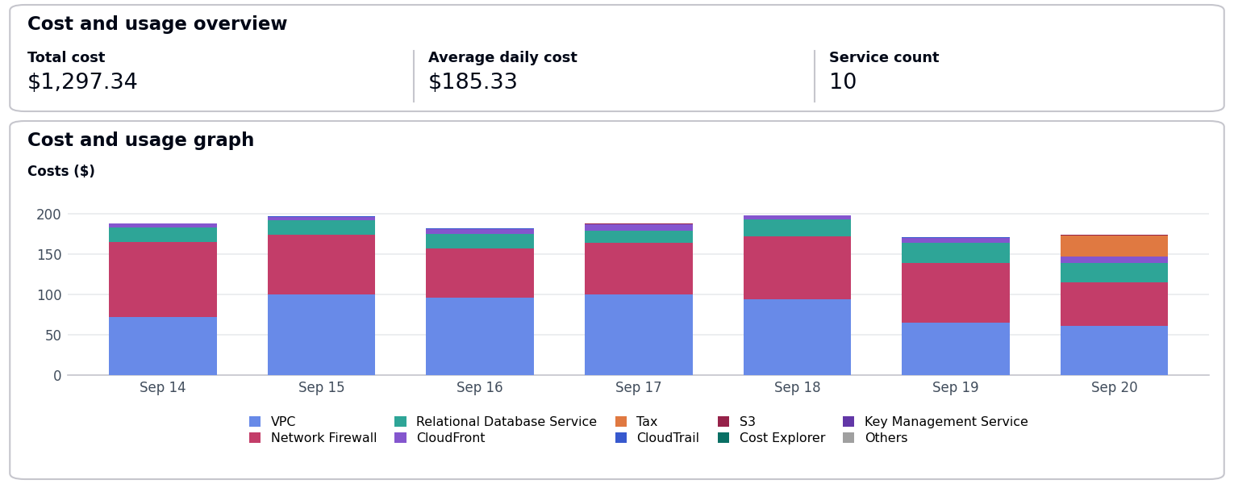
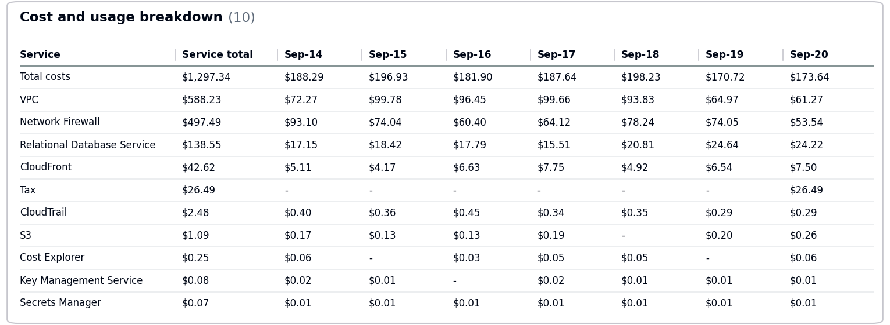
  - Total Tax Cost: $26.49
- The costs increased by $60.79 due to usage of following services: Network Firewall, Relational Database Service, VPC.
- No Activity performed by Operisoft in this account.
Resource Utilization & Alarms
All EC2 Server Alarms triggered between (14 September 2026 to 20 September 2026)
Server Name | Region | Memory/Disk/CPU | Alert date and no. of trigger
db-server-01 (i-0fedcba9876543210) | ap-south-1 | CPU 85% | September 14(4 Times)  September 17(1 Time)
db-server-01 (i-0fedcba9876543210) | ap-south-1 | Disk 85% [C:] | September 16(2 Times)  September 18(3 Times)
------------------------------------------------------- Summary -------------------------------------------------------
Aptrack 2.0 OldManagement A/c [MEL]/Production – 015747350560
--------------------------------------------------------------------------------------------------------------------------------
- Billing and Cost Overview
  - Total cost for the week: $618.21
  - Average Daily Cost: $88.32
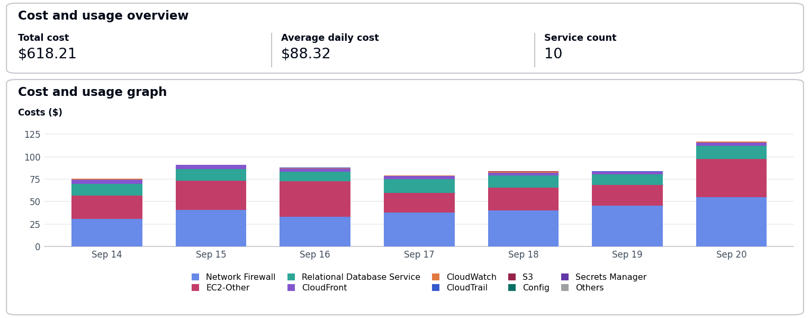
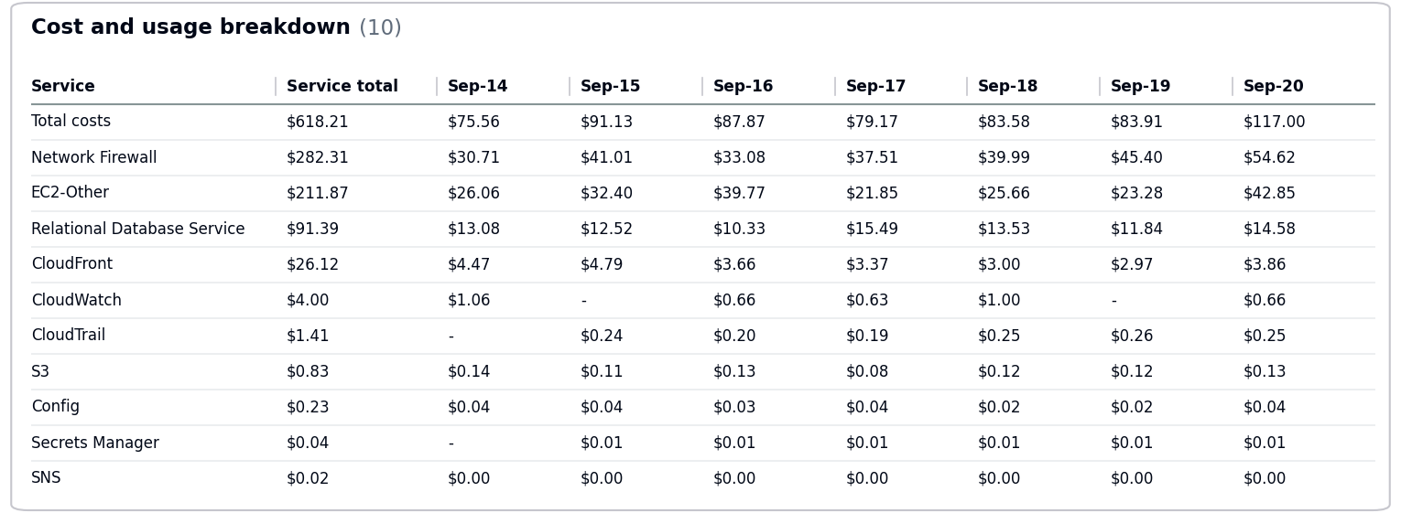
- The costs decreased by $85.18 due to usage of following services: Network Firewall, EC2-Other, CloudWatch.
- No Activity performed by Operisoft in this account.
Resource Utilization & Alarms
No Resource Utilization & Alarms.
------------------------------------------------------- Summary -------------------------------------------------------
Aptrack 1.0 - DR [Aptrack5.0] – 590183710228
--------------------------------------------------------------------------------------------------------------------------------
- Billing and Cost Overview
  - Total cost for the week: $1,539.31
  - Average Daily Cost: $219.90
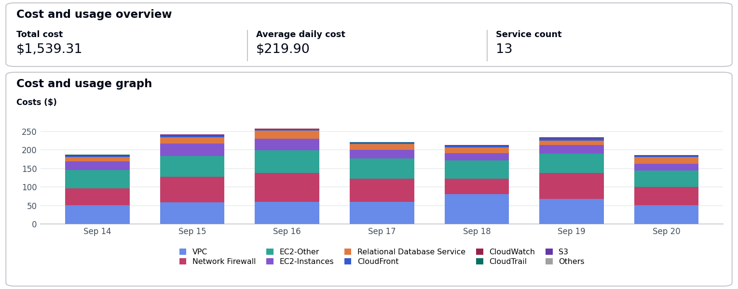
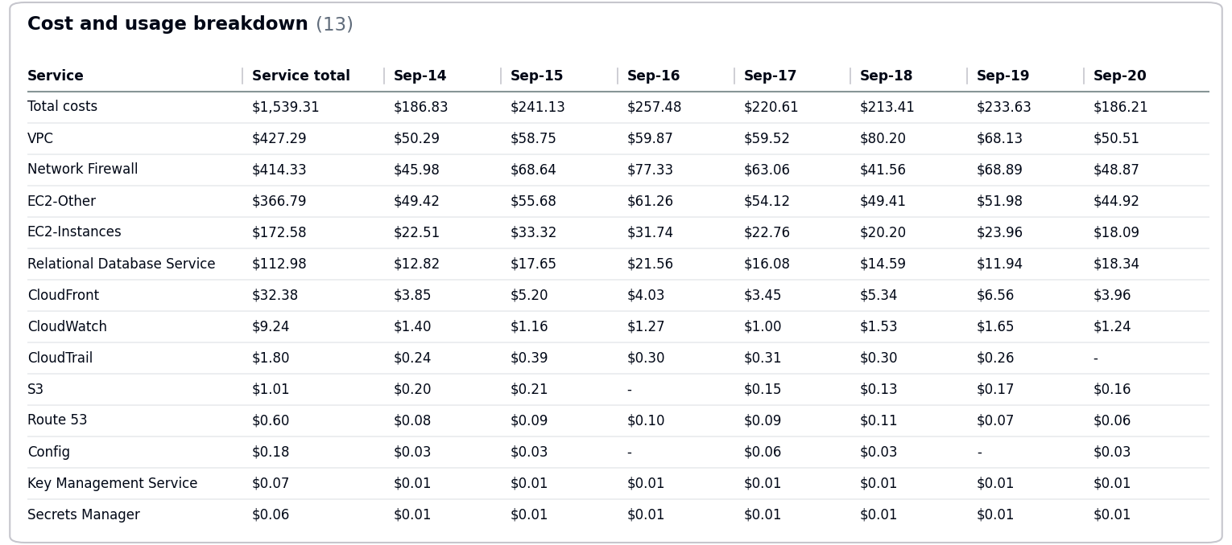
- The costs decreased by $26.68 due to usage of following services: VPC, EC2-Instances.
- No Activity performed by Operisoft in this account.
Resource Utilization & Alarms
All EC2 Server Alarms triggered between (14 September 2026 to 20 September 2026)
Server Name | Region | Memory/Disk/CPU | Alert date and no. of trigger
db-server-01 (i-0fedcba9876543210) | ap-south-1 | Disk 85% [C:] | September 17(4 Times)  September 18(3 Times)
web-server-01 (i-0123456789abcdef0) | ap-south-1 | CPU 90% | September 15(3 Times)  September 18(1 Time)
web-server-01 (i-0123456789abcdef0) | ap-south-1 | Disk 95% [/var] | September 14(5 Times)  September 15(4 Times)
------------------------------------------------------- Summary -------------------------------------------------------
Aptrack - ProAlle – 617172754330
--------------------------------------------------------------------------------------------------------------------------------
- Billing and Cost Overview
  - Total cost for the week: $985.27
  - Average Daily Cost: $140.75
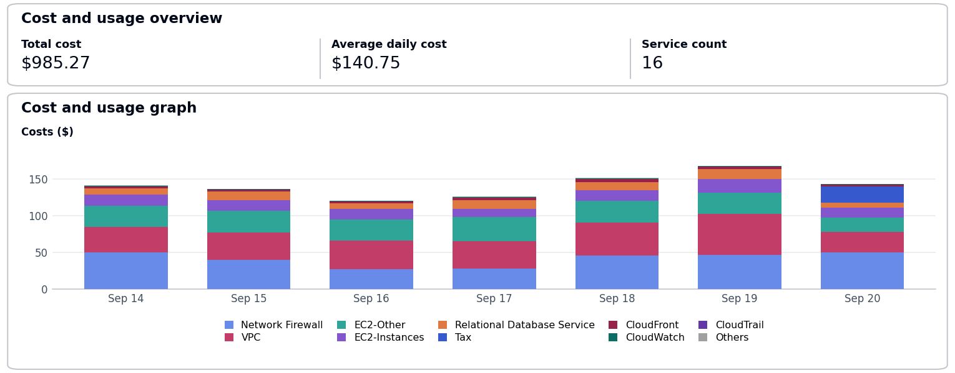
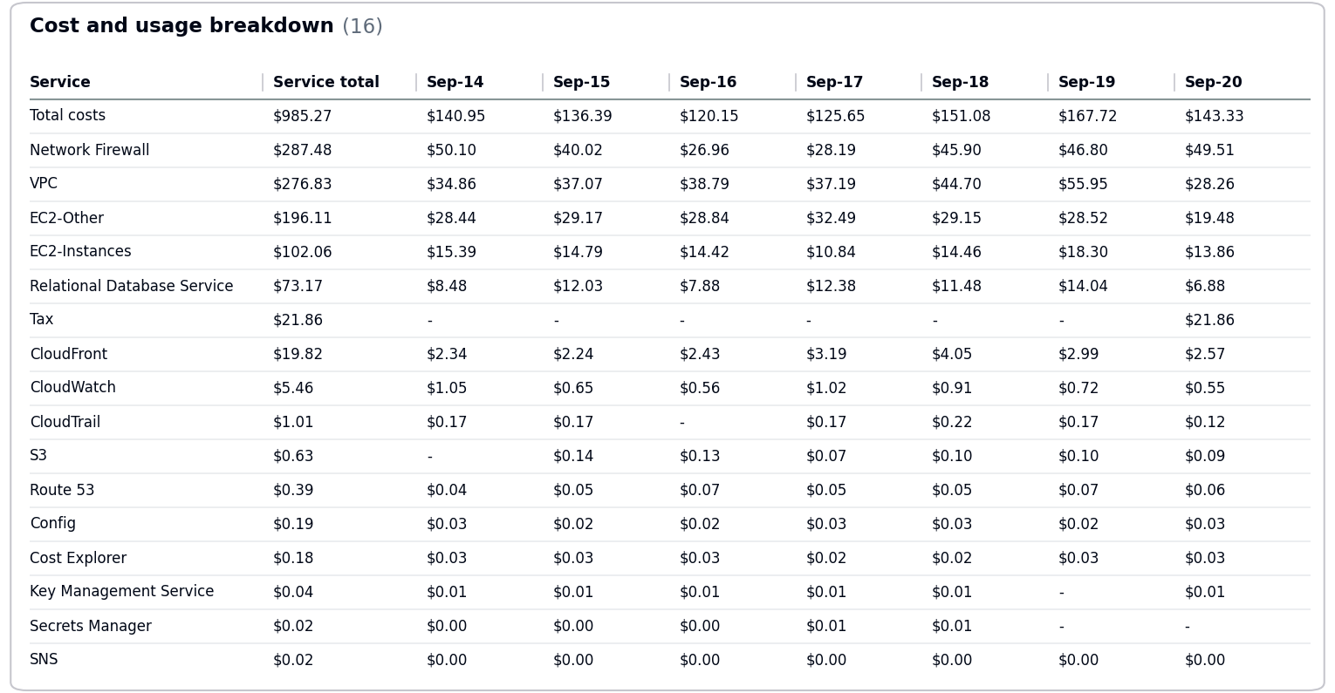
  - Total Tax Cost: $21.86
- The costs decreased by $67.04 due to usage of following services: EC2-Other, Network Firewall, EC2-Instances.
- No Activity performed by Operisoft in this account.
Resource Utilization & Alarms
All EC2 Server Alarms triggered between (14 September 2026 to 20 September 2026)
Server Name | Region | Memory/Disk/CPU | Alert date and no. of trigger
db-server-01 (i-0fedcba9876543210) | ap-south-1 | CPU 85% | September 16(5 Times)  September 19(6 Times)
web-server-01 (i-0123456789abcdef0) | ap-south-1 | CPU 90% | September 16(1 Time)  September 18(1 Time)
------------------------------------------------------- Summary -------------------------------------------------------
Aptrack - 2.0 - Shared Service [MEL] – 533267037955
--------------------------------------------------------------------------------------------------------------------------------
- Billing and Cost Overview
  - Total cost for the week: $1,268.84
  - Average Daily Cost: $181.26
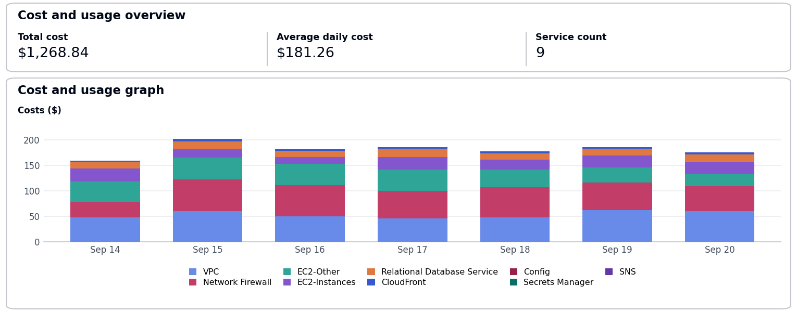
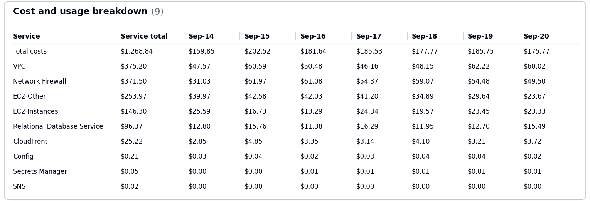
- The costs increased by $47.73 due to usage of following services: EC2-Instances, VPC, Relational Database Service.
- No Activity performed by Operisoft in this account.
Resource Utilization & Alarms
No Resource Utilization & Alarms.
------------------------------------------------------- Summary -------------------------------------------------------
Aptrack-SAP-Dev and Quality – 528757792293
--------------------------------------------------------------------------------------------------------------------------------
- Billing and Cost Overview
  - Total cost for the week: $1,160.63
  - Average Daily Cost: $165.80
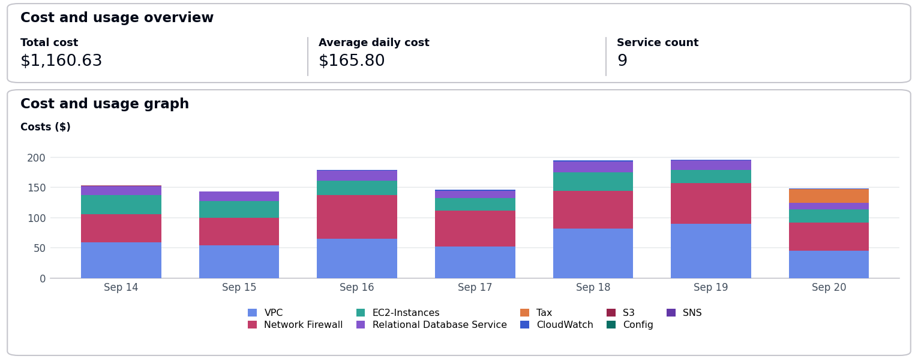
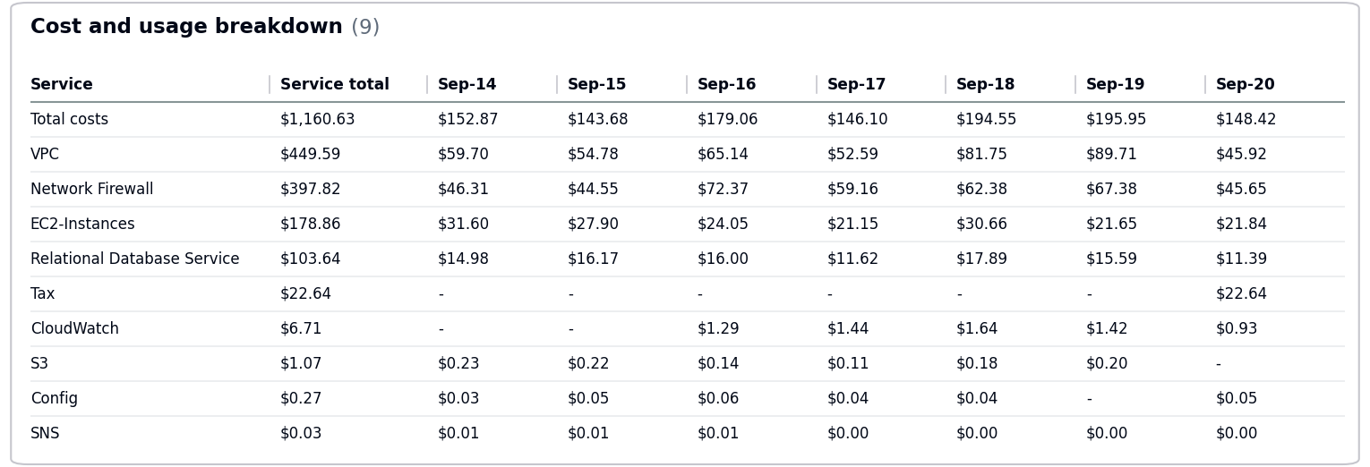
  - Total Tax Cost: $22.64
- The costs decreased by $1.02 due to usage of following services: Relational Database Service, EC2-Instances, CloudWatch.
- No Activity performed by Operisoft in this account.
Resource Utilization & Alarms
All EC2 Server Alarms triggered between (14 September 2026 to 20 September 2026)
Server Name | Region | Memory/Disk/CPU | Alert date and no. of trigger
web-server-01 (i-0123456789abcdef0) | ap-south-1 | Disk 95% [/var] | September 14(6 Times)  September 16(3 Times)
------------------------------------------------------- Summary -------------------------------------------------------
Aptrack-SAP-Production – 195275643918
--------------------------------------------------------------------------------------------------------------------------------
- Billing and Cost Overview
  - Total cost for the week: $295.82
  - Average Daily Cost: $42.26
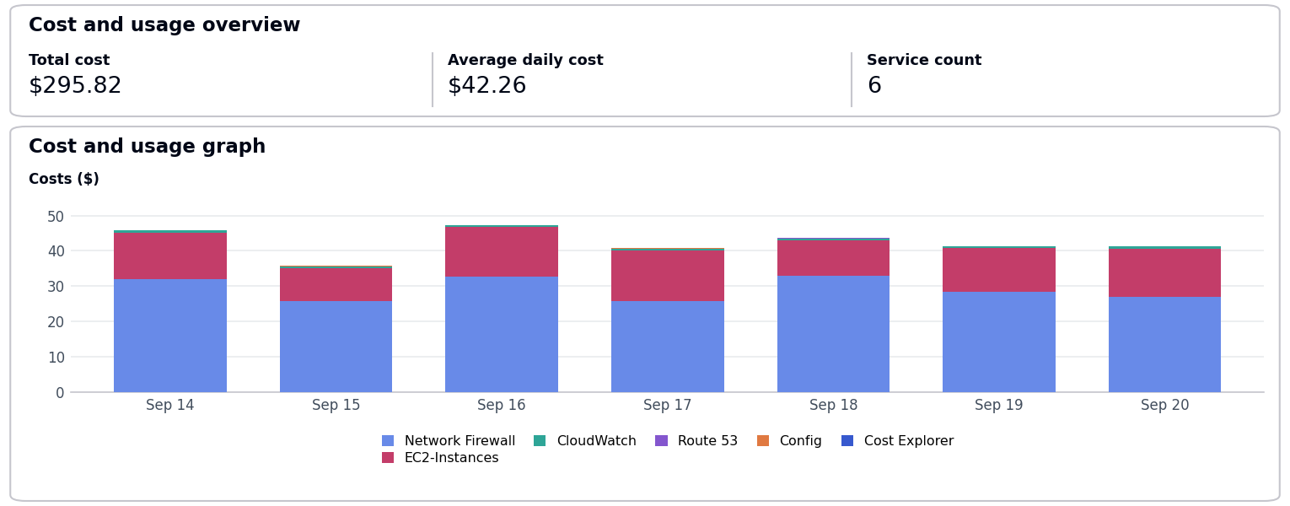
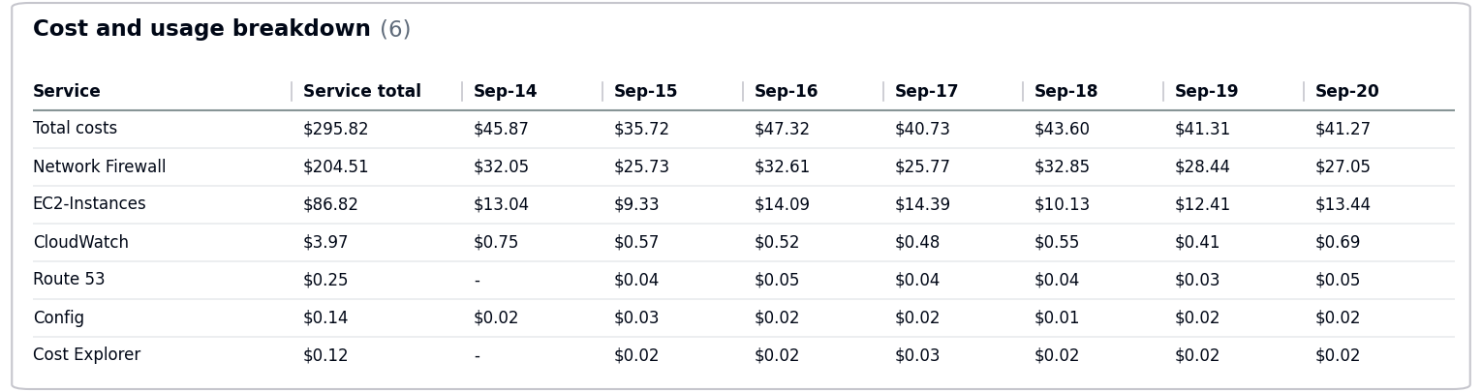
- The costs decreased by $16.37 due to usage of following services: Network Firewall.
- No Activity performed by Operisoft in this account.
Resource Utilization & Alarms
All EC2 Server Alarms triggered between (14 September 2026 to 20 September 2026)
Server Name | Region | Memory/Disk/CPU | Alert date and no. of trigger
app-server-01 (i-0987654321fedcba0) | ap-south-1 | Memory 90% | September 15(4 Times)  September 19(4 Times)
web-server-01 (i-0123456789abcdef0) | ap-south-1 | CPU 90% | September 15(6 Times)  September 19(5 Times)
------------------------------------------------------- Summary -------------------------------------------------------
Aptrack – LCMS – 771423618181
--------------------------------------------------------------------------------------------------------------------------------
- Billing and Cost Overview
  - Total cost for the week: $548.61
  - Average Daily Cost: $78.37
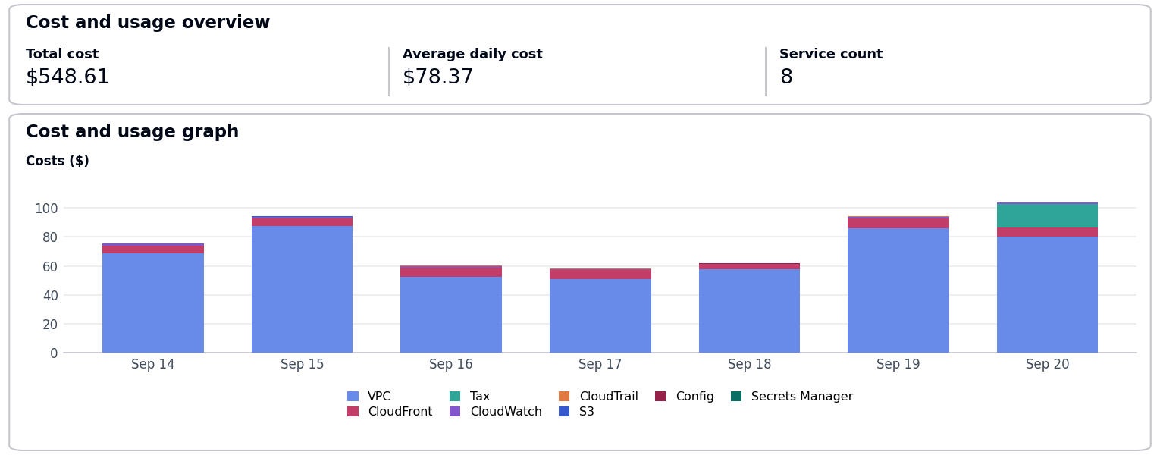
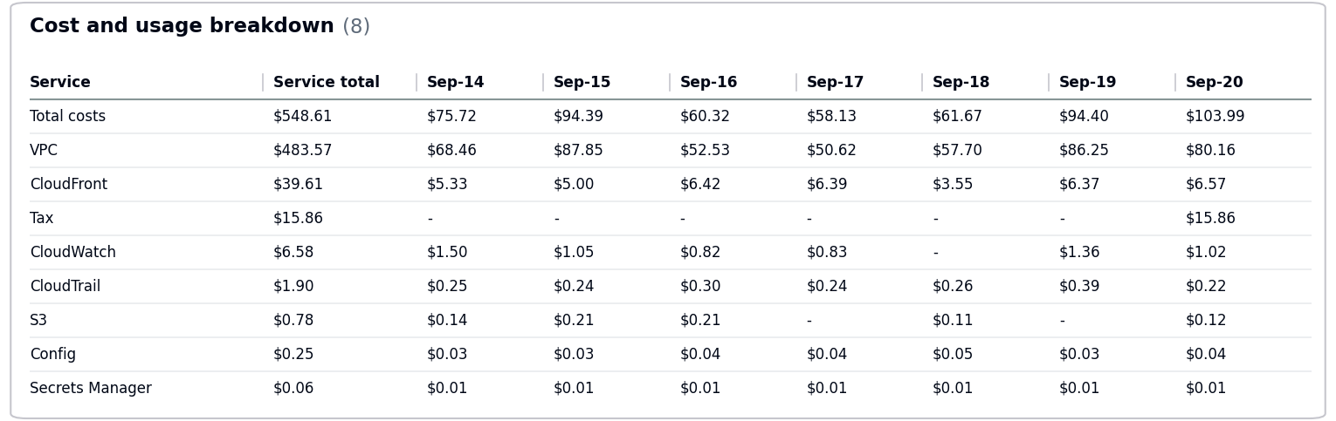
  - Total Tax Cost: $15.86
- The costs increased by $96.97 due to usage of following services: VPC, CloudFront.
- No Activity performed by Operisoft in this account.
Resource Utilization & Alarms
No Resource Utilization & Alarms.
------------------------------------------------------- Summary -------------------------------------------------------
Aptech-ProConnect – 108782065415
--------------------------------------------------------------------------------------------------------------------------------
- Billing and Cost Overview
  - Total cost for the week: $1,387.08
  - Average Daily Cost: $198.15
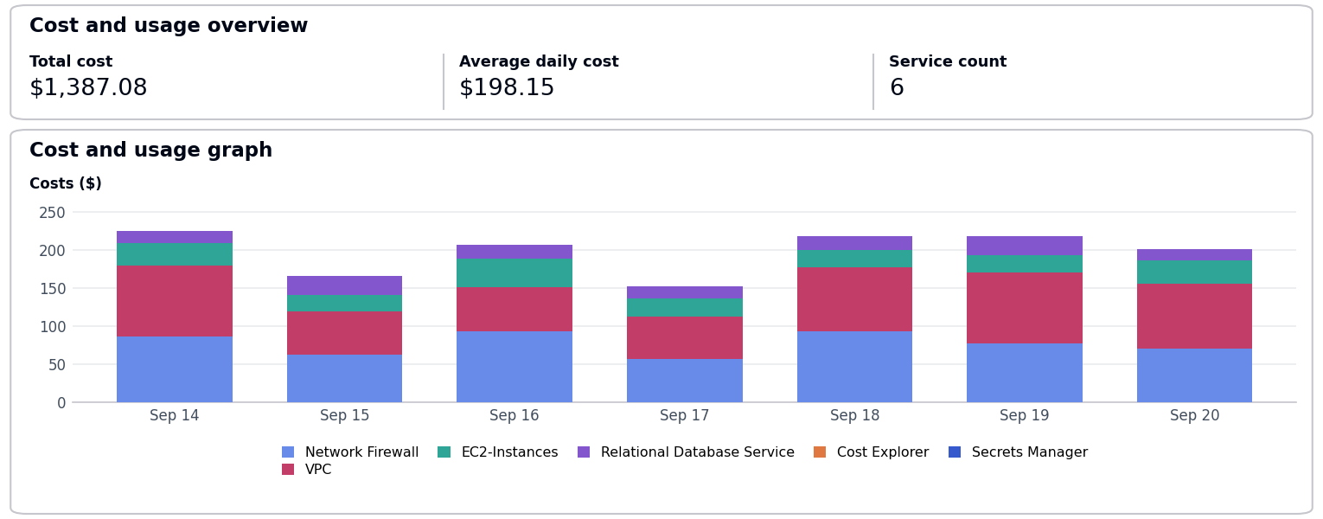
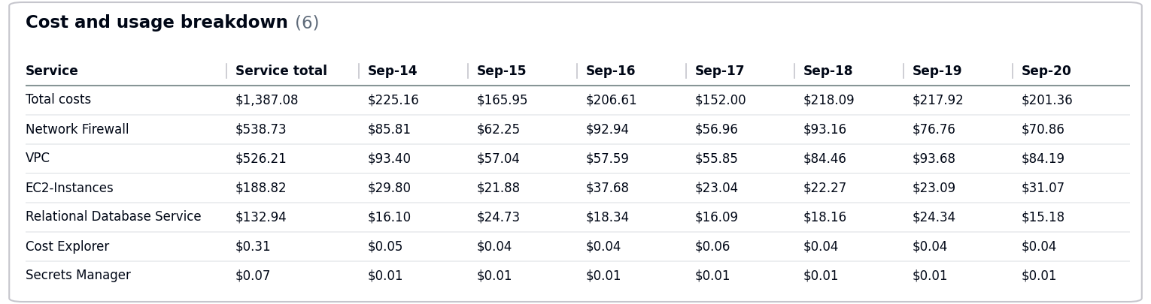
- The costs increased by $144.46 due to usage of following services: VPC, Network Firewall, EC2-Instances.
- No Activity performed by Operisoft in this account.
Resource Utilization & Alarms
All EC2 Server Alarms triggered between (14 September 2026 to 20 September 2026)
Server Name | Region | Memory/Disk/CPU | Alert date and no. of trigger
app-server-01 (i-0987654321fedcba0) | ap-south-1 | Memory 90% | September 14(6 Times)  September 20(6 Times)
------------------------------------------------------- Summary -------------------------------------------------------
Aptrack - QnA Solution – 211125374996
--------------------------------------------------------------------------------------------------------------------------------
- Billing and Cost Overview
  - Total cost for the week: $99.87
  - Average Daily Cost: $14.27
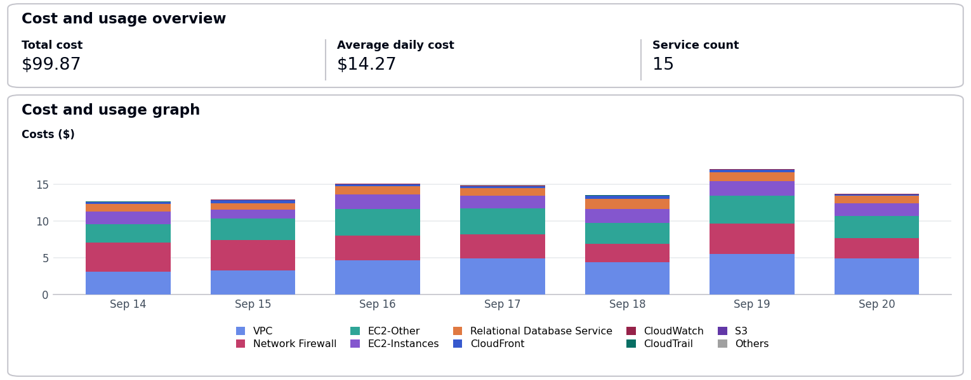
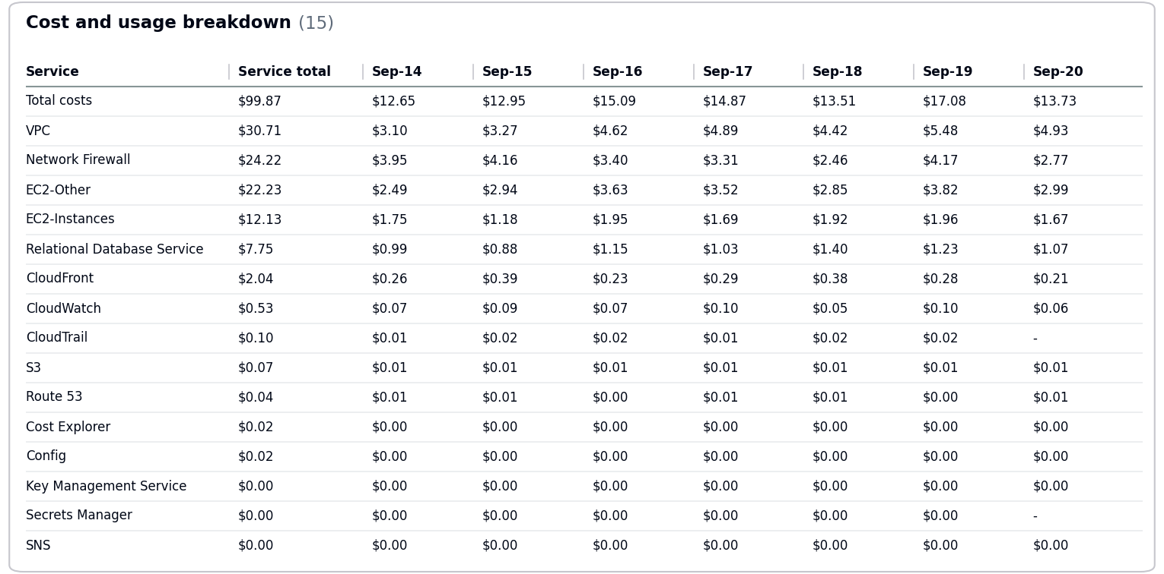
- The costs increased by $10.03 due to usage of following services: EC2-Other, VPC, EC2-Instances.
- No Activity performed by Operisoft in this account.
Resource Utilization & Alarms
All EC2 Server Alarms triggered between (14 September 2026 to 20 September 2026)
Server Name | Region | Memory/Disk/CPU | Alert date and no. of trigger
web-server-01 (i-0123456789abcdef0) | ap-south-1 | CPU 90% | September 18(5 Times)  September 19(2 Times)
------------------------------------------------------- Summary -------------------------------------------------------
Aptech-LAPA – 343218180162
--------------------------------------------------------------------------------------------------------------------------------
- Billing and Cost Overview
  - Total cost for the week: $391.41
  - Average Daily Cost: $55.92
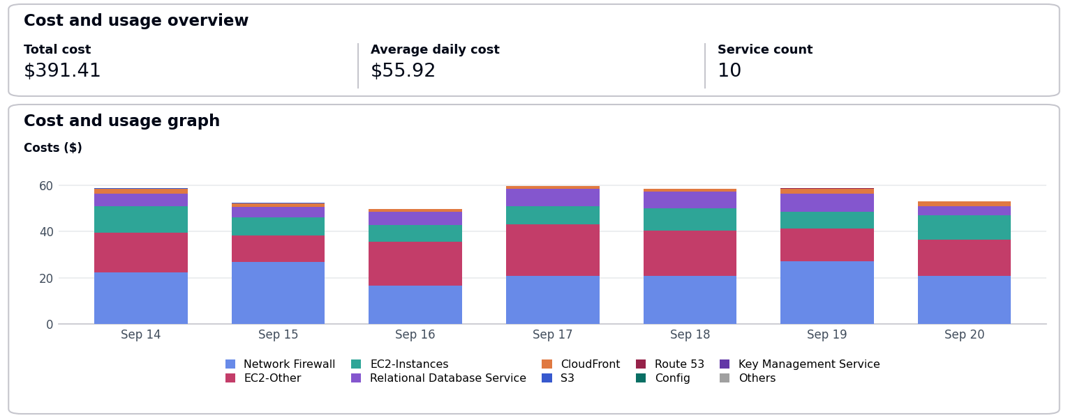
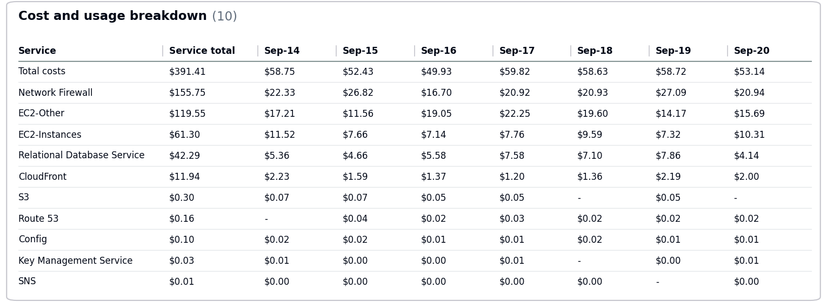
- The costs increased by $5.14 due to usage of following services: Network Firewall.
- No Activity performed by Operisoft in this account.
Resource Utilization & Alarms
No Resource Utilization & Alarms.
------------------------------------------------------- Summary -------------------------------------------------------
Aptrack-Arena – 034362049944
--------------------------------------------------------------------------------------------------------------------------------
- Billing and Cost Overview
  - Total cost for the week: $207.78
  - Average Daily Cost: $29.68
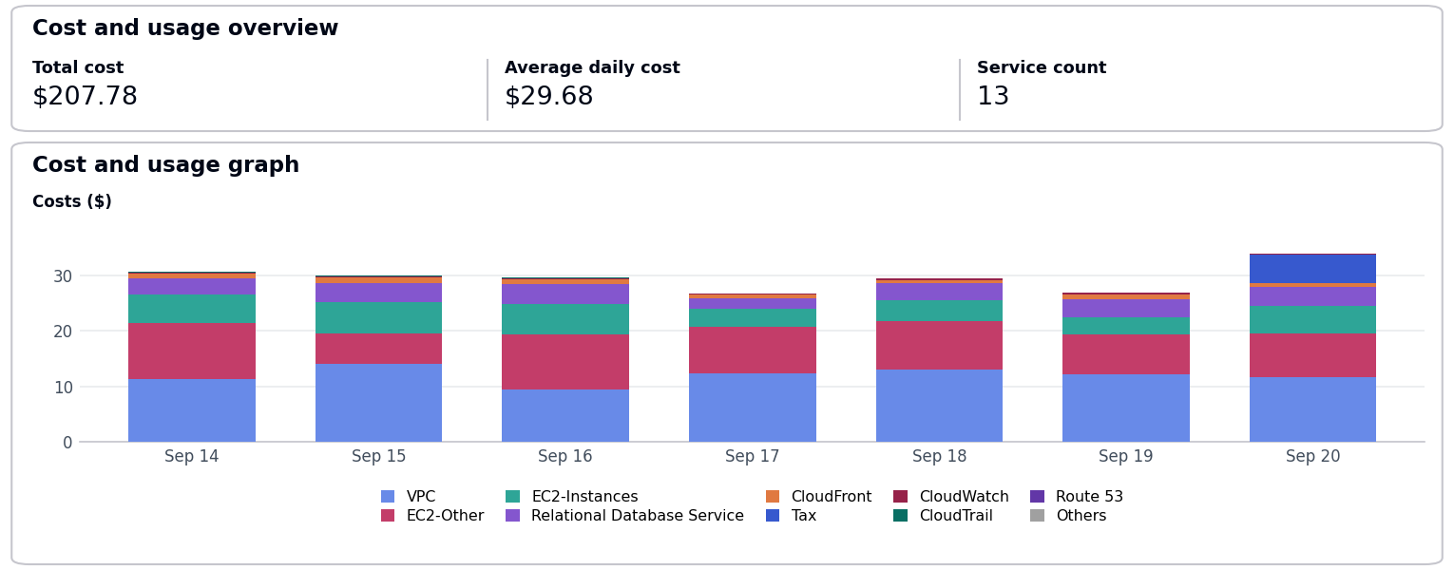
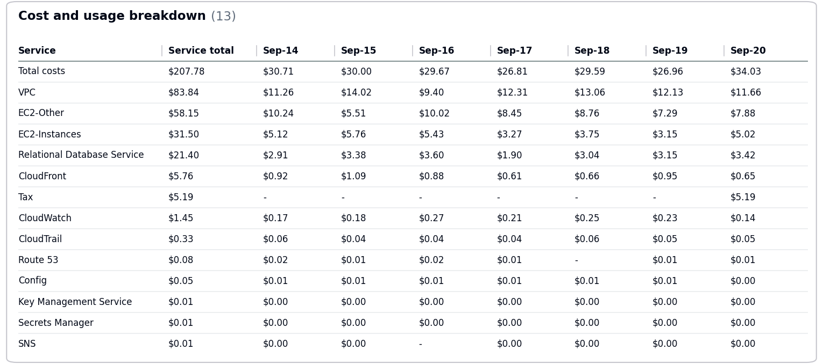
  - Total Tax Cost: $5.19
- The costs increased by $7.23 due to usage of following services: VPC, Relational Database Service, EC2-Other.
- No Activity performed by Operisoft in this account.
Resource Utilization & Alarms
All EC2 Server Alarms triggered between (14 September 2026 to 20 September 2026)
Server Name | Region | Memory/Disk/CPU | Alert date and no. of trigger
db-server-01 (i-0fedcba9876543210) | ap-south-1 | CPU 85% | September 18(4 Times)  September 20(6 Times)
web-server-01 (i-0123456789abcdef0) | ap-south-1 | CPU 90% | September 16(1 Time)  September 20(6 Times)
web-server-01 (i-0123456789abcdef0) | ap-south-1 | Disk 95% [/var] | September 16(5 Times)  September 17(5 Times)
------------------------------------------------------- Summary -------------------------------------------------------
Aptech Avalon – 985539791413
--------------------------------------------------------------------------------------------------------------------------------
- Billing and Cost Overview
  - Total cost for the week: $997.82
  - Average Daily Cost: $142.55
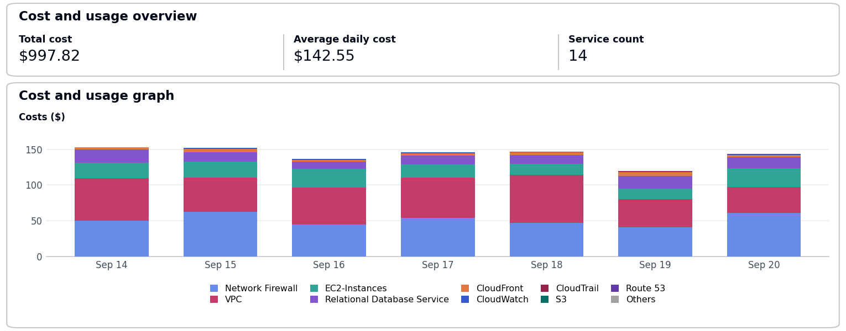
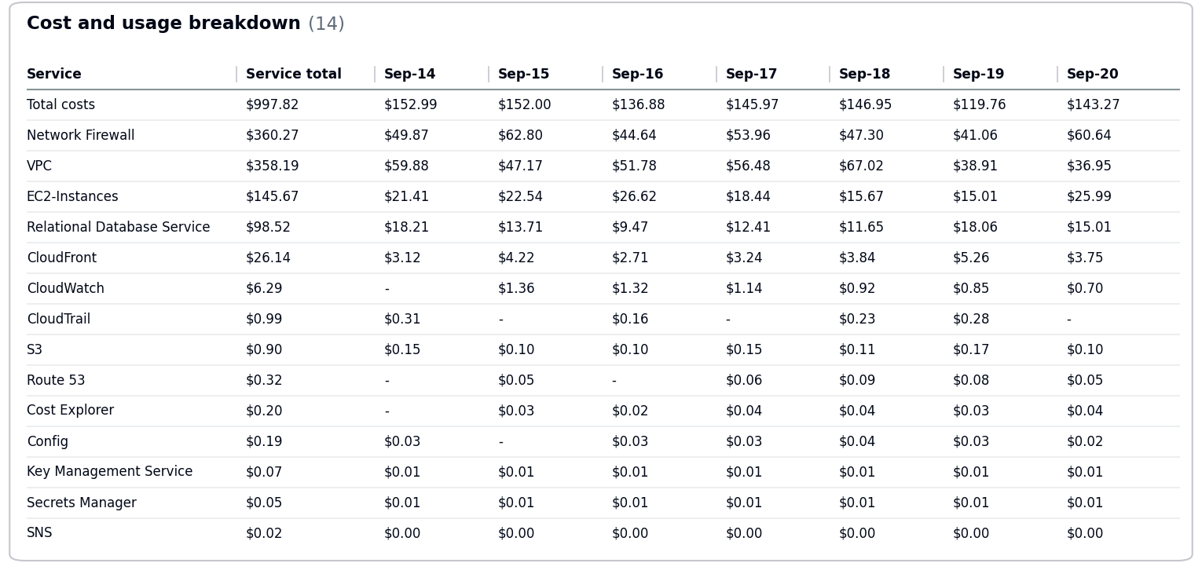
- The costs decreased by $12.03 due to usage of following services: VPC, CloudFront, CloudTrail.
- No Activity performed by Operisoft in this account.
Resource Utilization & Alarms
All EC2 Server Alarms triggered between (14 September 2026 to 20 September 2026)
Server Name | Region | Memory/Disk/CPU | Alert date and no. of trigger
app-server-01 (i-0987654321fedcba0) | ap-south-1 | Memory 90% | September 15(2 Times)  September 16(2 Times)
db-server-01 (i-0fedcba9876543210) | ap-south-1 | Disk 85% [C:] | September 18(3 Times)  September 20(3 Times)
web-server-01 (i-0123456789abcdef0) | ap-south-1 | CPU 90% | September 14(4 Times)  September 18(1 Time)
------------------------------------------------------- Summary -------------------------------------------------------
Aptech AI Applications – 166185345052
--------------------------------------------------------------------------------------------------------------------------------
- Billing and Cost Overview
  - Total cost for the week: $928.71
  - Average Daily Cost: $132.67
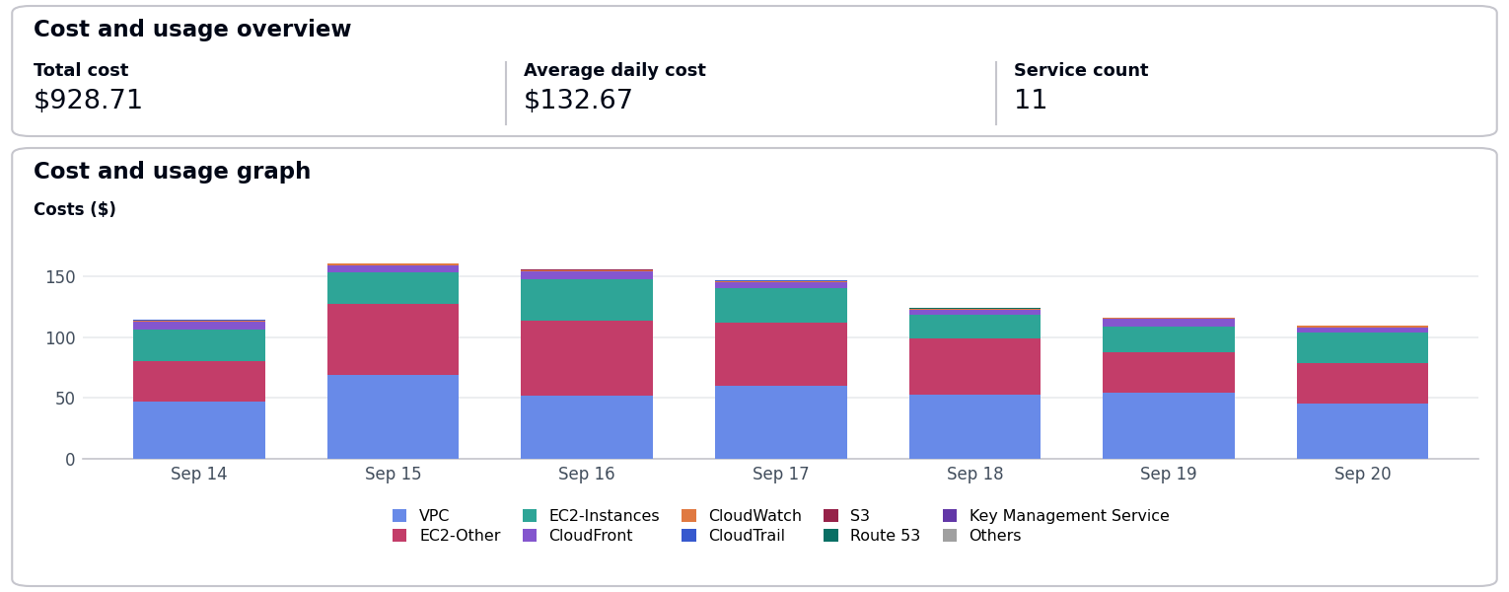
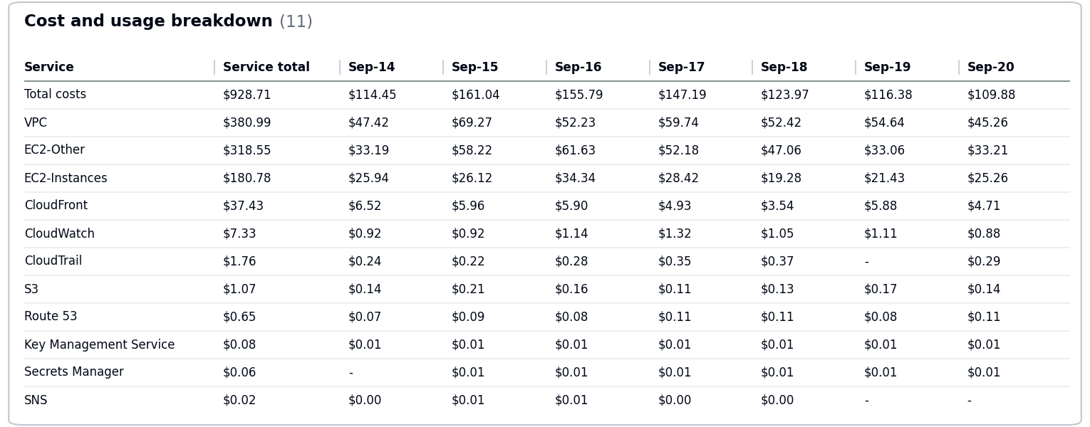
- The costs decreased by $151.24 due to usage of following services: VPC, EC2-Other, CloudWatch.
- No Activity performed by Operisoft in this account.
Resource Utilization & Alarms
No Resource Utilization & Alarms.
------------------------------------------------------- Summary -------------------------------------------------------
Aptrack AR_VR_MAAC – 377555974222
--------------------------------------------------------------------------------------------------------------------------------
- Billing and Cost Overview
  - Total cost for the week: $1,328.16
  - Average Daily Cost: $189.74
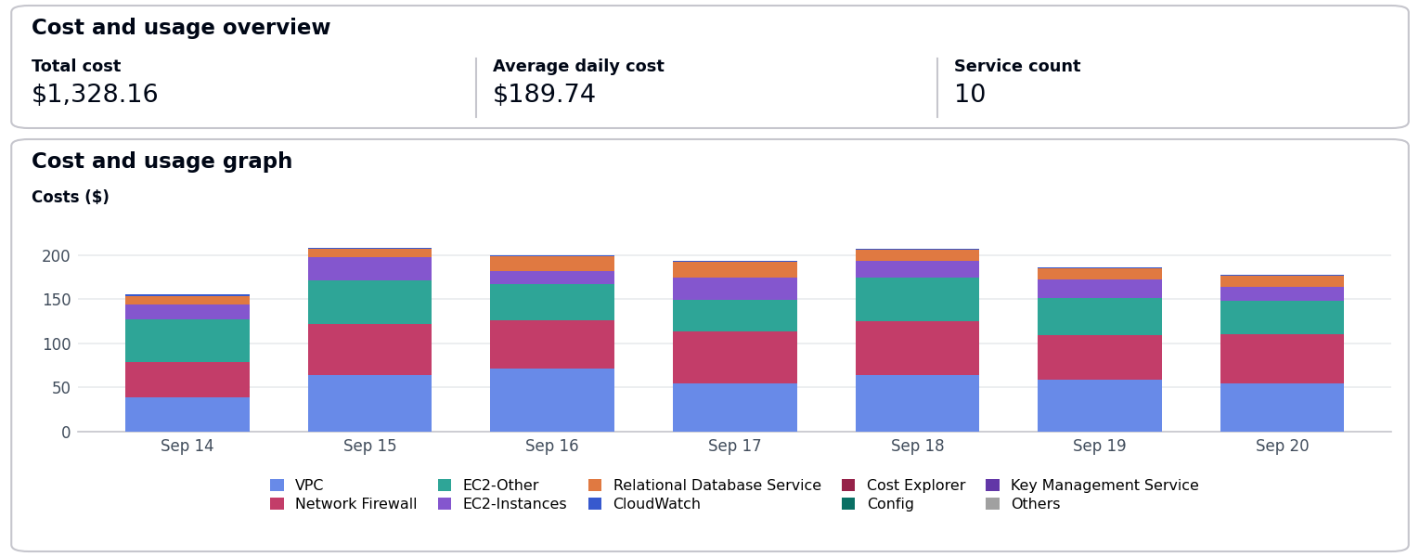
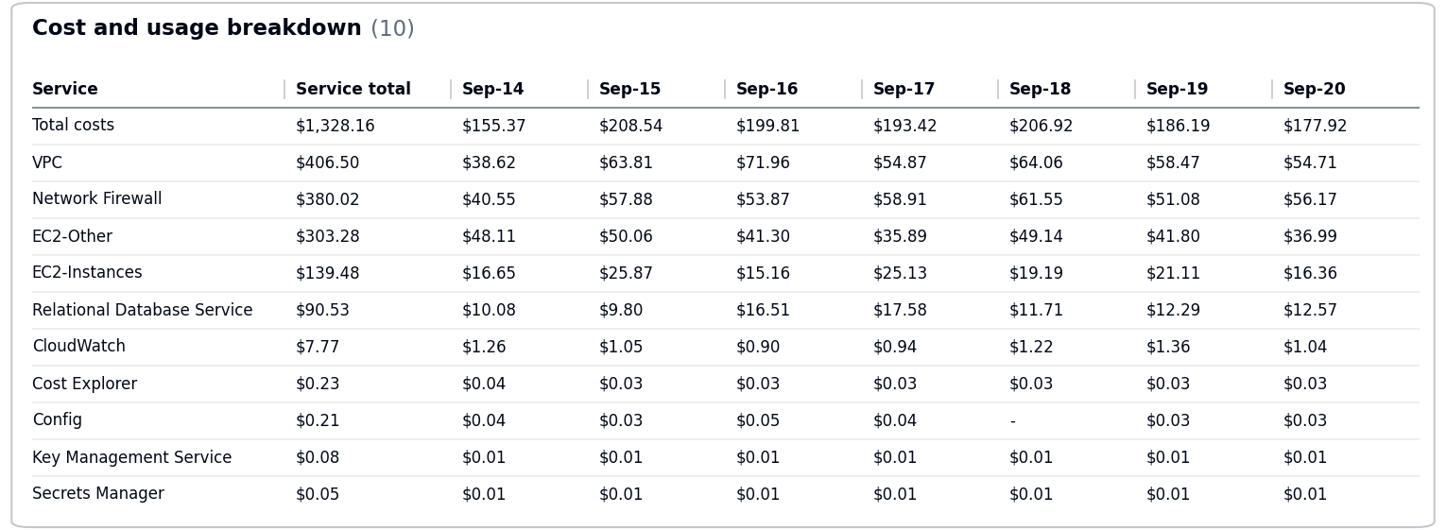
- The costs increased by $78.63 due to usage of following services: EC2-Other, Network Firewall, CloudWatch.
- No Activity performed by Operisoft in this account.
Resource Utilization & Alarms
All EC2 Server Alarms triggered between (14 September 2026 to 20 September 2026)
Server Name | Region | Memory/Disk/CPU | Alert date and no. of trigger
app-server-01 (i-0987654321fedcba0) | ap-south-1 | Memory 90% | September 14(3 Times)  September 16(3 Times)
web-server-01 (i-0123456789abcdef0) | ap-south-1 | Disk 95% [/var] | September 14(5 Times)  September 18(4 Times)
------------------------------------------------------- Summary -------------------------------------------------------
Aptrack - 2.0 - Log archive [MEL] – 637423329781
--------------------------------------------------------------------------------------------------------------------------------
- Billing and Cost Overview
  - Total cost for the week: $90.81
  - Average Daily Cost: $12.97
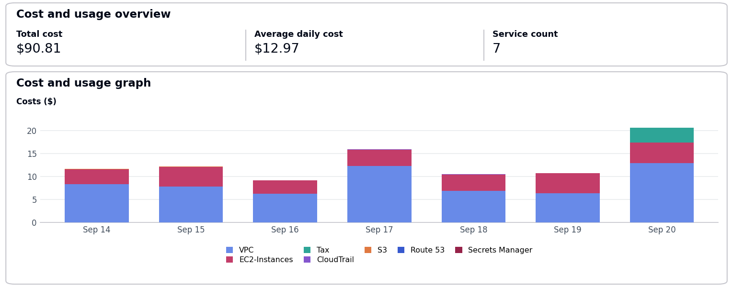
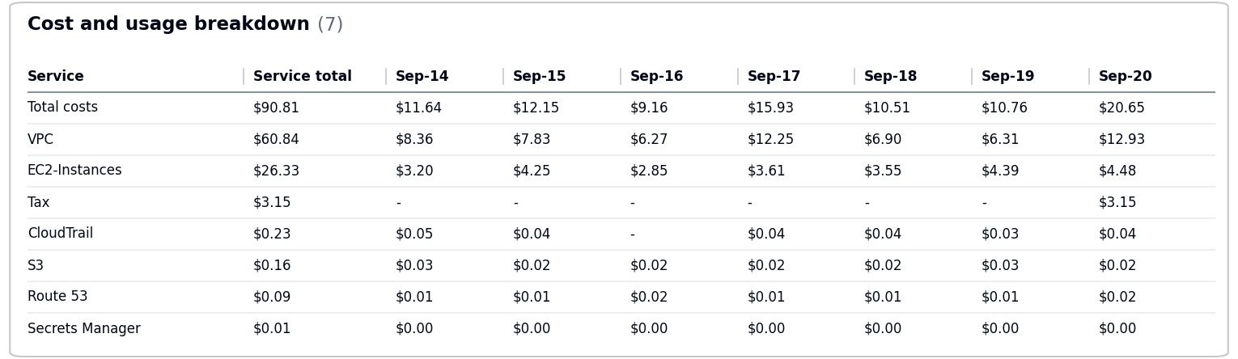
  - Total Tax Cost: $3.15
- The costs decreased by $7.81 due to usage of following services: VPC.
- No Activity performed by Operisoft in this account.
Resource Utilization & Alarms
All EC2 Server Alarms triggered between (14 September 2026 to 20 September 2026)
Server Name | Region | Memory/Disk/CPU | Alert date and no. of trigger
db-server-01 (i-0fedcba9876543210) | ap-south-1 | Disk 85% [C:] | September 15(6 Times)  September 17(4 Times)
------------------------------------------------------- Summary -------------------------------------------------------
Aptech-Domains – 622050225451
--------------------------------------------------------------------------------------------------------------------------------
- Billing and Cost Overview
  - Total cost for the week: $435.62
  - Average Daily Cost: $62.23
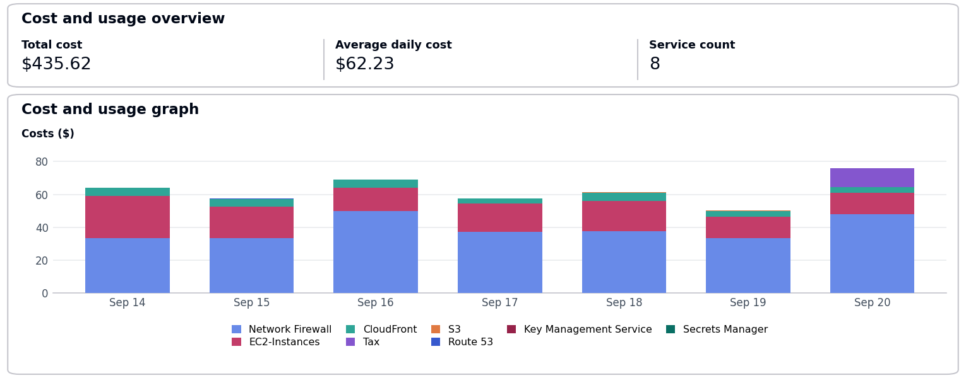
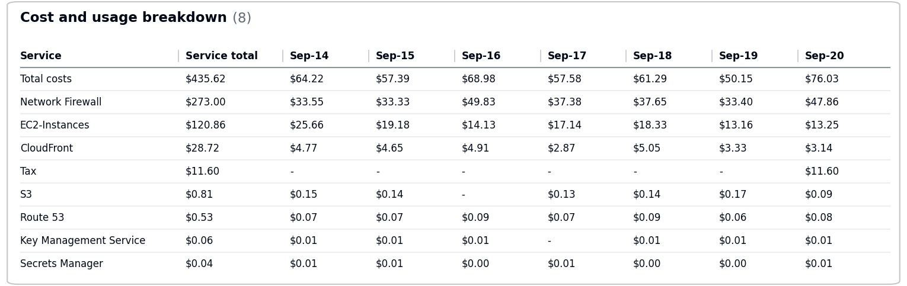
  - Total Tax Cost: $11.60
- The costs decreased by $86.47 due to usage of following services: Network Firewall, EC2-Instances.
- No Activity performed by Operisoft in this account.
Resource Utilization & Alarms
No Resource Utilization & Alarms.
------------------------------------------------------- Summary -------------------------------------------------------
Aptrack - 2.0 - Audit [MEL] – 851725245759
--------------------------------------------------------------------------------------------------------------------------------
- Billing and Cost Overview
  - Total cost for the week: $169.33
  - Average Daily Cost: $24.19
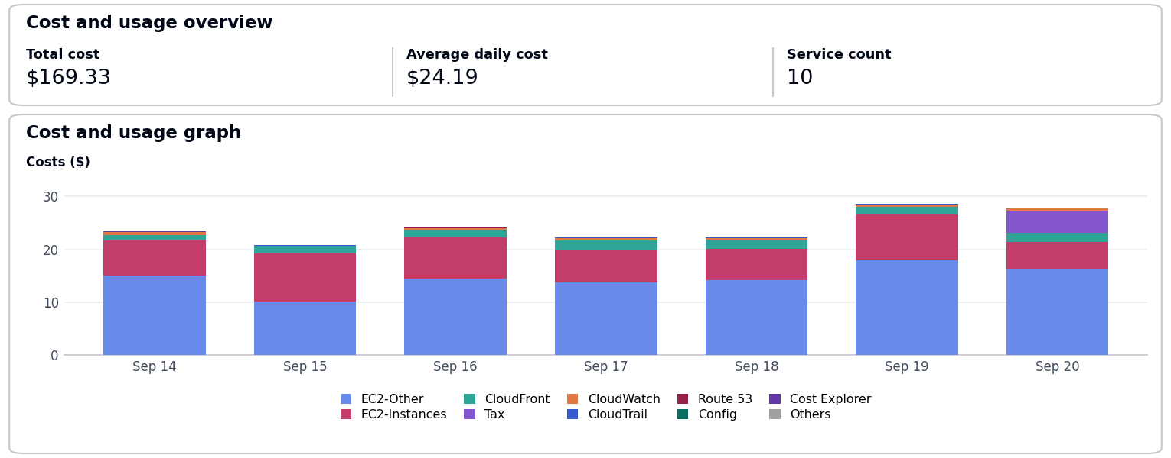
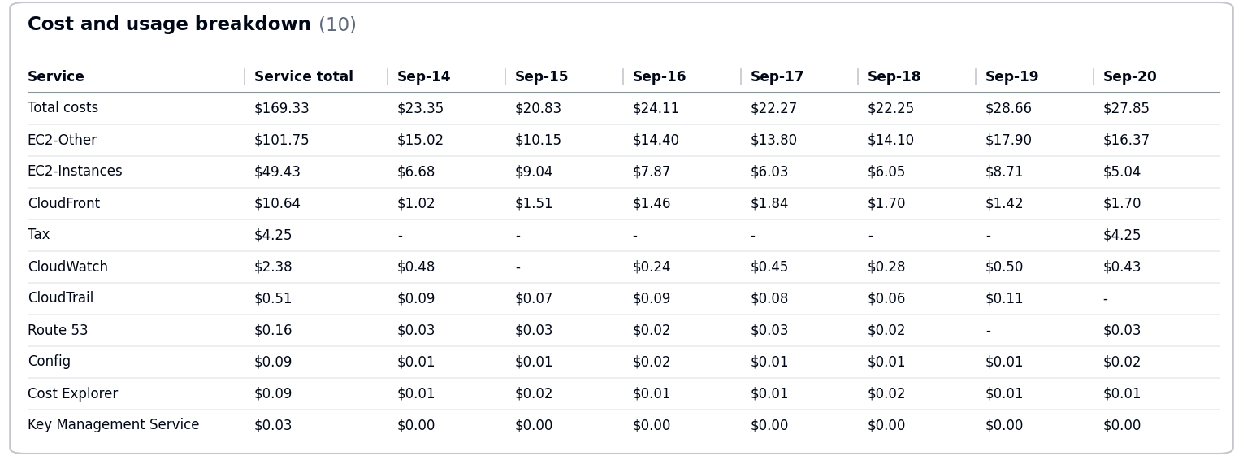
  - Total Tax Cost: $4.25
- The costs increased by $2.31 due to usage of following services: EC2-Other.
- No Activity performed by Operisoft in this account.
Resource Utilization & Alarms
All EC2 Server Alarms triggered between (14 September 2026 to 20 September 2026)
Server Name | Region | Memory/Disk/CPU | Alert date and no. of trigger
app-server-01 (i-0987654321fedcba0) | ap-south-1 | Memory 90% | September 16(4 Times)  September 20(6 Times)
db-server-01 (i-0fedcba9876543210) | ap-south-1 | CPU 85% | September 17(3 Times)  September 19(1 Time)
web-server-01 (i-0123456789abcdef0) | ap-south-1 | CPU 90% | September 17(5 Times)  September 20(2 Times)
------------------------------------------------------- Summary -------------------------------------------------------
Aptech International – 470684059456
--------------------------------------------------------------------------------------------------------------------------------
- Billing and Cost Overview
  - Total cost for the week: $196.24
  - Average Daily Cost: $28.03
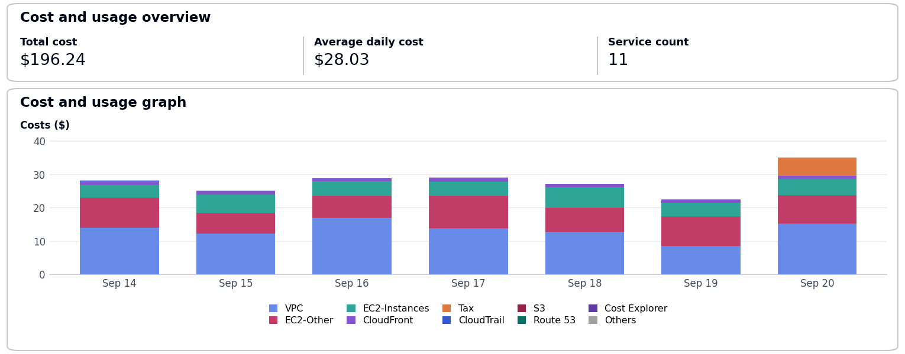
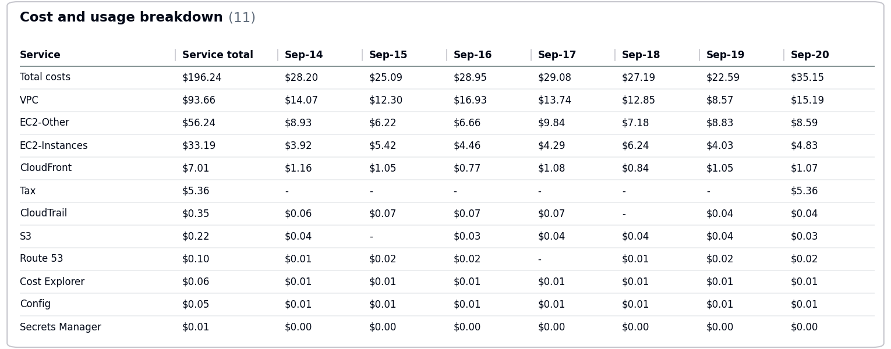
  - Total Tax Cost: $5.36
- The costs increased by $14.38 due to usage of following services: VPC, EC2-Instances.
- No Activity performed by Operisoft in this account.
Resource Utilization & Alarms
All EC2 Server Alarms triggered between (14 September 2026 to 20 September 2026)
Server Name | Region | Memory/Disk/CPU | Alert date and no. of trigger
web-server-01 (i-0123456789abcdef0) | ap-south-1 | CPU 90% | September 15(4 Times)  September 19(4 Times)

-- End Of Document --

