Screenshot of Task 3 – A (Hackerrank)

AJEETESH KUMAR – 25BCE11023
Link - https://www.hackerrank.com/profile/ajeetesh17980

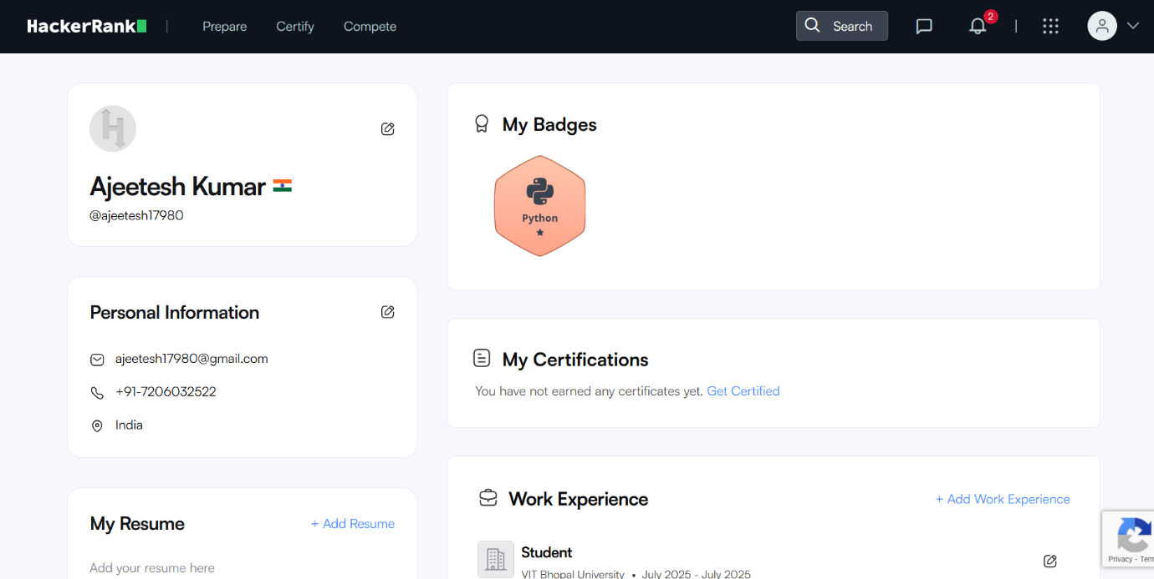

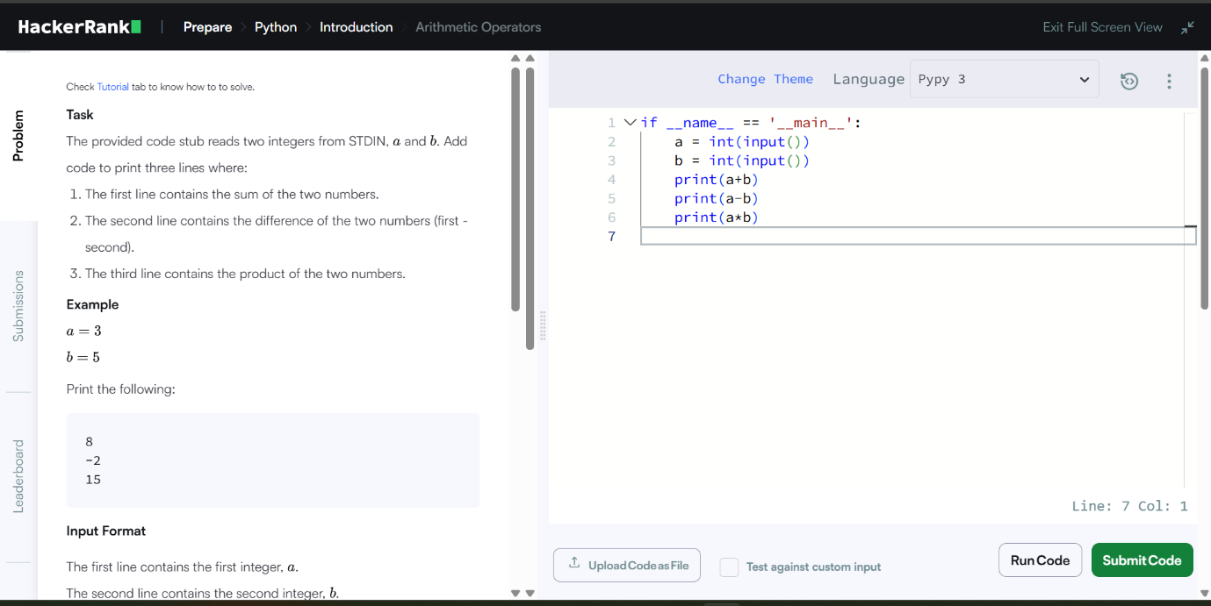

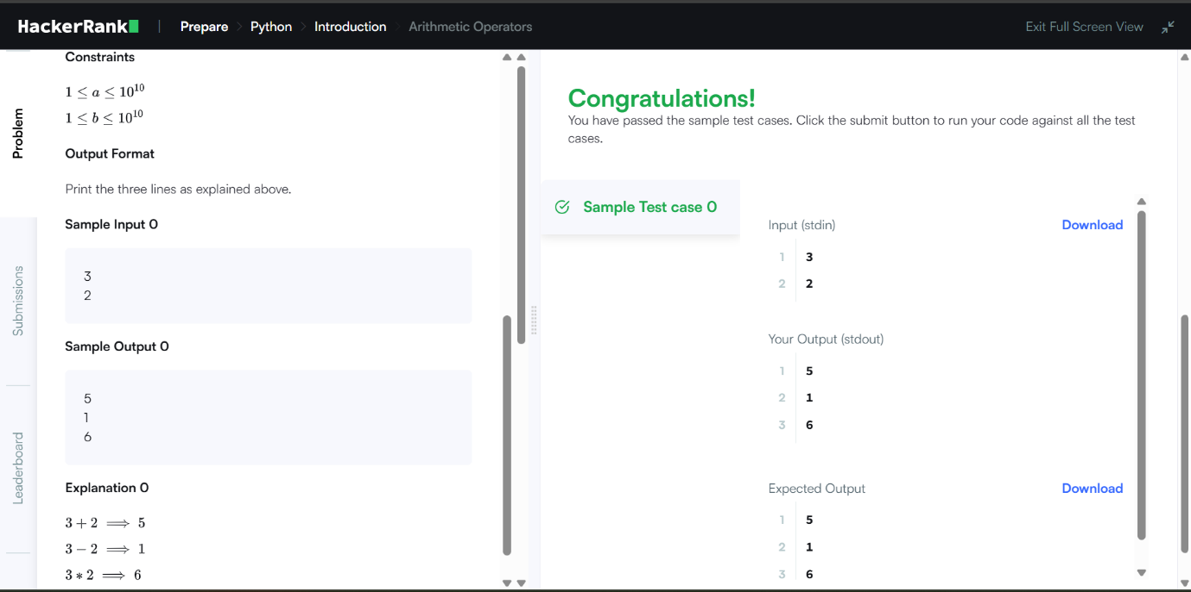

Screenshot of Task 3 – B (Google Form Quiz)

Digital Literacy Awareness Quiz

Link - https://forms.gle/ESBB7p3Z3FBmXXJZ6

