# WeRateDogs – Insights into the @dog_rates Twitter page

## Introduction and Background

Real-world data rarely comes clean. The dataset wrangled for this project is the tweet archive of Twitter user @dog_rates, also known as WeRateDogs. WeRateDogs is a Twitter account that rates people's dogs with a humorous comment about the dog.

This project gathered data from the WeRateDogs Twitter archive containing basic tweet data (tweet ID, timestamp, text, etc.) for all 5000+ of their tweets as they stood on August 1, 2017. Then, using Python and its libraries, the project gathered data using the Twitter API and Python's Tweepy library to gather each tweet's retweet count and favorite ("like") count, as well as the tweet image predictions, i.e., what breed of dog (or other object, animal, etc.) is present in each tweet according to a neural network.

Please feel free to reference my Jupyter Notebook titled “wrangle_act.ipynb” on my Github account: <https://github.com/chelseymarie6/Wrangle-and-Analyze-Data>

The following are insights gleaned from the data wrangling process.

## Tweets over Time

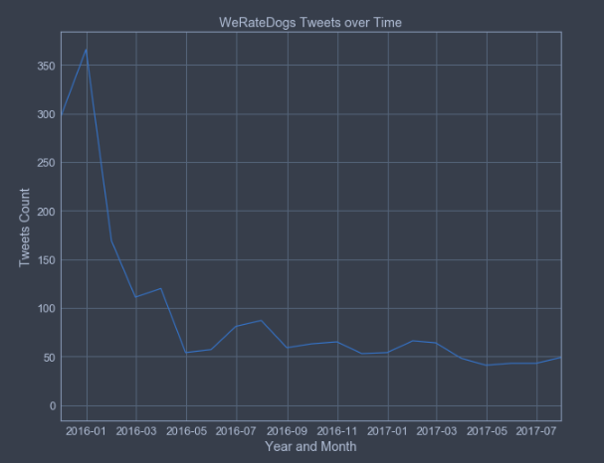

Over time tweets decreased sharply, with spikes in activity during the early spring of 2016, mid-summer of 2016, and generally decreasing from there.

## Favorite vs. Retweet Counts

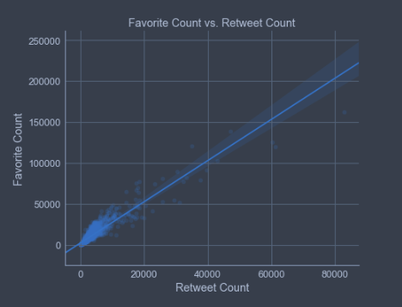

Favorite counts are correlated with retweet counts - this is a positive correlation.

## Dog Breed Popularity

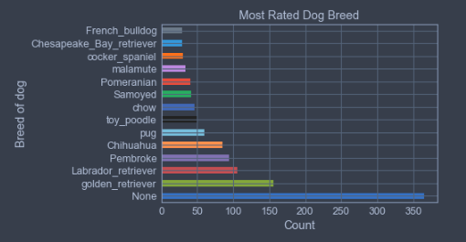

The most popular dog breed is a golden retriever (ignoring the None label), with a labrador retriever coming in as the second most popular breed. Pembroke isn't far behind.

## Dog Name Commonality

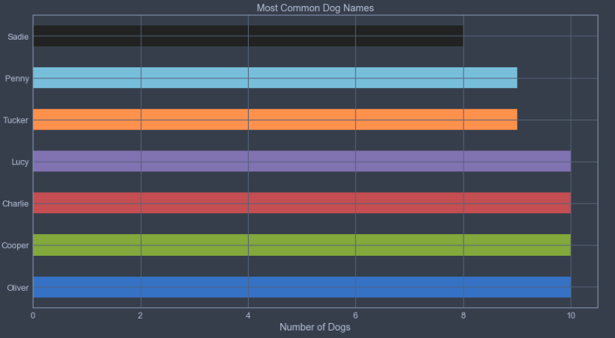

The three most popular dog names are Oliver, Cooper, Charlie, and Lucy for a tie at 10 each.