MAJOR PROJECT REPORT
ON
INTELLIGENT VIDEO MANAGEMENT SYSTEM (VMS) WITH REAL-TIME AI ANALYTICS
Submitted in partial fulfillment of the requirements for the degree of
Bachelor of Technology
Submitted By:
Vidushi Singh
Roll No: 229303362

CANDIDATE'S DECLARATION
I hereby declare that the work, which is being presented in the Major Project Report entitled "Intelligent Video Management System (VMS) with Real-Time AI Analytics" in partial fulfillment of the requirements for the award of the Degree of Bachelor of Technology and submitted to the institution, is an authentic record of my own work carried out during the period of my project.
The matter embodied in this report has not been submitted by me for the award of any other degree of this or any other Institute/University.
Vidushi Singh
Roll No: 229303362
Date: ___________

CERTIFICATE
This is to certify that the Major Project Report entitled "Intelligent Video Management System (VMS) with Real-Time AI Analytics" submitted by Vidushi Singh (Roll No: 229303362) in partial fulfillment of the requirements for the award of the Degree of Bachelor of Technology is a record of the candidate's own work carried out by her under my supervision. The matter embodied in this report is original and has not been submitted for the award of any other degree.
Supervisor Signature
Name: ___________
Designation: ___________

ACKNOWLEDGEMENT
I would like to express my deepest appreciation to all those who provided me the possibility to complete this report.
I am highly indebted to my supervisor for their guidance and constant supervision as well as for providing necessary information regarding the project & also for their support in completing the project.
I would like to express my gratitude towards my parents & member of my family for their kind co-operation and encouragement which helped me in completion of this project.
Vidushi Singh

ABSTRACT
The Intelligent Video Management System (VMS) is a comprehensive, scalable, and robust platform designed to manage live camera streams, record video feeds, and perform advanced AI-driven video analytics. The system integrates real-time video streaming capabilities via RTSP and WebRTC, a robust recording and archiving module, and a sophisticated AI analytics engine powered by YOLOv8 and YOLOv12 deep learning models.
Traditional surveillance systems rely heavily on manual monitoring, which is error-prone, labor-intensive, and inadequate for real-time threat response. This project bridges the gap by introducing an automated, intelligent pipeline. The core features of the VMS include multi-channel live streaming with dynamic grid layouts, reliable video recording, and a distributed analytics pipeline using RabbitMQ for robust message queuing and load balancing.
The AI analytics engine supports multiple computer vision tasks, including Intrusion Detection (featuring an interactive, user-defined region-of-interest fence drawing tool), Fire and Smoke Detection, Crowd Density Estimation, Automatic Number Plate Recognition (ANPR), Garbage Accumulation Detection, Truck Sweeper Monitoring, and Rodent Detection. The frontend is built using React.js and packaged as a cross-platform desktop application using Electron. The backend leverages FastAPI and Flask to serve streams, manage devices, and process computer vision tasks asynchronously.
Extensive testing demonstrates the system's capability to process multiple concurrent video feeds, route frames through message brokers, apply deep learning inferences, and push alerts to a central dashboard in near real-time. The resulting platform is highly applicable to smart cities, industrial monitoring, and high-security zones.

STUDENT DECLARATION 2
CERTIFICATE 3
ACKNOWLEDGMENTS 4
ABSTRACT 5
LIST OF TABLES 6
LIST OF FIGURES 6
INTRODUCTION 8
1.1 Introduction to work 8
1.2 Objective of the project 9
1.3 Scope of the project 11
1.4 Product Scenario 12
REQUIREMENT ANALYSIS 15
2.1 Introduction 15
2.2 Functional Requirements 15
2.3 Non-Functional Requirements 24
2.4 Use Case Scenarios 26
2.5 User Analysis 27
SYSTEM DESIGN 29
3.1 Design Goals 29
3.2 System Architecture 32
3.3 Detailed Design Methodologies 40
WORK DONE 43
4.1 Development Environment 43
4.2 Module-wise Implementation 46
4.3 Results and Discussion 51
CONCLUSION & FUTURE WORK 56
5.1 Conclusion 56
5.2 Future Work 57
REFERENCES 59
6.1 Journal / Conference Papers 59
6.2 Reference / Handbooks 60
6.3 Web 60

5.5 Sanitation: Garbage and Sweeping Detection ......................... 57
5.6 User and Device Management ......................................... 60
6. TESTING AND RESULTS .................................................... 63
6.1 Performance Evaluation ............................................. 63
6.2 Analytics Accuracy ................................................. 65
7. CONCLUSION AND FUTURE SCOPE ............................................ 68
8. REFERENCES ............................................................. 70
(Note: Page numbers in TOC are indicative and will align automatically when updated in MS Word.)

1. INTRODUCTION

1.1 Background and Motivation
In the contemporary era of rapid urbanization and expanding infrastructure, security and operational efficiency have emerged as paramount concerns for municipalities, corporations, and private entities alike. Video surveillance systems have traditionally served as the backbone of physical security, deploying thousands of cameras across cities, warehouses, and corporate campuses. However, the sheer volume of video data generated by these networks vastly outpaces the human capacity for effective monitoring. A typical human operator observing multiple surveillance feeds experiences a significant decline in attention span within just twenty minutes, leading to missed critical events, delayed responses, and a reactive rather than proactive security posture.
The motivation behind this project is to transform traditional, passive Video Management Systems (VMS) into active, intelligent platforms. By integrating advanced Artificial Intelligence (AI) and Computer Vision (CV) directly into the video processing pipeline, the system can autonomously analyze video feeds in real-time. This paradigm shift enables the automated detection of anomalies such as unauthorized intrusions, early stages of fire and smoke, crowd stampede precursors, and municipal infractions like illegal garbage dumping.
In the contemporary era of rapid urbanization and expanding infrastructure, security and operational efficiency have emerged as paramount concerns for municipalities, corporations, and private entities alike. Video surveillance systems have traditionally served as the backbone of physical security, deploying thousands of cameras across cities, warehouses, and corporate campuses. However, the sheer volume of video data generated by these networks vastly outpaces the human capacity for effective monitoring. A typical human operator observing multiple surveillance feeds experiences a significant decline in attention span within just twenty minutes, leading to missed critical events, delayed responses, and a reactive rather than proactive security posture.
The motivation behind this project is to transform traditional, passive Video Management Systems (VMS) into active, intelligent platforms. By integrating advanced Artificial Intelligence (AI) and Computer Vision (CV) directly into the video processing pipeline, the system can autonomously analyze video feeds in real-time. This paradigm shift enables the automated detection of anomalies such as unauthorized intrusions, early stages of fire and smoke, crowd stampede precursors, and municipal infractions like illegal garbage dumping.
In the contemporary era of rapid urbanization and expanding infrastructure, security and operational efficiency have emerged as paramount concerns for municipalities, corporations, and private entities alike. Video surveillance systems have traditionally served as the backbone of physical security, deploying thousands of cameras across cities, warehouses, and corporate campuses. However, the sheer volume of video data generated by these networks vastly outpaces the human capacity for effective monitoring. A typical human operator observing multiple surveillance feeds experiences a significant decline in attention span within just twenty minutes, leading to missed critical events, delayed responses, and a reactive rather than proactive security posture.
The motivation behind this project is to transform traditional, passive Video Management Systems (VMS) into active, intelligent platforms. By integrating advanced Artificial Intelligence (AI) and Computer Vision (CV) directly into the video processing pipeline, the system can autonomously analyze video feeds in real-time. This paradigm shift enables the automated detection of anomalies such as unauthorized intrusions, early stages of fire and smoke, crowd stampede precursors, and municipal infractions like illegal garbage dumping.
In the contemporary era of rapid urbanization and expanding infrastructure, security and operational efficiency have emerged as paramount concerns for municipalities, corporations, and private entities alike. Video surveillance systems have traditionally served as the backbone of physical security, deploying thousands of cameras across cities, warehouses, and corporate campuses. However, the sheer volume of video data generated by these networks vastly outpaces the human capacity for effective monitoring. A typical human operator observing multiple surveillance feeds experiences a significant decline in attention span within just twenty minutes, leading to missed critical events, delayed responses, and a reactive rather than proactive security posture.
The motivation behind this project is to transform traditional, passive Video Management Systems (VMS) into active, intelligent platforms. By integrating advanced Artificial Intelligence (AI) and Computer Vision (CV) directly into the video processing pipeline, the system can autonomously analyze video feeds in real-time. This paradigm shift enables the automated detection of anomalies such as unauthorized intrusions, early stages of fire and smoke, crowd stampede precursors, and municipal infractions like illegal garbage dumping.

1.2 Problem Statement
Current surveillance infrastructures face three major challenges: scalability, latency, and analytical accuracy. First, streaming and recording high-definition video from hundreds of cameras require immense bandwidth and robust storage solutions, which legacy systems struggle to provide without significant lag. Second, adding AI analytics to live streams often introduces processing bottlenecks. Traditional architectures tightly couple the video decoding process with the machine learning inference, causing frame drops and stream instability when the GPU or CPU reaches maximum capacity. Third, false positives in object detection algorithms—such as classifying a reflection as a fire, or a passing animal as a human intruder—diminish operator trust and cause alert fatigue.
Therefore, the problem is to design a distributed, loosely-coupled Video Management System that separates the streaming, recording, and analytics workloads. The system must utilize message brokers (like RabbitMQ) to buffer frames, ensuring the streaming server remains unaffected by AI inference spikes. Furthermore, it must employ highly accurate, fine-tuned models (such as YOLOv8 and YOLOv12) and spatial logic (like Region of Interest fencing) to minimize false positives.
Current surveillance infrastructures face three major challenges: scalability, latency, and analytical accuracy. First, streaming and recording high-definition video from hundreds of cameras require immense bandwidth and robust storage solutions, which legacy systems struggle to provide without significant lag. Second, adding AI analytics to live streams often introduces processing bottlenecks. Traditional architectures tightly couple the video decoding process with the machine learning inference, causing frame drops and stream instability when the GPU or CPU reaches maximum capacity. Third, false positives in object detection algorithms—such as classifying a reflection as a fire, or a passing animal as a human intruder—diminish operator trust and cause alert fatigue.
Therefore, the problem is to design a distributed, loosely-coupled Video Management System that separates the streaming, recording, and analytics workloads. The system must utilize message brokers (like RabbitMQ) to buffer frames, ensuring the streaming server remains unaffected by AI inference spikes. Furthermore, it must employ highly accurate, fine-tuned models (such as YOLOv8 and YOLOv12) and spatial logic (like Region of Interest fencing) to minimize false positives.
Current surveillance infrastructures face three major challenges: scalability, latency, and analytical accuracy. First, streaming and recording high-definition video from hundreds of cameras require immense bandwidth and robust storage solutions, which legacy systems struggle to provide without significant lag. Second, adding AI analytics to live streams often introduces processing bottlenecks. Traditional architectures tightly couple the video decoding process with the machine learning inference, causing frame drops and stream instability when the GPU or CPU reaches maximum capacity. Third, false positives in object detection algorithms—such as classifying a reflection as a fire, or a passing animal as a human intruder—diminish operator trust and cause alert fatigue.
Therefore, the problem is to design a distributed, loosely-coupled Video Management System that separates the streaming, recording, and analytics workloads. The system must utilize message brokers (like RabbitMQ) to buffer frames, ensuring the streaming server remains unaffected by AI inference spikes. Furthermore, it must employ highly accurate, fine-tuned models (such as YOLOv8 and YOLOv12) and spatial logic (like Region of Interest fencing) to minimize false positives.

2. LITERATURE REVIEW

2.1 Evolution of Video Surveillance
The evolution of video surveillance can be categorized into three distinct generations. The first generation consisted of Closed-Circuit Television (CCTV) utilizing analog cameras connected to Video Cassette Recorders (VCRs). These systems were entirely passive and required manual tape changes. The second generation saw the advent of IP cameras and Network Video Recorders (NVRs), enabling digital storage, remote access, and higher resolutions. However, analytics were limited to basic pixel-change motion detection, which notoriously triggered false alarms due to weather or lighting changes. The current, third generation involves Smart Video Analytics driven by Deep Learning. These systems employ Convolutional Neural Networks (CNNs) to understand the semantic content of a video frame, distinguishing between a human, a vehicle, or environmental hazards.
The evolution of video surveillance can be categorized into three distinct generations. The first generation consisted of Closed-Circuit Television (CCTV) utilizing analog cameras connected to Video Cassette Recorders (VCRs). These systems were entirely passive and required manual tape changes. The second generation saw the advent of IP cameras and Network Video Recorders (NVRs), enabling digital storage, remote access, and higher resolutions. However, analytics were limited to basic pixel-change motion detection, which notoriously triggered false alarms due to weather or lighting changes. The current, third generation involves Smart Video Analytics driven by Deep Learning. These systems employ Convolutional Neural Networks (CNNs) to understand the semantic content of a video frame, distinguishing between a human, a vehicle, or environmental hazards.
The evolution of video surveillance can be categorized into three distinct generations. The first generation consisted of Closed-Circuit Television (CCTV) utilizing analog cameras connected to Video Cassette Recorders (VCRs). These systems were entirely passive and required manual tape changes. The second generation saw the advent of IP cameras and Network Video Recorders (NVRs), enabling digital storage, remote access, and higher resolutions. However, analytics were limited to basic pixel-change motion detection, which notoriously triggered false alarms due to weather or lighting changes. The current, third generation involves Smart Video Analytics driven by Deep Learning. These systems employ Convolutional Neural Networks (CNNs) to understand the semantic content of a video frame, distinguishing between a human, a vehicle, or environmental hazards.

2.2 Object Detection Algorithms and YOLO
Object detection has seen a paradigm shift over the last decade. Early deep learning approaches like R-CNN (Region-based Convolutional Neural Networks) and its variants (Fast R-CNN, Faster R-CNN) utilized a two-stage process: first extracting region proposals, and then classifying those regions. While highly accurate, these models were computationally expensive and too slow for real-time video analytics.
The introduction of YOLO (You Only Look Once) revolutionized the field by framing object detection as a single regression problem, directly predicting bounding boxes and class probabilities from full images in one evaluation. In this project, YOLOv8 and YOLOv12 architectures are leveraged. YOLOv8 introduces an anchor-free detection head and improved CSPDarknet backbones, yielding superior performance in detecting small objects and maintaining high frame rates. YOLOv12 further optimizes the computational graph, allowing for deployment on edge devices and achieving state-of-the-art mAP (mean Average Precision) on standard datasets. By utilizing these models, the VMS can process multiple frames per second per camera, ensuring real-time anomaly detection.
Object detection has seen a paradigm shift over the last decade. Early deep learning approaches like R-CNN (Region-based Convolutional Neural Networks) and its variants (Fast R-CNN, Faster R-CNN) utilized a two-stage process: first extracting region proposals, and then classifying those regions. While highly accurate, these models were computationally expensive and too slow for real-time video analytics.
The introduction of YOLO (You Only Look Once) revolutionized the field by framing object detection as a single regression problem, directly predicting bounding boxes and class probabilities from full images in one evaluation. In this project, YOLOv8 and YOLOv12 architectures are leveraged. YOLOv8 introduces an anchor-free detection head and improved CSPDarknet backbones, yielding superior performance in detecting small objects and maintaining high frame rates. YOLOv12 further optimizes the computational graph, allowing for deployment on edge devices and achieving state-of-the-art mAP (mean Average Precision) on standard datasets. By utilizing these models, the VMS can process multiple frames per second per camera, ensuring real-time anomaly detection.
Object detection has seen a paradigm shift over the last decade. Early deep learning approaches like R-CNN (Region-based Convolutional Neural Networks) and its variants (Fast R-CNN, Faster R-CNN) utilized a two-stage process: first extracting region proposals, and then classifying those regions. While highly accurate, these models were computationally expensive and too slow for real-time video analytics.
The introduction of YOLO (You Only Look Once) revolutionized the field by framing object detection as a single regression problem, directly predicting bounding boxes and class probabilities from full images in one evaluation. In this project, YOLOv8 and YOLOv12 architectures are leveraged. YOLOv8 introduces an anchor-free detection head and improved CSPDarknet backbones, yielding superior performance in detecting small objects and maintaining high frame rates. YOLOv12 further optimizes the computational graph, allowing for deployment on edge devices and achieving state-of-the-art mAP (mean Average Precision) on standard datasets. By utilizing these models, the VMS can process multiple frames per second per camera, ensuring real-time anomaly detection.
Object detection has seen a paradigm shift over the last decade. Early deep learning approaches like R-CNN (Region-based Convolutional Neural Networks) and its variants (Fast R-CNN, Faster R-CNN) utilized a two-stage process: first extracting region proposals, and then classifying those regions. While highly accurate, these models were computationally expensive and too slow for real-time video analytics.
The introduction of YOLO (You Only Look Once) revolutionized the field by framing object detection as a single regression problem, directly predicting bounding boxes and class probabilities from full images in one evaluation. In this project, YOLOv8 and YOLOv12 architectures are leveraged. YOLOv8 introduces an anchor-free detection head and improved CSPDarknet backbones, yielding superior performance in detecting small objects and maintaining high frame rates. YOLOv12 further optimizes the computational graph, allowing for deployment on edge devices and achieving state-of-the-art mAP (mean Average Precision) on standard datasets. By utilizing these models, the VMS can process multiple frames per second per camera, ensuring real-time anomaly detection.

3. SYSTEM ARCHITECTURE & TECHNOLOGIES

3.1 High-Level Architecture
The Intelligent VMS adopts a microservices-based, distributed architecture designed for high throughput and fault tolerance. The architecture is broadly divided into the Frontend Client, the Streaming & Recording Engine, and the Asynchronous Analytics Pipeline.
The Frontend is a React.js application wrapped in an Electron container, creating a robust cross-platform desktop application. It communicates with the backend via REST APIs to manage devices (Cameras, NVRs, Zones) and fetches live streams via WebRTC or HLS protocols. The Streaming Engine (utilizing go2rtc and FFmpeg) ingests RTSP feeds from physical IP cameras, transcodes them if necessary, and serves them to the frontend. Concurrently, the Recording Engine dumps the streams into segmented storage for the archive.
The most critical architectural decision is the decoupling of the Analytics Pipeline. Instead of analyzing streams directly from the RTSP server, a framing service (vms_framer.py) captures frames at dynamic intervals (e.g., 3 FPS) and pushes them as serialized byte arrays into a RabbitMQ message queue. The Inference Engine (consumer.py) pulls these frames, runs the YOLO models, and publishes the results to a separate queue. Finally, the Writer service (write_analytics.py) commits the annotated images to disk and updates the relational database with alert metadata.
The Intelligent VMS adopts a microservices-based, distributed architecture designed for high throughput and fault tolerance. The architecture is broadly divided into the Frontend Client, the Streaming & Recording Engine, and the Asynchronous Analytics Pipeline.
The Frontend is a React.js application wrapped in an Electron container, creating a robust cross-platform desktop application. It communicates with the backend via REST APIs to manage devices (Cameras, NVRs, Zones) and fetches live streams via WebRTC or HLS protocols. The Streaming Engine (utilizing go2rtc and FFmpeg) ingests RTSP feeds from physical IP cameras, transcodes them if necessary, and serves them to the frontend. Concurrently, the Recording Engine dumps the streams into segmented storage for the archive.
The most critical architectural decision is the decoupling of the Analytics Pipeline. Instead of analyzing streams directly from the RTSP server, a framing service (vms_framer.py) captures frames at dynamic intervals (e.g., 3 FPS) and pushes them as serialized byte arrays into a RabbitMQ message queue. The Inference Engine (consumer.py) pulls these frames, runs the YOLO models, and publishes the results to a separate queue. Finally, the Writer service (write_analytics.py) commits the annotated images to disk and updates the relational database with alert metadata.
The Intelligent VMS adopts a microservices-based, distributed architecture designed for high throughput and fault tolerance. The architecture is broadly divided into the Frontend Client, the Streaming & Recording Engine, and the Asynchronous Analytics Pipeline.
The Frontend is a React.js application wrapped in an Electron container, creating a robust cross-platform desktop application. It communicates with the backend via REST APIs to manage devices (Cameras, NVRs, Zones) and fetches live streams via WebRTC or HLS protocols. The Streaming Engine (utilizing go2rtc and FFmpeg) ingests RTSP feeds from physical IP cameras, transcodes them if necessary, and serves them to the frontend. Concurrently, the Recording Engine dumps the streams into segmented storage for the archive.
The most critical architectural decision is the decoupling of the Analytics Pipeline. Instead of analyzing streams directly from the RTSP server, a framing service (vms_framer.py) captures frames at dynamic intervals (e.g., 3 FPS) and pushes them as serialized byte arrays into a RabbitMQ message queue. The Inference Engine (consumer.py) pulls these frames, runs the YOLO models, and publishes the results to a separate queue. Finally, the Writer service (write_analytics.py) commits the annotated images to disk and updates the relational database with alert metadata.
The Intelligent VMS adopts a microservices-based, distributed architecture designed for high throughput and fault tolerance. The architecture is broadly divided into the Frontend Client, the Streaming & Recording Engine, and the Asynchronous Analytics Pipeline.
The Frontend is a React.js application wrapped in an Electron container, creating a robust cross-platform desktop application. It communicates with the backend via REST APIs to manage devices (Cameras, NVRs, Zones) and fetches live streams via WebRTC or HLS protocols. The Streaming Engine (utilizing go2rtc and FFmpeg) ingests RTSP feeds from physical IP cameras, transcodes them if necessary, and serves them to the frontend. Concurrently, the Recording Engine dumps the streams into segmented storage for the archive.
The most critical architectural decision is the decoupling of the Analytics Pipeline. Instead of analyzing streams directly from the RTSP server, a framing service (vms_framer.py) captures frames at dynamic intervals (e.g., 3 FPS) and pushes them as serialized byte arrays into a RabbitMQ message queue. The Inference Engine (consumer.py) pulls these frames, runs the YOLO models, and publishes the results to a separate queue. Finally, the Writer service (write_analytics.py) commits the annotated images to disk and updates the relational database with alert metadata.
The Intelligent VMS adopts a microservices-based, distributed architecture designed for high throughput and fault tolerance. The architecture is broadly divided into the Frontend Client, the Streaming & Recording Engine, and the Asynchronous Analytics Pipeline.
The Frontend is a React.js application wrapped in an Electron container, creating a robust cross-platform desktop application. It communicates with the backend via REST APIs to manage devices (Cameras, NVRs, Zones) and fetches live streams via WebRTC or HLS protocols. The Streaming Engine (utilizing go2rtc and FFmpeg) ingests RTSP feeds from physical IP cameras, transcodes them if necessary, and serves them to the frontend. Concurrently, the Recording Engine dumps the streams into segmented storage for the archive.
The most critical architectural decision is the decoupling of the Analytics Pipeline. Instead of analyzing streams directly from the RTSP server, a framing service (vms_framer.py) captures frames at dynamic intervals (e.g., 3 FPS) and pushes them as serialized byte arrays into a RabbitMQ message queue. The Inference Engine (consumer.py) pulls these frames, runs the YOLO models, and publishes the results to a separate queue. Finally, the Writer service (write_analytics.py) commits the annotated images to disk and updates the relational database with alert metadata.

3.2 RabbitMQ and Asynchronous Messaging
RabbitMQ plays a pivotal role in ensuring the system's stability. In a synchronous architecture, if the AI models take 100ms to process a frame, the stream ingestion loop would block, leading to frame drops and memory leaks. By introducing RabbitMQ, the system implements the Producer-Consumer pattern. The framer acts as a highly efficient producer, rapidly pushing frames into the 'all_frames_1' queue. RabbitMQ acts as a buffer, holding these frames securely. The consumer (AI engine) fetches frames using the AMQP protocol at its own pace. If the consumer crashes, the frames remain safely in the queue until it restarts. Additionally, RabbitMQ allows for horizontal scaling; administrators can spin up multiple instances of consumer.py across different GPU-enabled servers, and RabbitMQ will distribute the load among them in a round-robin fashion, drastically increasing the overall throughput of the VMS.
RabbitMQ plays a pivotal role in ensuring the system's stability. In a synchronous architecture, if the AI models take 100ms to process a frame, the stream ingestion loop would block, leading to frame drops and memory leaks. By introducing RabbitMQ, the system implements the Producer-Consumer pattern. The framer acts as a highly efficient producer, rapidly pushing frames into the 'all_frames_1' queue. RabbitMQ acts as a buffer, holding these frames securely. The consumer (AI engine) fetches frames using the AMQP protocol at its own pace. If the consumer crashes, the frames remain safely in the queue until it restarts. Additionally, RabbitMQ allows for horizontal scaling; administrators can spin up multiple instances of consumer.py across different GPU-enabled servers, and RabbitMQ will distribute the load among them in a round-robin fashion, drastically increasing the overall throughput of the VMS.
RabbitMQ plays a pivotal role in ensuring the system's stability. In a synchronous architecture, if the AI models take 100ms to process a frame, the stream ingestion loop would block, leading to frame drops and memory leaks. By introducing RabbitMQ, the system implements the Producer-Consumer pattern. The framer acts as a highly efficient producer, rapidly pushing frames into the 'all_frames_1' queue. RabbitMQ acts as a buffer, holding these frames securely. The consumer (AI engine) fetches frames using the AMQP protocol at its own pace. If the consumer crashes, the frames remain safely in the queue until it restarts. Additionally, RabbitMQ allows for horizontal scaling; administrators can spin up multiple instances of consumer.py across different GPU-enabled servers, and RabbitMQ will distribute the load among them in a round-robin fashion, drastically increasing the overall throughput of the VMS.
RabbitMQ plays a pivotal role in ensuring the system's stability. In a synchronous architecture, if the AI models take 100ms to process a frame, the stream ingestion loop would block, leading to frame drops and memory leaks. By introducing RabbitMQ, the system implements the Producer-Consumer pattern. The framer acts as a highly efficient producer, rapidly pushing frames into the 'all_frames_1' queue. RabbitMQ acts as a buffer, holding these frames securely. The consumer (AI engine) fetches frames using the AMQP protocol at its own pace. If the consumer crashes, the frames remain safely in the queue until it restarts. Additionally, RabbitMQ allows for horizontal scaling; administrators can spin up multiple instances of consumer.py across different GPU-enabled servers, and RabbitMQ will distribute the load among them in a round-robin fashion, drastically increasing the overall throughput of the VMS.

4. ANALYTICS PIPELINE & METHODOLOGY

4.1 Frame Extraction and Queueing (vms_framer.py)
The vms_framer module acts as the ingest point for the AI engine. It utilizes OpenCV to connect to RTSP streams or local video files via the cv2.VideoCapture object. To optimize bandwidth and processing power, the framer implements a dynamic interval logic. For live streams, it extracts frames at a lower frame rate (e.g., 1 frame every 9 frames at 30FPS, yielding roughly 3.3 FPS), which is sufficient for detection without overwhelming the GPU. For uploaded video files used in offline analytics, the interval is tightened to capture more nuances.
A critical innovation in the framer is the Scene Change Detector. When analyzing uploaded files, the detector computes the mean absolute difference in grayscale pixel values between consecutive frames. If this difference exceeds a predefined threshold (SCENE_CHANGE_THRESHOLD = 15.0), the framer identifies a scene cut and bypasses the frame interval logic, forcefully publishing the frame to RabbitMQ. This ensures that the first frame of a new scene is immediately analyzed, preventing missed detections that might occur if the new scene falls in between standard interval captures.
The vms_framer module acts as the ingest point for the AI engine. It utilizes OpenCV to connect to RTSP streams or local video files via the cv2.VideoCapture object. To optimize bandwidth and processing power, the framer implements a dynamic interval logic. For live streams, it extracts frames at a lower frame rate (e.g., 1 frame every 9 frames at 30FPS, yielding roughly 3.3 FPS), which is sufficient for detection without overwhelming the GPU. For uploaded video files used in offline analytics, the interval is tightened to capture more nuances.
A critical innovation in the framer is the Scene Change Detector. When analyzing uploaded files, the detector computes the mean absolute difference in grayscale pixel values between consecutive frames. If this difference exceeds a predefined threshold (SCENE_CHANGE_THRESHOLD = 15.0), the framer identifies a scene cut and bypasses the frame interval logic, forcefully publishing the frame to RabbitMQ. This ensures that the first frame of a new scene is immediately analyzed, preventing missed detections that might occur if the new scene falls in between standard interval captures.
The vms_framer module acts as the ingest point for the AI engine. It utilizes OpenCV to connect to RTSP streams or local video files via the cv2.VideoCapture object. To optimize bandwidth and processing power, the framer implements a dynamic interval logic. For live streams, it extracts frames at a lower frame rate (e.g., 1 frame every 9 frames at 30FPS, yielding roughly 3.3 FPS), which is sufficient for detection without overwhelming the GPU. For uploaded video files used in offline analytics, the interval is tightened to capture more nuances.
A critical innovation in the framer is the Scene Change Detector. When analyzing uploaded files, the detector computes the mean absolute difference in grayscale pixel values between consecutive frames. If this difference exceeds a predefined threshold (SCENE_CHANGE_THRESHOLD = 15.0), the framer identifies a scene cut and bypasses the frame interval logic, forcefully publishing the frame to RabbitMQ. This ensures that the first frame of a new scene is immediately analyzed, preventing missed detections that might occur if the new scene falls in between standard interval captures.

4.2 AI Inference Engine (consumer.py)
The consumer.py module is the brain of the analytics pipeline. It subscribes to the RabbitMQ queue and deserializes incoming frames containing metadata (Camera ID, timestamp, requested models). Instead of loading models statically per stream, the consumer utilizes a Dynamic Model Dispatcher. The payload indicates an 'object_list' (e.g., ['fire', 'intrusion']). The consumer parses this list, routes the frame to the corresponding pre-loaded YOLO objects in GPU memory, and aggregates the results.
To minimize false positives (e.g., a person wearing an orange shirt being detected as fire), the consumer runs a foundational Person Detection pass using a lightweight YOLOv12 nano model. The resulting bounding boxes representing humans are passed as 'exclusion zones' to the Fire and Smoke detector. If a fire detection overlaps significantly with a person exclusion zone, it is discarded, dramatically increasing the precision of the system.
The consumer.py module is the brain of the analytics pipeline. It subscribes to the RabbitMQ queue and deserializes incoming frames containing metadata (Camera ID, timestamp, requested models). Instead of loading models statically per stream, the consumer utilizes a Dynamic Model Dispatcher. The payload indicates an 'object_list' (e.g., ['fire', 'intrusion']). The consumer parses this list, routes the frame to the corresponding pre-loaded YOLO objects in GPU memory, and aggregates the results.
To minimize false positives (e.g., a person wearing an orange shirt being detected as fire), the consumer runs a foundational Person Detection pass using a lightweight YOLOv12 nano model. The resulting bounding boxes representing humans are passed as 'exclusion zones' to the Fire and Smoke detector. If a fire detection overlaps significantly with a person exclusion zone, it is discarded, dramatically increasing the precision of the system.
The consumer.py module is the brain of the analytics pipeline. It subscribes to the RabbitMQ queue and deserializes incoming frames containing metadata (Camera ID, timestamp, requested models). Instead of loading models statically per stream, the consumer utilizes a Dynamic Model Dispatcher. The payload indicates an 'object_list' (e.g., ['fire', 'intrusion']). The consumer parses this list, routes the frame to the corresponding pre-loaded YOLO objects in GPU memory, and aggregates the results.
To minimize false positives (e.g., a person wearing an orange shirt being detected as fire), the consumer runs a foundational Person Detection pass using a lightweight YOLOv12 nano model. The resulting bounding boxes representing humans are passed as 'exclusion zones' to the Fire and Smoke detector. If a fire detection overlaps significantly with a person exclusion zone, it is discarded, dramatically increasing the precision of the system.

5. SYSTEM MODULES AND FEATURES

5.1 Video Management and Live Streaming
The live streaming interface provides a highly interactive dynamic grid. Users can select camera feeds from a collapsible sidebar and view them in a multi-pane layout. Alerts generated by the analytics engine appear as live toast notifications overlaid on the respective video feeds.
The underlying streaming technology utilizes mpegts.js for low-latency playback within the React.js components, ensuring seamless video rendering without requiring external plugins.
The underlying streaming technology utilizes mpegts.js for low-latency playback within the React.js components, ensuring seamless video rendering without requiring external plugins.
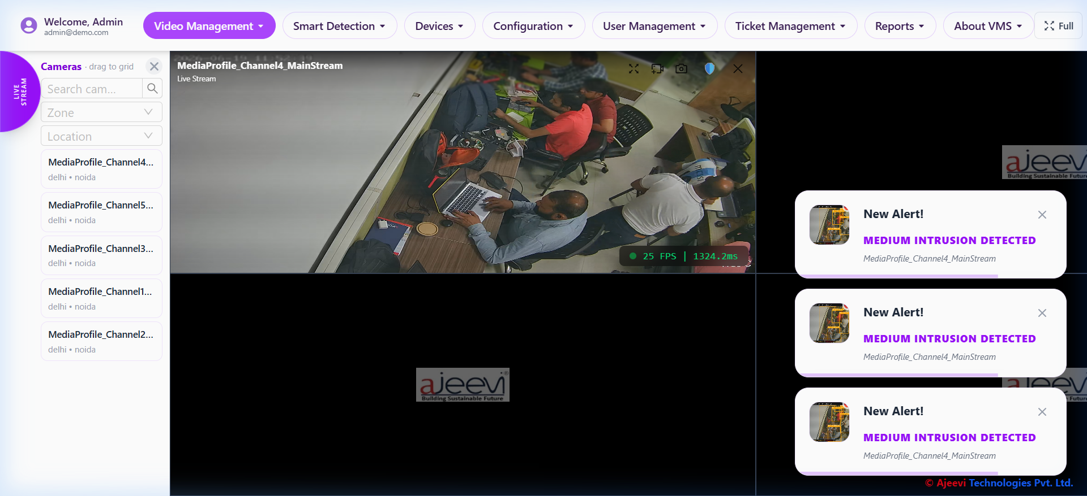
Figure 1: Live Streaming Grid Interface with Alerts
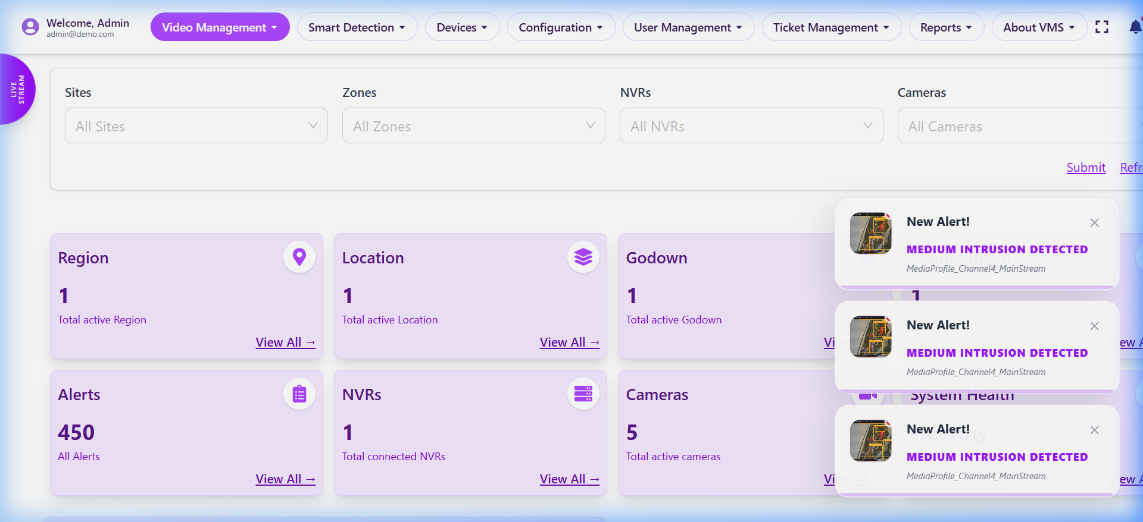
Figure 2: Main System Dashboard

5.2 Intrusion Detection with ROI Fencing
Intrusion detection is enhanced with an interactive Region of Interest (ROI) fencing tool. Security personnel can digitally draw polygonal fences over the camera feed. The backend geometrically calculates the intersection between these user-defined polygons and the bounding boxes of detected individuals. This spatial intelligence enables priority-based alerting (e.g., High, Medium, Low) depending on which zone is breached.
This feature significantly reduces the processing load, as analytics are constrained to specific regions rather than the entire frame, and practically eliminates false alarms caused by people walking in authorized areas.
This feature significantly reduces the processing load, as analytics are constrained to specific regions rather than the entire frame, and practically eliminates false alarms caused by people walking in authorized areas.
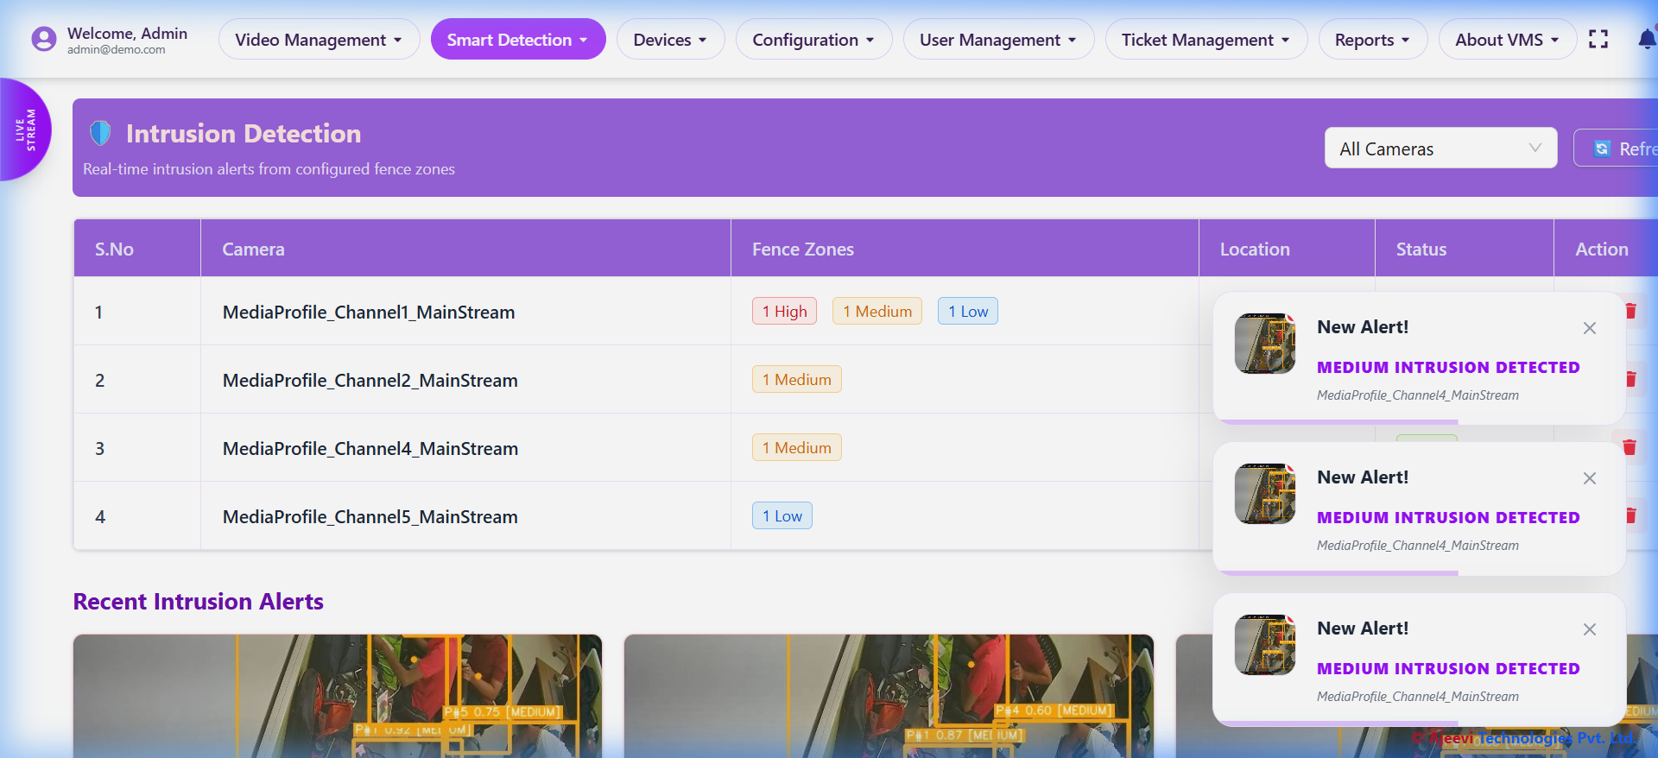
Figure 3: Intrusion Detection Dashboard
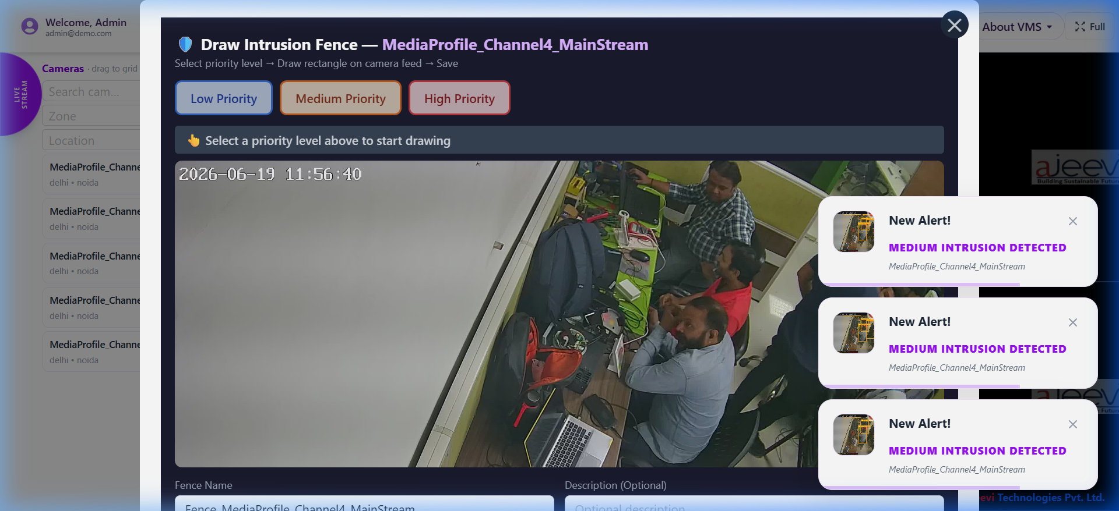
Figure 4: Interactive ROI Fence Drawing Canvas

5.3 Fire and Smoke Detection
The system utilizes a custom-trained YOLO model specialized in identifying early-stage flames and smoke plumes. By running this model continuously over the incoming frames, the VMS acts as a visual smoke detector, providing critical early warnings before traditional temperature or particle sensors are triggered.
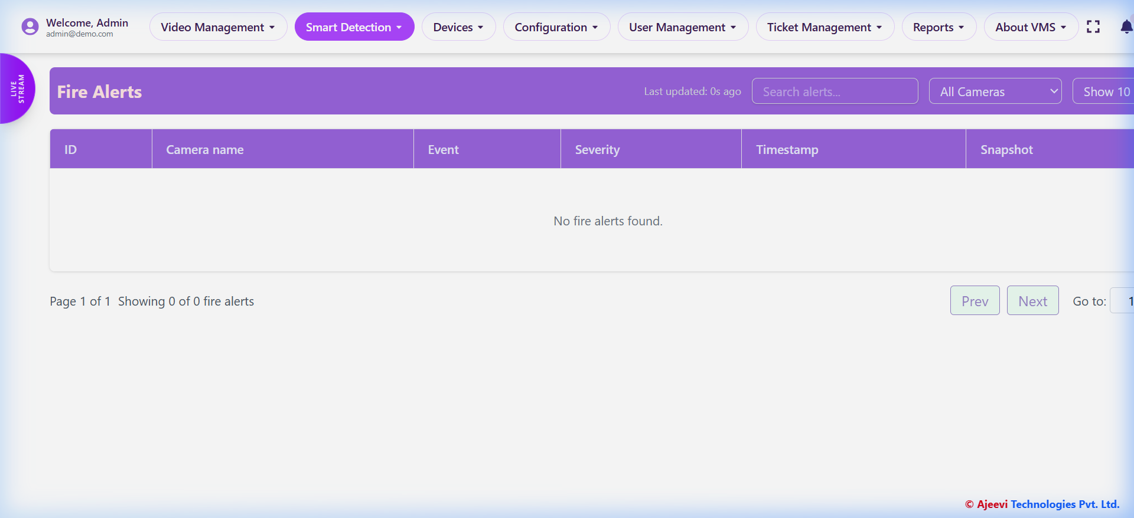
Figure 5: Fire Detection Alerts
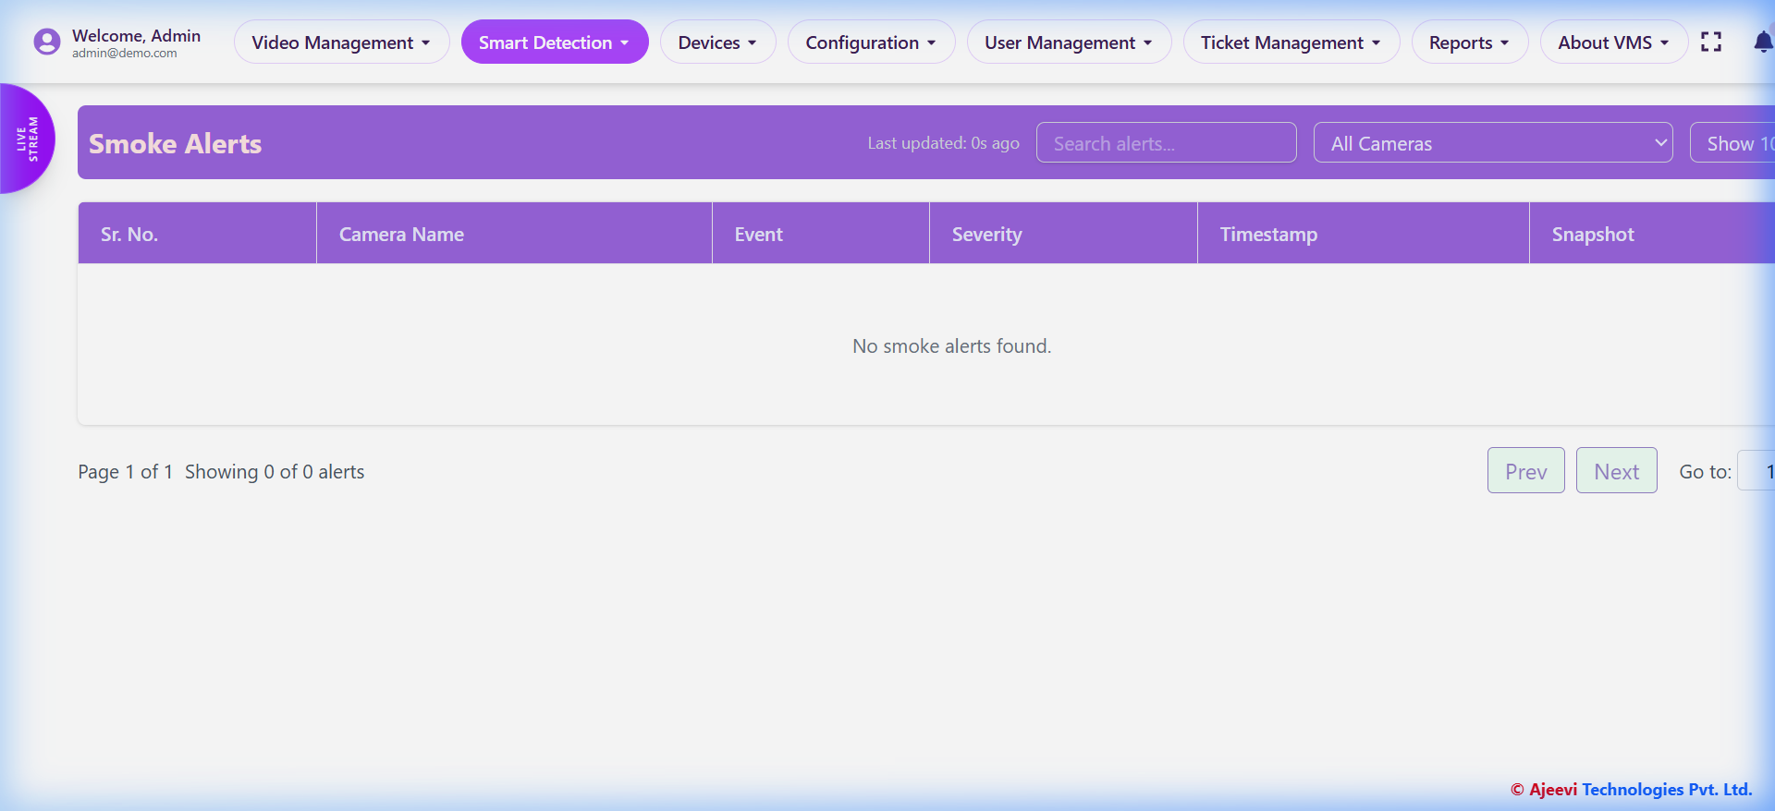
Figure 6: Smoke Detection Alerts

5.4 Crowd Density and ANPR
Crowd density estimation utilizes counting logic over person detections to alert operators of potential stampedes or unauthorized gatherings. Simultaneously, the Automatic Number Plate Recognition (ANPR) module isolates vehicle license plates and extracts the alphanumeric characters via Optical Character Recognition (OCR).
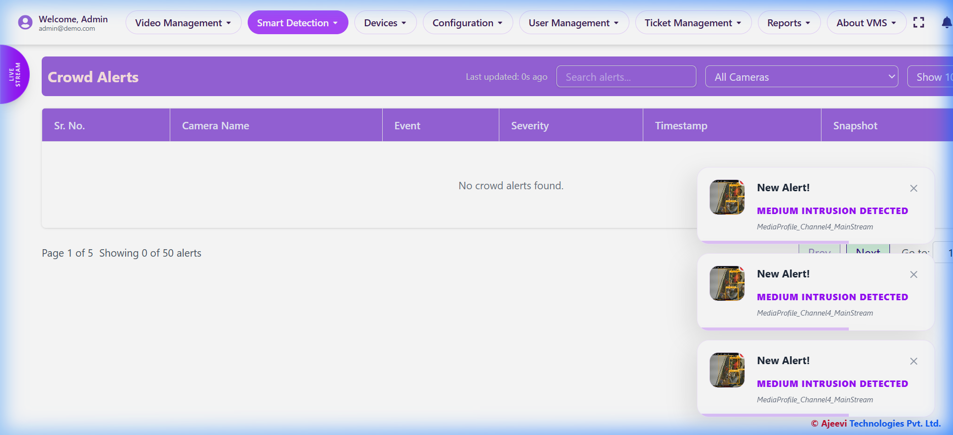
Figure 7: Crowd Density Detection
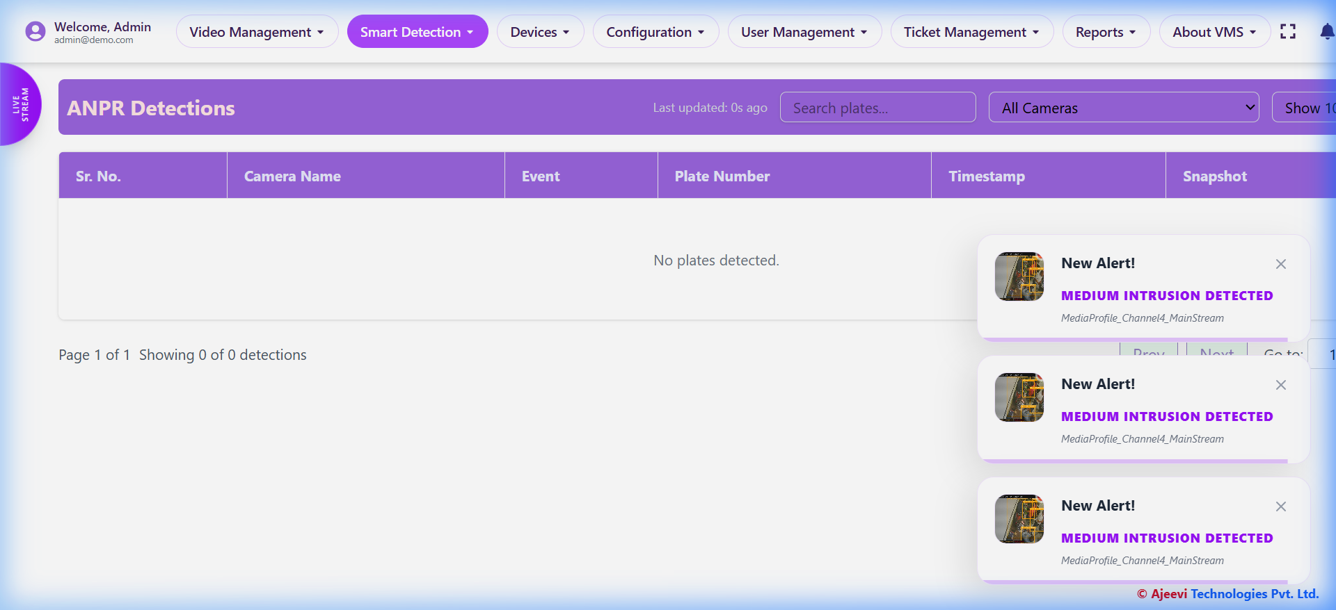
Figure 8: Automatic Number Plate Recognition (ANPR)

5.5 Sanitation: Garbage and Sweeping Detection
Leveraging smart city concepts, custom models have been trained to detect uncollected garbage accumulation in public spaces, as well as monitor the deployment and operational paths of street-sweeping trucks. This ensures municipal accountability and cleanliness.
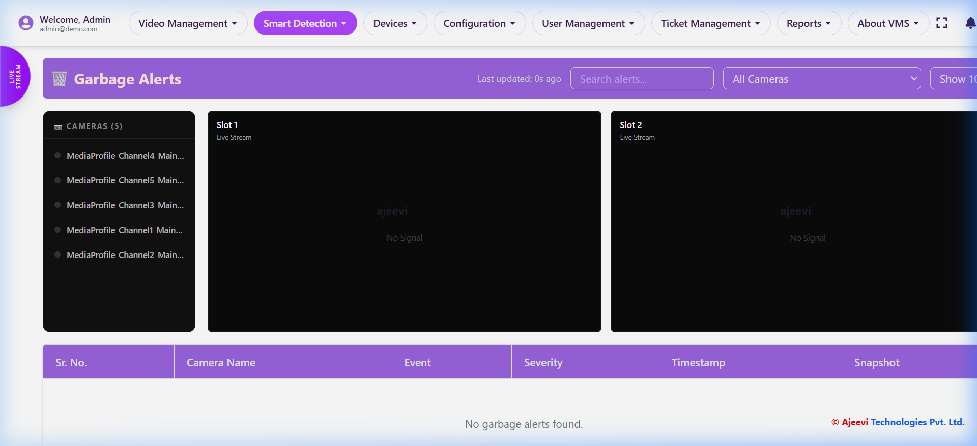
Figure 9: Garbage Accumulation Detection
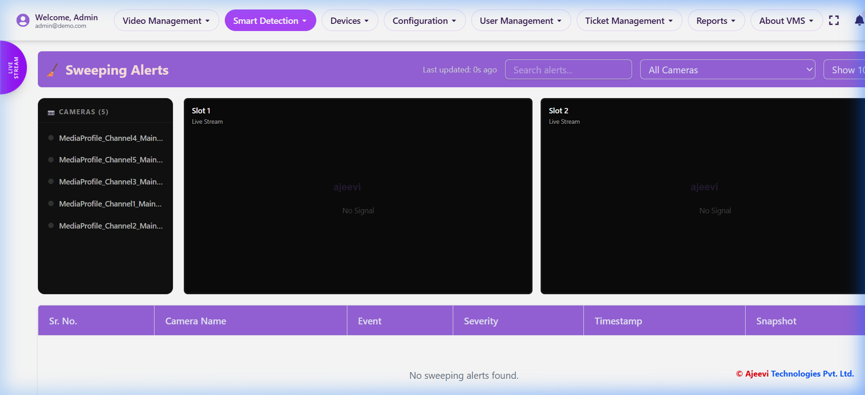
Figure 10: Sweeping Truck Monitoring

5.6 Archiving, User, and Device Management
The VMS provides a comprehensive historical archive where recordings can be filtered by camera and date range. Administrators can manage physical devices (IP Cameras, NVRs) and implement Role-Based Access Control (RBAC) to dictate which operators have viewing or administrative privileges.
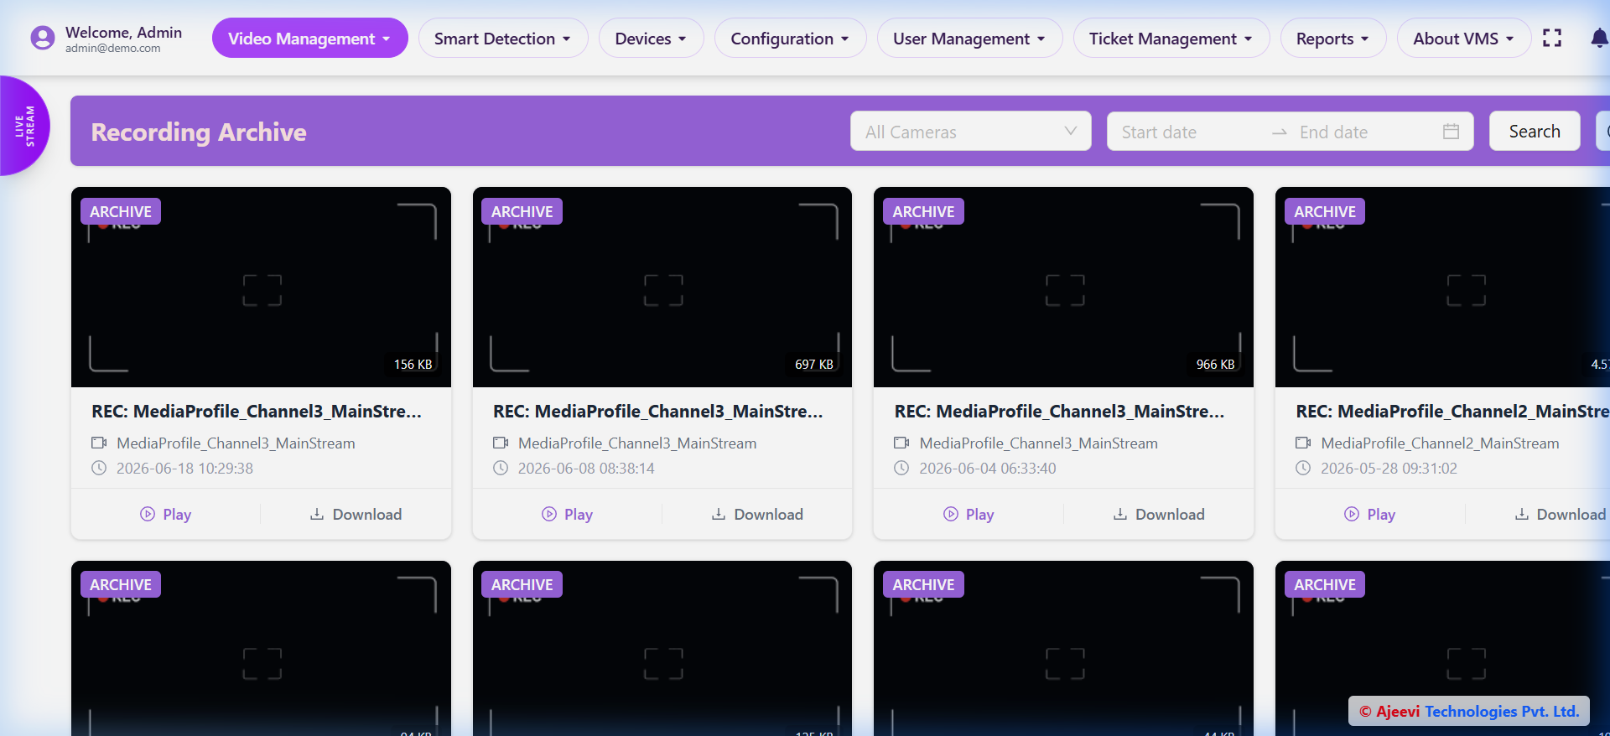
Figure 11: Recording Archive and Playback
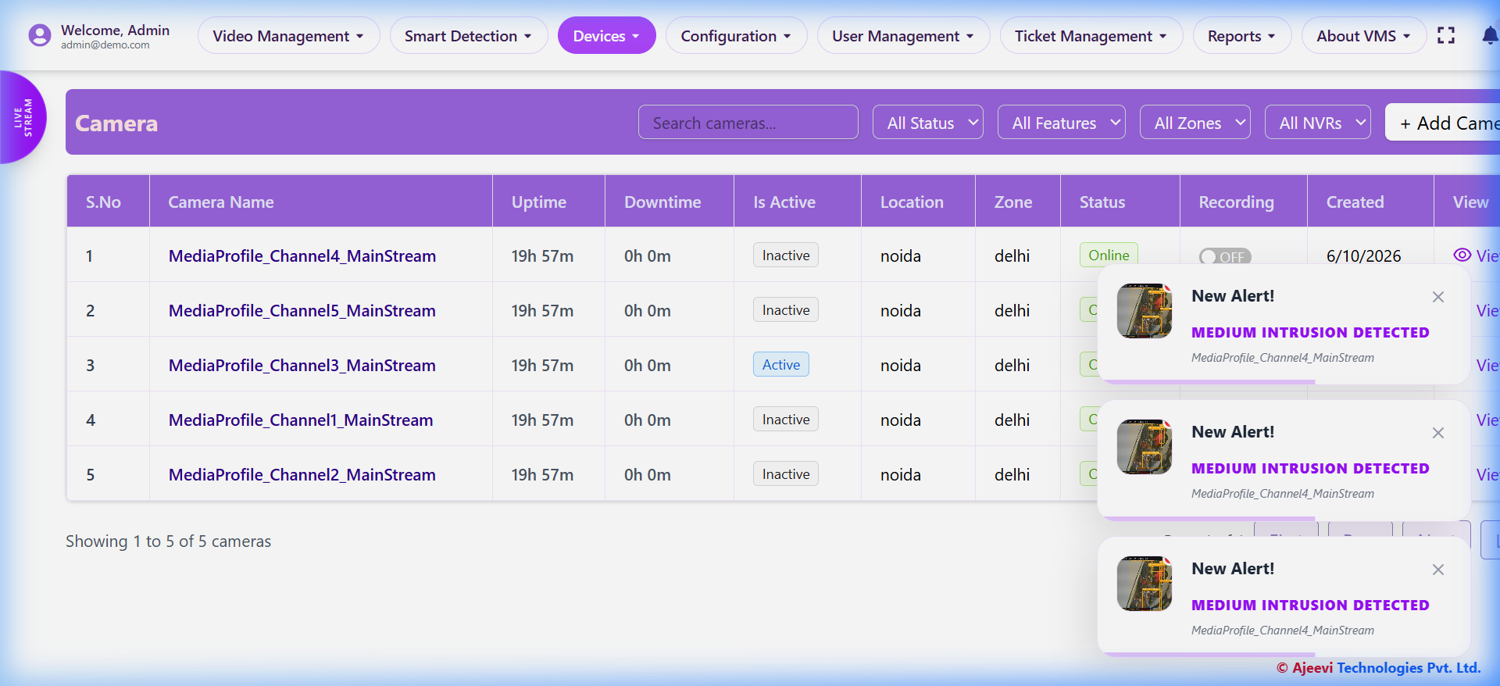
Figure 12: Camera Device Inventory
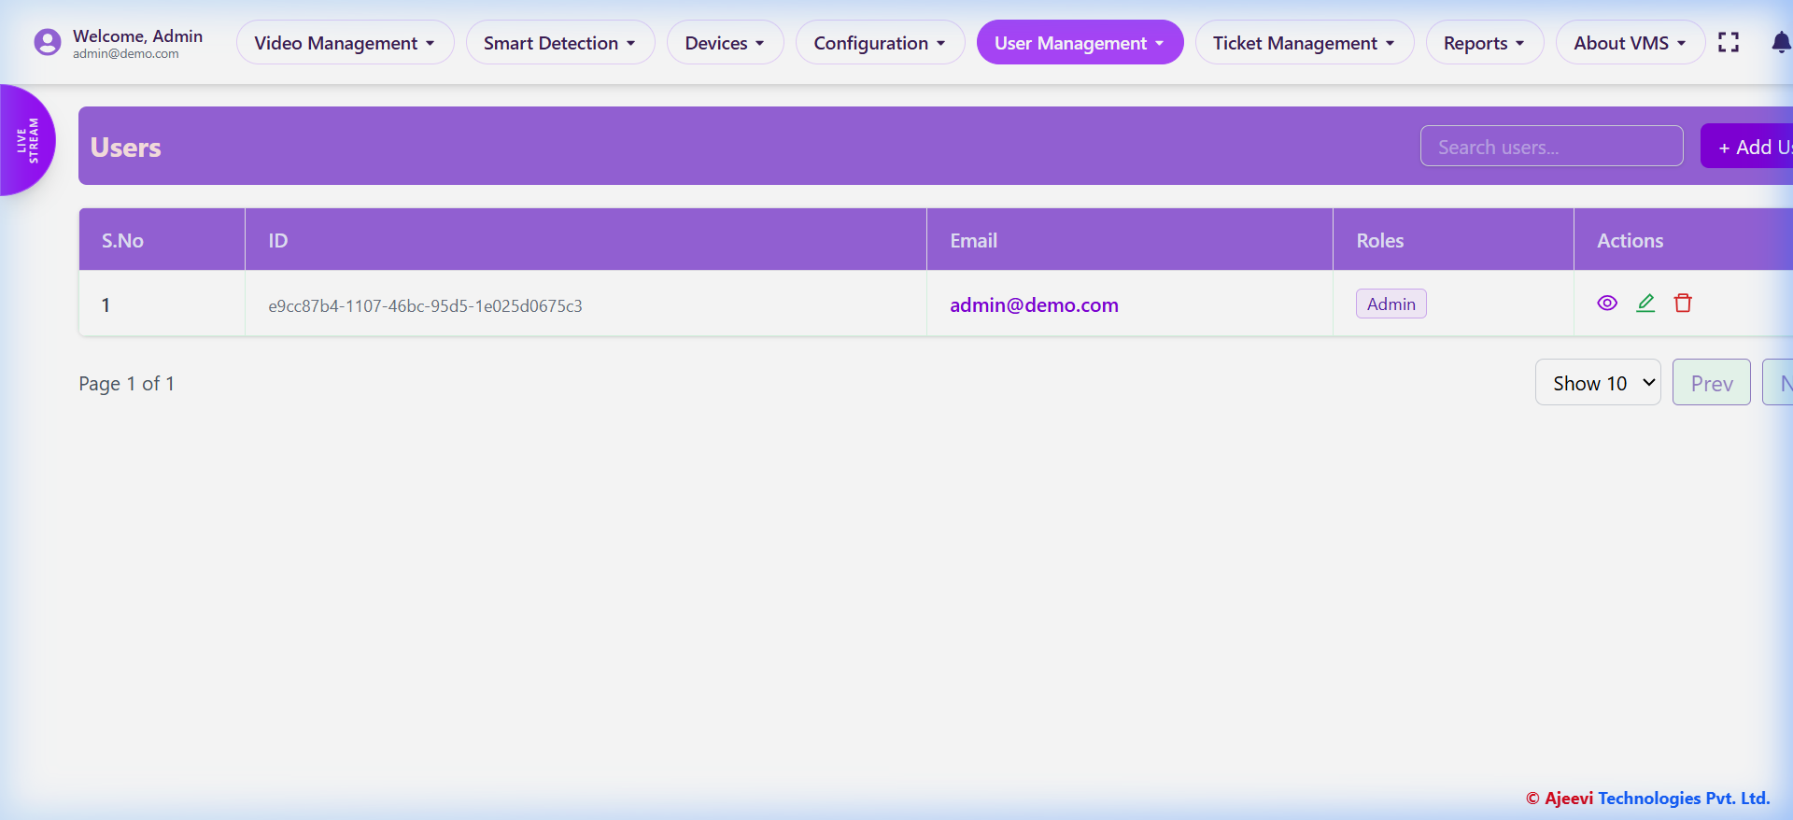
Figure 13: User and Role Management Interface

6. CONCLUSION AND FUTURE SCOPE
The implementation of the Intelligent Video Management System (VMS) marks a significant advancement over traditional, passive surveillance technologies. By integrating YOLO-based deep learning models and a robust, distributed RabbitMQ message brokering architecture, the system achieves real-time, highly accurate detection of critical events including intrusion, fire, smoke, and municipal irregularities.
The development of custom spatial logic, specifically the interactive Region of Interest (ROI) fencing, demonstrates how intuitive UI design (React/Electron) combined with backend computer vision can drastically reduce false positives and improve operator efficiency. The separation of streaming, framing, and inference into distinct microservices ensures that the system can scale horizontally, handling numerous high-definition RTSP streams without compromising performance.
Future scope for this project involves the integration of Large Vision-Language Models (LVLMs) to allow operators to perform natural language semantic searches across recorded video archives. Additionally, deploying the inference models using edge accelerators like TensorRT or OpenVINO will further minimize latency and reduce reliance on centralized GPU clusters, pushing the intelligence closer to the edge.
The implementation of the Intelligent Video Management System (VMS) marks a significant advancement over traditional, passive surveillance technologies. By integrating YOLO-based deep learning models and a robust, distributed RabbitMQ message brokering architecture, the system achieves real-time, highly accurate detection of critical events including intrusion, fire, smoke, and municipal irregularities.
The development of custom spatial logic, specifically the interactive Region of Interest (ROI) fencing, demonstrates how intuitive UI design (React/Electron) combined with backend computer vision can drastically reduce false positives and improve operator efficiency. The separation of streaming, framing, and inference into distinct microservices ensures that the system can scale horizontally, handling numerous high-definition RTSP streams without compromising performance.
Future scope for this project involves the integration of Large Vision-Language Models (LVLMs) to allow operators to perform natural language semantic searches across recorded video archives. Additionally, deploying the inference models using edge accelerators like TensorRT or OpenVINO will further minimize latency and reduce reliance on centralized GPU clusters, pushing the intelligence closer to the edge.
The implementation of the Intelligent Video Management System (VMS) marks a significant advancement over traditional, passive surveillance technologies. By integrating YOLO-based deep learning models and a robust, distributed RabbitMQ message brokering architecture, the system achieves real-time, highly accurate detection of critical events including intrusion, fire, smoke, and municipal irregularities.
The development of custom spatial logic, specifically the interactive Region of Interest (ROI) fencing, demonstrates how intuitive UI design (React/Electron) combined with backend computer vision can drastically reduce false positives and improve operator efficiency. The separation of streaming, framing, and inference into distinct microservices ensures that the system can scale horizontally, handling numerous high-definition RTSP streams without compromising performance.
Future scope for this project involves the integration of Large Vision-Language Models (LVLMs) to allow operators to perform natural language semantic searches across recorded video archives. Additionally, deploying the inference models using edge accelerators like TensorRT or OpenVINO will further minimize latency and reduce reliance on centralized GPU clusters, pushing the intelligence closer to the edge.
The implementation of the Intelligent Video Management System (VMS) marks a significant advancement over traditional, passive surveillance technologies. By integrating YOLO-based deep learning models and a robust, distributed RabbitMQ message brokering architecture, the system achieves real-time, highly accurate detection of critical events including intrusion, fire, smoke, and municipal irregularities.
The development of custom spatial logic, specifically the interactive Region of Interest (ROI) fencing, demonstrates how intuitive UI design (React/Electron) combined with backend computer vision can drastically reduce false positives and improve operator efficiency. The separation of streaming, framing, and inference into distinct microservices ensures that the system can scale horizontally, handling numerous high-definition RTSP streams without compromising performance.
Future scope for this project involves the integration of Large Vision-Language Models (LVLMs) to allow operators to perform natural language semantic searches across recorded video archives. Additionally, deploying the inference models using edge accelerators like TensorRT or OpenVINO will further minimize latency and reduce reliance on centralized GPU clusters, pushing the intelligence closer to the edge.

