MAJOR PROJECT REPORT
ON
INTELLIGENT VIDEO MANAGEMENT SYSTEM (VMS) WITH REAL-TIME AI ANALYTICS
Submitted in partial fulfillment of the requirements for the degree of
Bachelor of Technology
Submitted By:
Vidushi Singh
Roll No: 229303362

ABSTRACT
The Intelligent Video Management System (VMS) is a comprehensive, scalable, and robust platform designed to manage live camera streams, record video feeds, and perform advanced AI-driven video analytics. The system integrates real-time video streaming capabilities via RTSP and WebRTC, a robust recording and archiving module, and a sophisticated AI analytics engine powered by YOLOv8/YOLOv12 deep learning models.
The core features of the VMS include multi-channel live streaming with dynamic grid layouts, reliable video recording, and a distributed analytics pipeline using RabbitMQ for load balancing. The AI analytics engine supports multiple detection scenarios, including Intrusion Detection (with user-defined region-of-interest fences), Fire and Smoke Detection, Crowd Density Estimation, Automatic Number Plate Recognition (ANPR), Garbage Detection, Truck Sweeper Monitoring, and Rodent Detection. The frontend is built using React.js and wrapped in Electron for desktop deployment, while the backend leverages FastAPI and Flask to serve streams, manage devices, and process computer vision tasks.

1. INTRODUCTION

1.1 Project Overview
Traditional Video Management Systems (VMS) primarily focus on recording and playback, leaving the crucial task of threat detection and monitoring to human operators. This manual approach is highly prone to errors, fatigue, and latency in response times. The proposed Intelligent VMS addresses these limitations by embedding real-time Artificial Intelligence (AI) and Computer Vision algorithms directly into the video processing pipeline.

1.2 Objectives
1. To develop a robust VMS capable of handling multiple RTSP camera streams seamlessly.
2. To implement a scalable backend architecture using message queues (RabbitMQ) for asynchronous frame processing.
3. To integrate state-of-the-art YOLO-based deep learning models for detecting fire, smoke, intrusion, crowd anomalies, and other critical events.
4. To provide an intuitive, responsive user interface (built with React and Electron) for operators to monitor live feeds, view alerts, and manage device configurations.

2. SYSTEM ARCHITECTURE AND TECHNOLOGY STACK

2.1 High-Level Architecture
The system follows a distributed microservices architecture to ensure high availability and low latency:
• Frontend / Client: Built using React.js, Vite, and packaged as a desktop application using Electron. It communicates with the backend via REST APIs and handles video playback using mpegts.js and WebRTC.
• Streaming & Recording Servers: Manages RTSP streams using go2rtc/MediaMTX and provides HLS/WebRTC feeds to the frontend. A dedicated recording service archives the streams into chunked storage.
• Analytics Framer Pipeline (vms_framer.py): Captures frames from RTSP streams at dynamic intervals (e.g., 3 fps for live, higher for file uploads) and publishes them to a RabbitMQ queue. It implements scene change detection to force-send critical frames.
• AI Analytics Engine (consumer.py): Consumes frames from RabbitMQ and runs inference using Ultralytics YOLO models. It utilizes multi-threading and GPU acceleration (if available) to detect objects and anomalies.
• Alert & Storage Module (write_analytics.py): Processes the detection results, saves annotated frames to disk, and pushes alert metadata to the central database/API.

2.2 Technology Stack
• Frontend: React.js, Tailwind CSS, Ant Design, Electron, Dnd-kit (for draggable grids), Leaflet (for maps).
• Backend API: FastAPI, Flask, Python 3.
• Video Streaming: WebRTC, HLS, go2rtc, FFmpeg, OpenCV.
• AI & Computer Vision: PyTorch, Ultralytics YOLOv8/YOLOv12.
• Message Broker: RabbitMQ.

3. IMPLEMENTATION DETAILS

3.1 Core Feature: Live Streaming and Recording
The live streaming module is the core of the VMS. It features a customizable dynamic grid where users can drag and drop camera feeds. The system handles reconnections gracefully and provides ultra-low latency playback.
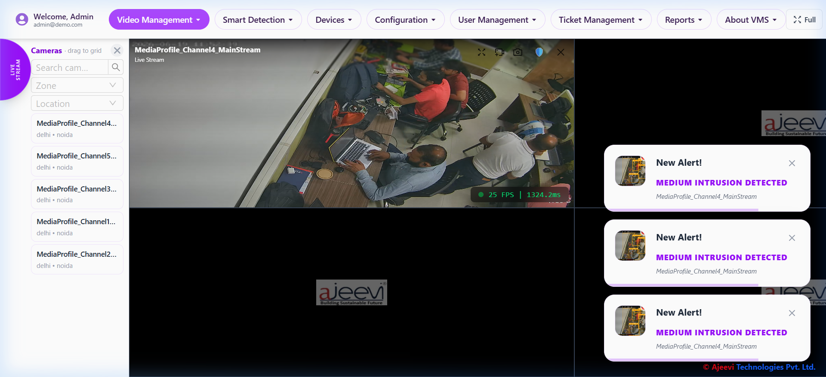
Figure 1: Live Streaming Grid Interface with Alerts
The recording archive allows users to retrieve and playback historical footage based on camera ID and date ranges. It uses an embedded video player capable of handling native TS (MPEG Transport Stream) files seamlessly via mpegts.js.
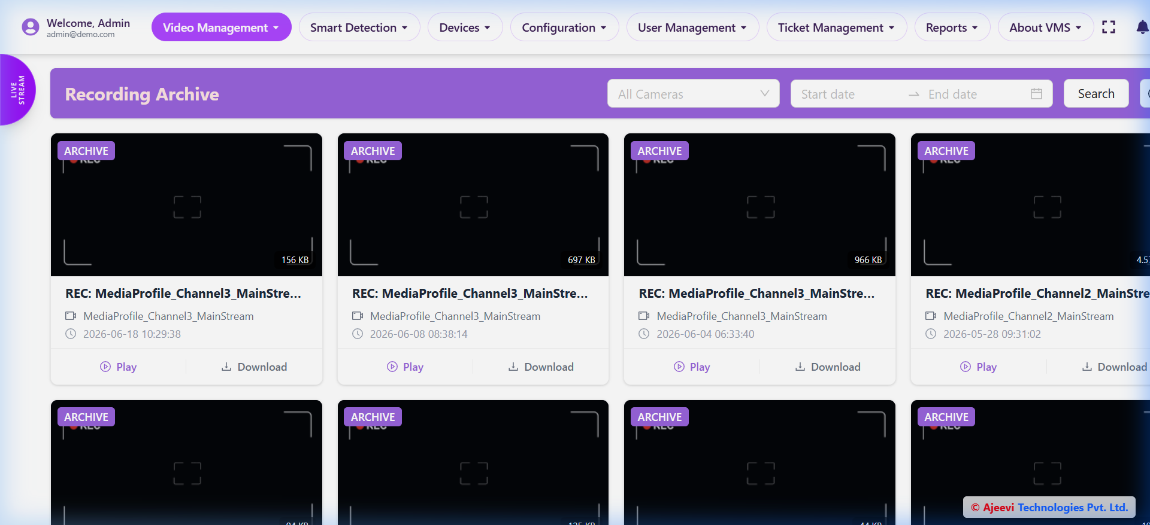
Figure 2: Recording Archive and Playback Interface

3.2 AI Video Analytics Pipeline
The analytics pipeline is decoupled from the streaming server to prevent bottlenecks. The pipeline executes the following sequence:
1. Frame Extraction: vms_framer.py pulls frames from configured cameras.
2. Queueing: Frames are serialized and sent to RabbitMQ (queue: 'all_frames_1').
3. Dynamic Routing: consumer.py inspects the requested analytical tasks for the frame (e.g., 'fire', 'intrusion') and routes the frame to the corresponding YOLO models loaded in memory.
4. Inference: The models run object detection. Person/Fire exclusion logic is applied to prevent false positives.
5. Alert Generation: Annotated frames are published to 'video_analytics_1' queue, which are then saved by write_analytics.py and pushed to the alert database.

4. SMART DETECTION MODULES

4.1 Intrusion Detection with ROI Fencing
The Intrusion Detection module monitors specific areas for unauthorized access. A standout feature of this VMS is the interactive 'Fence Drawer'. Users can define multiple polygonal Regions of Interest (ROI) directly on the camera feed. The backend evaluates bounding boxes against these polygons to trigger Low, Medium, or High priority intrusion alerts.
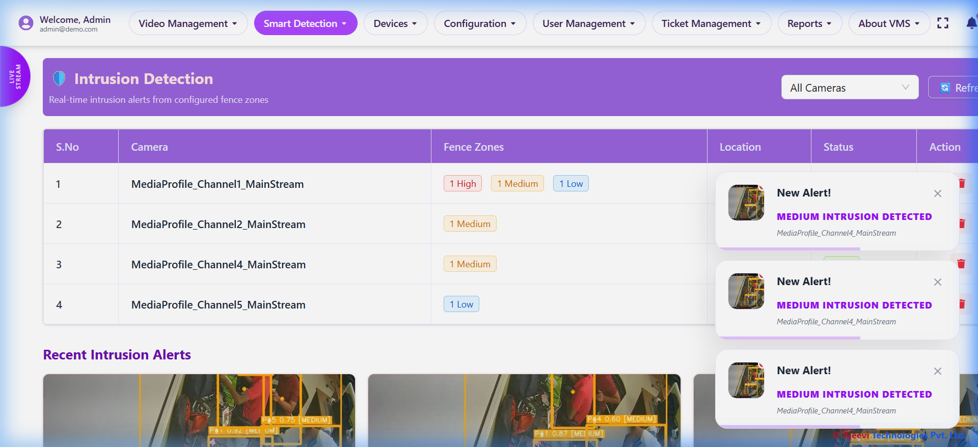
Figure 3: Intrusion Detection Dashboard
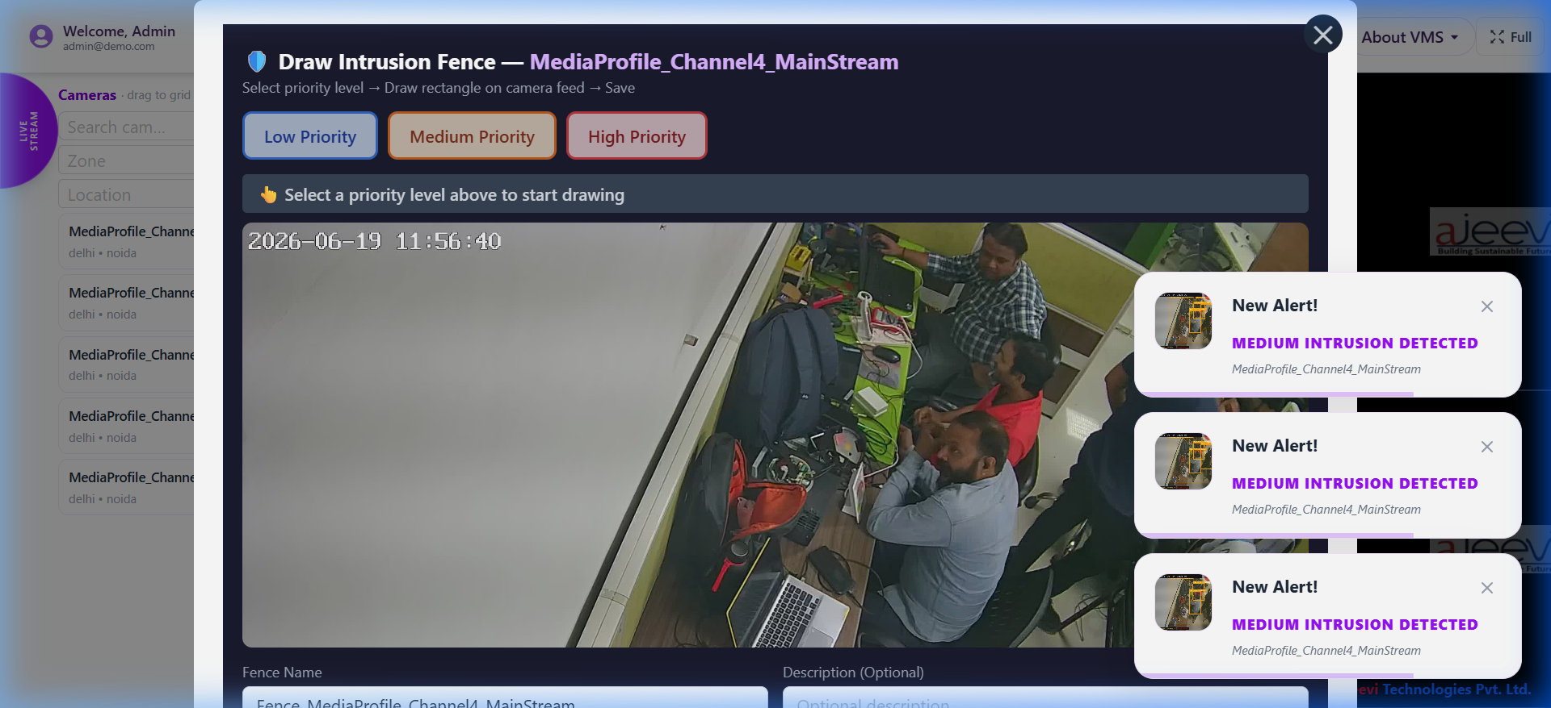
Figure 4: Interactive ROI Fence Drawing Canvas

4.2 Fire and Smoke Detection
Crucial for early disaster prevention, this module uses a custom-trained YOLO model (nikhil_firesmokeother_best.pt) to identify early signs of fire and smoke.
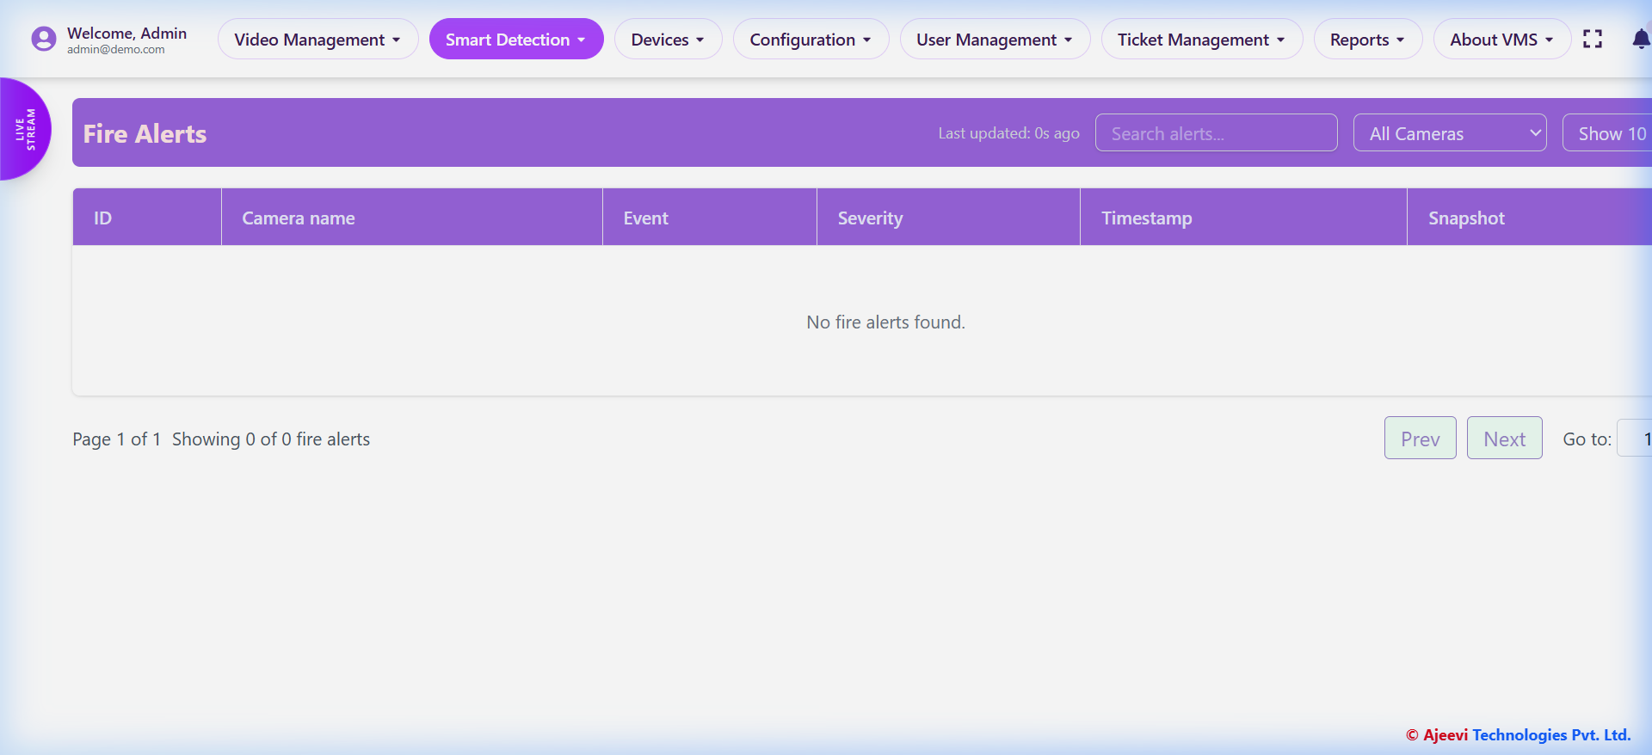
Figure 5: Fire Detection Alerts
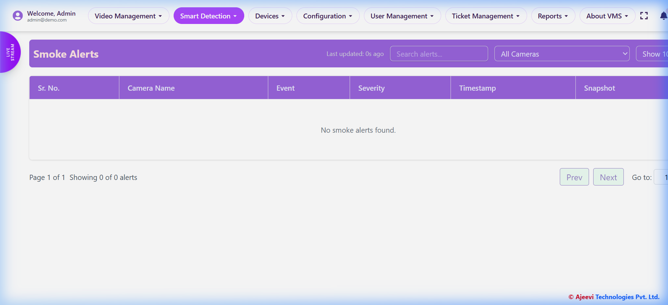
Figure 6: Smoke Detection Alerts

4.3 Crowd and ANPR Detection
The crowd detection model estimates density to prevent stampedes or monitor occupancy. The ANPR (Automatic Number Plate Recognition) module captures license plates of vehicles passing through checkpoints.
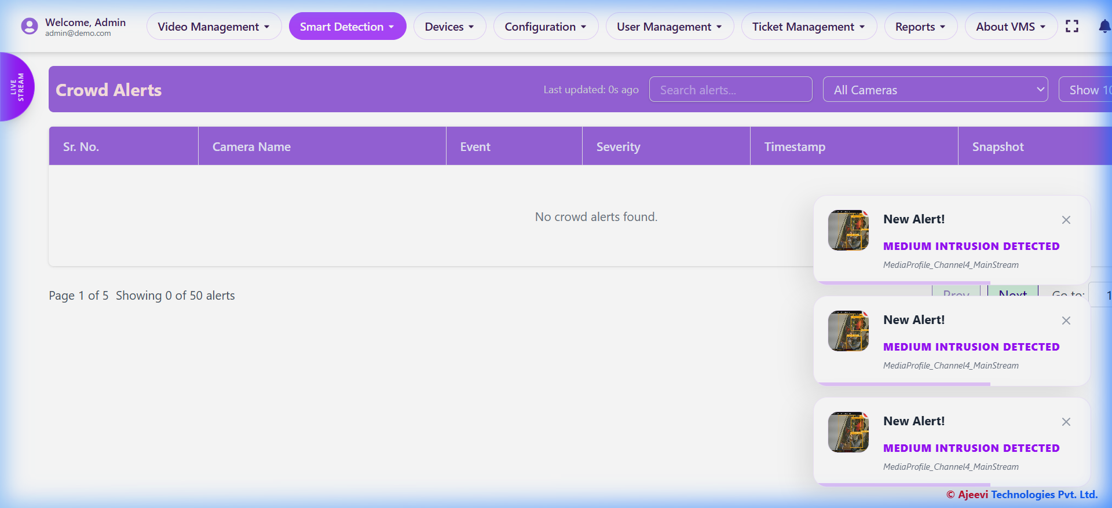
Figure 7: Crowd Density Detection
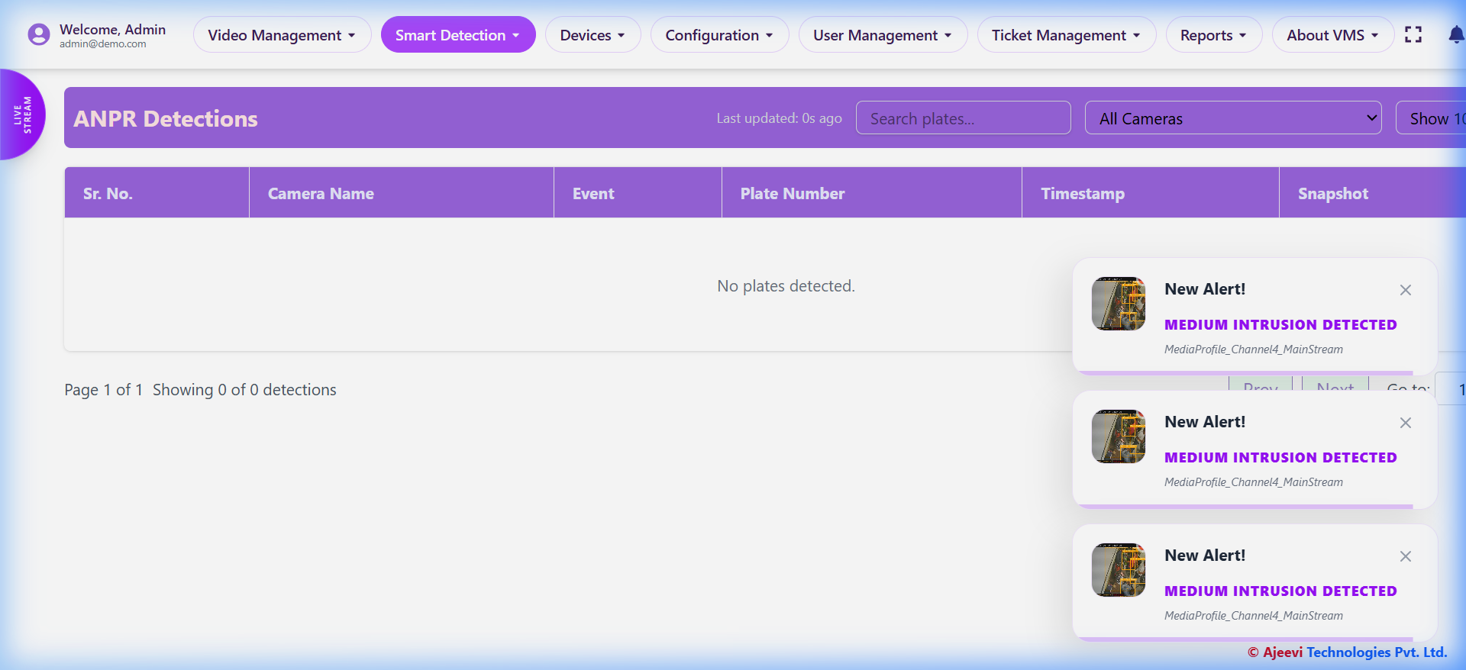
Figure 8: Automatic Number Plate Recognition (ANPR)

4.4 Sanitation and Municipal Detection
Designed for smart city applications, these modules detect uncollected garbage and monitor the deployment of street-sweeping trucks.
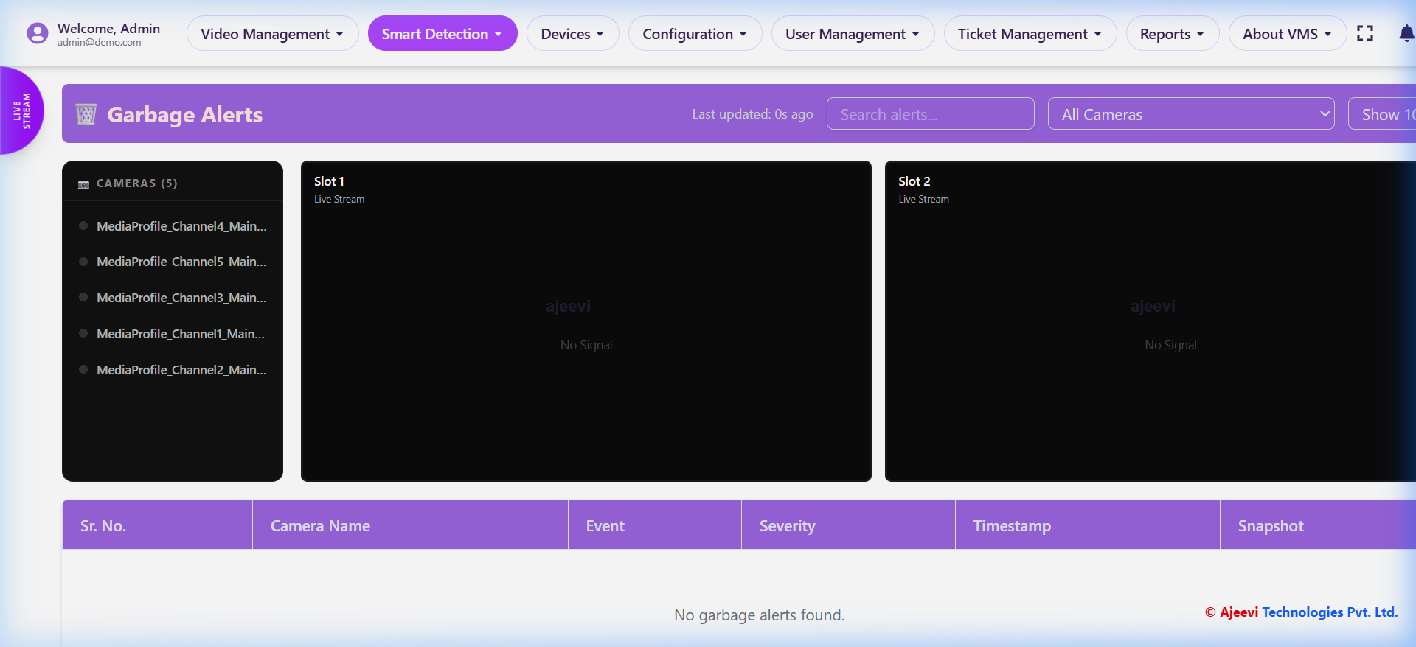
Figure 9: Garbage Accumulation Detection
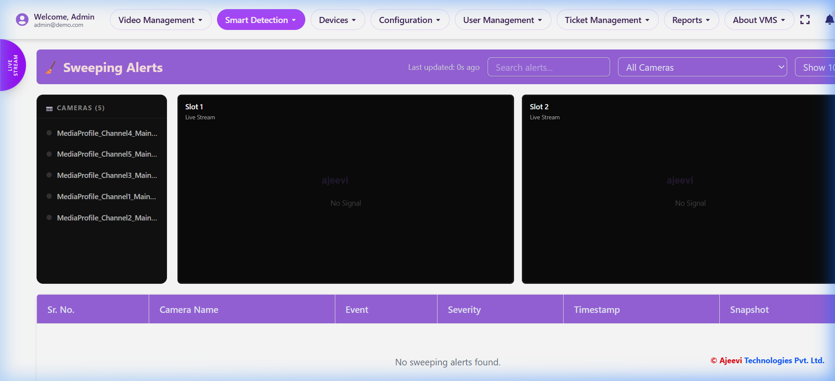
Figure 10: Sweeping Truck Monitoring

5. SYSTEM MANAGEMENT AND DASHBOARD
The VMS includes comprehensive administrative tools to manage the ecosystem.

5.1 Central Dashboard
The central dashboard provides a high-level overview of active sites, NVRs, connected cameras, and overall system health.
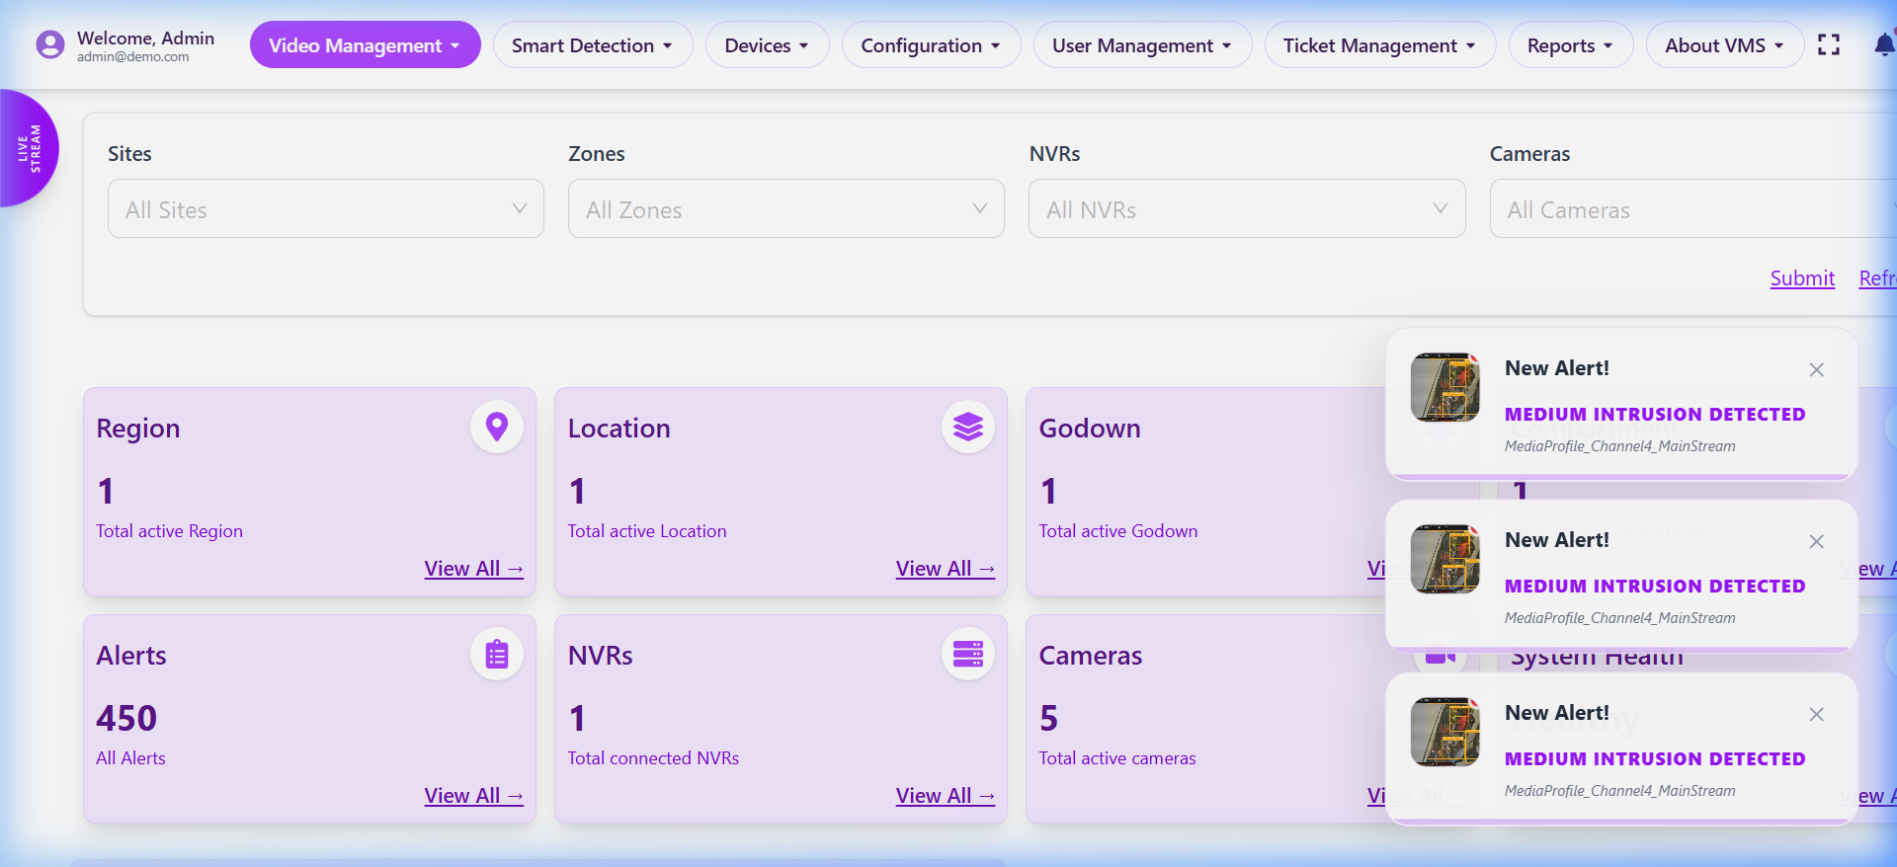
Figure 11: Main System Dashboard

5.2 Device and User Management
The platform allows administrators to add, configure, and monitor IP cameras (supporting ONVIF). The User Management module employs Role-Based Access Control (RBAC) to ensure secure operations.
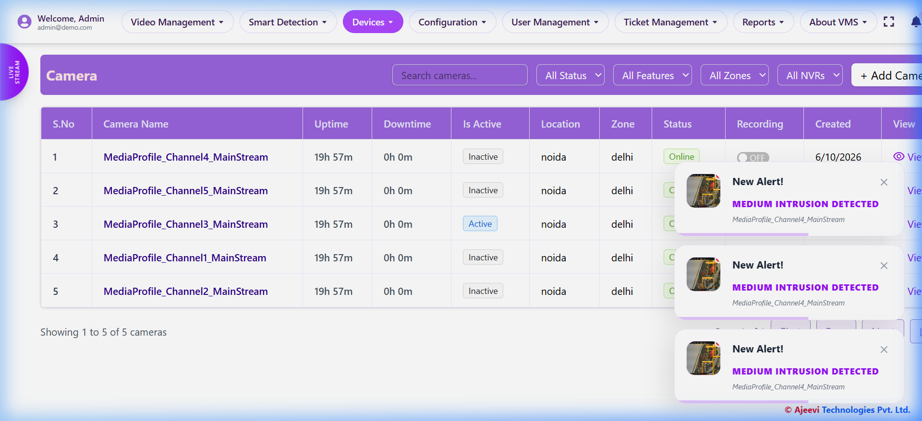
Figure 12: Camera Device Inventory
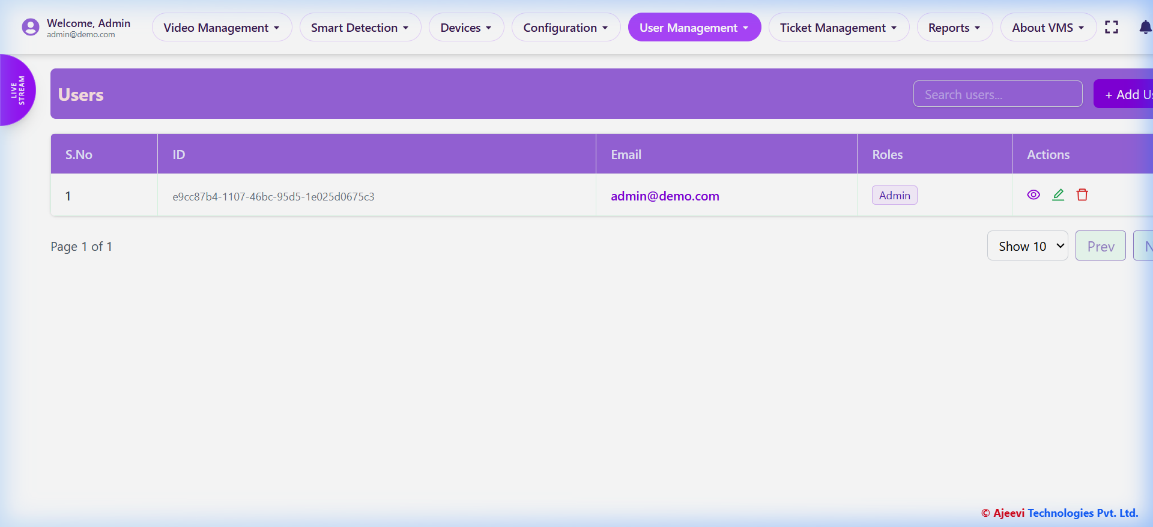
Figure 13: User and Role Management Interface

6. CONCLUSION AND FUTURE SCOPE
The Intelligent Video Management System successfully bridges the gap between traditional passive surveillance and proactive, AI-driven monitoring. By combining a modern, responsive user interface (Electron/React) with a highly scalable analytics backend (RabbitMQ/YOLO/FastAPI), the system delivers real-time situational awareness. The integration of the interactive ROI fence drawing directly links the user's intent with the backend spatial analytics, significantly reducing false positives in intrusion detection.
Future scope includes integrating Large Vision-Language Models (LVLMs) for natural language querying of video archives (e.g., 'Find the red car that passed at 3 PM'), and further optimizing the inference pipeline using edge accelerators like TensorRT and OpenVINO.

