# **Client and Topic**

For this assignment, I would like to create a personal website that is a portfolio showcasing my abilities in various areas, namely 3D modeling, web design, and perhaps programming. I have various 3D models showcased on my personal ArtStation.com page, but I would like to have a self-hosted space to share all my work.

# Development Process and Engagement

I’m making this website for myself for career development. It’s meant to show my abilities to potential employers. It could be useful for networking; perhaps people might discover the website and then reach out to me for opportunities. Or, it could be useful in submitting job applications, because I could share this website alongside my resume. To do this well, I will research articles on building portfolio websites and look at examples of successful ones.

# Testing

To make sure this website functions properly, several tests will be performed on various browsers and devices. First, each link on each web page will be tested to ensure proper functionality. Then, each web page will be viewed on a PC in the three most common browsers: Chrome, Firefox, and Edge, to make sure there are no browser-specific display issues. Finally, each web page will be viewed on a mobile device to make sure the mobile layout works properly.

# Description

As this website is designed for self-promotion, the “business” is my skill set offered for employment. The website’s purpose in this will be to show these skills and make it available for potential employers to see. The target audience, then, are people working in the technical industries where my 3D modeling, web design, and computer programming abilities can be marketed. Specific ones that come to mind are software development, website development, game design, and graphic design. The content on this website needs to be best suited to stand out to people working in these industries.

Most, if not all, of the content on the website will be created by me, since it is meant to show and promote my abilities to create content. The main focus of the website will of course be works in the portfolio, all of which will of course be original and fully mine. I don’t expect there to be any content from other sources, unless I perhaps find helpful tutorials and examples of code to improve my website layout. As for frequency of content, there will not be a set schedule of updates, but I hope to update it over time as I gain experience and have more works to share in my portfolio.

# Growth and Maintenance

I expect the design/layout of the website to remain mostly static, though that may change depending on trends and my evolving preferences. One way I do expect the website to continue to grow, though, is by adding content to the portfolio over time. I need to make sure I design the main page to easily add more works to display, and I should have a simple template for each work itself. It may be useful to find ways to minimize duplicate code, such as using iframes to embed content in pages rather than displaying them on their own pages.

# Organization

The website needs several overhead pages, and then each portfolio work to showcase will be a sub-page. The main/home page of the website will have a small amount of information and mostly emphasize navigation. The about page will have a small biography for myself and perhaps some highlights from my resume of relevant experience. The contact page will provide information for people to reach out to me, including my email address and LinkedIn profile page. Finally, the portfolio page will serve as the overview of the entire portfolio, with a gallery of images of each work that link to full subpages for each individual one.

## Website diagram:

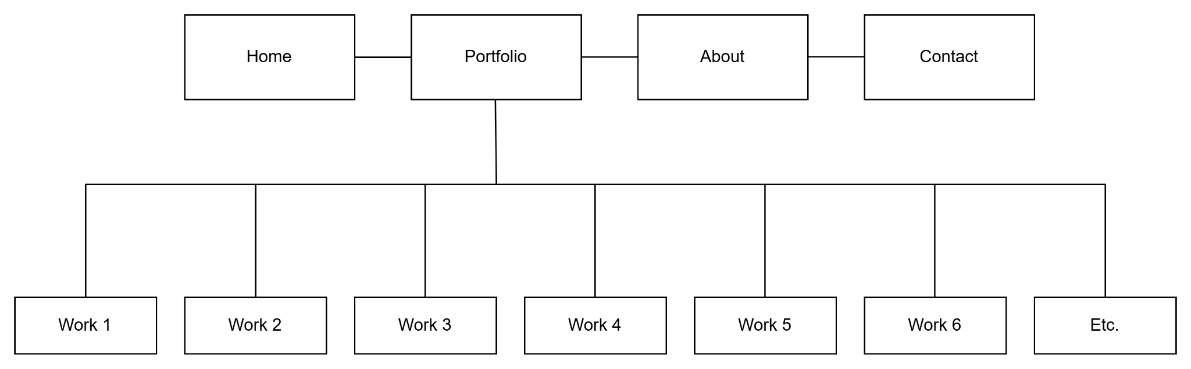

## Wireframe - Home Page

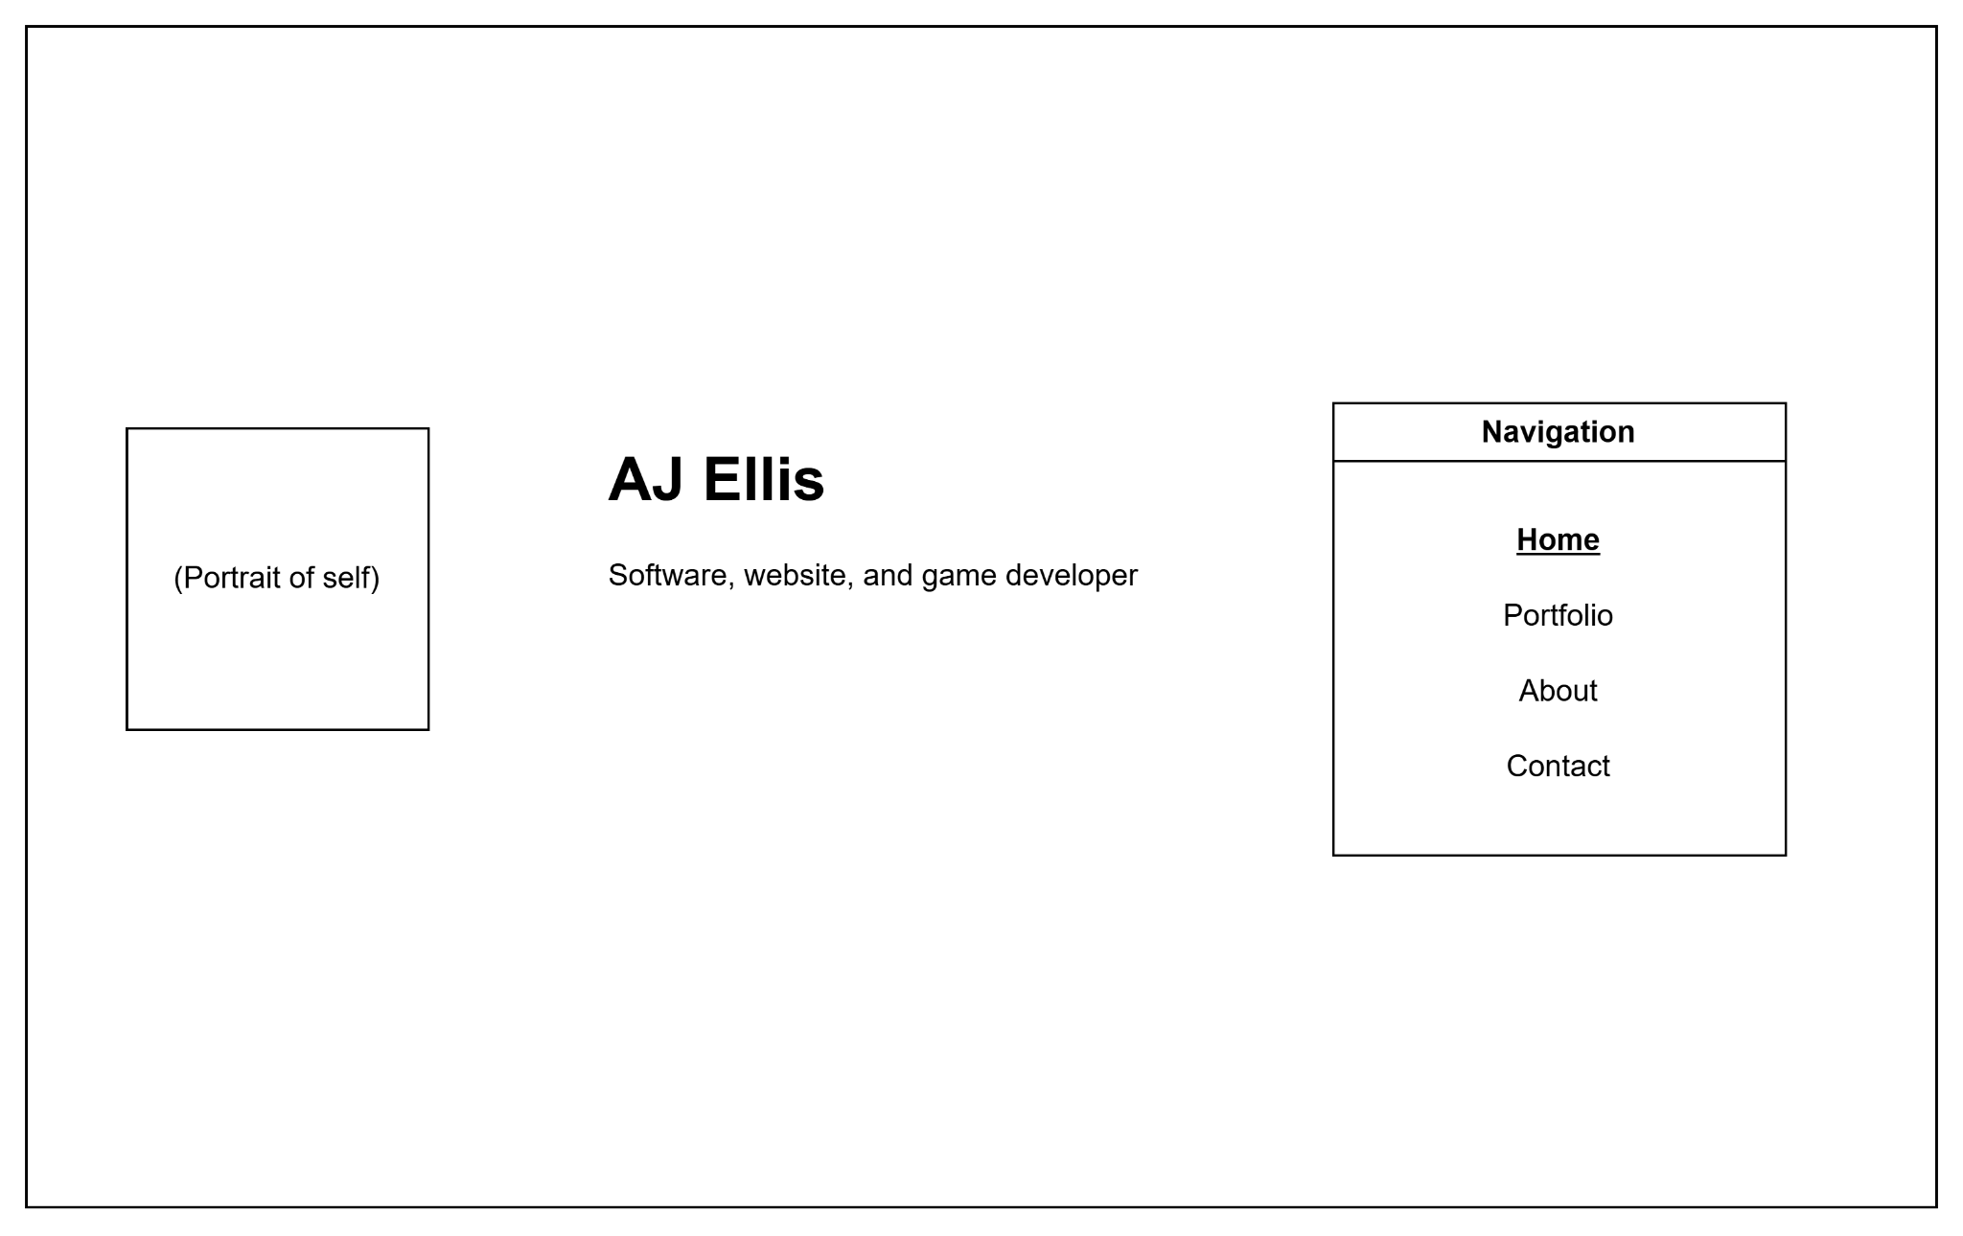

## Wireframe - Portfolio Page

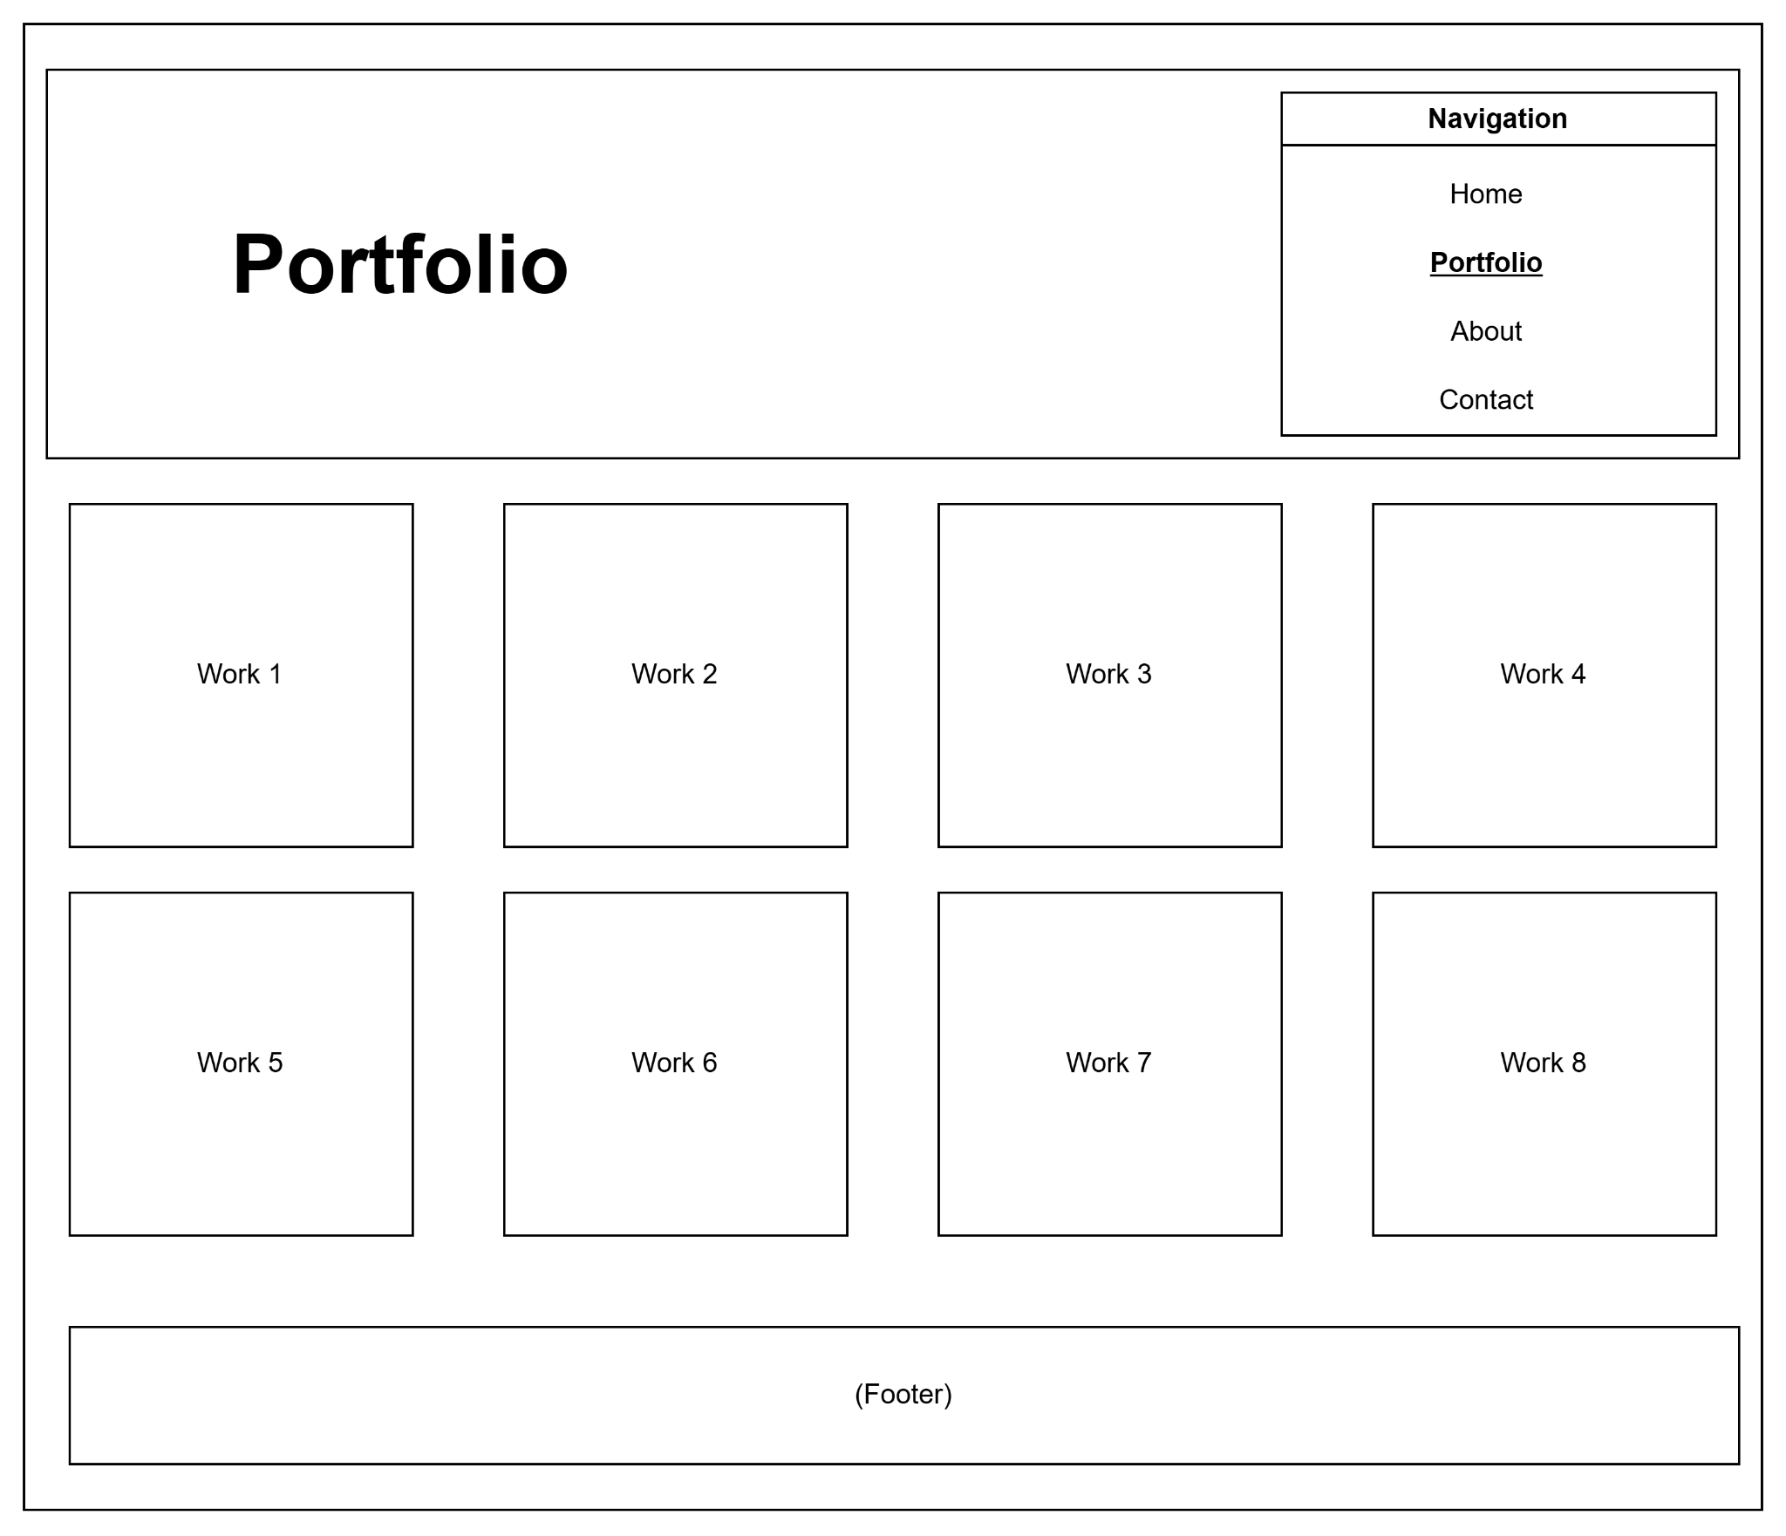

# Security

Thankfully, the website will not have any sort of e-commerce or user registration components, which lessens potential security risks. However, all information will be publicly available without password protection, which does pose some possible vulnerabilities. Perhaps it would be helpful to implement a CAPTCHA (or, preferably, CloudFlare Turnstile) on the contact page before giving users my information. Also, CloudFlare provides tools to safeguard websites against DDoS attacks, so that may be worth implementing as well. Finally, SSL certification is a must to ensure security and encourage visitors by assuring the safety of the site.

# Web Hosting

When considering what hosting service to use, I will go with the one that is cost-effective, secure, and useful for my specific needs. This website will be rather light, with each page coded myself, so I won’t need to worry about paying extra for WordPress hosting or any other CMS services. I will want to select a host that will reliably secure my website as well with SSL and other features mentioned above.

I expect to code the website entirely using HTML and CSS, but that may change as I gain experience. Perhaps I may decide to use JavaScript in the future to display certain features like portfolio works; for now that seems unnecessary, but it would be nice to have a web host that supports this.

For the domain: as I expected, “ajellis.com” is unavailable, but “ajellis.net” is. Another available domain I like is “ajellisportfolio.com”, and I think that would be my preferred choice.

# Marketing

The website will be marketed mostly by including in resumes and my LinkedIn profile. However, it would also be beneficial to utilize SEO in my website to potentially attract people who may be looking for my services. Some ways I could do this are by including relevant keywords and titles in the pages of my portfolio, especially for each individual work.

# Project Reflection

1. I used Draw.io to complete the wireframes and website diagram. This was very straightforward and easy for me to use, especially because I have used it before.
2. Building the website diagram was simple, but it made me think about which pages were top-level versus subpages. I had to make sure it was clear that each portfolio work page would be linked to from the portfolio page.
3. I used Draw.io because I am familiar with it and because I knew it had the capabilities to meet my needs for this assignment. It makes sense that it was listed for this assignment, but I would have used it regardless.
4. The main navigation was pretty straightforward to figure out, but it was a challenge to figure out how to separate the main top-level pages. One possibility was to combine the four main pages into one, but I feel that would have been too cluttered. Or, I could have included the About Me and Contact Info on the main page, but I would rather make it so users had to specifically seek out that information. Plus, I like the look of simplicity on the home page, as I have seen with other similar website designs.
5. I think the biggest challenge for this project comes down to figuring out how to organize everything. There’s a lot of work to be showcased that I want to highlight, and it can be very easy to do it wrong and make the website feel too cluttered. I think having a dedicated page for the portfolio with an overview of each work, then drilling down with subpages for each work with more information, is the best design.