

http://blip.tv/file/3549942

ASSAM

- Vllagers dig canals, end water problem.
Jiayur Rahman of Borjawrihati village, Borigog-Barbhag block / water/ cultivation after 25 years

Contact
No 1 Bardhanara (Padumkuwari Chowk)
Nalbari district
Nalbari 781350
Assam
Tel: 91-3664-258137

2. Unlike Bihar or Jharkhand, in Assam there is no legislation to deal with the situation, despite the increasing incidents of witch hunting."
Cases related to witch-craft in Assam, 2007-8
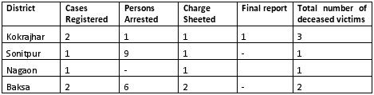
Cases related to witch-craft in Assam, 2008-9 (up to September)
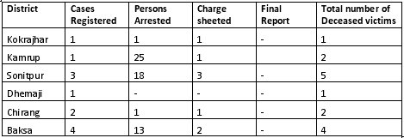

Uttarakhand

- Tehri dam – displacement vs employment.
The dam is ultimately going to displace 85,000 people. Govt says, ‘substantial’ no of jobs have been created. But locals say most employed people came from outside Tehri.

- Walnuts grow in abundance in uttarakhand. (grows in 10, 000 ha0 But there is no marketing mechanism. So compared to neighboring j and k and himachal, which earn 200 crores, uttarakhand loses its crop right on field.
production for MY 2009/10 (October/ September) at 35,000 tons (in shell basis),
West Bengal
- Pei Mei school – India’s only Chinese school in Tangra of Kolkata. Tangra is known as the China Town.
- The streets where Kolkata’s Ango-Indian community live, are being renamed. With old names, a part of the community’s identity go.

