Volunteering/Interning at Video Volunteers

Volunteers have been critical to the growth of Video Volunteers and have made deep and lasting contributions to the organization. Many past volunteers are still involved. Almost all volunteering or interning opportunities are in our main office in Goa, India though some could be in our field offices in central India. By interning with VV you will hopefully gain useful skills, such as how community media programs can be envisioned and created, and also about social entrepreneurship and running a small but growing non-profit.

Types of skills we look for:
- Organizational/program management (background in international relations, nonprofit, etc.)
- Filmmaking
- Graphic design
- Communications/PR/writing/social media
- Research
- Web design
- Business skills such as creating business plans,
Places you can volunteer:
- Goa, India – our main office where nearly all the team is located
- Regional offices – at the time of writing they are in Chattisgarh, Jharkhand & Maharashtra with more to be launched.
- With a community correspondent – in some a filmmaker could spend most of their time with a Community Correspondent, provided they speak the local language.
- New York – Though our board is in NY, it is difficult to place people there as all our staff is in India and we have no physical New York office, though from June- Sept the VV directors are often in New York. If you volunteer in NY, you will be operating independently, carrying out your work from home and being guided primarily via email.
- Distance volunteering – are you not able to volunteer at any of these places? Be a social media volunteer with VV. Read more about it on our intern page. You also may be able to do web-based work such as research, internet or graphic design, strategy consulting, etc. over email.
- Other countries? -- We are not currently placing people in any other countries/cities besides those listed above. If you are going to a specific country and want to volunteer there, we suggest you look at ashoka.org, the Youtube Video Volunteers program or idealist.org, to identify NGOs in the country you are going to. It is generally not difficult for a filmmaker to find an NGO to make a film for if they are willing to bear all the costs on their own.

Typical length of stay:
Three months is the usual length of stay and is the minimum we require except in rare cases. Many stay for up to six months.. Anything less than three months is usually not satisfying for the volunteer or for VV, given the time it takes to get up to speed.
Sample of past projects interns have done:
- Wrote first draft of a toolkit on youth media and adolescent girls, for our partners the Global Fund for Children
- Created a brochure for Video Volunteers
- Created a doc on VV community correspondents which they are turning into a feature
- Program managed a photography program with Magnum photo agency
- Handled all documentation during VV trainings, including written interviews with CC’s as well as creating photo slideshows and videos
- Created videos on Video Volunteers and individual CVUs and Community Correspondents
- Conducted audience research and surveys on our online video site including focus groups, newsletters and interviews with senior people in the field of community media
- Drafted training manual chapters and modules on critical thinking and creativity for advanced Community Producers
- Conducted market research with television stations regarding pricing points for stringers and freelance journalists to understand how VV could present CVU films via the mainstream media
- Did a research on best practices in program evaluation
- Was one of the lead program managers for a five-day Community Video Camp VV hosted in August 2009 with 150 participants from around India
- Conducted anthropological field research on a Tribal CVU for a Masters Thesis, and did an analysis of CVU films as anthropological films
- It is rarely possible for filmmakers to do direct training of Community Correspondents, unless they speak Hindi. We have full time trainers who train the CC’s and language is a major issue. Also, Video Volunteers only has two CC’s in Goa, so you will be working in an office environment. But almost all volunteers have the chance to interact with the CC’s and we make it a priority to ensure volunteers and interns get to participate in a training workshop.

Procedure for applying and types of projects:
It’s very informal. Please just fill out this form and send it back, and then we’ll have an email discussion about possible projects. We’ll make our best efforts to tell you what project you can work on as soon as you apply, but given that things change quickly, we may not be able to say what exact project you’ll be working on. But you will almost certainly be working on a specific, time-bound project that you run. You can also suggest and design your own project based on your interests.

Cost involved, what to bring, and other info:
- We cannot pay people’s travel to Goa or give them stipends during the time they are here, but when you travel for work, your costs will be covered
- VV has a guest house in our office and you may stay there while you find another place or for the duration of your internship if need be. Accommodation is basic. We ask that volunteers staying more than two weeks contribute Rs. 1000 a month towards basic costs like water, electricity, internet, housecleaning, etc. while they stay there. Please read the document on Interning in Goa for more information
- Volunteers must bring a laptop for work
- If you are making a film, you will need to bring your own equipment
- Renting apartments costs approximately 5000INR upwards if you are not staying in the office. A scooter is Rs. 3000 a month and a few hundred a week in petrol. Eating out costs about 60 INR (for a basic fish thali) onward but you can also choose to cook all your meals in the office.
- You can read about the experiences of past volunteers on the Video Volunteers blog

Staying engaged for the longer term:
Many volunteers stay engaged after their experience by blogging, researching and helping out at a distance. We try to build a community of past volunteers by bringing them together for events and brainstorming meetings when we come to their cities, and by sending them regular updates on our work

Information for new VV staff and volunteers
This document will be useful to you once you have finalized your trip

PART A: MOST IMPORTANT INFORMATION

Address and Directions

VV’s office is in Anjuna, Goa, a ten minute ride from the beach and the tourist belt. The office is an old Portuguese-style villa off a hill. It is a peaceful place just off the main road, but it is the country and so there are also mosquitos and lizards and snakes.

Postal Address:
Video Volunteers
1224 26/3
Rua St. Joao,
Gaum vaddi,
Anjuna
Goa - 403509
INDIA
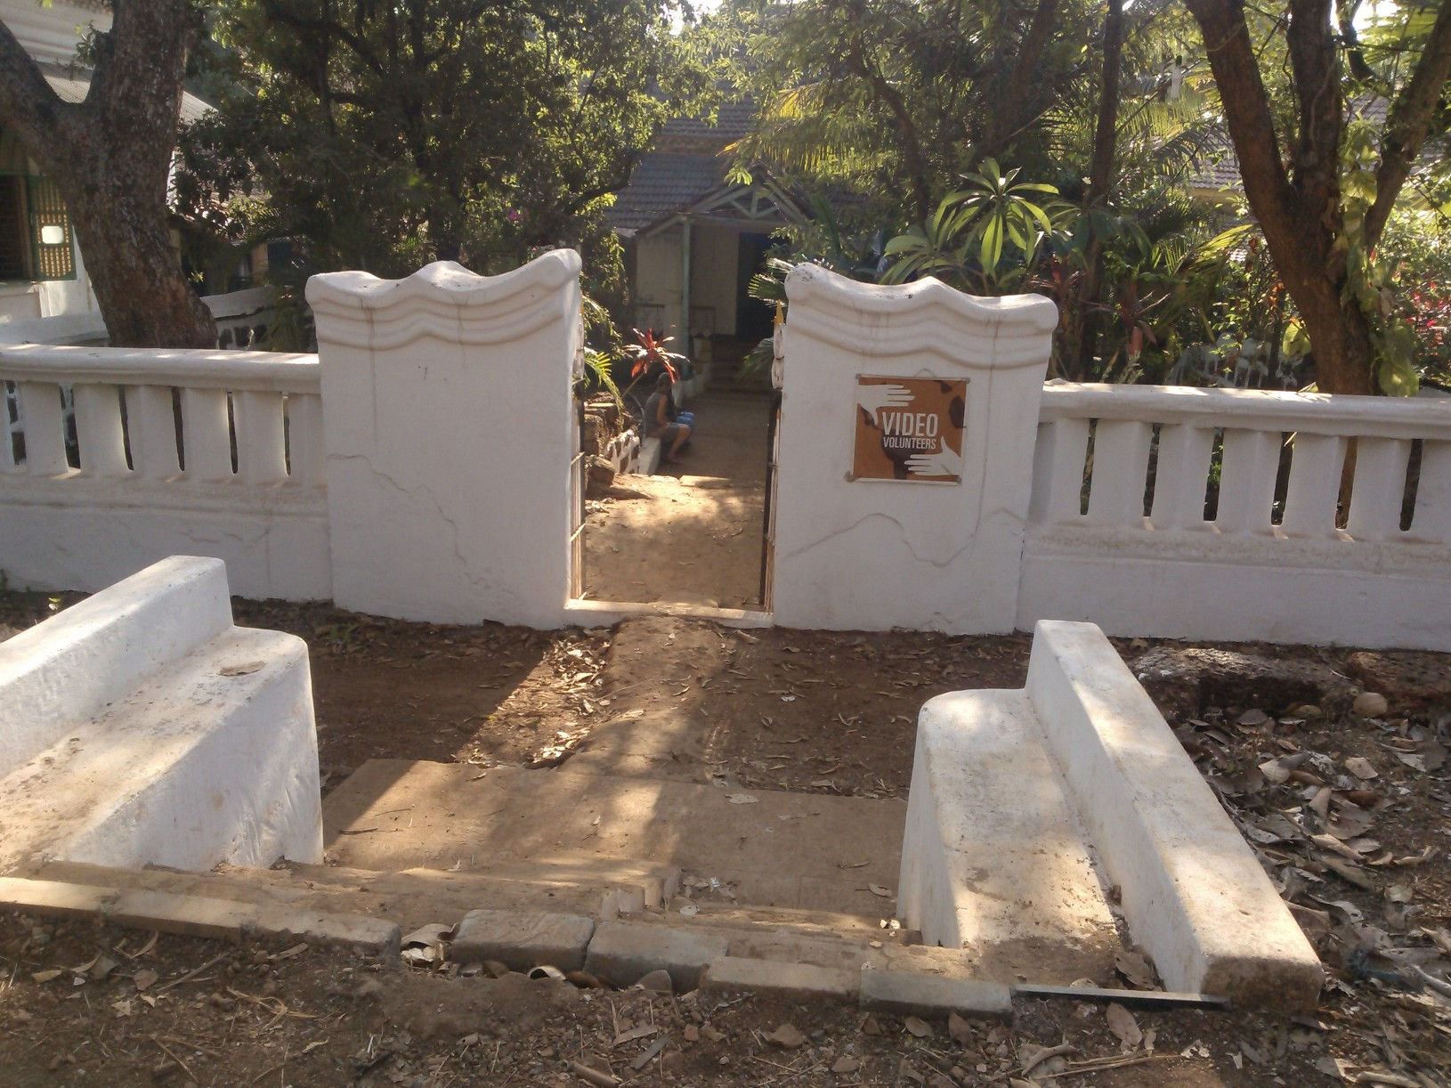
VV Guest Rooms
VV has the capacity for 3 volunteers at any one time to stay in the office, with single beds. Please enquire if the guest room is available when you are there. You may be required to share a room, to sleep in the main hall or to move out for a few days if we need to make space for short term visitors. We ask that people have made the bed and put away their things by 9:30am so the room can be cleaned. Morning tea will be provided either by Arun, who takes care of the house, or by you making your own. .If you are staying in the upstairs hall, please remember this doubles as a meeting room, so keep all your belongings in one corner so that people can use the room during the day.

There are serious water shortages in the area so please try to limit your showers to five minutes and don’t do laundry in the house.

There is only one shower and toilet and everyone staying should finish with the bathroom by 10am.

Alternates to the office guest rooms:
About half our volunteers choose to stay out of the office in rented accommodation. This is difficult to arrange before hand, as the agents who could do so only deal in high end accommodation. The best way to find this is to drive around on a scooter after you have arrived and look at the road signs for available rooms. Sometimes it is possible to share with other VV staff if they have a roommate who has recently left. Since Goa is a tourist area, there are a lot of places to stay. Costs are around 5000 INR per month on an average. Expect that it will take about 2 weeks to finalize a place. Ask other VV staff for phone numbers - everyone usually has a couple of numbers they can share with you.

There are cheap guesthouses within walking distance where the cost is around Rs. 800 to Rs. 1200 a night, sometimes negotiable during the off season (April to Sept) for as little as Rs. 600 a night if you are staying for several nights.

Security in the office
VV has been robbed three times. Security is a major issue. There is no place to lock up your belongings so don’t bring anything valuable to the office. There is a cupboard where you can put your laptop but that remains locked from 6pm to 10am.

For this reason and to not disturb the office housekeeper, Arun, please don’t arrive later than 11pm at the office. Please don’t bring friends to the office outside of office hours.

The front room cannot remain open. If you are the last to leave the room, please bolt the front door.

Transport
The best way to get around is scooter which can be rented for around Rs. 3000 per month through scooter dealers the office knows. Even if you don’t know how to ride a scooter it is worth learning and finding someone in the office to teach you. Taxis are very expensive . There are no autos. There are buses but they end at 6pm. There are ‘pilots,’ who are people who will drive you on their scooters and the office has their numbers – these are the cheapest form of transport besides scooter. Our area is not terribly walkable unfortunately.

Meals
Office staff either cook in the office or eat lunch at the nearby fish thali places. There is a fridge, stove and utensils.

Supermarkets
The nearest super market is Orchards, about a 25 minute walk from the office.

Laundry
There is a laundry service a 15 minute walk from the house. If you drop it in the morning it is available later in the day the next day. It is Rs 10 per item.

Visas
Applying for the right visa is very important. Write to VV separately about this. As of latest information, the government doesn’t seem to be giving out journalist or filmmaker visas and for any travel to India whether to visit VV or not, the best visas to get are a business visa or a volunteer/employment visas. Often the ten year multiple entry visas are not much more expensive than the single entry visas. VV can provide the documentation you need. Start the visa process early! It is nearly impossible to extend your visa once in India, unless you are on an employment/volunteer visa when it is slightly easier to do, at the Panjim foriegners registration office (FRO.)

Enjoying Goa
The office is in the heart of the touristy, hippy part of Goa and there are lots of places to go out. The beach is ten minutes away by scooter. Join the Goa Life facebook group to find out what is happening in Goa, from new age-y courses, to Indian classical music, to how to take part in a garbage collection clean up.

Cell phone
Get a prepaid phone down the road in Anjuna as soon as possible. The phone cost Rs. 1200 and an additional 500 Rs for 500 minutes. Do check with the retailer for best offers available - these vary from service provider to service provider.

Yoga:
Brahmani yoga is a ten minute walk from the office and has drop in classes every morning from Dec through March. 500 Rs for one session or 250 Rs if you get the 10 session package. Very expensive for India, but the courses are rigorous and the individual attention is impressive.

Erson is a private yoga teacher about 20 minutes scooter ride from the office in Arpora. Jess can give you his number.

Accessing Money
The closest ATMs are in Anjuna, about a 30 minute walk. Take out a sizable amount to avoid too many ATM fees. Very few businesses, and no restaurants take cards.

Internet
There is broadband wireless internet in the office. It is slow, and not very good for watching videos online so you may want to watch videos related to our work before you come. Please do not download movies in the office. Our internet connection for the whole month slows down if we have high usage which makes it incredibly difficult to upload the daily videos.

Lots of people use dongle internet and you might consider buying one of these while you are here, especially if you wont be staying in the office and will want internet at your home.

Safety
Goa is pretty safe but it is a tourist place with large groups of young men so there can be a lot of cat-calling and that kind of unpleasantness. Take the number of the police station to put in your cell phone. Also put the number of the taxi services VV uses – there are many – into your phone so that after a night out you can always take a taxi back, instead of a scooter after a few too many drinks.

Dress and behavior
Unlike in other parts of India, in Goa you can dress as you would at home.

Though Goa is a tourist destination and is known as one of the most liberal places in the country because of the large number of ‘outsiders’ (whether from abroad or other parts of India) living here, the Goans themselves (i.e., our neighbors) are often quite conservative and religious and feel threatened by ‘modern values.’ We had an incident in which we actually were evicted from our office because of our assumption that our neighbors shared the liberal values you see at the beach – when they don’t. So please behave around the office as you would in a much more conservative Indian city.

When traveling in the field with VV dress conservatively. Women should wear long skirts, long sleeves, and often wear a scarf on top of their tops. If you will be in the field a long time, consider getting or borrowing a salwar kameez or other Indian dress. No smoking or drinking in the slums or villages. Please remember that when you go on a shoot or to a screening with a community producer you are a guest and you stand out. Please don’t bring other foriegners along with you for field visits without first checking with VV. People in the community will talk to the CCs for weeks about the foreigners they brought to the village. So please be respectful.

Part B: FOR INTERNATIONAL VOLUNTEERS – FLYING TO GOA FROM ABROAD

Bombay is the closest international airport to Goa. Qatar airways flies direct to Goa from various points in the US and Europe via Doha, and generally seems the cheapest way to arrive.

If flying into Bombay, to get from Bombay to Goa one can fly for usually less than $100, which can be booked online at yatra.com. or you can take an overnight bus from Bombay which is the cheapest way to go and doesn’t require booking. The overnight bus has beds, but most people don’t sleep. Train is more comfortable and pleasant but is usually only available if you book at least 3 weeks in advance. Most flights from abroad arrive in the middle of the night in Bombay, and the earliest flights to Goa are around 6am. So you can either stay up all night in the airport, or stay in a hotel. There are no nice cheap airport hotels in either Bombay or delhi. hotel bookings can be made at the hotel desk in the airport. Cheapest is around $50 and they will give you a driver to drop you and pick you up in the morning. But they are pretty gritty rooms.

The domestic and international airports are in two different places, so you must allow significant time to transfer between the two airports. You need a print out of your domestic ticket to enter the airport.

Volunteers flying in the first time should tell us their flight info and we’ll have a taxi pick you up at the airport and take you up to the house.

PART C: PREPARING FOR YOUR TRIP

Items to Bring

Here is a handy list of items to bring with you to India, especially if you plan independent travel:

bandages
alcohol swabs
hand santizer
liquid soap
anti-histamine for allergies
pepto-bismol
bandage rolls
cough lozenges
current converter and plug adapters
hydrocortisone cream
insect repellent (DEET and non-DEET)
emergen-C
scissors
Cipro or pills for digestion
sunscreen
sunglasses
contact lens solution
thermometer
tweezers
fingernail clippers
vitamins
pollution mask
earplugs
sleep mask
chain and lock
tampons
bathing suit
towel
computer thumb drive or zip drive
Hindi language books

Resources on India to check out before you get here:

Books:
Behind the beautiful forevers
Bombay Maximum City
May You Be the Mother of 100 Sons
Freedom at Midnight
Participatory Video by Shirley A. White
Shantaram
How to change the world, David Bornstein
Lonely Planet
White Tiger, Aravind AdigaWilliam Dalrymple - The Age of Kali, City of Djinns.
Mark Tully - No Full Stops in India
V.S Naipaul - An Area of Darkness

Films: (look for copies with subs!)
BBC's The Story of India
Gandhi
Rang De Basanti
Monsoon Wedding
English, August
Born into Brothels

Some Indie films our ex-interns recommend are:
Shutlecock boys
Miss Lovely
Ship of Theseus
Mr and Mrs Iyer
Delhi in a Day

Resources on VV
VV has a document on ‘orientation of new staff and volunteers.’ Ask for this when you arrive. We also have a folder of key documents for all volunteers to read.

But before coming, do read www.videovolunteers.org thoroughly and watch as many videos as you can.

For people coming from universities, we are always extremely grateful for any article photocopies, books, resources or documentary films that you are able to provide for the office.

PART D: MORGAN’S RECOMMENDATIONS ON FUN THINGS TO SEE AND DO IN GOA AND BOMBAY (Morgan was a volunteer in 2009.)

Goa

Food - these are my favorites, highly recommend them all: Case Portuguesa, for delicious, traditional Portuguese food in an old Goan home on Baga road. German Bakery, over the hill in Anjuna, a place you can hang out all day with the neo-tribal European vagabond crowd, eat salads and drink fresh juices and Kombucha. Lila Cafe, the best coffee in Goa and great German fare as well, open for breakfast until 6pm, free wifi. Mona Lisa Angel Heart, the best beach shack on Baga, go for the Goan prawn curry or the fish stew. Thalassa, serves Greek food on a romantic hilltop overlooking Vagator beach. Le Plage, a French eatery 40 minutes away on Aswem beach, pricey but considered some of the best food in Goa and an excuse to run around on an uncluttered beach all day; Om Cafe in Anjuna, same owner as Le Poisson Rouge, gorgeous Mediterranean atmosphere of a Cote-d-Azur cafe, perched right up at the water.

Shopping: Literati in Calangute, one of my favorite bookstores in the world, in an old house with couches and serves coffee and quiche. Rangeela, a clothing boutique in Calangute, sells cotton scarves, well-made leather sandals, and jewelry by local designers. Saturday night market, an overwhelming number of vendors selling neo-tribal couture, typical Goan street-shack shwag, boutique designer goods, international assortment of food, and wine and beer.

Other tips: Inox is the multiplex theater in Panjim. Panjim itself is worth a visit, to walk around the old Portuguese era streets and churches. Over the weekend, rent a bike and go two hours south to Agonda, one of Goa's most pristine, quiet beaches, where you can rent a coco hut on the beach for 300-1000 Rs.

Bombay

If you fly into India through Mumbai, I highly recommend staying a few days before heading to Goa. Mumbai is a fascinating introduction to India and offers plenty distractions for a two night stay. And this way you can avoid the overnight lay-over at the Mumbai airport.

If you are coming from Bombay, the train is a nice way to go. You can sleep quite easily on the padded bunks or stay awake and watch the tropical Indian landscape. Men selling chai, coffee, water, and pretty decent food constantly walk by - try something. Get off at the first stop in Goa, Tivin or Margao.

Here are a few suggestions for spending days in Bombay.

Lodging: I stayed at the Bentley in Colaba, the tourist-heavy neighborhood near the Taj Mahal Hotel. The Bentley was cheap enough, spare and clean, on an old tree-lined street around the corner from some great restaurants, and the staff was helpful.

Food: Bombay food is knock out and reason enough to hang out for a while. Here were my favorites: Swati Snacks serves a variety of upscale street-style food (248 Karai Estate, Tardeo Rd, Tardeo) and concocts homemade ice cream. Britannia is a wildly delicious Parsee restaurant near the city's government buildings; order a mutton dish, paratis, and their silky greek yogurt dessert. Indigo Deli is an elegant Italian cafe in Colaba and open for breakfast lunch and dinner; it offers fresh baked goods and splendid brunch (Pheroze Bldg, Shivaji Marg).

Fun: You could check out the famous Taj Mahal Hotel lobby and relax on the plush couches in the AC. Nearby is the Gateway to India where you can take a cool, one-hour ferry ride to Elephanta island, where you'll dodge scavenging monkeys and stare at enormous, intricate Hindu rock carvings. Walk on Chowpatty beach during sunset. Bargain with vendors for sweet deals in clothes and jewelry at the Colaba street market, or for antiques and oddities at Chor Bazaar. Buy yourself a trendy kurta at Fabindia, India's answer to Banana Republic. Watch a Bollywood film at Regal Cinema. Rub shoulders with the young and hip at Zenzi Bar in the Bandra neighborhood. See India's impressive contribution to modernism at the National Gallery of Modern art. Take a stroll by the magnificent gothic architecture on the University of Mumbai campus.

