The view from within
ASHA SRIDHAR
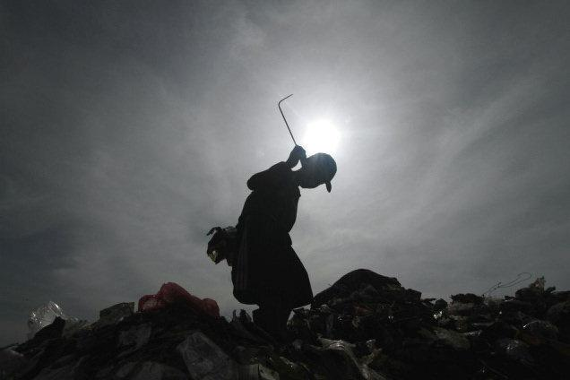
AFPIn focus: Video Volunteers throws the spotlight on small-town India.
Armed with a camera and stories from India's villages, Jessica Mayberry and her band of Video Volunteers are catalysts for social change
A Kodak video camera and a few thousand stories from the grassroots may seem like an odd combination in a world inhabited by the trappings of mainstream news and TRPs. But, Jessica Mayberry and her team of Video Volunteers have done just that — they armed locals with a video camera and made journalists out of day labourers, rickshaw drivers, and women from an India Unheard.
“Each of these films has a concrete cause and action,” says Jessica, the founding director of Video Volunteers, an award-winning international organisation with its headquarters in New York, and programmes in India and Brazil.
Started in 2003 in India, Video Volunteers' correspondents are from communities whose members lead lives in a forced safe house, untouched by the nation's development. Most of these correspondents are now leaders in their communities.
After a training period of around two weeks, where these correspondents are taught to conceptualise, shoot, report, script and edit video stories about local social issues, they become the voices from the inside.
A broadcast journalist who worked at CNN and Fox News Channel, Jessica came to India as a Fellow of the American India Foundation. While she spent a year with the NGO, SEWA, training women from rural India in filmmaking, she realised that most women only knew to shoot; the other aspects of production were handled by the staff.
“Watching these women was incredibly moving. They spent all these years shooting videos, and still worked only as technical operators. Someone had to teach and train them to articulate and think critically, something that is inherent in them,” she says.
Inspirational medium
And, that is how the idea of Video Volunteers germinated — technology was getting affordable, video as a medium was high on the inspirational front, and her partner Stalin, who had 20 years of experience as an activist, knew almost every NGO in the country.
“Where are the reporters in the smaller districts of India?” she asks. “There is nobody. The media talks about pulling out stories from the districts. We are talking about pushing out stories from there. We want to create an alternative kind of news wire with stories from the grassroots,” says Jessica.
Jessica and Stalin say they want to “change the lens — from outsiders seeing in, to insiders looking out”.
Under the India Unheard programme, the stories of community correspondents are uploaded on the India Unheard Website. However, in their other programme, Community Video Units, the first target audience is the community itself — every story is screened in the villages, and discussions held.
A community Video Unit is usually a team of six to 10 members — one looks after the production while the others arrange for the screening of the movie, interact with the villagers and follow up to ensure that some affirmative change is brought about. “Solutions, not problems, are discussed,” says Jessica.
While the correspondents for India Unheard are paid for every story, the members of Community Video Units work in partnership with an NGO and are paid a monthly salary, since they make longer videos and their work structure is different.
Going mainstream
However, the biggest challenge, Jessica says, “is to take these stories to the mainstream media. We, as an organisation, represent community producers and talk to media organisations to get their stories published or broadcast on their channels and websites.” They have partnered with global media organisations such as CNN and MTV networks and Indian organisations such as MSN India and News X.
Winner of prestigious awards such as the Knight News Challenge, 2008, and Manthan Award South Asia, 2009 among others, Video Volunteers is looking at democratising the news space, while, at the same time, making it a sustainable business model. “We want our correspondents to be like stringers that mainstream news organisations trust,” she says. They are now working with the Indian Institute of Management, Ahmadabad to develop sustainable business models for the communities involved.
The videos have brought about affirmative change — such as education committees being formed in villages, public hearings being called for and migrant children being admitted to schools.
However, Jessica says: “We walk a tight rope in terms of how much we interfere. Subjects such as caste, religion and human rights are sensitive issues; so, we make sure the stories don't take a slant.”
Jessica says their biggest achievement so far has been to awaken people's creativity. “We want to build a network of stories and storytellers,” she adds.
On Air
Mani is one of the two India Unheard correspondents in South India. He says that he was initially scared, and so were people when they saw the camera. Now, he is one the reporters who will feature in Speak Out, a half-hour weekly show on News X, in partnership with Video Volunteers. The other correspondent is Christy Raj from Bangalore, India's first transgender journalist.
Keywords: social issues, Jessica Mayberry

