simplwrds
Just another WordPress.com site

What if the poorest half a billion people of India has their voice: It’s possible by innovative journalism
leave a comment »
The shining stories in media about the rise of India––from rubble to the second fastest growing economy in the world––has certainly eclipsed the fact that India is also a country with the highest number of poor people in the world.
According to the latest figures by World Bank and Indian Planning Commission, around 40% of Indians are living below the international poverty line. This is approximately 420 million people––more than the total number in sub-Saharan African countries.
The World Bank has identified the ‘access to a voice’ as the number one obstacle for the advancement of the poor, even above the food, shelter, or education. In India, the booming economic growth has shifted the focus of national media from 70% of the rural––mostly poor––population to the 30% of urban population. Because, this is where the revenue is generated. However, there are some exceptional people and organizations, who have come up with innovative ways to make the voice of poorest heard.
P. Sainath: The Walking Journalist
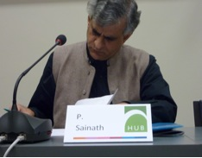
Palagummi Sainath spends 250-300 days a year, living and walking through the villages across rural India. He is reporting about the everyday problems of the poor villagers and neglected farmers from the last 15 years.
I interviewed him recently at a conference, where I asked him, why did he decide to pursue this form of journalism. He replied, “this is actually the real journalism, presenting everyday problems of common people”. He told in the conference that there is not a single full time correspondent in India covering the 70% India that is rural––roughly 900 million people––whereas more than 500 full time journalist covers a typical fashion week in Mumbai.
He made the plight of poor farmers impossible to ignore, through his extensive coverage on farmer suicides. It made a strong impact on the national and regional governments and forced them to pay attention to the situation. His reporting inspired several leading newspapers, and TV channels of India to start reporting on rural issues.
Sainath’s serious effort has begged him the prestigious Ramon Magsaysay award ––Asia’s Nobel Prize––for journalism in 2007. His book, ‘Everybody Loves A Good Drought’ is one of the biggest nonfiction sellers and is considered as a handbook for NGOs.
India Unheard: A Video Volunteers’ Initiative
Jessica Mayberry, a winner of the prestigious Knight Fellowship in Journalism, founded Video Volunteers (VV), after spending a year in India, training the rural Indian Women in Film making as a fellow of the American Indian Foundation.
IndiaUnheard is the first ever community news service launched by VV. In this initiative, VV trains some volunteers from poor communities in India as community reporters. These reporters are trained with basic journalistic skills, and media training including the video training.
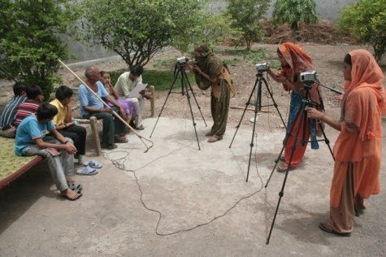
These trained community reporters cover the hyper local issues that are often unnoticed by the regional or national media. The reports range on a variety of social, and cultural issues ranging from corruption, development, human rights violations, and discrimination to local festivals.
IndiaUnheard is making a significant impact on the grass root level, and the national media have broadcasted many of the stories made by its community reporters.
CGNet Swara: Making use of mobile phones
The Indian telecommunication industry is the fastest growing industry in the world. The number of mobile phone subscribers in India has surged more than 100 fold in the last ten years (5 million in 2001 to 687 million in 2010). What if we can use these mobile phones for citizen journalism?
Shubhranshu Chaudhary launched a new initiative based on mobile technology, CGNet Swara in Chhattisgarh, India. The prestigious US institution MIT and Microsoft Research India designed the technology behind CGNet Swara. In this new platform, citizen-journalist can call a phone number and record their reports on a server. The citizens can listen these recorded reports by calling a phone number. The subscribers get an SMS, whenever a recorded report is approved for release.
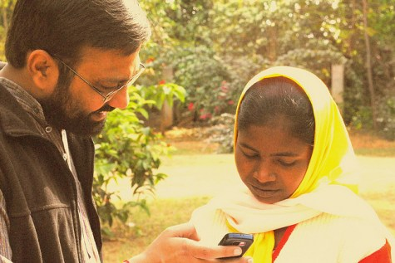
CGNet Swara trains local people on how to record their reports, and about some basic journalistic techniques. Some of the recorded reports are also published on the websites ofCGNet Swara and are also translated into Hindi and English.
The service can be particularly useful to get reports from the remote and violent areas that are difficult to access and will go unreported otherwise. The best thing is that the people, whom these reports matter the most, can hear them in their own language and their own dialect.
These innovative methods of journalism are not only helpful in getting local stories, but they could make a difference in lives of millions of people. This local journalism promotes vigilance and democracy at the grass root level and could be a vital tool for spreading the awareness on various social and health issues.
Written by simplwrds
January 10, 2011 at 3:43 pm
Posted in Uncategorized

