Andi’s Eurorack Patch Library
  - Documenting Useful Eurorack Patches for Inspiration and Reference

Why Document Eurorack Patches?
Modular synthesis is all about exploration. Documenting patches helps me:
- Remember successful or interesting sounds I’ve created
- Track my learning progress over time
- Return to complex patches that would otherwise be forgotten
- Share techniques with the wider modular community

The Mighty Andi Eurorack & Co.
Modules and other gear at my disposal:
In the 84HP Tiptop Rack:
- Tiptop Audio uZeus (power supply)
- Doepfer A-141-2 VCADSR (ADSR / LFO)
- 2hp S&H (sampe & hold)
- Erica Synths Pico VCO2 (VCO: pulse wave and triangle wave)
- Erica Synths Pico VC EG (Envelop Generator and LFO)
- Eventide Misha (Melodic sequencer)
- Tiptop Audio Forbidden Planet (VCF – HP, BP, LP Filter)
- Tiptop Audio ONE (Sampler)
- ALM Pamela’s PRO Workout (Clock Divider, Envelope Generator, LFO, Sequencer…)
- Dopfer A-135-2 Quad VCA / VC Mixer
In the Inellijel palette case 62HP (including 2x 1 into 4 mulitplier):
- Intellijel Steppy (sequencer)
- Koma Detective (Envelope Follower)
- Intellijel Digiverb (Reverb)
- Intellijel Stereo IN
- Behringer Brains (Digital VCO)
- ADDAC System 103 T-Networks (analogue drums)
- Intellijel Tetrapad (control center)
- Expert Sleepers Disting Mk4 (multifunctional Swiss army knive for Eurorack)
- Intellijel MEMS mic (micropone)
- Inellijel Mixup (mixer)
- Inellijel Outs (Stereo Line Level output)
- Intellijel Unity Mixer (2x 3 into 1 mixer)
Other gear to be combined with the Eurorack:
Arturia Drumbrute Impact Roland J-6 (Chord Sequencer and Juno 60) Akai MPC One and tons of guitar pedals…

Patch 001: Dual VCO Scales Sound Exploration

- Description / Purpose:
  - My first patch. Used to explore the different “sounds” of scales selected on the Eventide Misha. How does A minor sound, how does E Lydian sound etc.
  - Teached me the basics of how to use a VCO, EG and VCA

- Modules used:
  - Doepfer A-141-2 VCADSR / LFO
  - Erica Synths Pico VCO2
  - Erica Synths Pico VC EG
  - Doepfer A-135-2 Quad VCA
  - Eventide Misha

- Instructions:
  - Yellow: VCO outs to VCA (would constantly play a tone if not triggered with…
  - Red: Trigger signals from Envolope Geneators (or LFO) to the CV input of the VCA
  - Green: End of Release (EOF) into own Gate on A-141-2 makes it an LFO
  - Orange: End of Attack (EOA) is used as trigger for the Pico EG (stearing the second voice)
  - White: the only job of the Eventide Misha is to give the frequency/note value from its CV out into the 1V/Oct on the VCO2

- Notes:
  - My very first usable patch, allowing me to explore scales and teaching me the very basics of modular synthesis.
  - The green cable puts the ADSR/LFO into LFO mode and acts as the starting trigger here.

- Categeories / Tags:
  - Basics, Scales, VCO and triggers

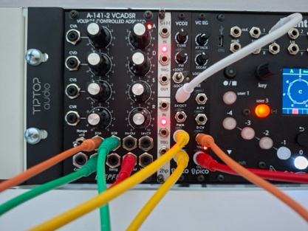
- Images:
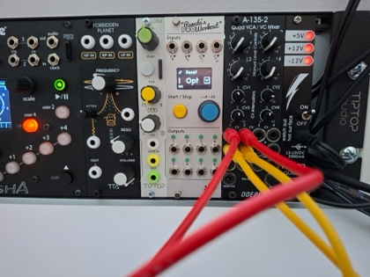
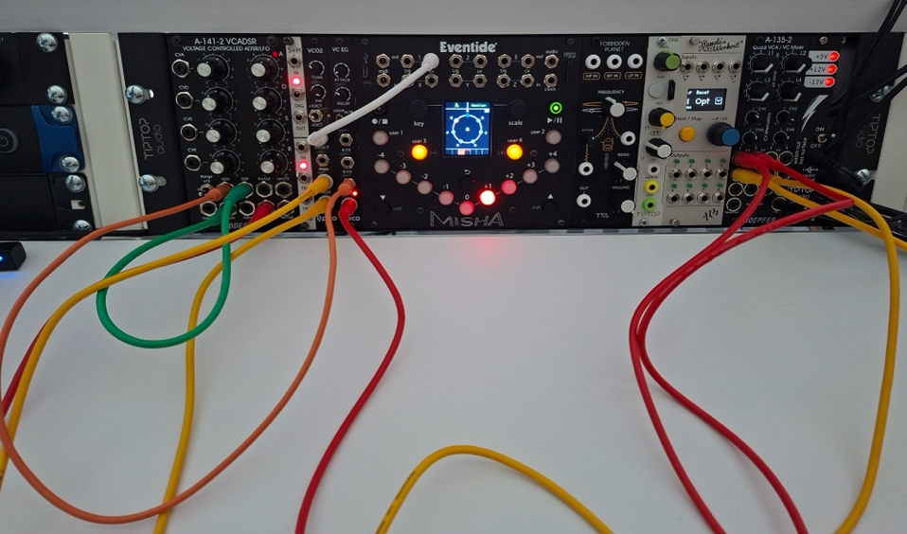
- Sounds: https://hearthis.at/ernilab/patch1/

Patch 002: My second patch

- Description / Purpose:
  - 123
  - 321

- Modules used:
  - …
  - …

- Instructions:
  - Yellow: …
  - Red: …
  - Green: …

- Notes:
  - aaa
  - bbb

- Categeories / Tags:
  - ccc

- Images:

- Sounds:

