**BHASHA**

**An application to learn language**

**Version 2.0**

**Vasudeva Nayak Kukkundoor**

[**https://www.linkedin.com/in/vasudeva-nayak-kukkundoor-04183816/**](https://www.linkedin.com/in/vasudeva-nayak-kukkundoor-04183816/)

1. Introduction

2. Installation

3. Folder Structure

4. Language Configuration

5. Translation

6. Multiple Choice Games - memorization

7. Audio - Native speaker mode

8. Pronunciation - Validate your pronunciation

9. Reading 1 - Missing sentences

10. Reading 2 - Missing words

11. Reading 3 - Classifieds Matching

12. About - Contributions

13. Preparation Materials Links

14. Issues/Suggested Settings

# Introduction

For learning any language, important factors are Vocabulary and Grammar. Unfortunately learning traditional way takes time and effort. So we seek help from Technology, with google python modules for simplifying the complexity.

Bhasha focuses more on vocabulary part of the language learning process. We use Google Modules to build translation, audio files creation and speech capture and recognition operations. These can then be used to develop interactive challenge oriented games to improve memorization of vocabulary.

Also as part of extension to the features, we also have provided support for Reading section. Learners can input their own text and solve different kinds of Reading tasks.

**Features**

* Vocbulary learning for google supported Languages
* Multiple Choice Questions (html download, in-app )
* Audio files created with native speaker mode
* Speech capture and recognition in target language
* Reading Exercise - Missing sentences
* Reading Exercise - Missing words
* Reading Exercise - Classifieds reading and matching
* Download latest updates from internet

Please ensure that you also go through the section 14. Issues/Suggested Settings, as this application is very basic and not robust.

# 2. Installation

Latest Installer can be found in [Github Link](https://github.com/ajeyln/bhasha/releases) . Please download EXE installer and then proceed with installation of Bhasha application at your favorite location.

Please note that the installer does not modify any of your System settings (path, Env variables etc). The installer just prepares folder structure, Bhasha content etc. those are already bundled within the installer.

**Note :**

* As the installer is not from trusted source, operating system may complain. Ignore the warning and install it anyway.
* Run the installer as administrator, into a disk drive with enough storage space.
* For any installation issues, especially involving message “Error opening file for writing..”, check troubleshooting videos for the same.

# 3. Folder Structure

There are totally 4 folders which are very much essential to get the understanding of the application, which are as follows

* **Config [part of installation]** Application specific JSON files such as configuration, About Information and Literaraians informations are bundled. The application needs to save user settings and those are saved in *config.json* file. Also, *about.json* file contains information about Bhasha application. Application also displays information various Literarians randomly, their information too are saved here. As user/learner, you do not need to change anything here.
* **Input_Words** **[user selected folder]** This is very important folders for learners. User must list all his/her words in a simple text file and must place in this folder. During configuration of Bhasha, this location is required to be selected with GUI. Bhasha application fetches all files inside this folder and uses translators to find translations and saves them as *\*.bhasha* (translated file) inside project folder.
* **Output**  **[user selected folder]** This folder needs to be selected for storing all HTML downloadable MCQ Items, reading exercise and audio tracks. User can set this in configure section of Bhasha application. Also Audio files for native speaker mode will be stored in this folder.
* **Project [part of installation]** After translation of input files from input_words folders, the translated files are stored inside Project folder with extension *.bhasha. These are application specific files, which are used for MCQ games, Audio and pronunciation tasks.
* **Reading_Samples** **[part of installation]** For preparation of Reading games, there is necessity of source text files. Folder Reading_Samples contain sample files for initial understanding of the game.
* **Resources [part of installation]** This folder is exclusively available for application.

# 4. Language Configuration

In this section, user needs to configure his/her language preference.

Focus Language is the language you are trying to learn. Please make sure you are creating your wordlist in the focus language. Similarly user can select two helper languages for translation. All the settings will be then saved with application.

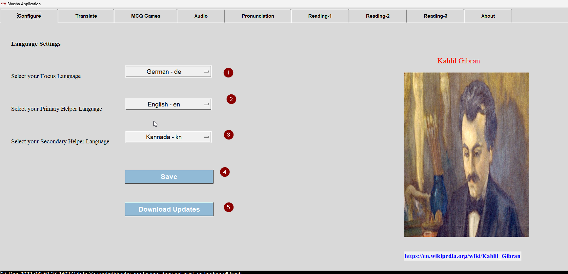

1. Focus language Dropdown list
2. Primary helper language (default is English)
3. Secondary helper language (default is Kannada)
4. “Save” button to persist the preferences of user
5. Latest updates such as wordlist, translated files (*.bhasha), reading compositions etc. can be downloaded with this button. User needs to select preferred location to download all updates, and then he/she can use the contents of these updates for his/her learning.

# 

# 5. Translation

In this tab, the translation of words from input_words folder take place. The files *.txt forms are fetched and based on language preferences configured, the translation of words are prepared.

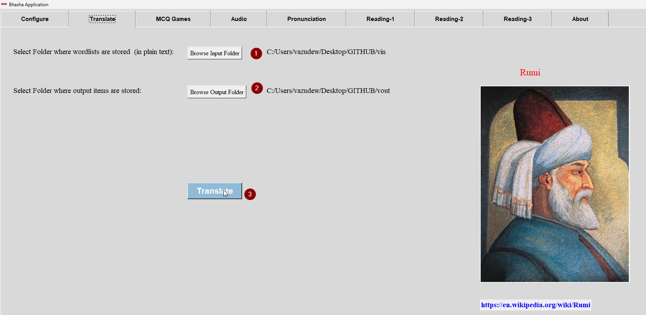

The resulting translated files (*.bhasha) are stored in project folder. The same filename as input word list is retained for translated files for easier reference.

1. Input_words folder must be selected
2. Output folder must be selected. Here MCQ games, reading games and audio files will be later downloaded. User can make them useful in offline mode as well.
3. Translate button invokes correct google apis for translating words in languages as preferred by user. These settings will also be saved.

# 6. Multiple Choice Games - memorization

Here based on translated files, Multiple Choice Games can be prepared with random question sequence and options.

Question will be a word in focus language and options will be its translation in helper languages. Selecting correct option, will improve memorization of words. This will be standard mode of the game. However the mode can also be reversed i.e. the question will be translated word in helper language and options will be words in focus language. This way, user is prepared for compete understanding of the word.

1. Here select the *.bhasha file for which user wants to prepare MCQ game
2. You can select mode you prefer
3. Clicking this button starts the game
4. Download button with number of sets of games (dopdown) helps users to play game in offline mode.

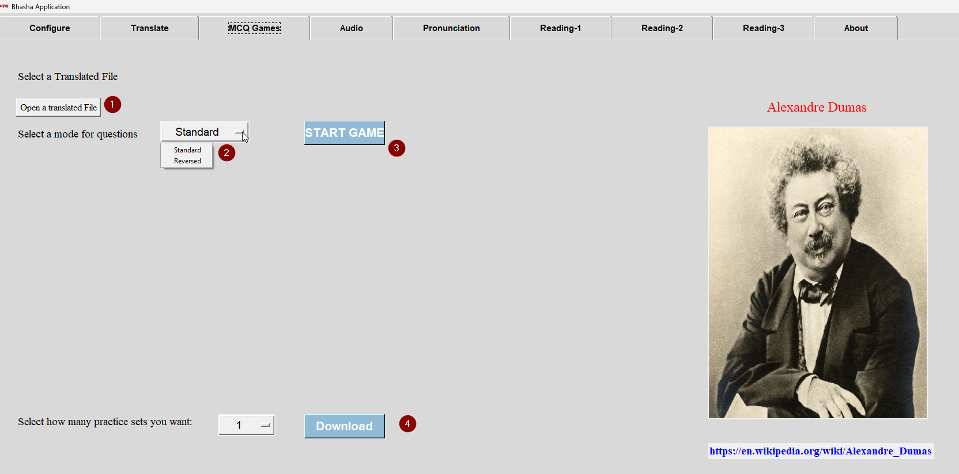

Sample question answer situation is displayed as shown in the image.

1. Question word
2. Next button to display next word

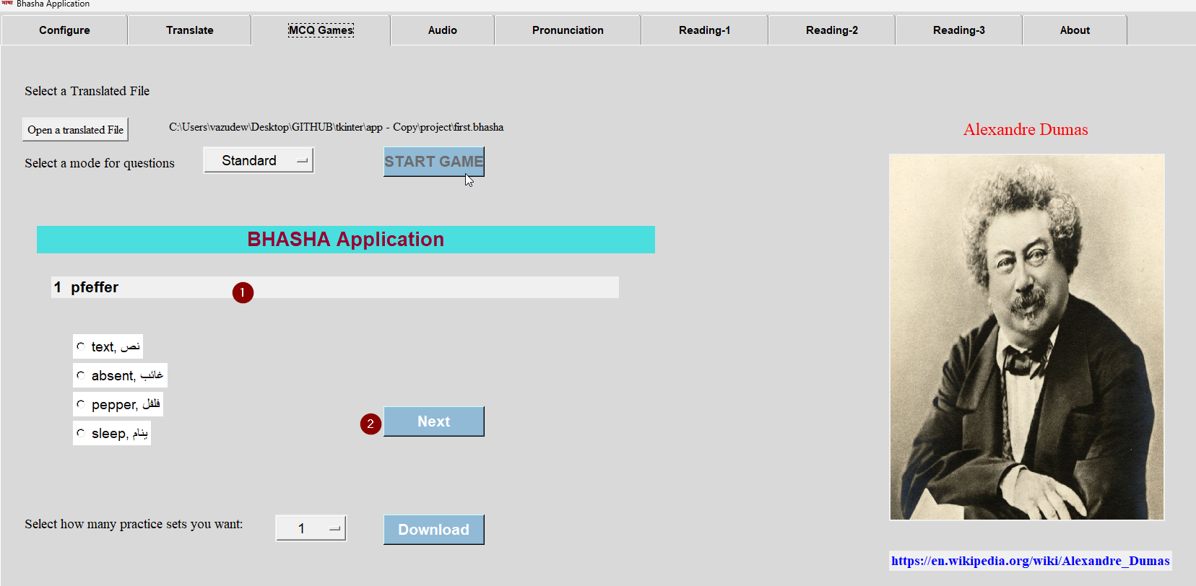

# 7. Audio - Native speaker mode

Here based on translation file, application create audio files for all the words in the wordlist. The google api is invoked and audio files are generated for the same. User can listen to each word and understand how to to pronounce the word. This module helps in Listening section of exams.

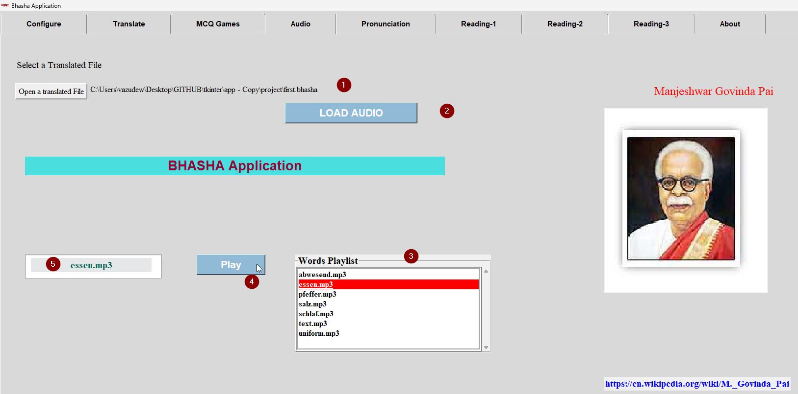

1. Select translation file (*.bhasha) for which you need to creator audio files
2. Click Load Audio Button, which creates audio track files (*mp3) in output folder
3. The scrollable list of all words and their audio tracks. User can select word for focus
4. Button Play plays the selected word in native speaker mode
5. The focussed word is also displayed separately for reference

Please note that the generated audio files are stored in “output” folder, for offline reference.

# 8. Pronunciation - Validate your pronunciation

With unique speech_to_text module from Google Apis, application can capture users’ voice and can then convert them into text, which can be validated with simple textual comparison. This is the basis of pronunciation validation.

Please note that application can be erroneous here sometimes. The accuracy is often dependent on your environment, the application processing and timing. But it gives a general idea how close user’s pronunciation is.

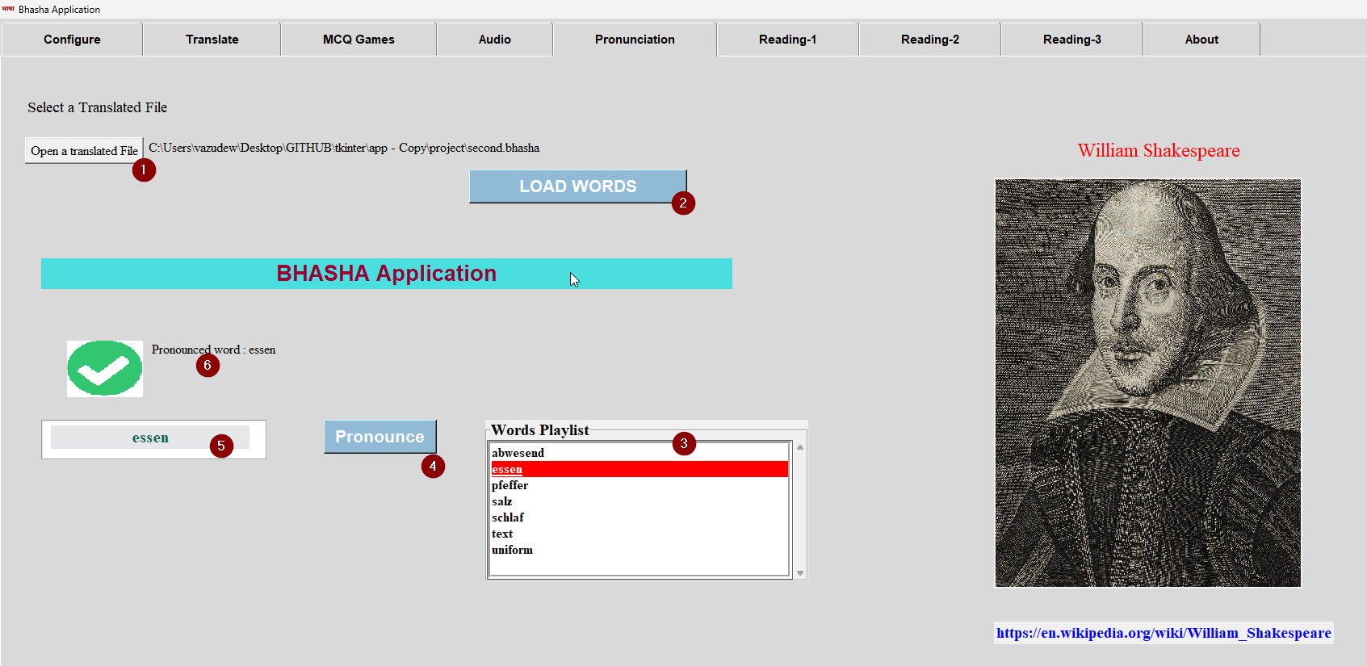

1. Select translated file *.bhasha
2. Load words button prepares scrollable and sorted list of all words from file for users to pronounce
3. Select any word for pronunciation
4. Clicking Pronounce button, prepares application to capture your voice and record
5. Highlighted word is again displayed here
6. Upon correct pronunciation, status is displayed here along with pronounced word

# 9. Reading 1 - Missing sentences

These Reading sections are listed to help users to prepare for Reading section of the exam. Users can prepare their own source text file and can feed to the application. The application then ensures preparation of tasks by introducing randomness in missing sentences or words.

1. Here select the source text file. Please ensure the text file to be free of special characters, having 3 or more paragraphs. And each paragraph to contain at least 5 full sentences. You can download appropriate text from internet to prepare for the game. Also check text files from Reading_Sample folder.
2. Load Reading 1 button displays Question text, with missing sentences as options
3. List of options available. User may enter matching letters to missing sentences
4. Submit your options
5. Answer key
6. Message with score details

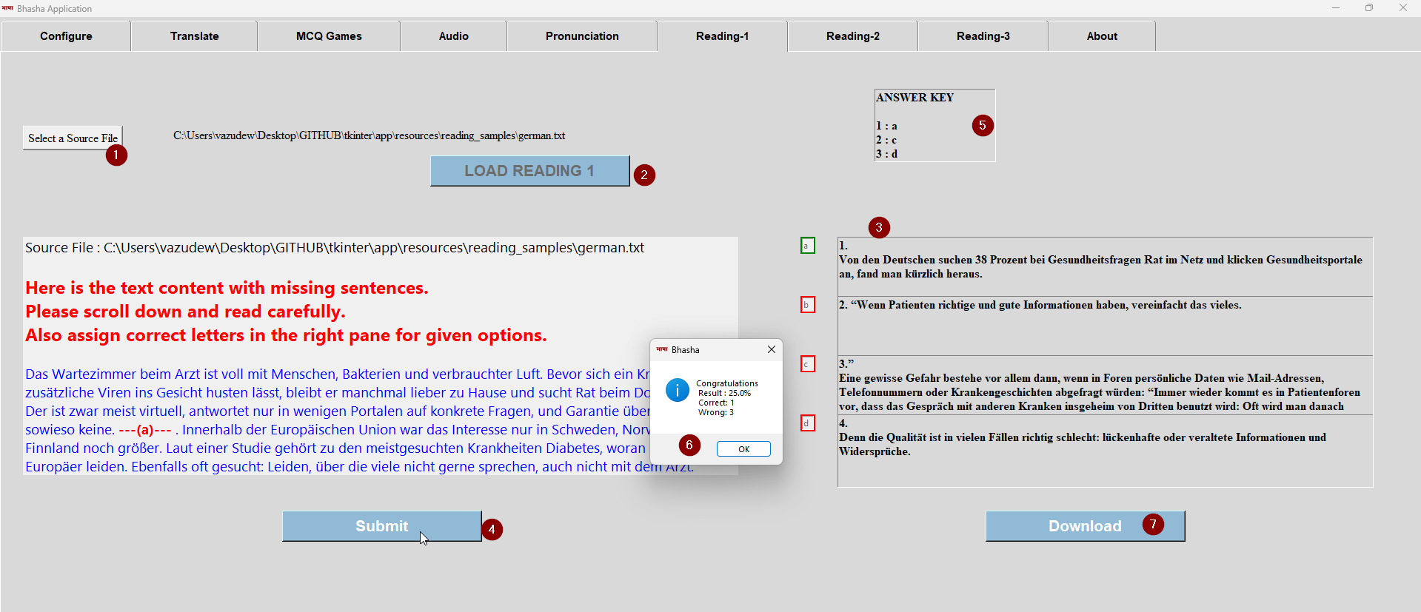

# 10. Reading 2 - Missing words

Unlike Reading-1, this game focusses on words from sentences. There will be standard 10 options for a given text comprehension. The instructions to use is same as Reading-1

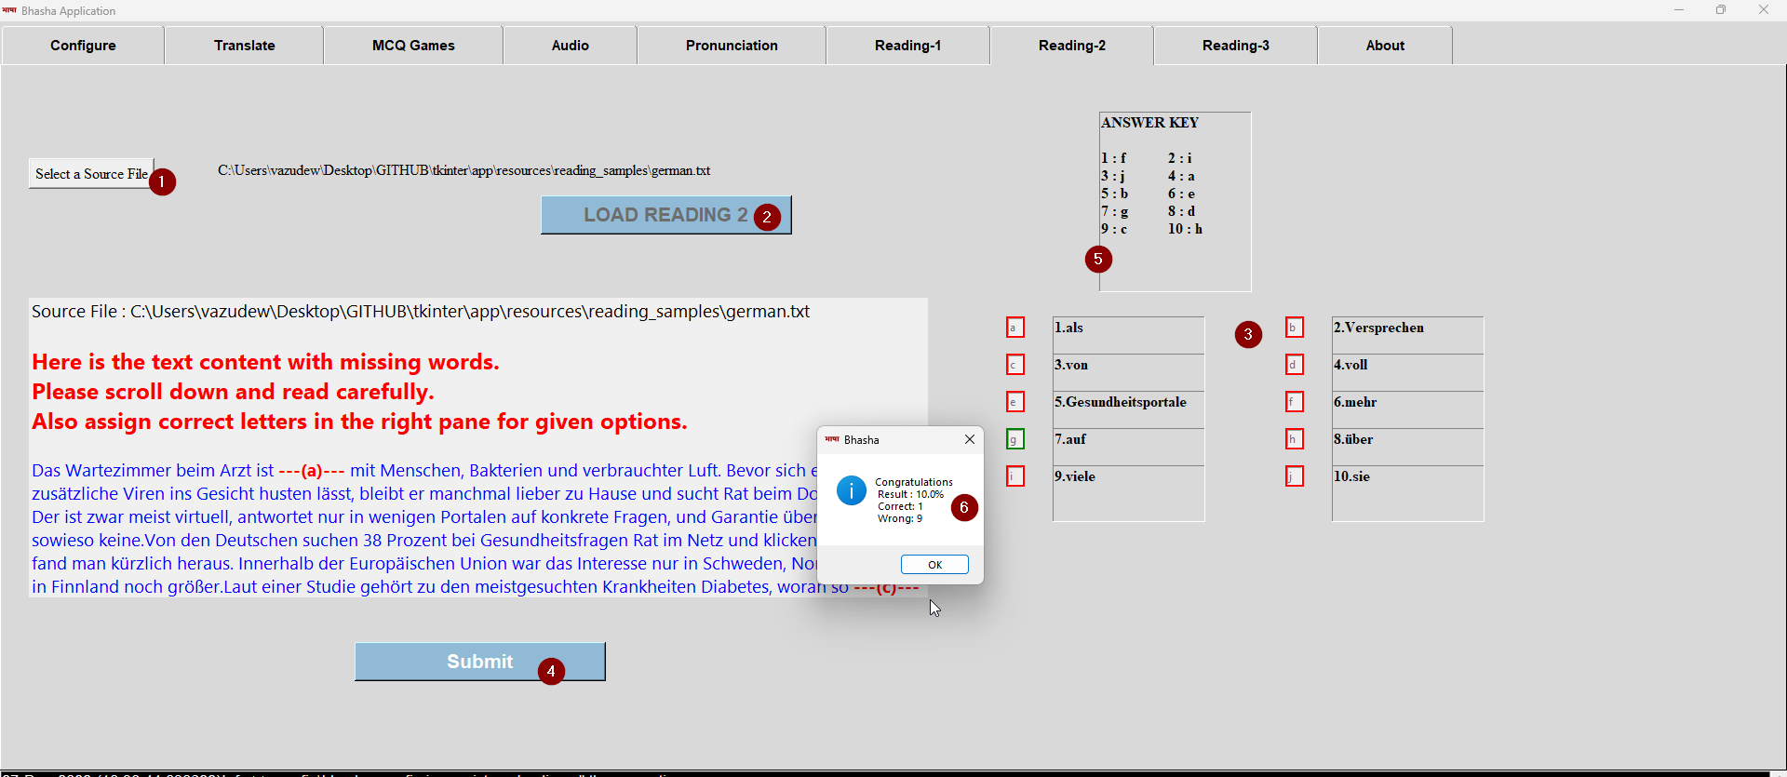

# 11. Reading 3 - Classifieds Matching

In this game, different small textual content will be displayed with various options. User must then match right classified with correction question. The instructions of use, is similar to Reading-1 and Reading-2. However here the text source is JSON file with textual content and query.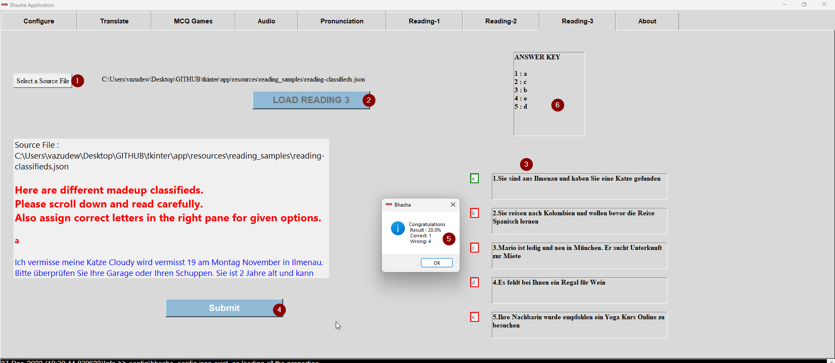

# 12. About - Contributions

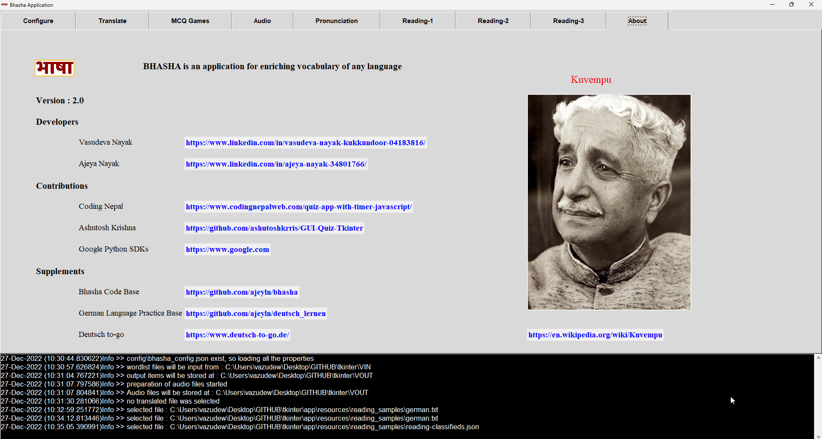This tab displays all the people and sources behind Bhasha application

# 13. Preparation Materials Links

* **Bhasha Code Base**  : <https://github.com/ajeyln/bhasha>
* **German Language Practice** : <https://github.com/ajeyln/deutsch_lernen>
* **Deutsch to-go** : <https://www.deutsch-to-go.de/>

# 14. Issues/Suggested Settings

1. **Installation issues**

Please check “note” section under section 2. Installation for various troubleshooting issues.

1. **Button, and tabs do not appear fullfledged**

Bhasha application is tested with Windows 11 Home edition with specific Monitoring specifications . Also during development of application, focus on GUI and appeaprance has been kept miminal with less agressive testing. Unfortunately not all combinations could be tested. As long as some part of GUI is visible, functionality can be ensured.

1. **Wordlist in a text file**

For translation to work, please ensure at least 5 words to be listed in a text file in input_folder. This is because options for the questions will be fetched from these wordlists.

1. **TRY AGAIN error during Pronunciation game**

In the Pronunciation game, you may often encounter status “TRY AGAIN ERROR”. This is due to google api and timing of speaking from user. Please try pronouncing the word again.

1. **Reading 1 and Reading 2 games**

Ensure source text file for Reading games, to have at least 4 Paragraphs. And in each paragraph, there must be at least 5 full sentences.