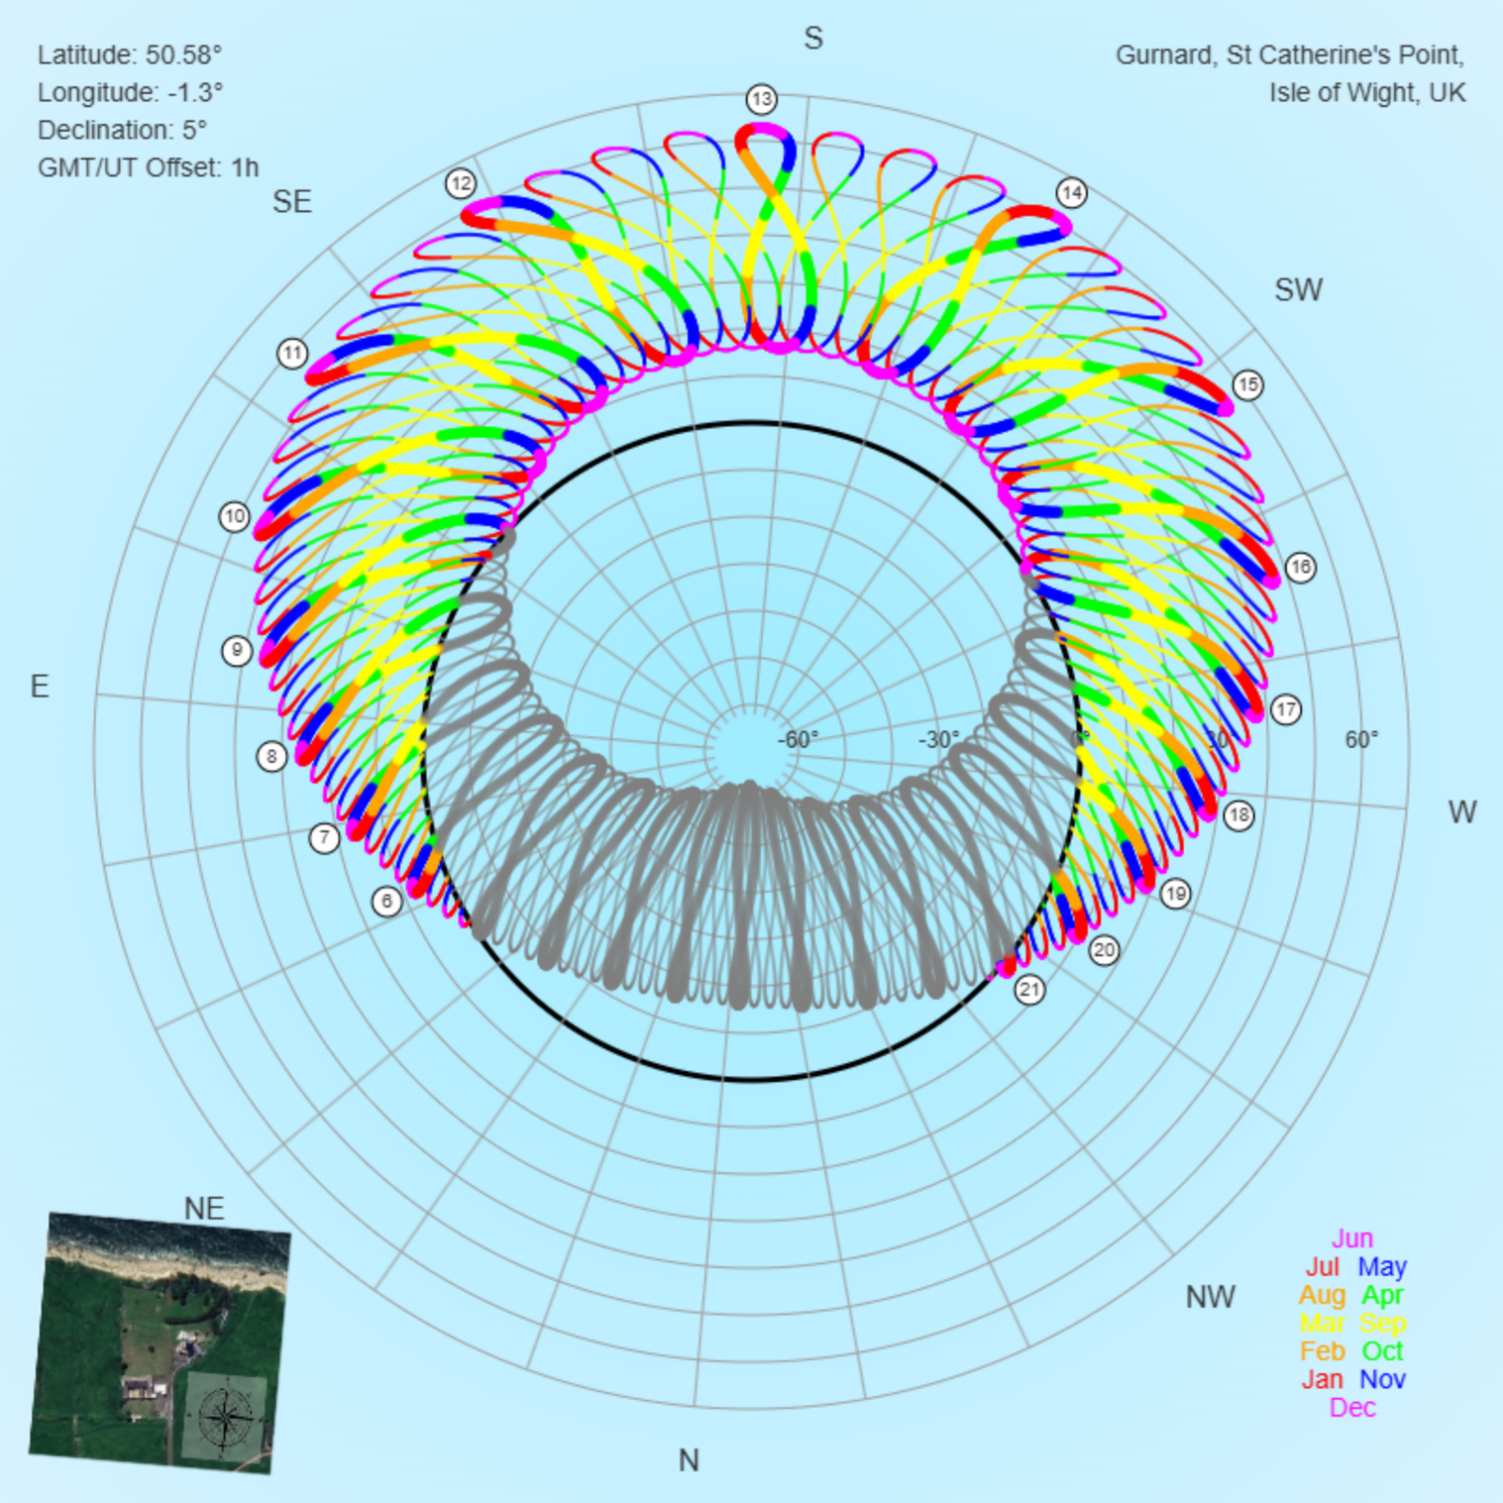
This graphic shows the position in the sky of the sun (azimuth from north shown around the circle, and elevation above the horizon shown along the radius) at all hours and quarter-hours throughout the year.
The months are shown in different colours, with grey indicating that the sun is below the horizon.
Hours are BST (GMT+1). You should be able to work out the time of sunrise for today’s date.
The figure of eight effect at each hour is due to the Equation of Time (the difference between sun time and clock time) varying though the year.
The graphic is rotated so that the page aligns with the windowsills in Gurnard.

