Inject 2:

Network Topology

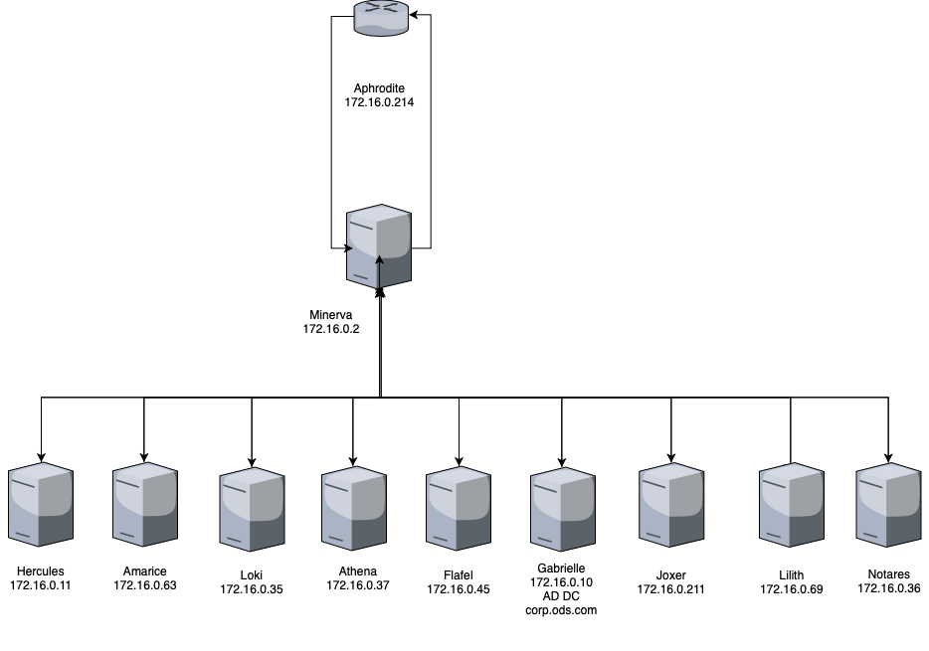

Machines

|  |  |
| --- | --- |
| Host “Hercules”  IP: 172.16.0.11 OS: Windows Server 2012 (Version 6.2)  Services: IIS 8.0  Domain: corp.ods.com | Host “Amarice”  IP: 172.16.0.63 OS: Alpine Linux (3.2.3)  Services: SSH (OpenSSH 6.8), HTTP (nginx 1.8.1) |
| Host “Aphrodite”  IP: 172.16.0.214 OS: Ubuntu (16.04.1)  Services: Docker (18.6.1/ce), SSH (OpenSSH 7.2p2), SMBd (4.3.11) | Host “Athena”  IP: 172.16.0.37 OS: Alpine Linux (3.8)  Services: SSH (OpenSSH 7.7, disabled), HTTP (Apache 2.4.35, disabled), FTP (vsftpd 3.0.3, disabled) |
| Host “Flafel”  IP: 172.16.0.45 OS: Debian (6)  Services: SSH2 (OpenSSH 6.7), HTTP (Apache 2.4.10) | Host “Gabrielle”  IP: 172.16.0.10 OS: Windows Server 2016  Services: AD Domain Services, IIS (8.0), Microsoft ftpd  Domain: corp.ods.com |
| Host “Joxer”  IP: 172.16.0.211 OS: CentOS (6)  Services: SQL (MySQL 5.1) | Host “Lilith”  IP: 172.16.0.69 OS: Windows 7 Version 6.1  Services: No services  Domain: corp.ods.com |
| Host “Loki”  IP: 172.16.0.35 OS: Windows Server 2012 Version 6.2  Services: IIS (8.0) | Host “Minerva”  IP: 172.16.0.2 & 172.16.0.1 OS: CentOS hosting PanOS 8.1.2  Services: Unknown (system down, Black Team advised) |
| Host “Notares”  IP: 172.16.0.36 OS: Windows Server 2008 Version 6.0  Services: IIS (8.0)  Domain: corp.ods.com |  |