Inject 3:

XMPP server identified as Tigase Server 8.0.0. Default administrator password changed.

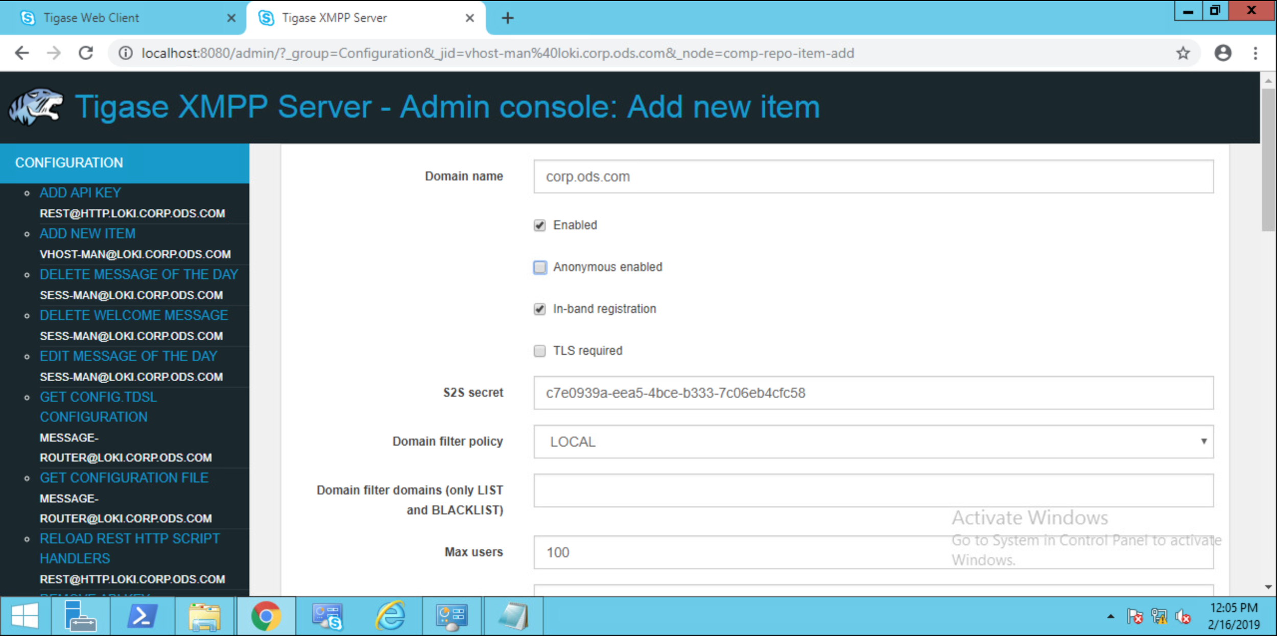

Added domain “corp.ods.com” to XMPP configuration. Disabled anonymous login.

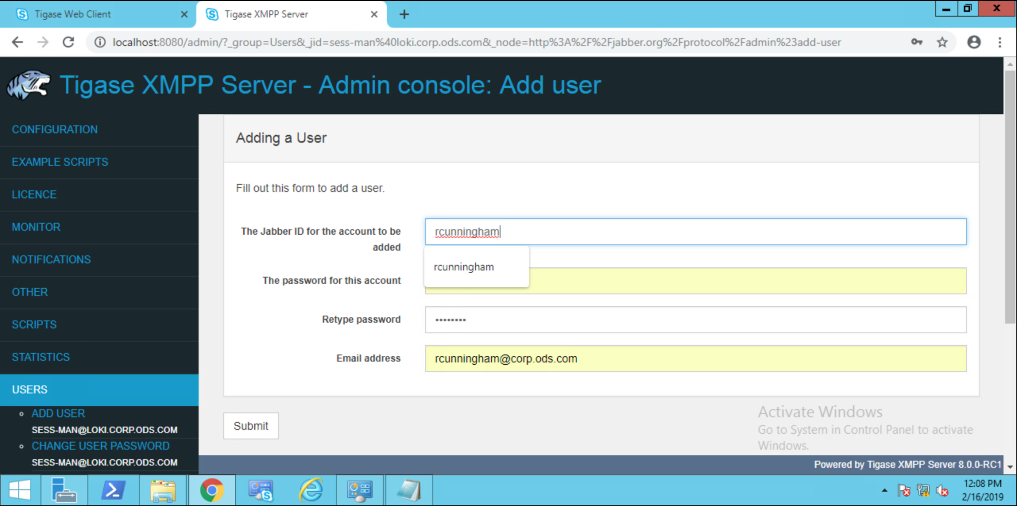

Creating a new test user for corp.ods.com domain.

XMPP server can be accessed by logging into loki.corp.ods.com, however network access is currently down. Black Team has been advised with a resolution pending.