Inject 4:

Inject 4 requires us to add Active Directory domain authentication to the blog hosted on the Amarice (Alpine Linux) and Amarice itself to allow password changes in one place, Active Directory users to be authenticated on Linux, and to consolidate user information in one place.

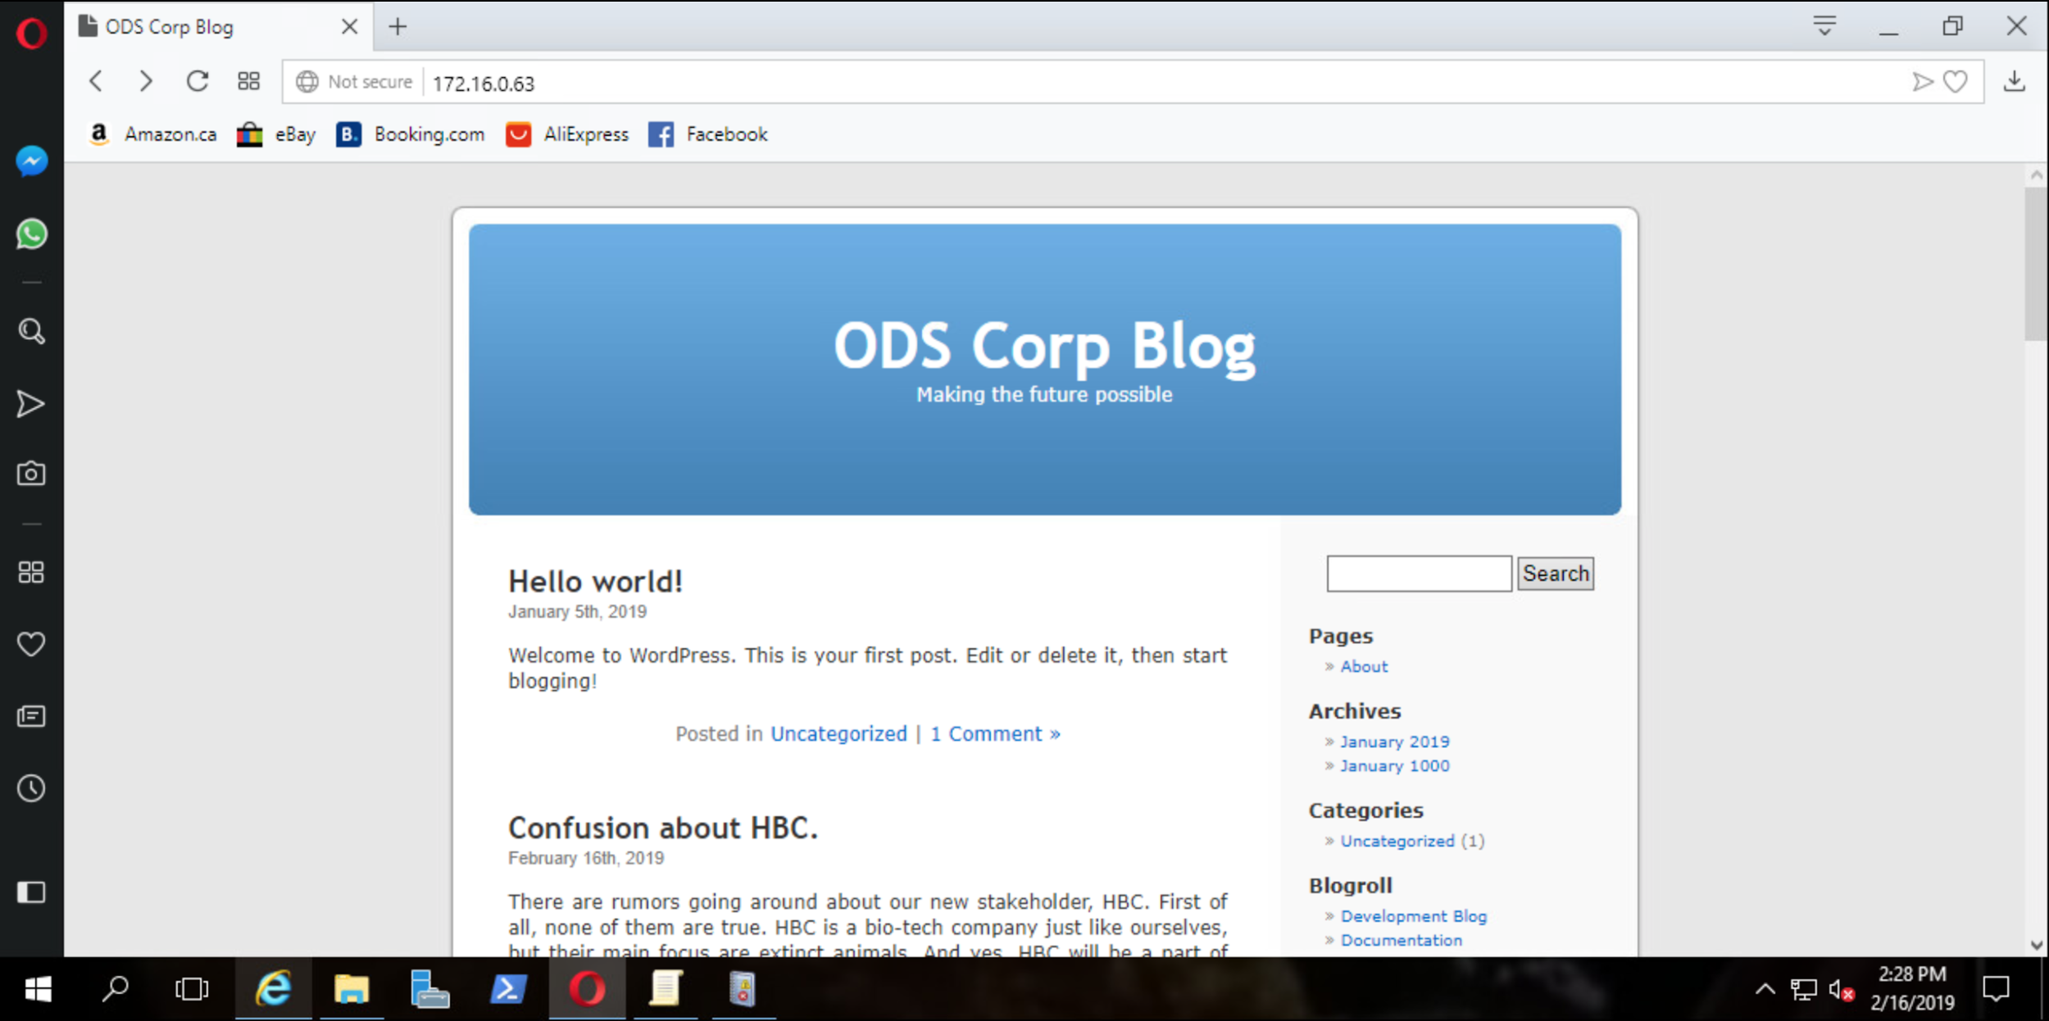

Pictured: Accessing the blog at 172.16.0.63 (Amarice)

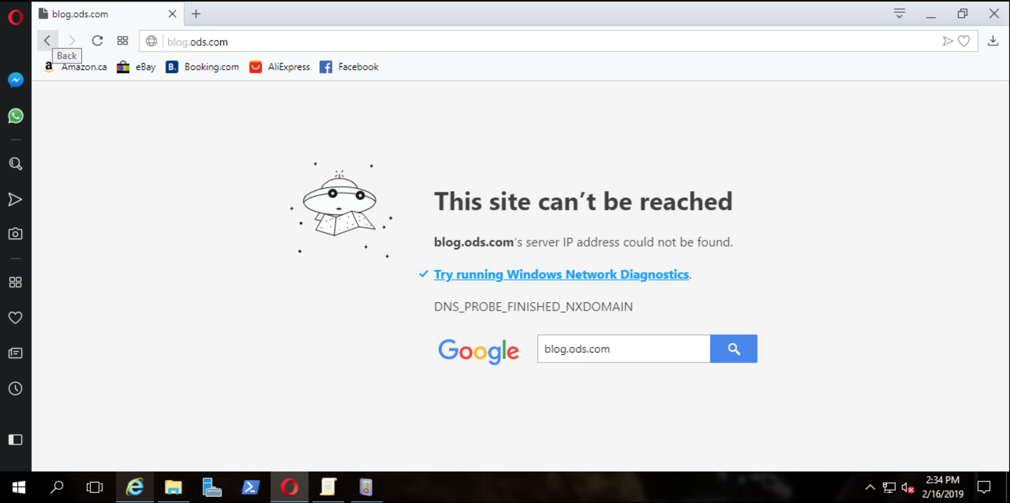

Pictured: Unable to resolve name blog.ods.com

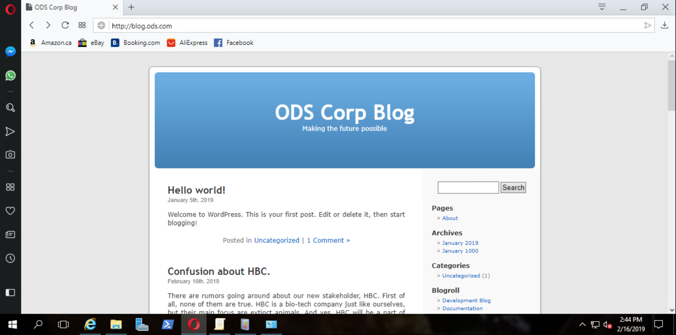

Pictured: Corrected domain issue

Next step is configuring AD authentication on Amarice, allowing users to login with their SAM accounts authenticated by our Domain Controller, Gabrielle. This required setting up SAMBA on Amarice, an open-source variant of Server Message Block (SMB) for non-Windows machines.

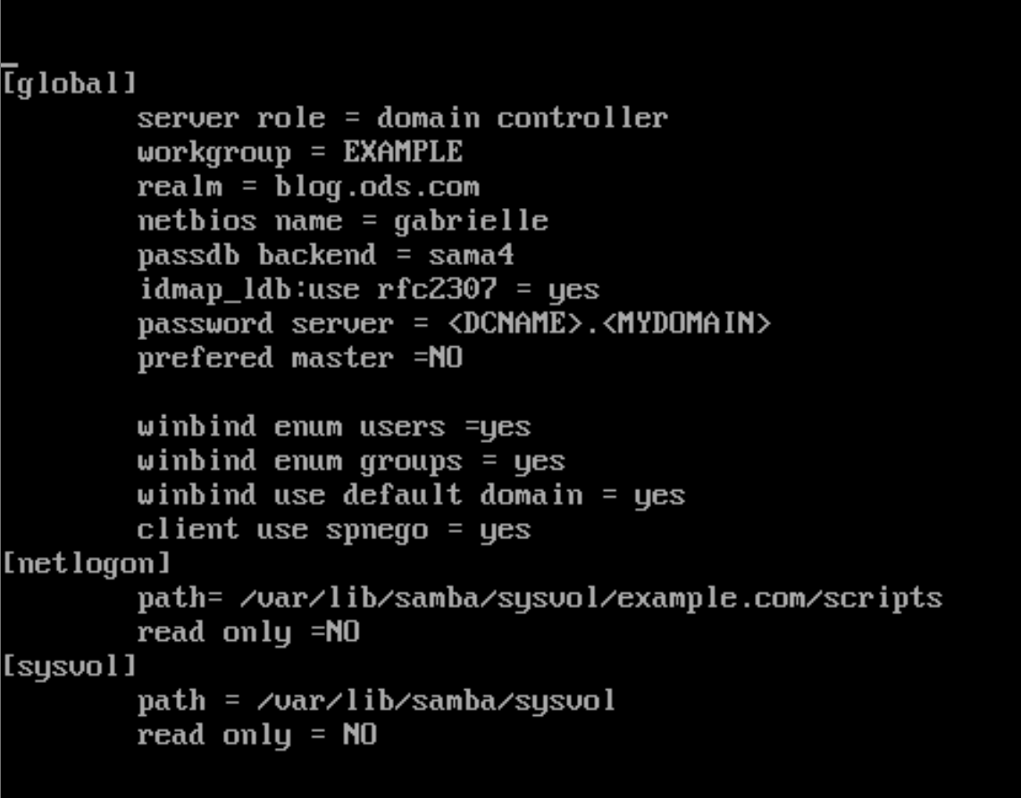

Pictured: SAMBA configuration file on Amarice

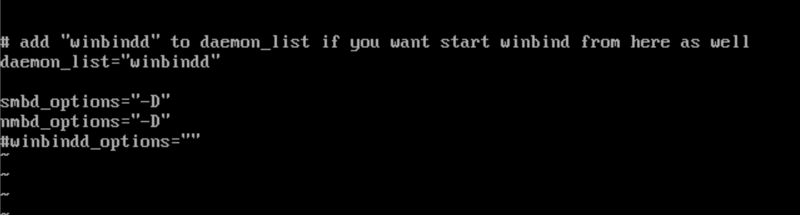

Pictured: Connecting winbindd daemon to the SAMBA server