Inject 6:

To purpose of inject 5 is to add Amarice to the Active Directory domain “corp.ods.com”. This allows Active Directory users login to the machine using their SAM accounts authenticated by the Domain Controller Gabrielle.

The first step to adding Amarice to the domain is to install and configure SAMBA on Amarice. SAMBA is an open-source variant of Server Message Block, a Windows protocol which allows shared access to network resources and acts as a pillar of Microsoft’s Active Directory.

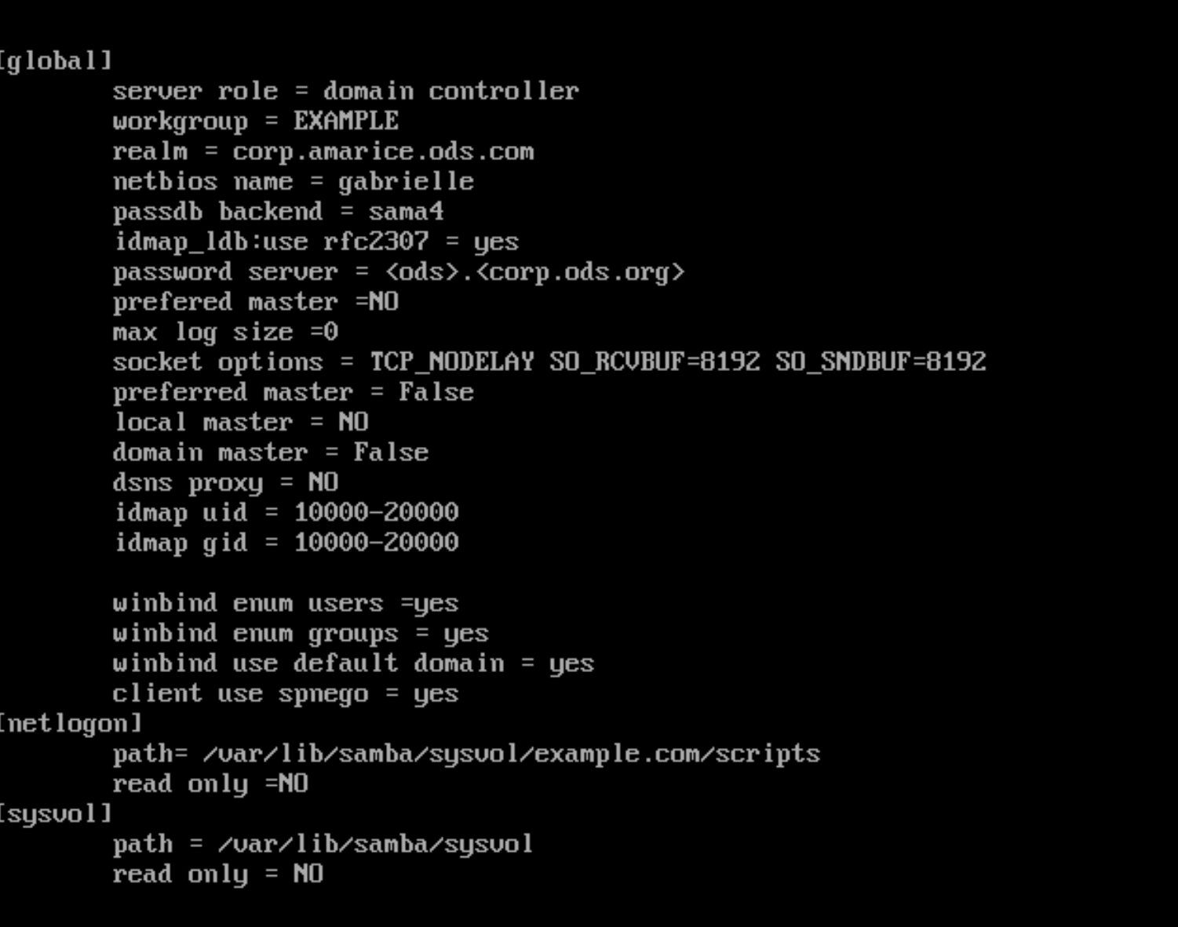

Pictured: SAMBA configuration on Amarice

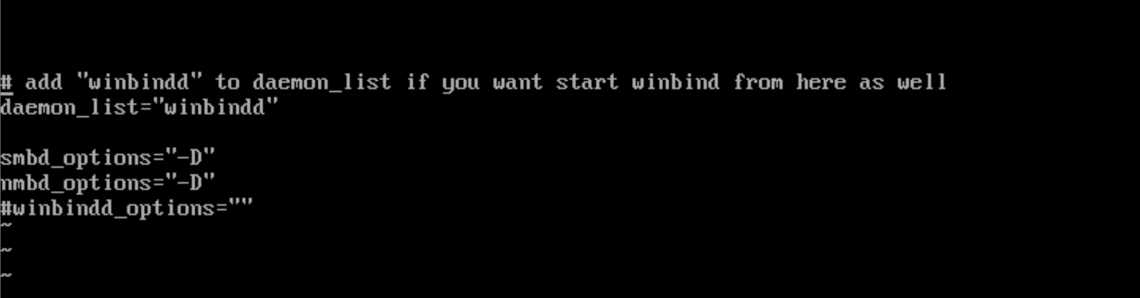

Pictured: Connecting winbindd daemon to the SAMBA server

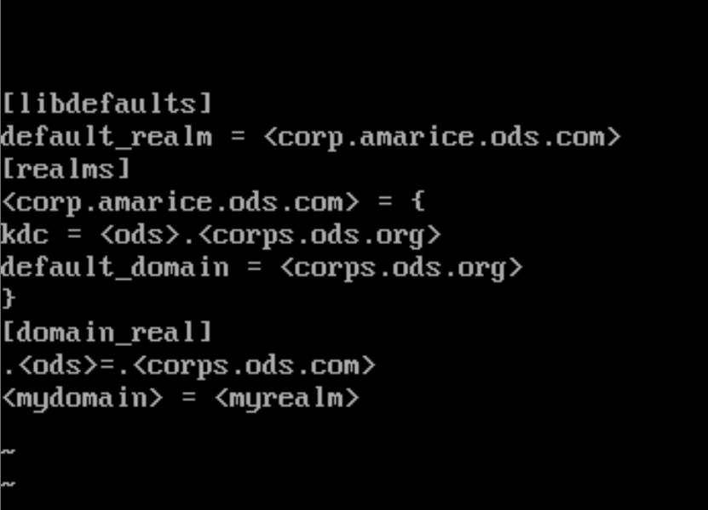

Pictured: krb5.conf configuration for Kerberos authentication

Due to Red Team intervention Active Directory linking on Amarice was not possible to complete.