**Pidgin.im**

**Summar:** XMPP has not been fully installed and configured properly, but we have begin to install Pidgin.im on all desktop environments. We are highly optimistic that this will be completed soon and a memo has been passed around to the company informing everyone that these changes will be taking effect soon.

Hercules

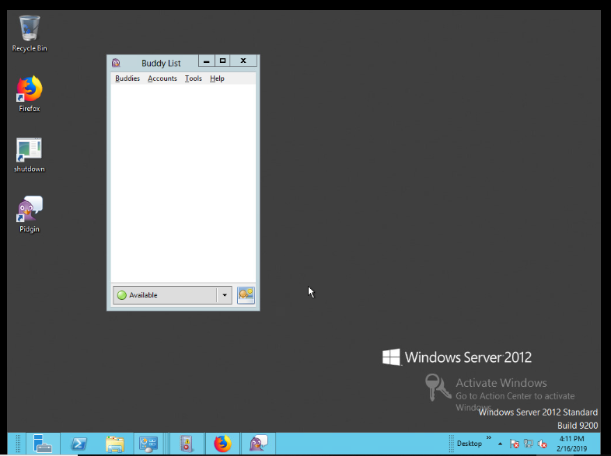

Gabrielle

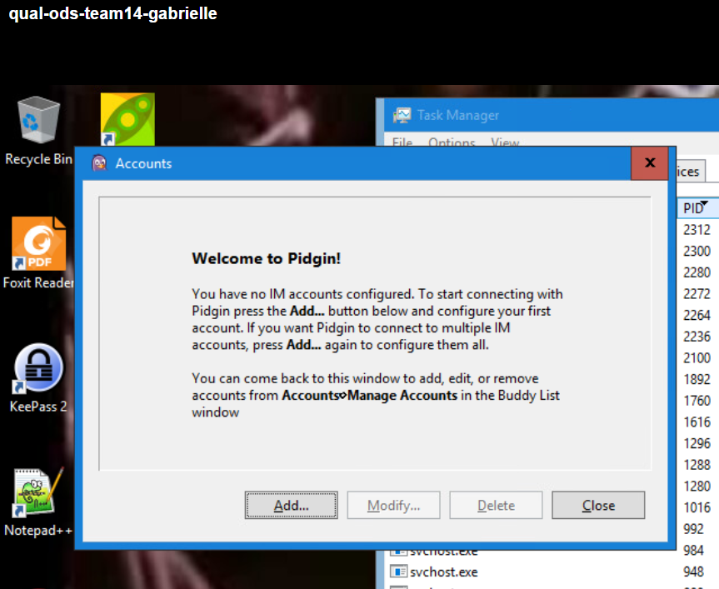

Loki

