“FOR ALL MANKIND”

SYSTEM ARCHITECTURE, DESIGN AND TESTING

AUTHORS | Dr Al Gill  Claude Sonnet 5
VERSION | 0.3
DATE | 2026-08-02

TECH STACK

Core Technologies
HTML5 — Semantic, universally supported markup that needs nothing more than a standard web browser to view, directly satisfying the requirement that the product be accessible to anyone without plugins or extra runtimes.
CSS3 — Modern layout features (flexbox, grid, media queries) deliver the verified responsive behaviour across phone, small tablet and desktop widths with no JavaScript overhead, keeping the client lightweight.
Vanilla JavaScript (client-side, no framework, no jQuery) — Keeps the client payload minimal to meet the requirement of remaining usable over constrained, high-latency links (20Mbps, including via NASA's O2O to the ISS/Moon); avoids build tooling entirely; modern native DOM APIs (fetch, querySelector, classList) already cover what jQuery used to be needed for, so it adds weight with no real benefit today.
TheLCARS.com HTML/CSS template (Jim Robertus) — Pure HTML5/CSS3 with no images, verified genuinely responsive across phone, small tablet and desktop widths (63 tuned media-query breakpoints), already integrated into the current codebase, and delivers the required LCARS aesthetic out of the box; its non-commercial EULA will be handled via on-site attribution and a written-consent request given the project's business-park outreach angle.
Node.js (server-side) — Already the runtime in use across server.js and readNews.js; native fetch and the built-in node:sqlite module keep the stack to a single language end-to-end, which reduces context-switching for a small team.
In-process scheduling via Node's setInterval, rather than OS-level cron — Matches the polling pattern already implemented in readNews.js and requires no authority to schedule jobs on the hosting service, since the timer runs entirely inside the same long-running Node process; if the chosen host cannot guarantee a continuously running process (e.g. it sleeps or restarts on serverless-style hosting), the fallback is an external scheduled HTTP trigger — either a free cron-as-a-service such as cron-job.org or the hosting platform's own managed scheduler — calling a refresh endpoint on a timer instead of relying on shell-level cron access.
SQLite (via node:sqlite) — Zero-ops embedded database already in use for space_news.db; comfortably handles current and expected ingestion volumes (TLEs, news, weather snapshots) without the operational overhead of running a separate database server.
Static hosting for the frontend — either a CDN/edge platform (e.g. Cloudflare Pages, Netlify) or a standard host (e.g. GoDaddy) — A CDN/edge platform gives free global distribution and git-based deploys, but that's a convenience rather than a requirement, since the project already has to tolerate multi-second latency for its most remote users; a standard shared host serving the same static files is equally valid.
VPS, PaaS, or a Node-capable shared host for the backend — Whichever is chosen just needs to run a persistent Node.js process for the API and ingestion; a VPS or PaaS guarantees this by design, and a shared host (e.g. a GoDaddy cPanel plan) can too, provided its plan supports a Node.js app and cron jobs.
CesiumJS — Industry-standard open-source WebGL library for 3D geospatial and orbital visualisation, needed for the LEO globe, satellite ground tracks, sensor cones and related orbital views.
Plotly.js — Handles most of the rendering work out of the box for 2D charts and the star catalogue visualisation, reducing custom charting code for things like Kp-index history and launch time series.

Third Party Libraries and Technologies
satellite.js — The standard JavaScript port of the SGP4/SDP4 orbit propagator; runs entirely client-side against the TLE data already pulled from CelesTrak, and covers ground tracks, the overhead-now predictor, GEO-belt density and sensor cones without any server round-trip.
Numerical Integrators for Orbital Mechanics - A hand-rolled numerical integrator (RK4) for the Orbital Mechanics Demonstrator, rather than a full HPOP library — A genuine HPOP (J2–Jn harmonics, drag, solar radiation pressure, third-body perturbations, GR) is heavy, and the closest mature open-source option, Orekit, is a JVM library that would require standing up a separate Java microservice for one feature; since the demonstrator is an educational sandbox rather than an operational SSA tool, a simple selectable-perturbation integrator in JS keeps the scope bounded and the stack client-side.
suncalc.js — A small, dependency-free library for sun/moon position and twilight calculations, needed for the day-night-terminator ground-track overlay and the aurora viewing-location layer.
OpenStreetMap Nominatim — Free geocoding service to turn a user-typed place name into coordinates for the overhead-now predictor, rather than building geocoding in-house.

ARCHITECTURE
This describes a system architecture that delivers the system and functional requirements.

Client-Side Files (HTML5 / CSS3 / JS)
- index.html — The single-page entry point and "mission control" landing view that all visualisation panels are navigated from.
- assets/classic.css — The TheLCARS.com-derived stylesheet providing the responsive LCARS layout, colour scheme and breakpoints, verified fluid from phone through desktop widths.
- assets/lcars.js — Core client-side interaction logic: navigation between panels and the space-news display already implemented against space_news.db.
- assets/Antonio-*.woff/.woff2 — The self-hosted Antonio typeface used for LCARS-style headings, avoiding a dependency on an external font CDN.
- One JS module per visualisation panel (satellite tracking, orbital demonstrator, star chart, space weather/aurora, launches, Earth observation, organisations, news) — Loaded on demand as the user navigates to each panel rather than bundled into one monolithic script, keeping the initial payload small for the low-bandwidth requirement.
- Self-hosted copies of third-party front-end libraries (CesiumJS, Plotly.js, satellite.js, suncalc.js) — Served from the project's own assets rather than linked from a CDN, so the client isn't dependent on a third party's uptime and nothing is hotlinked.

Server-Side Hosting
- One Node.js process per data domain, rather than a single shared process — An API server process (server.js) serves the endpoints the client calls, and each data-ingestion job (news, TLE, space weather, launches, Earth observation imagery) runs as its own separate Node.js process; this keeps each process's code and responsibilities simple, lets ingestion jobs run concurrently without competing for the same event loop, and means a crash or slow run in one ingestion process can't stall the API server or any other job.
- All processes hosted on the same machine, under whichever of a VPS, PaaS, or Node-capable shared host is chosen — Per techStack.md; the processes communicate with each other only indirectly, via the separate database files described below, not via direct inter-process calls.
- Static frontend files, optionally hosted separately from the backend — Since the frontend is just static HTML/CSS/JS, it can be served from a CDN/edge platform or a standard host independently of where the Node processes run; the two only need to be able to reach each other over ordinary HTTPS.

Process Supervision
- Each Node.js process is independently supervised and auto-restarted on crash — Now that ingestion runs as several separate processes rather than one, each needs its own restart-on-failure policy; use whatever the hosting layer already provides rather than building custom supervisor logic — a PaaS's own process manager, or systemd/PM2 on a VPS, each configured with one service entry per process.
- Per-process failure isolation — Because each ingestion process owns exactly one database file and has no direct dependency on the others, one process crashing and restarting has no effect on the API server or the other ingestion jobs, beyond that one dataset being briefly stale until it restarts.

Minimum Link Specification
- Client–server link — Minimum 20Mbps, with a design that tolerates multi-second round-trip latency (covering access as far as the ISS or the Moon via O2O); the client must not depend on fast round-trips, so it uses polling with long timeouts rather than websockets or assumptions of near-instant responses.
- Server–third-party API link — Standard broadband is sufficient; ingestion runs on a schedule rather than per user request, so it is not latency-sensitive.

Minimum User Device Specification
- Screen size — Tablet-sized or larger (roughly 768px+) for the intended full visualisation experience, per the software requirements; the underlying layout also renders correctly down to phone widths, so basic navigation and reading remain usable on a phone even though the 3D globe panels aren't designed to shine there.
- Browser — Any modern evergreen browser with WebGL support (required by CesiumJS) and ES2020-level JavaScript; no plugins and no installed app required, satisfying the "nothing more than a web browser" requirement.
- Network — As low as 20Mbps at high latency, matching the link specification above.

Server-Side Databases
- One SQLite database per data domain, each owned by exactly one ingestion process — Splitting by domain keeps each schema simple, lets a new prototype dataset be added as its own file without touching any live database, and means only one process ever writes to a given file, avoiding the write-lock contention that would occur if multiple ingestion processes shared one file; the API server process connects to all of them, but only ever reads.
- space_news.db (SQLite) — Already implemented; written by the news ingestion process, storing deduplicated news articles from the RSS feed list.
- merged_100pc.sqlite (SQLite) — Already built via buildStarDB/merge.py; the merged Hipparcos/Gaia star catalogue for stars within 100pc, static rather than continuously ingested, served to the client for star-chart rendering.
- An orbital-data cache (SQLite) — New; written by the TLE ingestion process, storing the latest TLE sets pulled from CelesTrak/Space-Track with a per-record last-refreshed timestamp, so the client isn't re-fetching from the third-party source on every request.
- A space-weather time-series store (SQLite) — New; written by the space-weather ingestion process, retaining Kp-index, solar wind and CME/flare event history over time rather than just the latest value, needed for the historical dashboards in the software requirements.
- A launches database (SQLite) — New; written by the launches ingestion process, storing launch records pulled from Launch Library 2, supporting the heat-map, time-series, by-organisation and by-vehicle views.
- An organisations/reference-data store (SQLite or a simple config file) — New; hand-maintained rather than written by an ingestion process, holding content with no API source, such as the organisations directory, glossary entries and CubeSat spotlights.
- WAL (Write-Ahead Logging) mode enabled once per database file — Each process sets PRAGMA journal_mode = WAL; the first time it opens its own database file; because the setting is stored permanently in the file itself, and each file has exactly one writer, this needs no ongoing management.

Scheduled Jobs
- News ingestion process — Already implemented in readNews.js; polls the RSS feed list every 30 minutes and writes new articles to space_news.db.
- TLE ingestion process — New; pulls updated orbital elements from CelesTrak (and Space-Track where registered) roughly hourly, since TLEs go stale quickly.
- Space weather ingestion process — New; polls NOAA SWPC and NASA DONKI every few minutes, given how fast Kp-index and solar wind data change.
- Launches ingestion process — New; polls Launch Library 2 every few hours, since launch schedules change comparatively rarely.
- Earth observation imagery ingestion process — New; checks for new Sentinel/Landsat/GIBS imagery daily, matching typical satellite revisit cadence.
- Scheduling mechanism — Each ingestion process runs its own internal setInterval-based timer at its own cadence, per techStack.md, with the external-HTTP-trigger fallback documented there for hosts that cannot guarantee continuous uptime for every process.
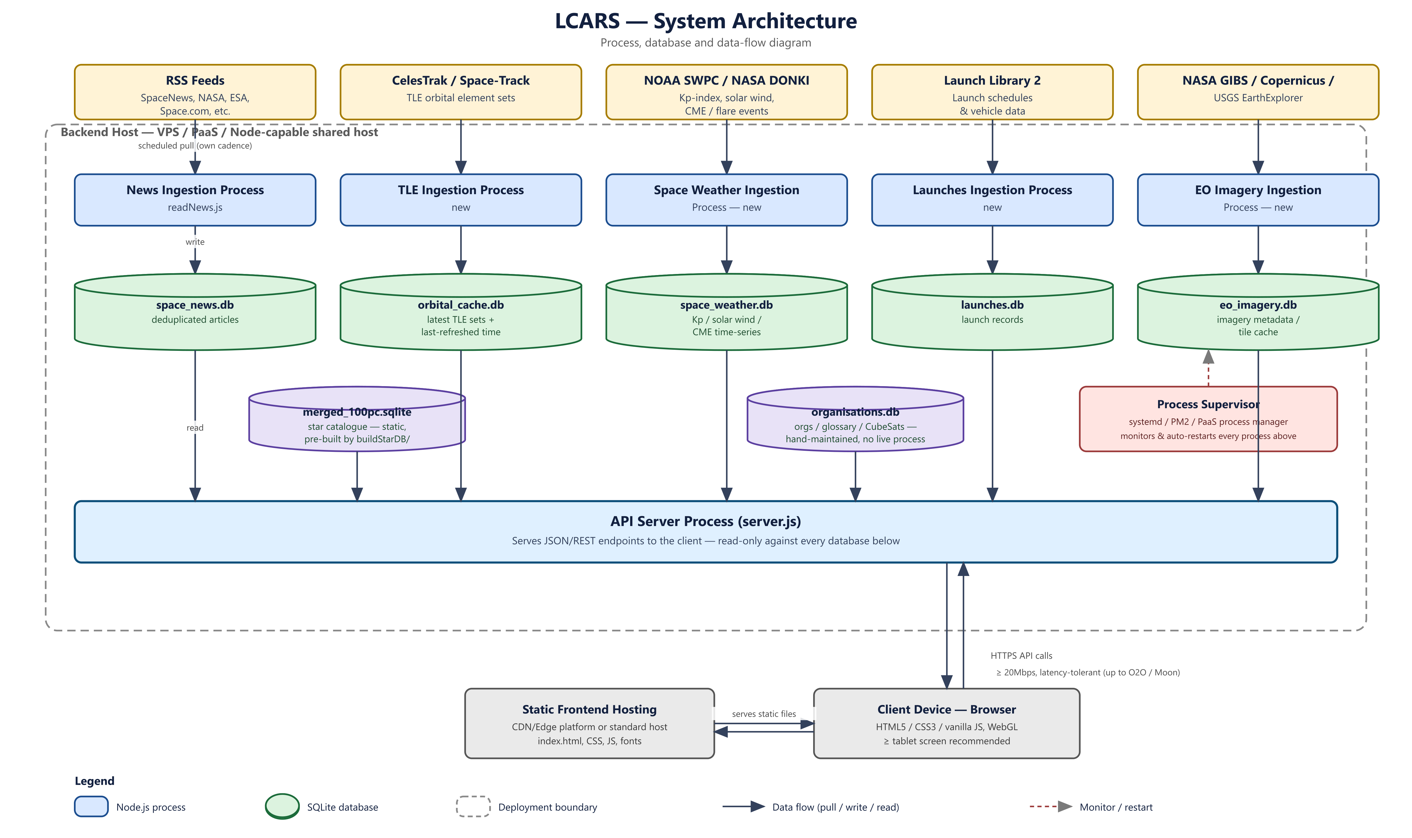

GUI
- LCARS-FAM (top-left corner, panel-1) — the structural elbow anchor for the whole frame; holds the product's own identity and doubles as a home link back to index.html.
- Location Banner (banner, top-right) — the current-section indicator; currently static text reading "FAM • MAIN", intended to update dynamically (e.g. "FAM • EARTH OBSERVATION") once section-switching logic is wired up.
- Inputs Panel (data-cascade-button-group / nav) — used for detailed inputs: typed fields, pill-cap action buttons, and selecting sub-sections within whichever main section is active. Not yet wired up to anything.
- Top bar (first-bar-panel, bar-1 to bar-5) — used for status indicators showing, e.g. the status of the data ingestion.
- Left Menu Sidebar (left-frame, panel-3 to panel-10) — the main section navigation menu. Currently placeholder labels (SW-DRIVERS, SW-FCST, SAT-ON ORBIT, SAT-GROUND, EO-IMAGERY, etc.); two of them (panel-3, panel-4) already toggle content via showSection().
- Bottom bar (bar-panel, bar-6 to bar-10) — reserved for scrubbers and +/- size controls acting on whatever's currently shown in the payload area. Not yet wired up.
- Main / payload area (<main>) — the actual visualisation viewport; its content swaps based on the selected section. Currently holds the default welcome text plus placeholder content for SW-DRIVERS, SW-FCST, and news.
- Footer — required attribution link to TheLCARS.com, per the template's licence terms.
- Headtrim / baseboard — thin decorative bars at the very top and bottom of the page, inherited from the LCARS template; no functional role.

DATA SOURCES
To provide the functionality described, data will need to be ingested from a variety of public domain sources. This will be in a variety of formats and accessible via a variety of different means – RSS, API, scraping etc..
A provisional list of data sources likely to be useful is shown in the Table.

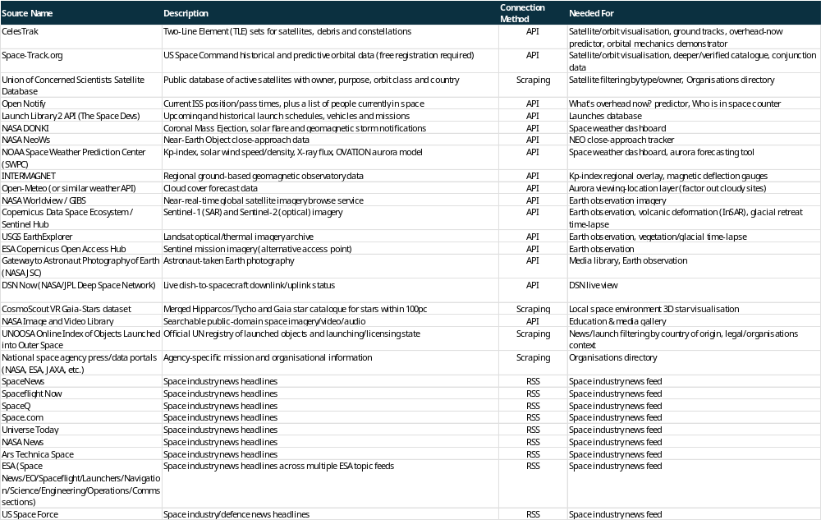

Ancillary Architecture

Static Database Build Tooling
Alongside the live Node.js ingestion processes described previously, several of the project's databases are quasi-static reference data rather than continuously refreshed feeds. For example, a list of the world’s space agencies changes only rarely. It can built once by standalone Python scripts run offline and then occasionally refreshed. The resulting database is simply shipped and read by the API server.
Because the underlying source data changes slowly, none of these scripts need a recurring schedule in the way the space-news or TLE ingestion does. They are run by hand, infrequently, whenever the source data is worth refreshing.

Canary Jobs — Live API Schema-Drift Monitoring
These are a different kind of ancillary script from the ones above. Rather than building a database, a canary job's sole purpose is to call a real third-party API on a low, fixed cadence (e.g. once daily) and check that the response still has the shape the ingestion code expects. This is designed to catch the failure mode that matters most in production — an upstream provider silently changing its API or response format.
This should look for things like the required fields being present, types are as expected, no unannounced deprecation or error response are returned. It should not validate the data's content. Such problems would not be caught by regular pre-deployment testing.
One small canary script per external source (CelesTrak, NOAA SWPC, NASA DONKI, Launch Library 2, etc.) should cover this. Each script would run independently of both the fixture-based tests and the live ingestion processes. It should raise an alert on failure rather than block anything as it is a monitoring signal, not a deploy gate.

Glossary
If implemented, this feature would be a curated list rather than being scraped from any particular source. For this reason, it might make sense to have some form of data entry tool, such as an XL document on which a python script could be run to produce a suitable SQL-flavoured database.

Star Catalogue
This is the most involved of the static databases, so it's worth documenting in full. The goal is a catalogue of stars within 100 parsecs of the Sun for the "Visualisation of Local Space Environment" feature, and it's built from two public catalogues combined by three scripts: `gaia100pc.py`, `hipparcos100pc.py`, and `merge.py`.

Why Two Data Sources?
Gaia DR3 is the modern, and by far the more complete source, having hundreds of thousands of stars within 100pc, with precise positions and (for most rows) measured stellar parameters, pulled directly from the Gaia archive via ADQL.
But Gaia has a specific, well-known deficiency: for instrument reasons, its astrometric and spectroscopic pipelines saturate for very bright, often nearby stars. These include some of the best-known naked-eye stars in the sky which are precisely the stars that are most obvious to humans and which it is most important to show correctly. These are missing or unreliable in Gaia DR3.
Hipparcos, an older and much smaller mission (~118,000 stars, whole sky, nowhere near Gaia's density within just 100pc), has no such saturation problem at the bright end. It's used here specifically to patch in the bright stars Gaia can't handle, not as a replacement for Gaia's overall dataset.

Modifications to the Raw Data
Neither catalogue is used as-is:-
Distance — Gaia's own photogeometric distance estimate is used where available, falling back to simple parallax inversion (1000/parallax) otherwise; Hipparcos has no Bayesian distance estimate at all and uses parallax inversion throughout. Rows whose parallax relative error exceeds 20% flagged in a `distance_reliable` column.
Absolute magnitude — computed manually for both catalogues (M = m − 5·log₁₀(d) + 5) from each catalogue's own apparent magnitude and distance. This is not extinction-corrected in either case, a known approximation carried into the output rather than hidden.
Temperature — Gaia rows use a three-tier fallback: its own photometry-based measurement (`teff_gspphot`) first, its separate spectroscopy-based measurement (`teff_gspspec`) second where the first is missing, and a derived estimate from BP-RP colour (Jordi et al. 2010) third, only for colours within that relation's valid range. Hipparcos has no measured temperature at all, so its temperature is derived entirely from B-V colour using a different published relation (Ballesteros 2012). Every row's `teff_source` column records exactly which method produced it, because the two catalogues' colour-derived estimates are not directly comparable methods or precision.
Names — neither catalogue carries proper star names. Both scripts resolve names via a single bulk positional cross-match against SIMBAD. Rather than one network call per star, which would trip SIMBAD's rate limiter, we use a 10 arcsec match radius. That radius was deliberately widened from an initially tighter 2 arcsec after real stars — Vega among them — came back unnamed: Gaia's epoch (2016.0) and SIMBAD's stored epoch for a given star can differ by decades, and nearby high-proper-motion stars drift several arcsec in that gap, so a tight radius systematically misses exactly the stars this catalogue cares about. Unmatched stars simply keep their catalogue identifier (Gaia source_id or Hipparcos HIP number) as a fallback name.
Merging — Gaia and Hipparcos share no common identifier, so `merge.py` cross-matches the two purely by sky position, again at a 10 arcsec radius, using each catalogue's own epoch coordinates (neither saved dataset carries proper-motion columns, so no motion propagation is attempted — a known limitation, audited via a `match_sep_arcsec` column on every matched row rather than left invisible).
Where a star appears in both catalogues, the Gaia row is kept as the primary record and Hipparcos is used only to fill genuinely missing fields, chiefly temperature. Unmatched Hipparcos rows — disproportionately the brightest, Gaia-saturated stars — are appended as their own entries. Every output row is tagged `gaia`, `hipparcos`, or `gaia+hipparcos` via a `source_catalogue` column.
Known deficiencies – Gaia's core weakness is bright-star saturation, which is the entire reason Hipparcos is in the pipeline at all. Hipparcos's weaknesses are its much smaller sample and the total absence of measured temperature. Both catalogues' absolute magnitudes are uncorrected for extinction. The cross-catalogue match itself is approximate: a fixed positional radius with no proper-motion propagation can occasionally miss a very fast-moving star or mismatch a close visual double, which is why every match is left auditable rather than resolved silently.
Why this approach? Combining Gaia's breadth and precision with Hipparcos's bright-star completeness, while preserving `teff_source`, `source_catalogue`, `match_sep_arcsec`, and `distance_reliable` as audit columns in the final `merged_100pc.sqlite`, gives the most complete local star catalogue achievable from public-domain data without hiding where its precision is approximate — appropriate for a public-facing visualisation that should be inviting rather than clinical, while still being honest about its limits if anyone downstream needs to filter on data quality.
Refresh Cadence – This data is effectively static. Stellar positions and properties don't change on any timescale that matters here with even nearby stars with high proper motions not moving that much. The only reason to rerun this pipeline is to pick up a new Gaia data release (e.g. DR4) every few years, not on any recurring schedule.

In Orbit

Orbital Object (TLE) Ingestion

1. Purpose
Ingest and serve current orbital element data (TLEs) for on-orbit objects, supporting ground-track visualisation, the orbital-mechanics demonstrator, and satellite filtering/plotting features described in the software requirements document.

2. Data Sources
Three complementary sources were selected for orbital object ingestion, each fulfilling a distinct role rather than duplicating the others' coverage. CelesTrak's General Perturbations (GP) API (gp.php) serves as the primary source: a RESTful, unauthenticated endpoint offering pre-packaged category queries (GROUP=active, GROUP=starlink, etc.) that map directly onto the client's panel-level filtering requirements, and confirmed as CelesTrak's actively maintained, officially documented interface.
Space-Track.org, the U.S. Space Command's authoritative catalogue, provides a fallback and verification pass: its gp class is queried for objects updated within the preceding 48 hours, backfilling any NORAD IDs CelesTrak's category files failed to return in a given run, and is additionally the source of record for the four SATCAT-equivalent fields (OBJECT_TYPE, LAUNCH_DATE, DECAY_DATE, RCS_SIZE) returned inline with the orbital elements rather than as a separate resource.
SatNOGS DB supplies a narrow supplemental pass limited to amateur-radio and CubeSat objects falling outside both mainstream catalogues' typical coverage. Within a single ingestion run, source priority is strictly ordered — CelesTrak, then Space-Track, then SatNOGS — so a lower-priority source can only add coverage a higher-priority one missed that run, never overwrite it.
Source | Role | Redistribution basis | Auth
CelesTrak | Primary | Established public-redistribution practice; purpose-built for this use case | None
Space-Track | Fallback / full-catalog  verification | Explicit blanket approval for redistribution of basic SSA data (TLE, OMM, SATCAT, decay data), conditioned on citation — per current Space-Track documentation, superseding the "prior approval" language in the 2019 User Agreement | Username / password → session  cookie
SatNOGS DB | Supplemental | Independently observed, not a Space-Track derivative – can surface objects ahead of the official catalog. | None

CelesTrak and Space-Track publish materially the same current on-orbit population (~34,000 objects); SatNOGS is the only source able to add coverage the other two don't have.
Alternatives considered and rejected. Two further sources were evaluated and found unsuitable for a scheduled, programmatic ingestion process. Heavens-Above, though a long-established pass-prediction service, offers no public API; its Android application communicates with proprietary, undocumented internal endpoints, and its maintainers publicly direct developers requiring programmatic orbital-element access to CelesTrak instead, on the basis that both platforms draw from the same underlying data. Jonathan's Space Report / the General Catalog maintained at planet4589.org is similarly unsuited to this architecture: it is published as a collection of static text files and manually maintained tables rather than a queryable service, is explicitly positioned by its maintainer as a resource for historical analysis and cross-catalogue correction rather than real-time operational tracking, and would require bespoke flat-file parsing with no update-detection mechanism of the kind CelesTrak and Space-Track both provide natively. Neither is compatible with the twice-daily automated refresh cycle this ingestion process is built around.
The industry is shifting from the legacy Two-Line Element (TLE) format to the CCSDS Orbit Mean-Elements Message (OMM) standard reflects structural limits inherent to a format designed for 1960s fixed-width output. TLE's five-digit catalog-number field is approaching exhaustion under the combined pressure of mega-constellation deployment and an accelerating launch cadence; its two-digit epoch year resolves via a sliding pivot-year convention that becomes permanently ambiguous from 2057 onward; and its fixed ASCII fields cannot represent satellite names outside the Latin character set. OMM, expressed as structured JSON, XML or KVN rather than fixed-column text, removes each of these constraints while remaining data-equivalent to a TLE for SGP4/SDP4 propagation, and is natively machine-parseable without the bespoke column-position parsing this ingestion process must otherwise implement for classic 3LE responses. This shift is reflected directly in the APIs this process consumes: Space-Track has retired its legacy tle and tle_latest classes in favour of the OMM-based gp and gp_history classes, and CelesTrak's own gp.php endpoint — named for General Perturbations data, the OMM term of art — has likewise superseded the static, fixed-width .txt element files the service published historically.

3. Ingestion Process
The jobs shall run as two separate processes to reduce the risk that a single fail-over will take out both jobs or that the server side processing will exceed the restrictions of a cheap hosting package. Ingestion for both should run twice per day. Less ought to be adequate for something that is primarily entertaining but sooner or later people are going to want to watch satellites launched aboard e.g. SpaceX.

Job | Cadence | Rationale
TLE/GP  element  fetch | Twice daily (every 12h) | Within CelesTrak's polling ceiling; most objects don't get a fresh TLE from source more than once every 1–2 days regardless, so this loses negligible freshness vs. the earlier 6h proposal
SATCAT metadata fetch | Twice daily (every 12h) | Matches CelesTrak's own SATCAT update cadence (1–2×/day)

All three downloads shall be chunked and throttled to avoid reaching the rate limit.

4. Storage
The orbital objects data shall be held in a new domain database: ingestionDBs/orbitalObjects.db (SQLite via node:sqlite, WAL mode) — consistent with the project's one-process-per-domain, one-database-per-domain architecture. The data will be held in a single table, with data upserted (rather than appended) keyed on the NORAD catalog number, since this is current-state data.
Decayed objects (decay date IS NOT NULL) are retained but excluded from ground-track queries by default, preserving the audit trail — same approach as the star-catalogue pipeline. The main reason for this is distinguishing real decay from a silent ingestion failure.
If a row simply disappears from the database, there are two very different explanations that look identical from the outside: (a) the object genuinely reentered, or (b) something broke in the ingestion — a source dropped it from a group file, a query filter excluded it by mistake, a schema change silently orphaned it. If decayed rows are deleted, both cases produce the same symptom: "this object used to be there, now it's gone." You'd have no way to tell, after the fact, whether that's expected or a bug. Keeping the row with decay_date set turns that ambiguity into a visible, queryable fact — "decayed" is a state on a record, not the record's absence.
A few more concrete reasons behind it, roughly in order of how likely they are to matter in practice:-
- Source data isn't always clean. CelesTrak/Space-Track occasionally correct a decay flag that was set in error (mis-attributed reentry, later reversed). If the row's already deleted, "un-deciding" a decay means recreating the object from scratch rather than just clearing a field on next ingest.
- Dangling references. If anything else in the app ever keys off norad_id — a launch-database cross-reference, a news-article tag, a future "objects of interest" list — deleting the row breaks that join silently rather than leaving a resolvable, flagged record.
- Future reentry/decay feature. A "recently reentered objects" panel is a plausible natural companion to the launches database you already have planned. Deleting on decay would foreclose that before it's even been considered.
- Historical/time-scrubbing views. If the app ever lets someone look at "what was on orbit as of [past date]," an object that decayed after that date needs to still exist in the table to render correctly for that view.
None of this is expensive to keep — it's a few tens of thousands of small rows either way — so there's no real storage trade-off pushing toward deletion. The decay date IS NOT NULL filter already gives you the same practical effect (decayed objects don't show up in ground-track queries by default) without giving up the ability to tell "gone because decayed" from "gone because something broke."

5. API / Serving
GET /api/orbital-objects?group=<group> — returns only the requested category (active, stations, visual, starlink, gps-ops, etc.), mirroring CelesTrak's own category system. A full unfiltered dump is deliberately not implemented by default. The full catalog's raw TLE text alone is about equal to the project’s 5MB initial-load budget and served as JSON would be of order 15-25Mb so per-category filtering is a bandwidth requirement, not an optimisation.

6. Client-Side Rendering
New lazy-loaded panel module assets/orbitTrack.js are fetched only when the relevant panel opens as per the usual per-panel lazy-load pattern. The client will then use the self-hosted satellite.js library to propagate each TLE across one orbital period and render the ground track. Propagation and TEME→ECEF/geodetic conversion happens entirely client-side from UTC alone (with no Earth Orientation Parameters feed) — since the resulting precision loss (sub-few-hundred-metres) is invisible at map scale and consistent with Space-Track's own guidance that public TLEs aren't for precision-critical use.

7. Data Flow
The data flow for ingestion will be as follows:-

CT[CelesTrak] -->|primary| ING[ingestOrbitalData.js]
ST[Space-Track.org] -->|fallback + verification| ING
SN[SatNOGS DB] -->|supplemental| ING
ING -->|upsert by noradID| DB[(orbitalObjects.db)]
DB --> API["/api/orbital-objects?group=..."]
API --> CLIENT[orbitTrack.js]
CLIENT -->|satellite.js SGP4 propagation| MAP[Ground track render]

The data will be held in a single table:-
ER Diagram (Entity Relationship Diagram)
ORBITAL_OBJECTS {
INTEGER noradID PK
TEXT name
TEXT line1
TEXT line2
TEXT epoch
TEXT objectType
TEXT owner
TEXT launchDate
TEXT decayDate
REAL rcsSize
TEXT source
DATETIME fetchedAt
}
Field notes updated accordingly: `noradID` (PK), `objectType`/`owner`/`launchDate`/`decayDate`/`rcsSize` (SATCAT job), `decayDate IS NOT NULL` is the exclusion filter, `source` and `fetchedAt` as before.Where:-
- noradID — primary key, unique NORAD catalog number, used for upsert.
- line1 / line2 — raw TLE lines, kept verbatim rather than fully decomposed, matching the "store the source alongside the derived value" audit pattern from the star-catalogue pipeline.
- objectType, owner, launch_date, decay_date, rcs_size — populated/refreshed by the SATCAT job, on its own slower cadence.
- decayDate IS NOT NULL — the flag ground-track queries filter on to exclude reentered objects.
- source — which feed (celestrak / space-track / satnogs) supplied the most recent update for that row.
- fetchedAt — last successful ingestion timestamp for that row.
- Let me know when you want to move to implementation.

We store which CelesTrak groups each satellite belongs to. A satellite can belong to more than one group at once. Starlink satellites sit in both "starlink" and "active." A single column cannot hold that cleanly, so we use a second table, orbital_object_groups, with one row per satellite per group.
This creates a risk. Counting rows in the new table would overcount satellites that belong to several groups. We avoid this by convention. We always count satellites from the main orbital_objects table, never from the groups table. The groups table only answers "which satellites are in this group," never "how many satellites exist."
Not every satellite has a group. CelesTrak does not sort every object into a named list. It has no general group for rocket bodies or debris, only three for specific fragmentation events. Objects that come from Space-Track or SatNOGS also have no group, since neither source tags objects by group. A satellite with no rows in the groups table is not an error. It simply means CelesTrak places no named list around that object.

Interpretation of Fields

Value | Meaning | Source
PAY | Payload — an active or inactive spacecraft/satellite | CelesTrak (satcat.csv)
R/B | Rocket Body — a spent launch-vehicle stage left in orbit | CelesTrak (satcat.csv)
DEB | Debris — fragments from breakups, collisions, or discarded mission hardware | CelesTrak (satcat.csv)
UNK | Object type not yet classified | CelesTrak (satcat.csv)
UNKNOWN | Object type not yet classified (unabbreviated equivalent of UNK) | Space-Track (gp class, backfill only)

Organisations Directory
Populates the "Organisations" section of the software requirements — space agencies, commercial space companies, and other space-sector organisations. Unlike the star catalogue, this is compiled from public reference/directory sources (e.g. UNOOSA's list of member state space agencies, and public lists of commercial spaceflight companies) into a simple structured table (name, type, country, founding year, website, etc.) written to `organisations.db`.
Because this list changes slowly — new agencies and company launches/mergers are rare events — the build script would be run occasionally by hand (perhaps quarterly, or whenever a gap is noticed), not on any automated schedule.

INDUSTRY INFRASTRUCTURE
This will provide a map of where the space industry's ground segment infrastructure is located.

Mapping Tool
Rendered on a Leaflet.js map using a self-hosted static world-boundary outline rather than a tile service, per the earlier decision to avoid third-party tile quotas — keeps the panel's cost flat regardless of page-view volume, consistent with self-hosting other front-end libraries.
Each of the nine categories of ground infrastructure asset is held as its own Leaflet layer group. Nine categories don't fit the six-button control-area group used elsewhere, so toggling is done via the key itself rather than dedicated buttons: clicking a legend row's swatch calls addLayer/removeLayer on that category's layer directly, with a further ALL row toggling every layer together.

GUI
Assets are plotted as colour-coded points, one colour per category — Launch Sites, Teleports, Deep Space Network, Mission Control Centres, Ground Segment as a Service, Space Situational Awareness, Constellation Gateways, Space Parks, and Space Test Facilities, superseding the six-category list in swareRqts_0.2.docx now that the source research (infrastructureRsch/) has settled on nine — circle size scaled to each installation's relative size/importance.
The key is rendered in the control area's left-hand slot — the same slot that normally shows the section label — as a small colour-swatch-plus-name legend, one row per category, sitting immediately left of the buttons that control it.

Data Storage
Industry infrastructure asset data is held in its own SQLite database, infrastructure.db, following the same one-database-per-domain convention as space_news.db and merged_100pc.sqlite. Unlike those two, no ingestion process owns it: entries are added via direct INSERT statements run ad hoc whenever a new asset needs recording, the same hand-maintained pattern already used for the organisations directory and glossary. The API server's only role is a read-only GET /api/infrastructure endpoint, matching the existing /api/news handler's shape. Source data is the nine spreadsheets under infrastructureRsch/ (one per category), each transcribed into the database by hand rather than parsed programmatically, since the sheets are one-off research rather than a stable format worth writing a loader for.
A flat file (JSON) was considered as an alternative, on the reasoning that hand-maintained data benefits from being human-readable and git-diffable. That reasoning doesn't hold here: entries are added by LLM sessions over time rather than a single continuous human maintainer, so an enforced schema is worth more than diff-readability — a CHECK constraint on the category column (one of spaceport, teleport, dsn, mcc, ground_segment, ssa, constellation_gateway, space_park, research) and on size (an integer 1–5 driving each point's circle radius on the map) catches a malformed entry at insert time rather than letting it silently corrupt the map's colour-coding or sizing later. Each row additionally carries a stable text id slug rather than an autoincrement integer, lat/lon in WGS84 decimal degrees for direct use by Leaflet, and optional country/operator/notes fields surfaced in each point's popup.

