

|  |  |
| --- | --- |
| **Group:** | James Beasley, Charles Beck, Charles Duso, Alexander Grzesiak, Erik Strauss |
| **Project Title:** | Boston University - Microfluid Experimentation Data Generator |
| **Deliverable:** | D.2.2. Use Cases |
| **Course:** | CS386 – Spring 2017 |
| **Instructor:** | Professor Gerosa |
| **Github:** | <https://github.com/TheAwesomeEgg/CS386ProjectGroup1.git> |

# Introduction

The purpose of this document is to describe and illustrate the use cases for the microfluidic data generator. We must first state, however, that the use cases are few because the product is intended to fill a specific need for the researchers at Boston University. This is not to say that the product itself is lacking in complexity as the implementation is quite complex, but that the use cases will not be as numerous as other systems.

# System Use Case Diagram

In this section, we list a diagram that serves as an abstract overview of the use cases. All use of the product will be from researchers participating in microfluidic experimentation at Boston University. These use cases are derived from interviews that we cited in our previous document regarding the discovery of the consumer. If it becomes necessary to add features or other actors to the system, we will update this documentation at that time.

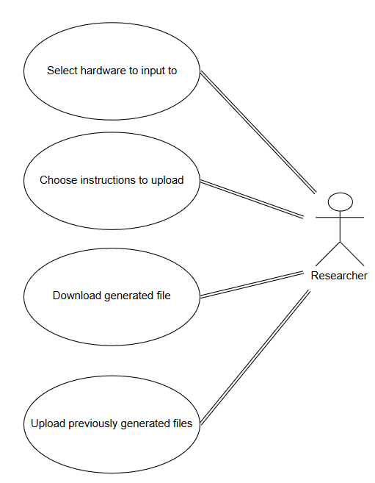

Figure : Use Case Diagram

# Use Case Descriptions

The purpose of this section is to provide a more detailed, textual description of the use cases presented in the previous section.

|  |  |
| --- | --- |
| Use Case: 1 | |
| **Use Case** | Select hardware to input to |
| **Actor** | Researcher |
| **Descriptions** | The researcher selects the hardware device they would like to generate instructions for |
| **Preconditions** | The researcher must be connected to the web application |
| **Post-conditions** | The application will be prepared to generate instructions for the specific hardware selected |
| **Main Flow** | 1. The user clicks the drop-down menu pertaining to the hardware selection 2. The user clicks the hardware they wish to use 3. The user clicks a submission button |
| **Special Requirements** | N/A |

|  |  |
| --- | --- |
| Use Case: 2 | |
| **Use Case** | Choose instructions to upload |
| **Actor** | Researcher |
| **Descriptions** | The researcher chooses the instructions they would like to generate for the hardware |
| **Preconditions** | The researcher must have determined which hardware to use prior to this step |
| **Post-conditions** | The application will generate a set of instructions for the user |
| **Main Flow** | 1. The user types the instructions they would like to execute 2. The user clicks a submission button 3. The application generates the instructions in a form appropriate for the hardware they selected |
| **Special Requirements** | N/A |

|  |  |
| --- | --- |
| Use Case: 3 | |
| **Use Case** | Download generated file |
| **Actor** | Researcher |
| **Descriptions** | The researcher receives a prompt to download the generated instruction file to which they choose where to store it locally |
| **Preconditions** | The researcher must have specified a hardware device and the instructions necessary |
| **Post-conditions** | The user will have a file that is capable of being loaded and executed on the hardware they chose |
| **Main Flow** | 1. The user is prompted to save the generated file 2. The user downloads the generated file to the path they specified |
| **Special Requirements** | N/A |

|  |  |
| --- | --- |
| Use Case: 4 | |
| **Use Case** | Upload previously generated files |
| **Actor** | Researcher |
| **Descriptions** | The researcher selects a file they have already generated within the application on a separate occasion |
| **Preconditions** | The researcher must be connected to the web application and have an appropriate instruction file |
| **Post-conditions** | The application will have loaded the instruction file so that it can be modified or converted to an appropriate form for a different hardware |
| **Main Flow** | 1. The user navigates to the upload code section of the application 2. The user clicks a button to browse for instructions that are stored locally 3. The user submits the instruction file online |
| **Special Requirements** | N/A |

# Conclusion

This concludes the use case description for the current version of the product we plan to create. As the project progresses, there will most likely be additions to the use case set, but the current list is what has been determined as necessary based on the information we have gathered from our stakeholders.

# Group Participation

Listed below is a table containing the group participation weights for each team member.

|  |  |
| --- | --- |
| **Team Member** | **Participation** |
| James Beasley | 25% |
| Charles Beck | 25% |
| Charles Duso | 25% |
| Alexander Grzesiak | 25% |
| Erik Strauss | 0% |