

|  |  |
| --- | --- |
| **Group:** | James Beasley, Charles Beck, Charles Duso, Alexander Grzesiak, Erik Strauss |
| **Project Title:** | Boston University - Microfluid Experimentation Data Generator |
| **Deliverable:** | D.4 Class Diagram |
| **Course:** | CS386 – Spring 2017 |
| **Instructor:** | Professor Gerosa |
| **Github:** | https://github.com/TheAwesomeEgg/CS386ProjectGroup1.git |

# Introduction

The purpose of this document is to list and describe the class diagram we have produced with intention of implementing to create the software application we feel would satisfy the requirements set out for us. As a reminder, we intend to create an instruction generator for the microfluidic experimentation research group at Boston University.

# Class Diagram

In this section, we will list the complete class diagram to give a holistic view of the system – as well as – several dissections of the complete class diagram to increase visibility of the components.

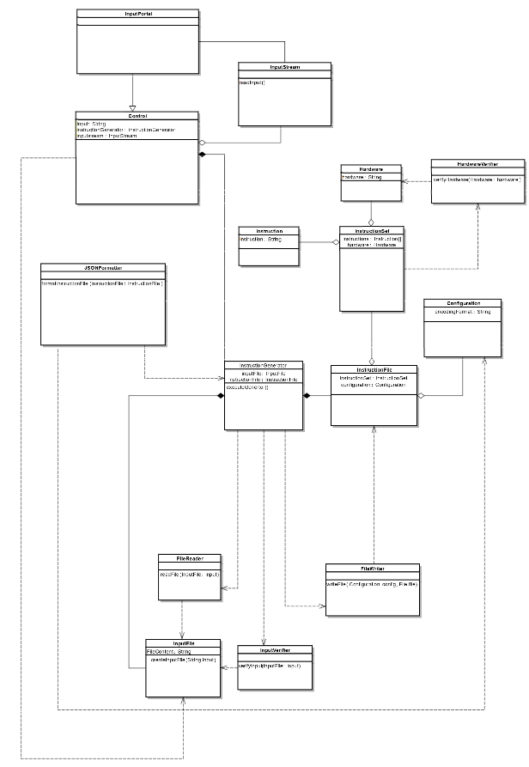

Figure 1: Class Diagram - Complete View

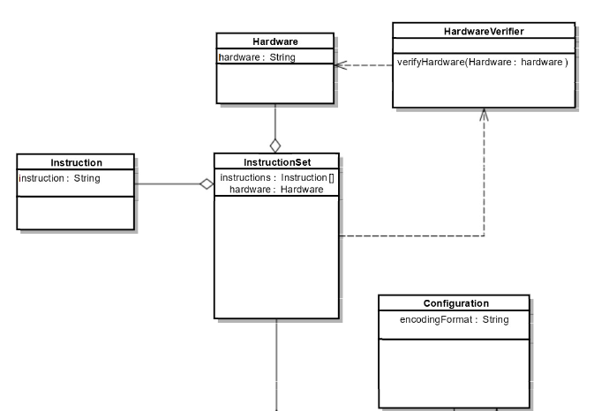

Figure 2: Class Diagram - Dissection 1

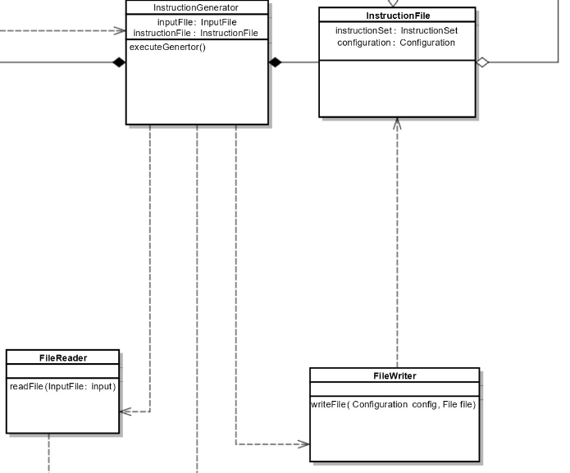

Figure 3: Class Diagram - Dissection 2

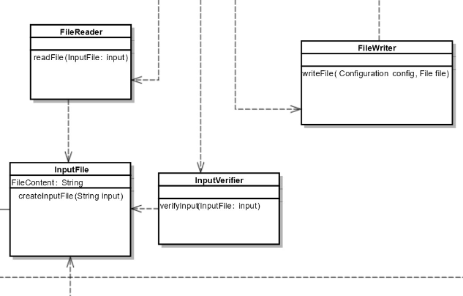

Figure 4: Class Diagram - Dissection 3

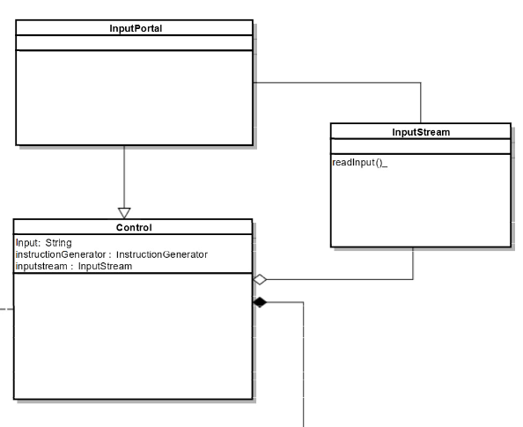

Figure 5: Class Diagram - Dissection 4

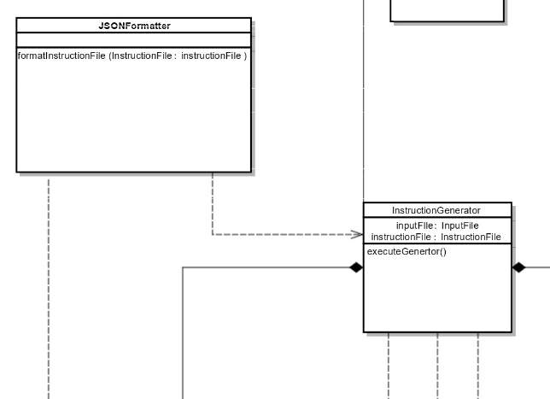

Figure 6: Class Diagram - Dissection 5

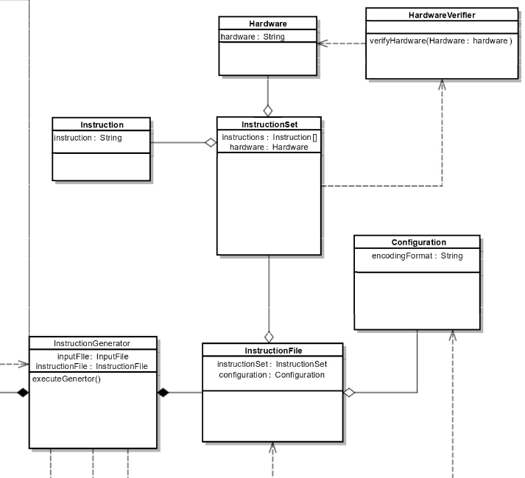

Figure 7: Class Diagram - Dissection 6

# Class Diagram Descriptions

In this section, we will describe the various classes presented in the complete class diagram. This description will be of the functionality and interaction with other classes in the diagram.

* Instruction
  + An abstraction of a hardware instruction
  + Contains a string that has the actual instruction to generate to file
* Instruction Set
  + A class that acts as a container of instructions
  + Contains hardware data necessary for file generation
* Hardware Verifier
  + Verifies the validity of a specified hardware
* Hardware
  + An abstraction of the possible experimental hardware used at Boston University
* Configuration
  + A file containing formatting data for the eventual file output
  + Formatting data is contained in a string
* Instruction File
  + An abstraction of a set of instructions and the relevant configuration data needed to write a correct file
* Instruction Generator
  + Controls the flow of instruction generation by collecting a raw instruction data set and converting it into a valid Instruction File instance
* File Writer
  + Writes Instruction File instances to an appropriate file
* Input File
  + Abstraction that contains raw instruction data to be formatted
* File Reader
  + Reads from a file stream into an Input File instance
* Input Verifier
  + Verifies an Input File instance for syntax and structuring
* JSON Formatter
  + Modifies an Instruction File instance to appropriate JSON format
* Control
  + Handles the flow of execution of the system, getting input data and invoking the Instruction Generator
* Input Stream
  + Class designed to read a continuous stream of raw data to be stored and translated
* Input Portal
  + Portal of interaction for the user that transfers input data to the input stream

# Group Participation

Listed below is a table containing the group participation weights for each team member.

|  |  |
| --- | --- |
| **Team Member** | **Participation** |
| James Beasley | 25% |
| Charles Beck | 25% |
| Charles Duso | 25% |
| Alexander Grzesiak | 25% |
| Erik Strauss | 0% |

Table : Group Participation Weights