

|  |  |
| --- | --- |
| **Group:** | James Beasley, Charles Beck, Charles Duso, Alexander Grzesiak, Erik Strauss |
| **Project Title:** | Boston University - Microfluid Experimentation Data Generator |
| **Deliverable:** | D.3.1 – Release 1 |
| **Course:** | CS386 – Spring 2017 |
| **Instructor:** | Professor Gerosa |
| **Github:** | https://github.com/TheAwesomeEgg/CS386ProjectGroup1.git |

# Introduction

This document serves to describe our current implementation of the project, and list the technologies that we have used to achieve the current artifact. We will also consider our future vision of the product in later releases.

# Technologies and Justification

In this section, we list the technologies that have been used or will be used, and justify their usage in this project.

## HTML/CSS

We have and will continue to use HTML/CSS for our project. As a reminder, the application we are creating is web-based and so HTML/CSS is an absolute necessity.

## JavaScript

We will be using JavaScript for all aspects of the application that deal with the data generation process. We are opting for JavaScript, although PHP and other programming languages can also work, because JS acts on the client-side and so we can guarantee faster response times between when the user submits their instructions and when the data is output to the user.

## PHP

We may use PHP if our progress allows for it. We say this because the portion of the application in which the PHP would be used may not be reached before the final product is required for the course. If we do have time, we will be using PHP to handle server-side storage and user accounts so that data can be retained outside of the user’s computer.

# Current Implementation

We will now list and describe our current implementation of the application we are designing. To see a live version of the product, one can visit the following link, <https://cefns.nau.edu/~cd622/>. Below we have included several images depicting the current product and the user stories that were satisfied as a result.

## User Stories

Below are the user stories that were implemented in this release of the product. Our current progress can be monitored on Trello at, <https://trello.com/b/bJnjJHMg/user-stories>.

* Upload files
* Change UI Theme
* Visit homepage
* Download files
* Select Hardware

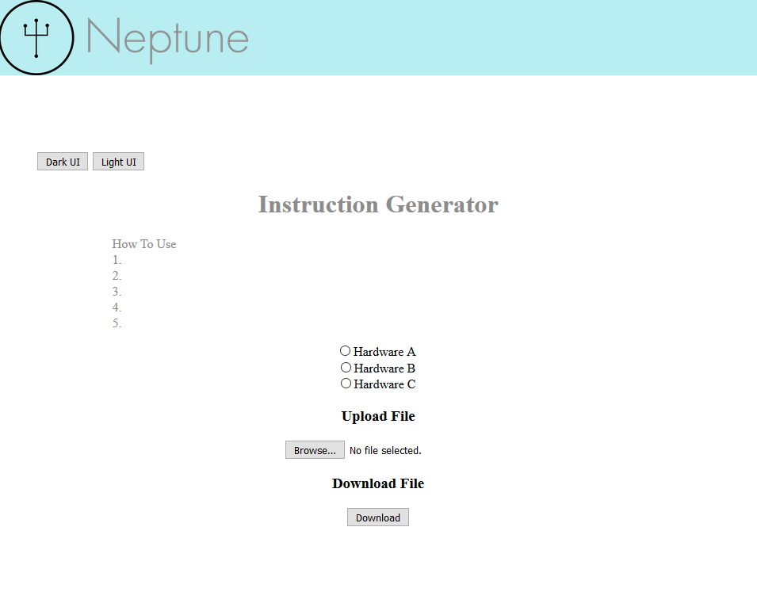

Figure 1: Release 1 - Website (light)

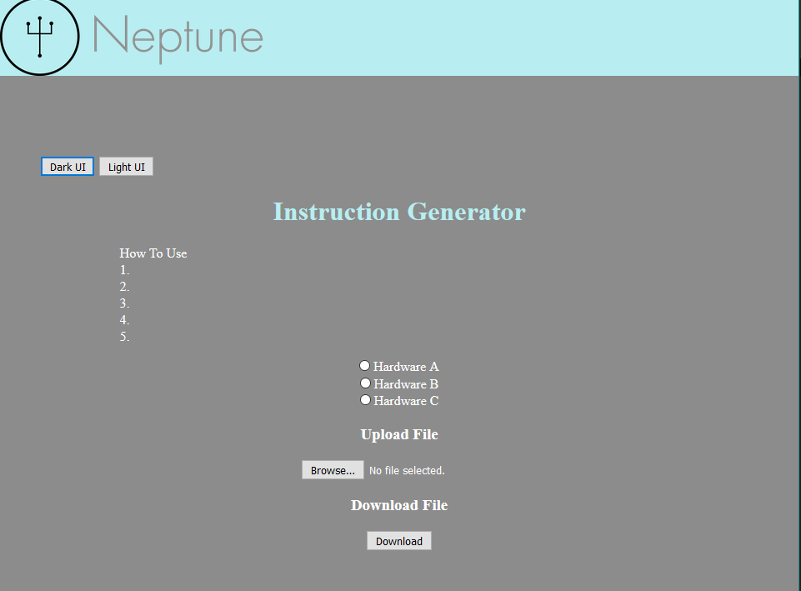

Figure 2: Release 1 - Website (dark)

# Future Implementations

In our future implementations, we would like to focus on aesthetics as well as functionality. Listed below is some of the design features we plan to implement in upcoming releases.

## Profile Page

We would like to create a profile page for users and their groups.

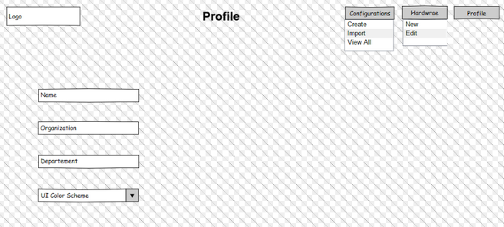

Figure 3: Profile Page

## Homepage

We would like a homepage tailored to the user.

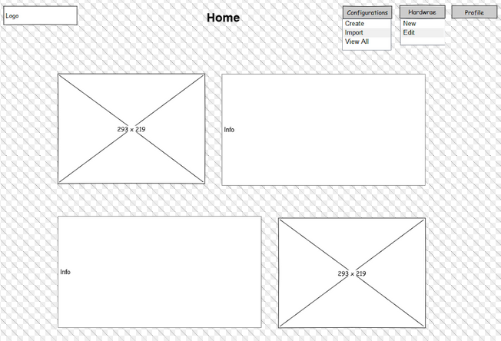

Figure 4: Homepage

## Configuration Page

We would like to add a configuration page for constructing the metadata needed to generate instructions.

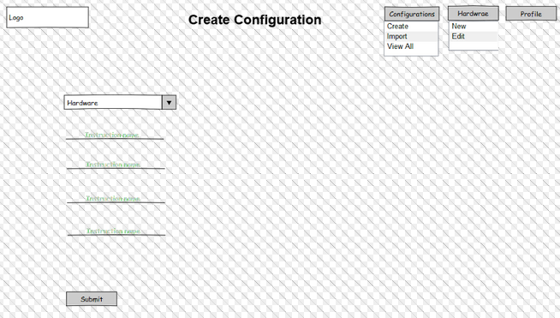

Figure 5: Configuration Page

# Group Participation

Listed below is a table containing the group participation weights for each team member.

|  |  |
| --- | --- |
| **Team Member** | **Participation** |
| James Beasley | 33% |
| Charles Beck | 0% |
| Charles Duso | 33% |
| Alexander Grzesiak | 33% |
| Erik Strauss | 0% |

Table : Group Participation Weights