

|  |  |
| --- | --- |
| **Group:** | James Beasley, Charles Beck, Charles Duso, Alexander Grzesiak, Erik Strauss |
| **Project Title:** | Boston University - Microfluid Experimentation Data Generator |
| **Deliverable:** | D.3.2 - Release 2 |
| **Course:** | CS386 – Spring 2017 |
| **Instructor:** | Professor Gerosa |
| **Github:** | https://github.com/TheAwesomeEgg/CS386ProjectGroup1.git |

# Introduction

The following document serves to detail the user stories that we have implemented for this release. We will also discuss changes planned for the next and final release.

# Current Implementation

We are satisfied with our current progress as we are near completion of the primary functionality for the project. To see a live version of the product, one can visit the following link, <https://cefns.nau.edu/~cd622/>. We will also list below examples of the current implementation should the live version not be accessible.

## User Stories

Listed below are the user stories that we have implemented in this release of the product. With this release, we have completed seven user stories, leaving us with five left to implement for the final release. Our current progress in regards to user stories can be seen at the following link, <https://trello.com/b/bJnjJHMg/user-stories/>.

* Select multiple hardware options
* Change file formats
* Type custom instructions
* Choose pre-defined instructions
* Error check uploaded files
* Webpage responds to user’s selections
* View all instructions concurrently

# 

Figure 1: First landing page

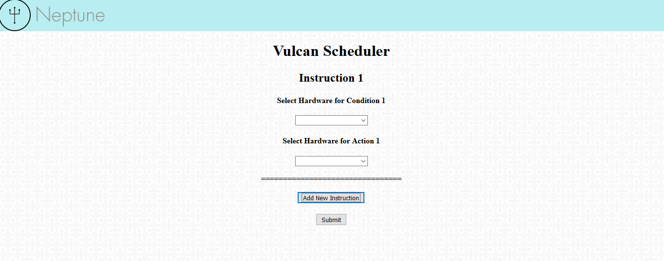

Figure : Single Generation of Instruction

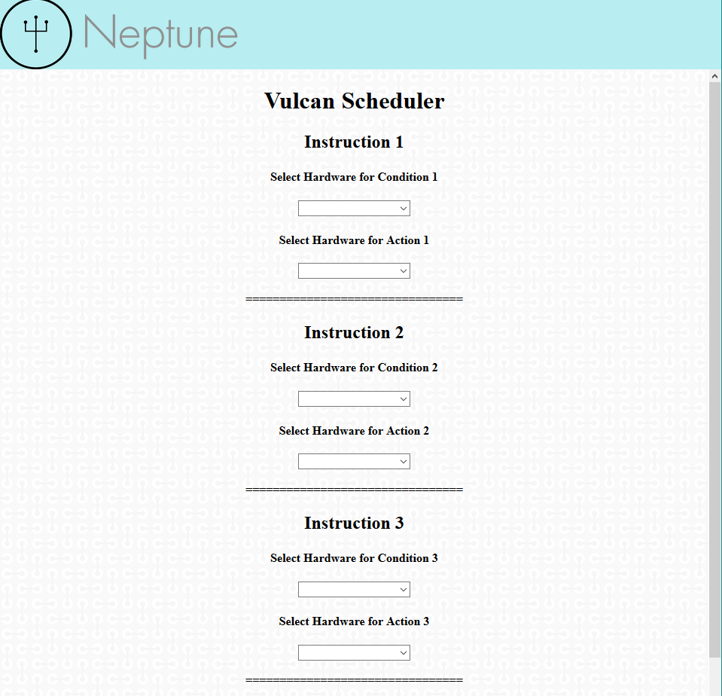

Figure : Multiple Instructions

|  |  |
| --- | --- |
| **Language Distribution** | |
| **Language** | **Percentage** |
| HTML/CSS | 55% |
| JavaScript | 40% |
| PHP | 5% |

Figure : Language Distribution Table

# Future Implementations

Primary focus:

As stated previously, we have five more features that need to be implemented before completion of the project. Our primary focus, however, will be styling the page to be more hospitable to researchers. In its current rendition, the website is quite plain and reminiscent of a website created in the 1990’s. We would like to create an environment for the users that feels professional as well as a fast working product.

Alternate objectives:

Log in

As noted in the user stories we would like to implement changes other than user interface. The ability to log in to the system would permit some security. More importantly, the ability to store old instructions and commonly used instructions to save time in replicating and generating new instructions.

File Upload

To generate instructions, the user needs the ability to upload files to provide the application with some input to work with. Error detection in this is important as the correct files need to be uploaded or else the parser cannot read the file correctly.

Result Distribution

One of the important aspects of our web application is the speed in which it allows the users to generate new instructions. To increase productivity, we would like to introduce a way to store or share the results of the translation. The user can email it to themselves or others involved with the research.

# Group Participation

Listed below is a table containing the group participation weights for each team member.

|  |  |
| --- | --- |
| **Team Member** | **Participation** |
| James Beasley |  |
| Charles Beck |  |
| Charles Duso |  |
| Alexander Grzesiak |  |
| Erik Strauss |  |

Table : Group Participation Weights