ImageTrend WOrkout

By Anthony Pearson

## What is the ImageTrend Workout?

The ImageTrend Workout is a five high-intensity fitness workout routine that focuses on multiple areas on the body.

## Technologies Used

* HTML
* Firebase -> mobile and web application development platform
* Polymer -> JavaScript Framework
* AWS S3 -> Storage for files
* AWS Route 53 -> DNS for routing ImageTrend Workout to project files.

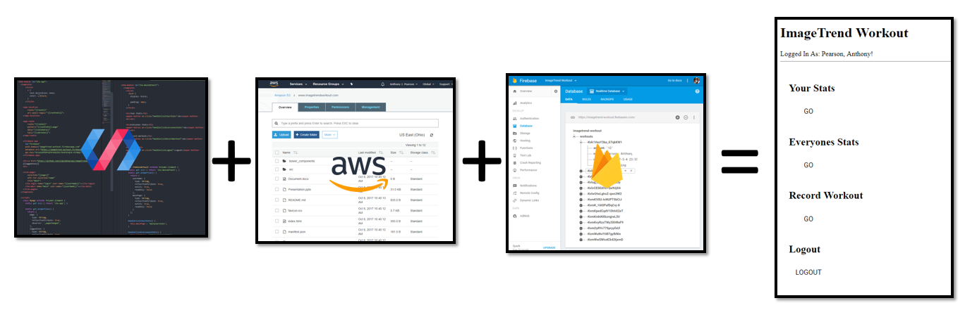

## Resources and Links

http://www.imagetrendworkout.com/

https://github.com/ajgoldenwings/imagetrendworkout

* Includes documents and PowerPoint slides

**Disclaimer**

The Hooligans in this project shall not be liable for any reason including offensive material, wasted time, injury or death. For workout advice, please consult a professional. People who do the ImageTrend Workout should know that this has not been evaluated and any claims by the Hooligans should not be believed.