IGLib C# – Numerical Library

Revision 0

Igor Grešovnik



Contents:

1 Introduction 1
2 External Libraries 1
3 Linear Algebra 1
4 Functions and Transformations 1
4.1 Real Single-valued Functions 1
4.1.1 General Implementation Notes 1
4.1.2 Mathematical Details of Implementation 2
5 Sandbox (this is not part of this report) 1

Introduction

IGLib (Investigative Generic Library) is a set of utility libraries whose aim is to facilitate the development of technical applications.

External Libraries

Linear Algebra

Functions and Transformations

Introduction to Function Classes

Classes described in this section represent various kinds of mathematical functions.

At a glance, one could think that it is not sensible to relate mathematical functions with classes. In program languages, a closely related concept is that of functions (or methods) and delegates (or function pointers, or function references).
Such a view seems consistent when dealing with more elementary operations on functions. For example, if we needed an algorithm for numerical integration of real functions, we would pack it in a method whose parameters would be the integral limits, number of divisions of an interval, and the integrated function specified as a delegate.
However, in complex systems we need to account for more complex ways of interaction of function definition with other entities of which some can not be foreseen in advance. Sometimes we need do deal with parametric families of functions and need to perform standard operations on specific members of the families with parameters of the family being fixed. Other times, we donšt have an explicit definition of a function, but the function is evaluated through solution of some numerical problem. In line searches, a function of one variable is defined through a multivariate function evaluated on a line through function domain. Each evaluation of this function needs to perform evaluation of the underlaying multivariate function, and it might be, for example, beneficial to remember parameters and values of that multivariate function for further use after desire operations are performed on the line search function. Furthermore, we need sometimes to have function derivatives defined along with the function itself, or we need to create runtime definitions of complex composed functions.

Due to the bove considerations, it makes sense to represent different kinds of functions by a number of hirearchiclly organized classes tailored to different purposes. Basic methods of these classes will provide the essential functionality that defines the notion of function as that of a mathematical entity that takes an input and returns an output. Beside that, function objects of various classes will enable querying whether the implementation provides analytical derivatives or integrals, evaluation of these, parametric deifnitions, various kinds of interaction with runtime environment such as storing evaluation results, definition through numerical calculations, runtime combination of functions, etc.

Classification and Naming Conventions
The first classification of function classes is according to types of mathematical functions that they represent. For example, we have real univariate functions, scalar functions of vector variables, vector functions of vector variables, etc.
Each kind of mathematical functions has a corresponding basic class. Names of derived classes are derived from this name. Names are chosen in such a way that more elementary functions have less parts of the name that suggest what kind of functions the class can represten.
We use simply the name Function for real functions of a single real variable. We use the name ScalarFunction for scalar functions of a vector variavble. Then, we use the name VectorFunction for vector function of a vector variable.

Each kind of mathematical functions has its corresponging base class that defines the basic functionality that should be provided by any function class belonging to that kind of fuctions. Base class is usually an abstract class that specifies a verz basic functionalitz that every class representing the specified kind of mathematical functions should provide.

Real Single-valued Functions

General Implementation Notes

Mathematical Details of Implementation

In class Function, the function is specified by a transformed reference function where both dependent and independent variable are transformed by an affine transformation. We denote the reference function as

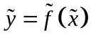, (

Actual function  represented by the Function object is obtained by the following transformation of variables:

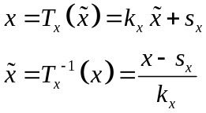, (

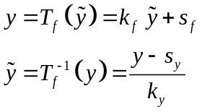, (

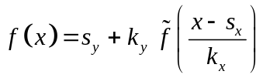, (

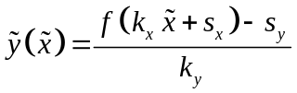, (

Derivatives:
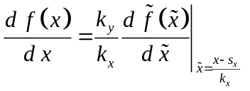, (

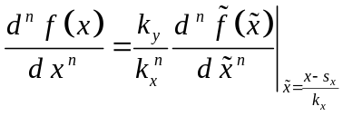, (

Integral:

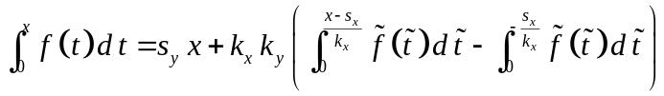 (

Derivation:
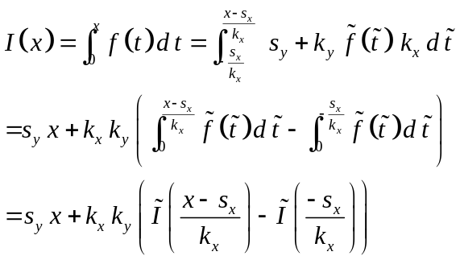

Inverse function:

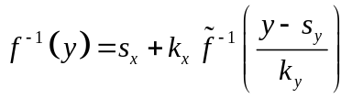, (

References:

[] I. Grešovnik et al.: Optimisation program Inverse, http://www.c3m.si/inverse/doc/man/frame.html
[] I. Grešovnik: A General Purpose Computational Shell for Solving Inverse and Optimisation Problems - Applications to Metal Forming Processes, Ph. D. thesis, University of Wales Swansea, U.K., 2000. http://www.c3m.si/inverse/doc/phd/frame.html
[] I. Grešovnik: IOptLib – Investigative Optimization Library. http://www2.arnes.si/~ljc3m2/igor/ioptlib/

Sandbox (this is not part of this report)

