Quick To Do:
- Solve how to perform symmetric encryption in files
  - How to handle salts appended to passwords before key generation by multiple hashing
    - Using the same salt for simultaneous encryption of multiple files for efficiency
    - Save hashed passwords (hashed with salt)
    - Save and retrieve for multiple combinations of password / salt / number of iterations
      - Question: can be hashing with multiple iiterations be done in several bundles?
  - How to handle prepended random blocks?
    - Probably should be generated anew for each file to be encrypted?
    - Probably prepend rather to append
    - Probablz they should not be stored anywhere
    - Study the effect of this!

IGLib Cryptography Notes

Revision 0, 2010.

Igor Grešovnik

Contents:

1 Introduction 2
2 Passwords and Keys 2
2.1 Passwords for Authentication 2
2.1.1 Authentication on Servers 2
2.2 Passwords and Keys for Encryption 2
3 Symmetric Encryption 2
3.1 Symmetric Encryption - Basic Functions 2
4 Glossary of Terms 2
4.1 Defence against attacks 2
4.1.1 Salt 2
4.1.2 Nonce 2
4.2 Algorithms 2
4.2.1 Cipher 2
4.2.2 Symmetric algorithm 2
4.2.3 Asymmetric key algorithm 2
4.2.4 Avalanche Effect 3
4.2.5 Confusion 3
4.2.6 Diffusion 3
4.3 Attacks 3
4.3.1 Cryptoanalysis 3
4.4 More Specific Terms 3
4.4.1 Prof-of-work System 3
4.5 See also 4
4.5.1 Product Cipher 4
5 Sandbox ii
5.1.1 Maxwell’s Equations iii

Introduction
This document contains various notes related to implementation of cryptographic funcitons in IGLib.

Passwords and Keys

Passwords for Authentication
Authentication procedures and management of password information must be such that various attacks are effectively prevented.
Password information must be stored in some form in the password authentication system. It must always be assumed that password information can be stolen from the authentication system, therefore information must be stored in such a way that even somebody that has access to password information used by the authentication system can not efficiently use this information to guess the original password.
In particular, the system must be resistant to brute force attacks and various variants of dictionary attacks.

Authentication on Servers

Passwords and Keys for Encryption
There are different approaches to compromise passwords for authentication and passwords for encryption.

Symmetric Encryption
Symmetric encryption use the same key for encryption and decryption.

Symmetric Encryption - Basic Functions of Cryptographic Shell
Basic functions should not be used in final applications because they are not safe. They are accessible through cryptographic shell for testing and education purposes.

Asymmetric Encryption

Glossary of Terms

Basic Concepts

Confidentiality
A property that information is not made available or disclosed to unauthorized individuals.

Integrity
Data integrity means maintaining and assuring the accuracy and completeness of data over its entire life-cycle. This means that data cannot be modified in an unauthorized or undetected manner.

Non-repudiation
A property that that one party of a transaction cannot deny having received a transaction nor can the other party deny having sent a transaction.

Authenticity - Message Authentication
Massage authentication or data origin authentication is a property that a message has not been modified while in transit (data integrity) and that the receiving party can verify the source of the message.
It is typically achieved by message authentication codes (MACs), authenticated encryption or digital signatures.
Message authentication does not necessarily include the property of non-repudiation.

Message Authentication Code (MAC)
A short piece of information used to authenticate a message - to confirm that the message came from the stated sender (authenticity) and has not been changed in transit (integrity).
A MAC algorithm accepts as input a secret key and a message to be authenticted, and outputs a MAC (or a tag). MAC value protect message's data integrity and authenticity, because it allows verifiers (that also possess the secret key) to detect any changes in message content.
Name "keyed cryptographic hash function" is also used, but is misleading because a cryptographic hash function is not the only way to generate MACs.

Defence against attacks

Salt
A block of random bytes appended to a password or passphrase before it is hashed (usually multiple time) for storage. Salt is usually stored with hashed password and it should usually be assumed that potential attacker can know it (as well as the password hash). A new salt is randomly generated for each password. Salt and password are concatenated and input to cryptographic hash function, and the resulting output and the salt is stored with the salt in authentication's system database.
This makes less efficient to use dictionary attacks and against pre-computed rainbow table attacks.
More precisely, a public salt makes more time consuming to crack a list of passwords, but does not make dictionary attacks harder when cracking a single password.

Nonce
A random number that may be used only once, issued in authentication protocol such that old communications can not be used in replay attacks.

Algorithms

Cipher
An algorithm performing encryption or decryption (plaintext->ciphertext or vice versa).

Symmetric algorithm
A cipher where the same key is used for encryption and decryption.

Block Cipher
Encryption algorithm that operates on fixed-length blocks, , with an unvarying transformation that is specified by a symmetric key. Widely used in encryption/decryption of bulk data.

Block Cipher Mode of Operation
An algorithm that uses a block cipher to encrypt messages of arbitrary length in a way that provides confidentiality and anuthenticity.

Electronic codebook (ECB)
Simplest block cipher encryption mode of operation. Message is divided into blocks and each block is encrypted separately.
This is very insecure because identical plaintext blocks are encrypted to identical ciphertext blocks, therefore data patterns are not hidden well.

Cipher Block Chaining (CBC)
Each block of plaintext is XORed with the previous ciphertext block before it is encrypted. In this way, each ciphertext block depends on all plaintext blocks processed up to that point.
To make each message unique, an initialization vector must be used in the first block.
Drawbacks are that encryption can not be parallelized and that message must be padded to a multiple of the cipher block size.
Interesting facts:
Decrypting with the incorrect IV causes the first block of plaintext to be corrupt but subsequent plaintext blocks will be correct. This is because each block is XORed with the ciphertext of the previous block, not the plaintext, so one does not need to decrypt the previous block before using it as the IV for the decryption of the current one. This means that a plaintext block can be recovered from two adjacent blocks of ciphertext. As a consequence, decryption can be parallelized. Note that a one-bit change to the ciphertext causes complete corruption of the corresponding block of plaintext, and inverts the corresponding bit in the following block of plaintext, but the rest of the blocks remain intact. This peculiarity is exploited in different padding oracle attacks, such as POODLE.
Explicit Initialization Vectors takes advantage of this property by prepending a single random block to the plaintext. Encryption is done as normal, except the IV does not need to be communicated to the decryption routine. Whatever IV decryption uses, only the random block is "corrupted". It can be safely discarded and the rest of the decryption is the original plaintext.

Initialization Vector (IV)
Initialization vector (IV, or starting variable) is a fixed-size input to a block cypher that is typically required to be random or pseudorandom. Provides randomization and is crucial for semantic security, whereby repeated usage of the same scheme under the same key does not allow an attacker to infere relationships between segments of the encrypted message.
For block ciphers, its size is usually the cipher's block size.
It is usually assume that a potential attacker can access the initialization vector.

Authenticated Encryption
A block cipher mode of operation which simultaneously provides confidentiality, integrity, and authenticity assurances on the data; decryption is combined in single step with integrity verification.

Asymmetric key algorithm
A cipher where one key is used for encryption and the other is used for decryption. Synonym is public key cryptography. In public key cryptography, a public key is used for encryption and the corresponding private key is used to decrypt the encrypted text. Most modern algorithms are based on the assumption that it is difficult to solve a given mathematical problem and thus computationally difficult to find a private key corresponding to a known public key. Some algorithms' security (such as the RSA, used both for public key encryption and digital signatures) rely on extreme difficulty of factoring large integers.
Asymmetric algorithms enable secure key exchange without requesting prior exchange of secret information over secure communication channels.

Avalanche Effect
A necessary property of cryptographic algorithms (especially block ciphers and cryptographic hash functions) that small changes in input (such as flip of a single bit) produce completely different output.
In block ciphers, either a small change in key or in plaintext must cause a drastic change in ciphertext. If this is not true (i.e. the algorithm has poor randomization effect) then cryptoanalysts can more easily make predictions about the input (usually secret) based on output of algorithms.

Confusion
Property of a secure cipher that each bit of the ciphertext depends on several parts of the key.

Diffusion
A property that a change of a single bit of the plaintext will introduce a change of (statistically) half of bits of ciphertext. Similarly, if one changes a single bit of ciphertext then, statistically, a half of bits in decrypted plaintext will change.

Semantic security
Cryptosystem is semantically secure if any probalistic, polynomial time algorithm (PPTA) that has as input the ciphertext of a message and message's length, can not determine any partial information about the message with probability non-negligibly higher than all other PPRAs that has as input only the message length.

Attacks

Cryptoanalysis
Study of analyzing information system in order to discover hidden aspect of these systems. Used to breach cryptographic security and access the contents of encrypted messages even when cryptographic keys are not known.
Side channel attacks do not look for weaknesses of cryptographic algorithms themselves, but exploit weaknesses in their implementation (by exploiting e.g. electromagnetic leaks, data remanence, social engineering, etc.).

Ciphertext-only Attack
Attack model for cryptanalysis where the attacker is assumed to have access only to a set of ciphertexts. In practical situations, the attacker still has some knowledge of the plaintext. For example, the attacker might know the language in which the plaintext is written in or the expected statistical distribution of characters in the plaintext.

Known-plaintext Attack
Attack model for cryptanalysis where the attacker has access to both the plaintext and its corresponding ciphertext. These can be used to reveal further secret information such as secret keys.

Chosen Plaintext Attack
Attack model for cryptoanalysis which presumes that the attacker can obtain the ciphertexts for arbitrary plaintext. The goal is to obtain infomation that reduces the security of the encryption scheme.
This is important in public key cryptography where encryption keys are public and attackers can encrypt any plaintext they choose.
This attack is more powerful than known-plaintext attack, where attackers can obtain only one pair of plaintext-ciphertext and thus less data for cryptoanlaysis. System that is resistant to chosen plaintext attack is also resistant to known-plaintext attacks and cyphertext-only attacks.
This attack is less powerful than the chosen-ciphertext attack, where the attacker can obtain the plaintexts of arbitrary ciphertexts. A CCA-attacker can sometimes break a CPA-secure system.

Chosen-ciphertext Attack
Atack model for cryptoanalysis where the attacker can obtain plaintext for any given ciphertext without knowing the key. From the obtained information, the attacker tries to recover the secret key used for decryption.

Padding Oracle Attack
Performed using padding of a crytographic message.
The attack relies on having a "padding oracle" who freely responds to queries about whether a message is correctly padded or not.
Mostly associated with CBC mode decryption used within block ciphers.

More Specific Terms

Prof-of-work System
A proof-of-work system, protocol or function is a measure to deter denial of service attacks, spam and other service abuses, by requiring some work to be done by service requester (which requires e.g. some CPU time and can be verified by the service).
Approaches include partial hash inversions to prove that work was done.
Variants:
- Challenge-response protocols assume a direct interactive link between requester and provider. Provider chooses a challenge (e.g. an item in a set with a property), requester finds the relevant response and sends it back to be checked by the provider. Difficulty can be adapted by provider according to its current load.
- Solution-verification protocols do not assume an interactive link between the provider and server. The problem must be self-imposed by the requester before it is solved and provider must check both the problem choice and the found solution.
Used in cryptocurrencies.

See also

Product Cipher
Product cipher combines a sequence of simple transformations such as substitution, permutation and modular arithmetic.
S-boxes and P-boxes are used in bloch ciphers to make the relation between plaintext and ciphertext difficult to understand (property of confusion).

S-box
Substitution box.
Fixed lookup tables can be used (e.g. in Data Encryption Standard - DES) or tables are generated dynamically from the key (e.g. in Blowfish or Twofish).

P-box
Permutation box, a method of bit-shuffling used to permute or transpose bits across S-boxes inputs, retaining diffusion while transposing. Classified as compression, expansion and straight, where only straight P-boxes are invertible.

Useful Links

- Cryptography Stack Exchange

References:

[] Samir Farhat, Carl D. Scott: Review of the Arc Process Modelling for Fullerene and Nanotube Production. Journal of Nanoscience and Nanotechnology, Vol. 6, pp. 1189-1210, 2006. American Scientific Publishers.
[]
[]
[]
[]
[]
[]
[]
[]
[]
[]
[]

Sandbox

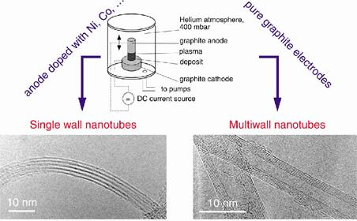
Figure 1: Experimental setup for arc discharge apparatus. Source: ==>.

See also:
- Plasma
- Plasma modeling
- Corona discharge
- Lightning
- St. Elmo’s fire

Enačbe v Equation editorju (okrnjena različica MathType):

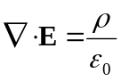. (

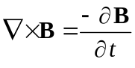. (

Maxwell’s Equations

Formulation in terms of total charge and current:

a) Gauss’ law:
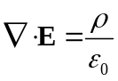. (
b) Gauss’ law for magnetism:

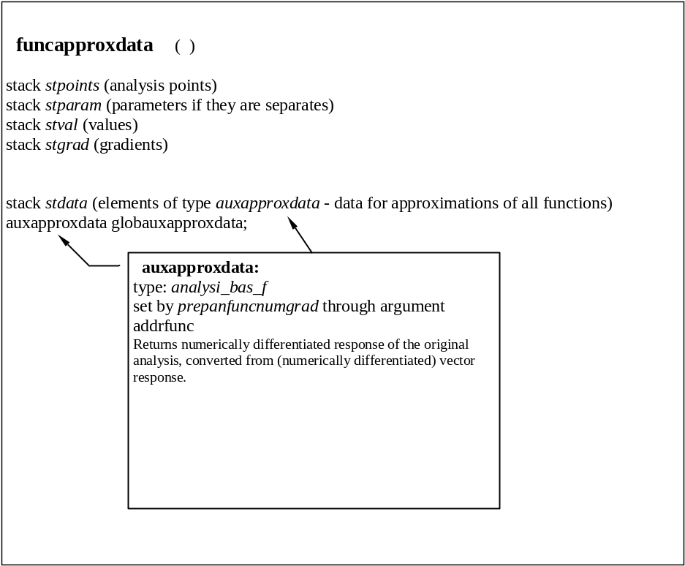
Figure 2: xxx.

