“What Is” Reference List of Optimization Related Expressions for TUNCONSTRUCT

Working draft

edited by Igor Grešovnik

I kindly ask partners to help me to supplement this list. Additions can be best sent to me incorporated in a word document created from a copy of this document (in order to avoid formatting corrections). There is no need to stick with a strictly formal style – a bit of can make even serious things better.

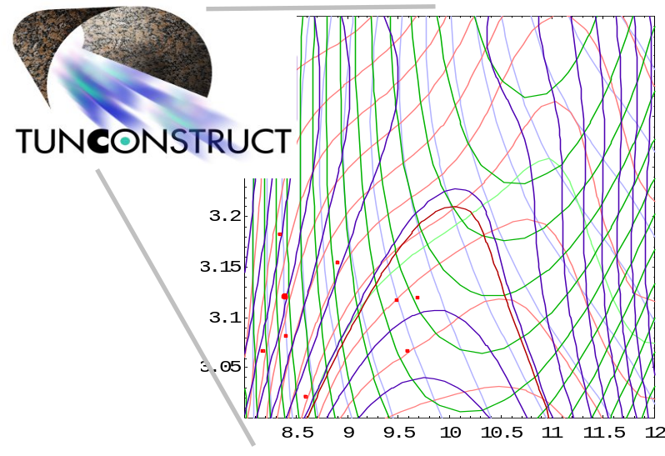

Contents:

1 Introduction 1
2 Optimization 1
3 Parameterization 2
4 Toonconstruct 4
5 Sandbox 6

Introduction

This document is to explain some terms commonly used in relation with the fields of inverse analysis & optimization.

Optimization

From Merriam-Webster:
optimization: an act, process, or methodology of making something (as a design, system, or decision) as fully perfect, functional, or effective as possible; specifically : the mathematical procedures (as finding the maximum of a function) involved in this.

The term will usually be used in the specific (mathematical) content, but also referring to the target of optimization (i.e. what is meant to be made as good as possible) and the necessary procedures that must be taken in order to formulate the mathematical procedure that will be performed in order to achieve optimization.

To make as perfect as possible can refer to many different things (dependent on the target). In the context of inverse parameter identification this refers to making the discrepancy between the results of a numerical model at given values of unknown parameters (those we are looking for), and equivalent quantities that are measured in an experiment, as small as possible.

Prior to performing numerical optimization, the problem will be defined in a form similar to the following:

minimize 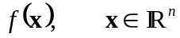
subject to 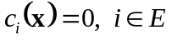 (
and 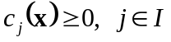,
where 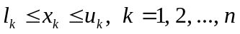

In the above equation, f is the objective function, c_{i} and c_{j} are constraint functions and l_{k} and u_{k} are upper and lower parameter bounds. The second and third line of the equation are referred to as equality and inequality constraints, respectively. We will collectively refer to f, c_{i} and c_{j} as response functions. Optimization or design parameters p specify the trial design (in the case of optimization) or assumed parameters of the physical model (in the case of inverse analysis), and determine the input for numerical analysis of the considered system. Derivatives of the response functions with respect to design parameters are used in gradient-based optimisation algorithms.

Evaluation of the response functions of a particular problem at specific optimization parameters will be referred to as direct analysis.

Parameterization

From Merriam-Webster:
parameterize: to express in terms of parameters.

The meaning of parameterization in the context parametric numerical optimization (solving optimization problems by using numerical models) is explained below.

In order to solve a specific optimization problem, one must first define a set of response functions from equation relevant to the problem. These definitions must be implemented in software in terms of functions (subroutines) and data, such that these definitions can be used (i.e. functions evaluated) by the subroutines that implement algorithms for the solution of optimization problems.

An example of software implementation prototype is the standard analysis function prototype described in the deliverable D1.3.2.1 (Section 6.2.1) In C programming language style the prototype can be written as

int analysisfunction (
vector param,int *calcobj,double **addrobj,
int *calcconstr,stack *addrconstr,
int *calcgradobj,vector *addrgradobj,
int *calcgradconstr,stack *addrgradconstr,void *cd);

In this particular form, parameters are passed to the function through the param argument and the values of response functions and their gradients are returned through arguments addrobj, addrconstr, addrgradobj and addrgradconstr. The input argument cd is reserved for eventual definition data (e.g. for selection between response functions for different problems that are implemented within some software framework). The precise form of the function prototype is important only because the subroutines implementing optimization algorithms require functions and data arguments of strictly prescribed forms. Basic implementations can be provided in different forms and wrapper functions provided for conversion to the required form.

Parameterization in broader sense means implementation of such an analysis function for a given problem within some software framework (i.e. in a program or in a library) with everything this procedure involves.

More specifically, parameterization means preparation of all the input data that is used in calculation of the response functions and depends on optimization parameters, according to the values of these parameters. More precisely the term parameterization refers to set up of all the procedures for preparation of the input that depends on parameters.

Example:
In back analysis, the optimization parameters will typically define some material properties (such as rock strength parameters and contact parameters for the joints). The objective function will be typically a measure of the discrepancy between some measurements obtained in the excavated tunnel (e.g. a set of displacements) and the equivalent quantities calculated by the numerical model (i.e. the same displacements as measured in the real tunnel).
Parameterization means setting up procedures for generation of all the input data needed for the evaluation of the objective function (leave aside the constraints) at given (arbitrary) values of the optimization parameters. In this case, evaluation of the response will involve analysis of the numerical model of the tunnel in which measurements were performed (with proper boundary conditions such as those implied by the excavation process), therefore input for the numerical model must be generated and parameterization refers to setting up procedures for generation of this input.
In the specific case, the whole numerical model will typically be prepared in advance for some reference parameters (e.g. strength of the rocks of type A this and this, etc.) and will reside in the computer storage for the whole time of the optimization procedure. The parameterization routines will pick up the trial values of optimization parameters and modify the input data of the models in such a way that the model will reflect precisely these parameters. For example, there will be a subroutine that will take optimization parameters as input, read the simulation input file (a template with reference values for the optimization parameters), modify those material properties in the input that represent the optimization parameters according to the trial values of these parameters, and save the input file (possibly to another location). The input will be used by the numerical simulation that will be called after the parameterization routine(s), therefore the simulation results will actually correspond to the trial values of optimization parameters. Needless to say, countless variations are possible since the input can be scattered in several files, more than one simulation, possibly performed by different simulation software can be used for calculation of the response functions, etc.
It is important to realize that the trial parameters will be passed to parameterization routines through some calling protocol. Typically the optimization subroutine will call the analysis function (subroutine; e.g. with the above described prototype) and the analysis function will call one or more parameterization routines (which may also be implemented as auxiliary external programs), the simulation itself, and some routines for extraction of relevant simulation results and evaluation of the response functions. Therefore the parameterization procedures must be implemented in such a way that they run automatically and non-interactively. One should have in mind that the whole process will be run hundreds of time in an optimization loop, and we typically don’t want to employ somebody who will click on some buttons and press <Enter> those hundreds of times.
In the broader sense, parameterization can refer to complete implementation of the analysis function for a given problem, with everything it involves, that is preparation of input according to the trial values of optimization parameters, running the simulation, collection of relevant simulation results and calculation of the response functions from these results. Preparation of input can consist of preparation of template input data for the numerical model and procedures that can modify this input according to the provided trial values of optimization parameters.
Technically, different approaches can be used for preparation of simulation input (its modification according to parameter values). Two basic classes involves access through input file and direct memory access. In the first case, the parameterization procedures will modify the data in input files and will typically run the simulation on these modified files as an external program.
In the second case, parameterization procedures will run the simulation as subroutine, and they will modify the input data directly in the memory space of the simulation program. In this case, parameterization routines must have write access to the appropriate portions of analysis memory, and will typically be linked with the simulation program. The template input (created for some reference parameters) can be read form the file in the initialization stage that is executed only once prior to the first run of parameterization and simulation routines, or is executed prior to each run.

In the above mentioned case, parameterization was very direct because each optimization parameter corresponded to a particular individual data piece in the simulation input, which is represented by a number in an input file or at a particular memory location. In more complex cases, groups of data (numbers) can depend on individual parameters and there can be interdependencies, i.e. some data are affected by more than one optimization parameters.
One such situation occurs when optimization also involves the shape of some objects (e.g. the circumferential variation of thickness of the lining, or shape of the tunnel circumference – just as example, I know nobody has the need to optimize that). In a finite element simulation, shapes of objects are defined by the positions of surface nodes, and as a matter of fact (for numerical reason), variation of surface nodes should in general not be performed without simultaneous and coherent variation of at least some layers of the interior nodes close to the surface. Taking all nodes as parameters would normally cause numerical problems (ill posed problems, regularization needed), the resulting problem would be too computationally expensive and usually much of the information produced by optimization would be redundant. Therefore we usually construct a parametric description of the targeted surfaces and interior of objects, which define the location of material points in terms of a finite number of shape parameters, which is normally much smaller than the number of affected nodes. The most tricky to understand here is the notion of material points. One can make a parallel to deformation of material, where material points are indexed by co-ordinates in the undeformed configuration in some reference co-ordinate system. For the purpose of parameterization of shape, one can define the reference geometry of some object, and then “deform” this geometry by a parameter dependent map to obtain the initial configuration at given optimization parameters. Object can be meshed in the reference configuration, in which case the parameterized mesh is obtained simply by applying the parameter dependent transform to co-ordinates of the reference mesh.
Procedures for shape parameterization can be implemented in similar ways than those for less complex kinds of parameterization, i.e. one can read the reference mesh form a template input file, apply parameter dependent map to this mesh and store it in the input file for analysis, or one can perform this task directly in memory on the data that represents the mesh within a simulation program.
Everything that was written for the finite element simulation is valid in an equivalent way for boundary element, finite difference and other types of simulation.

Toonconstruct

A large European project related to underground construction where nobody knows what other partners are doing or are supposed to do in the scope of the project.

Some partners in this project have a very clear idea of what themselves should do for the good of the project, citizens the European Union and Humanity in general, but other partners tend to give them perception that their notion is completely wrong. From time to time, such situations cause identity crises, especially at poor Slovenian guy named Igor Grešovnik who once studied physics and is (a special kind of professional deformation common to physicists) too much emotionally attached to things that are well defined.

References:

[]
[]
[]
[]
[]
[]
[]
[]
[]
[]
[]
[]
[]

Sandbox

