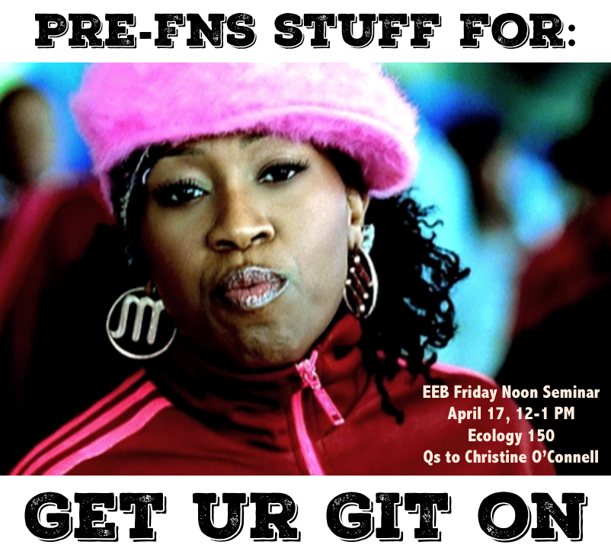

Planning on getting ur Git on during the April 17 Friday Noon Seminar?

**Please do the following before arriving. (Total time estimate: 20 minutes)**

**DEFINITELY DO THESE**

1. Go to this website: <https://www.youtube.com/watch?v=FPoKiGQzbSQ>. Play in background. Dancing along is optional, but recommended.
2. Sign up for a github account

* [github.com](http://github.com/" \t "_blank)
* Pick a username/password/email
* Important: use an email that ends in .edu
* Choose the "free" plan (you can later upgrade to the micro plan for free with your .edu email)

1. Install git (the revision control system that tracks changes to docs and folders)

* [https://help.github.com/articles/set-up-git/](https://help.github.com/articles/set-up-git/" \t "_blank)
* Do the steps in the "setting up git" section
* You might need to upgrade your operating system if you're way behind
* Ignore everything below "Next steps: Authenticating with GitHub from Git" (we're not going to deal with the command line)
* This video walks through the website if any of this gets confusing: [https://www.youtube.com/watch?v=TI3yVcSahzk&index=2&list=PL5-da3qGB5IBLMp7LtN8Nc3Efd4hJq0kD](https://www.youtube.com/watch?v=TI3yVcSahzk&index=2&list=PL5-da3qGB5IBLMp7LtN8Nc3Efd4hJq0kD" \t "_blank)

1. Install the Github software (which allows you to use git without using the command line)

* Mac: [https://mac.github.com/](https://mac.github.com/" \t "_blank)
* Windows: Github directed Windows users to get git bundled with the Github software, so you already did this in step (3) when you downloaded git. If for some reason you already had git but now need Github For Windows, you can find it here: [https://windows.github.com/](https://windows.github.com/" \t "_blank)
* You might need to upgrade your operating system if you're way behind

**That's it!  We'll walk through how to use each of these tools during FNS.**

**OPTIONAL BEFORE FRIDAY NOON SEMINAR**

1. If you want to upgrade to the micro plan (free private repositories; Christine recommends):

* [https://education.github.com/](https://education.github.com/" \t "_blank), click "request a discount" (takes you to [https://education.github.com/discount\_requests/new](https://education.github.com/discount_requests/new" \t "_blank))
* Fill out and you'll eventually get an email that informs you you've been upgraded to the micro plan (make take a day or two – I think they do these by hand)