Cucumber project in Eclipse

Open the Project Wizard

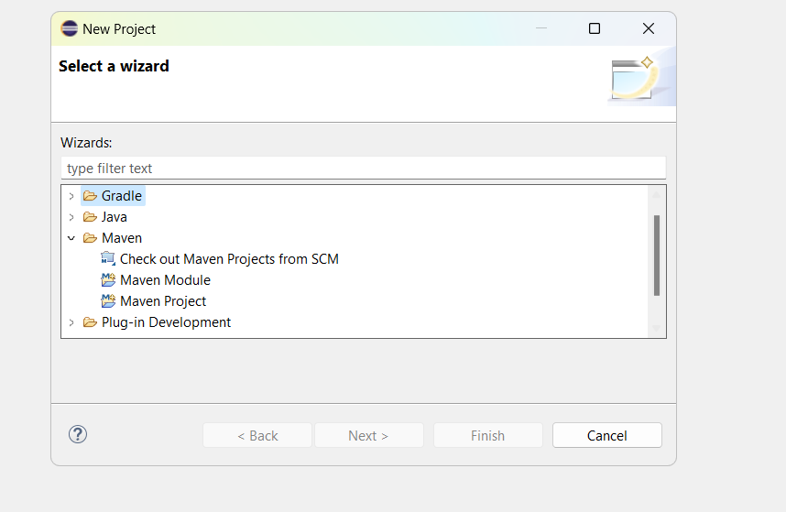

Select Default workspace.

You will be on Archtype wizard. In filter add this archetype : maven-archetype-quickstart

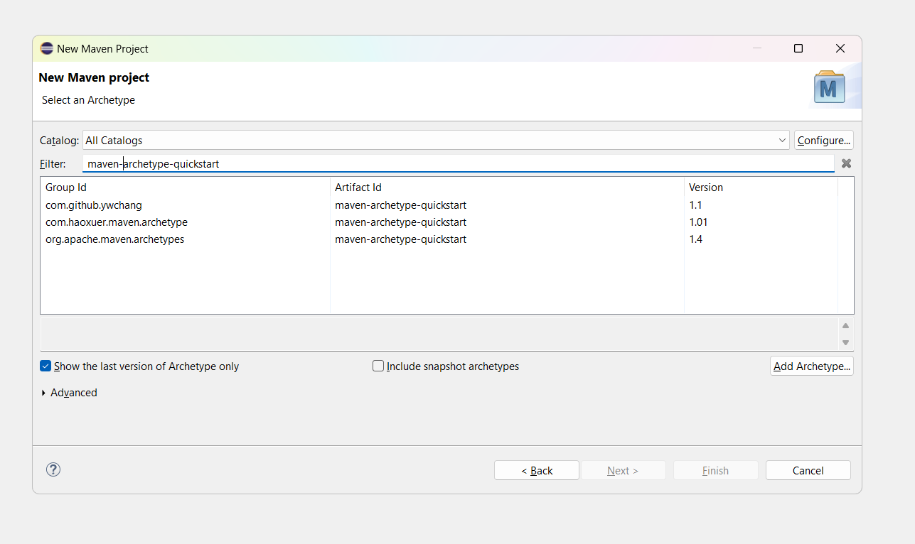

Select the artifact with id as 1.4 or any version for group id should be org.apache.maven.archetypes

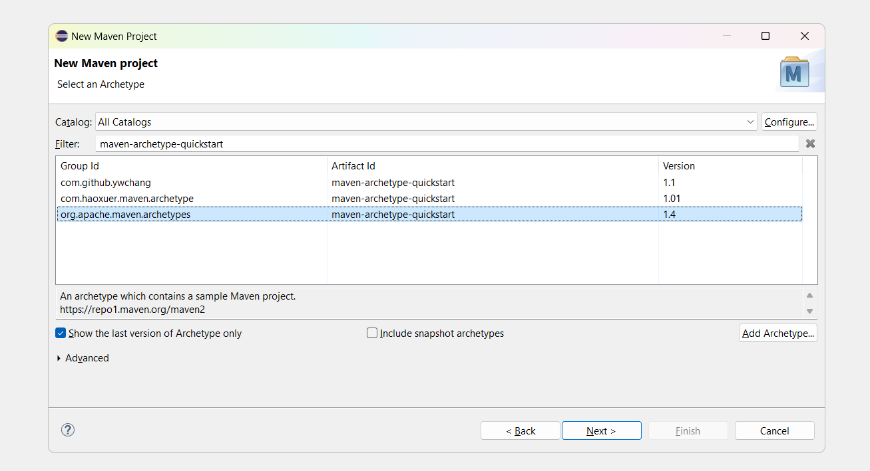

Press Next

Give groupid and artifact ID as same

Lesson5-CucumberDemo

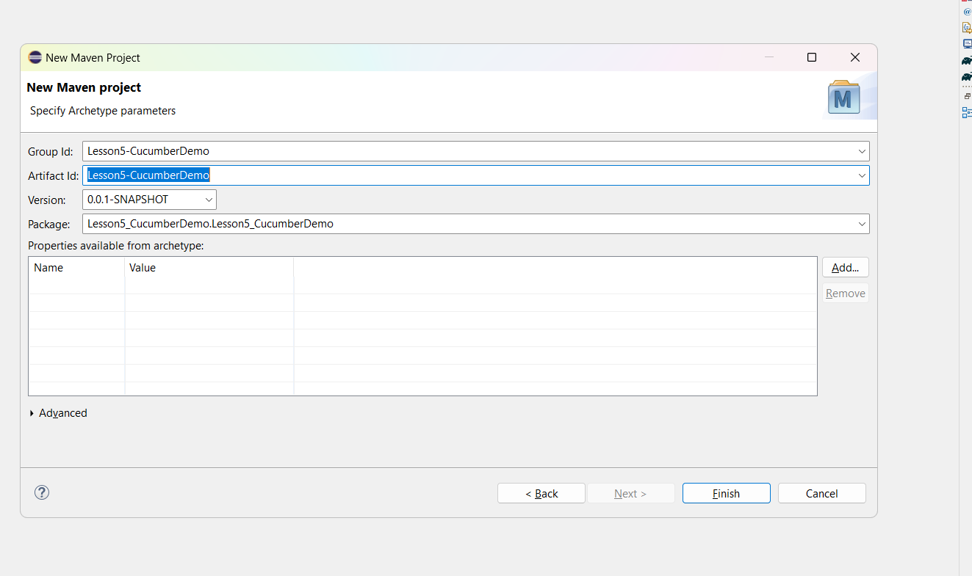

Click on finsh button and then downloading will start

Wait for some time and it will prompt for giving Y

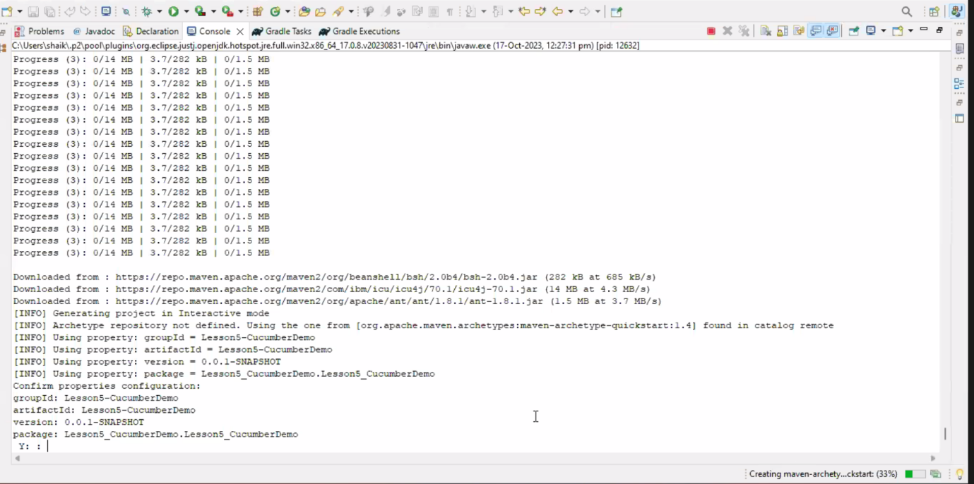

Give Y and enter key

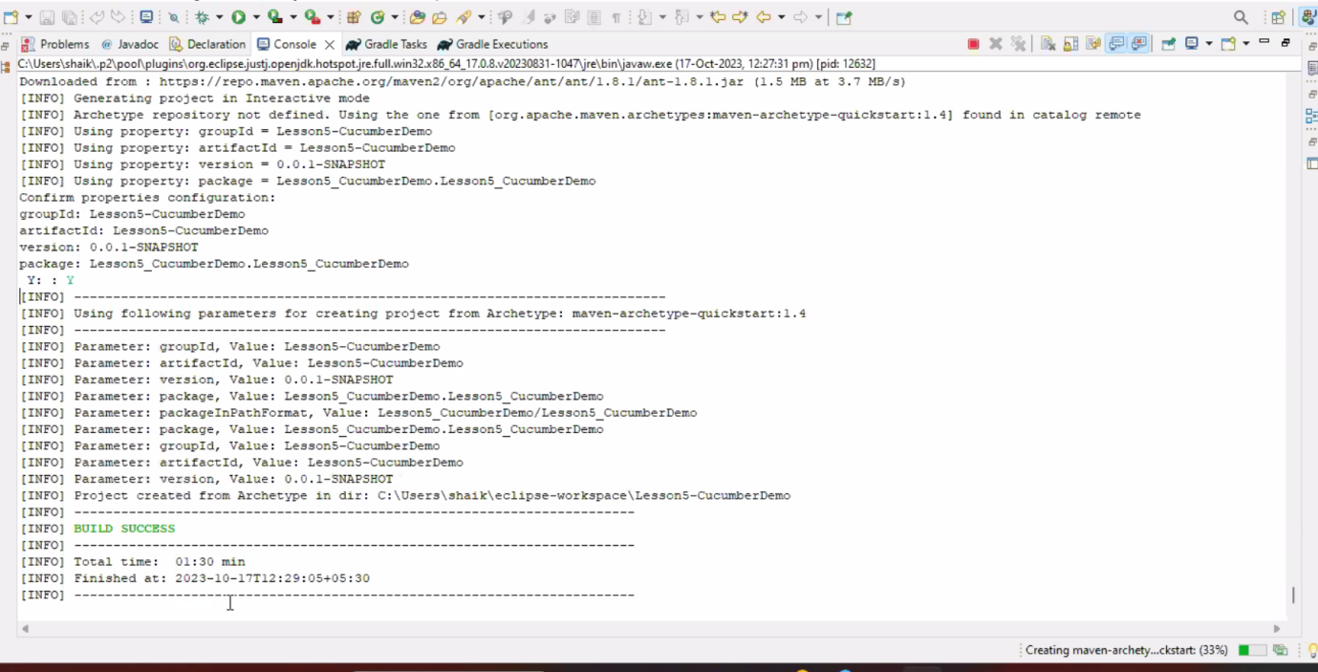

Build will be success.

Open the Pom.xml file and remove the Junit dependency

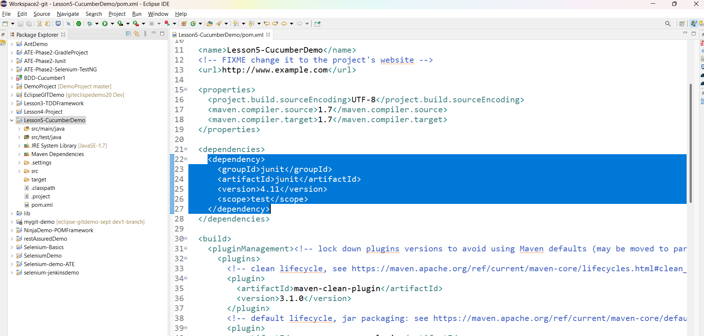

Now add the below cucumber, selenium and junit. Testing depenecies

<dependency>

<groupId>junit</groupId>

<artifactId>junit</artifactId>

<version>4.11</version>

<scope>test</scope>

</dependency>

<!-- https://mvnrepository.com/artifact/io.cucumber/cucumber-java -->

<dependency>

<groupId>io.cucumber</groupId>

<artifactId>cucumber-java</artifactId>

<version>7.10.1</version>

</dependency>

<!-- https://mvnrepository.com/artifact/io.cucumber/cucumber-java -->

<dependency>

<groupId>io.cucumber</groupId>

<artifactId>cucumber-junit</artifactId>

<version>7.10.1</version>

<scope>test</scope>

</dependency>

<!-- https://mvnrepository.com/artifact/io.cucumber/cucumber-java -->

<dependency>

<groupId>io.cucumber</groupId>

<artifactId>cucumber-core</artifactId>

<version>7.10.1</version>

</dependency>

<dependency>

<groupId>org.seleniumhq.selenium</groupId>

<artifactId>selenium-java</artifactId>

<version>4.11.0</version>

</dependency>

<!-- https://mvnrepository.com/artifact/io.github.bonigarcia/webdrivermanager -->

<dependency>

<groupId>io.github.bonigarcia</groupId>

<artifactId>webdrivermanager</artifactId>

<version>5.4.1</version>

</dependency>

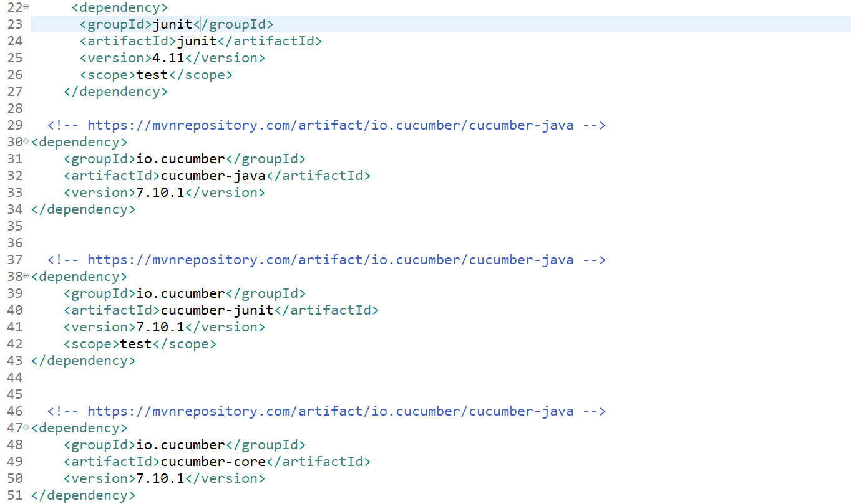

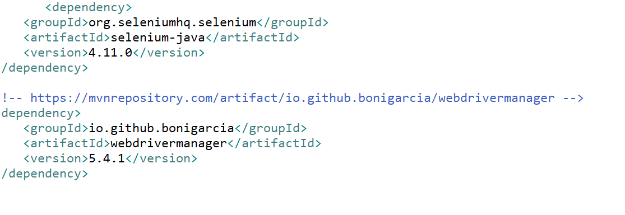

Download Cucumber Plugin for Eclipse

Go to Help on the eclipse

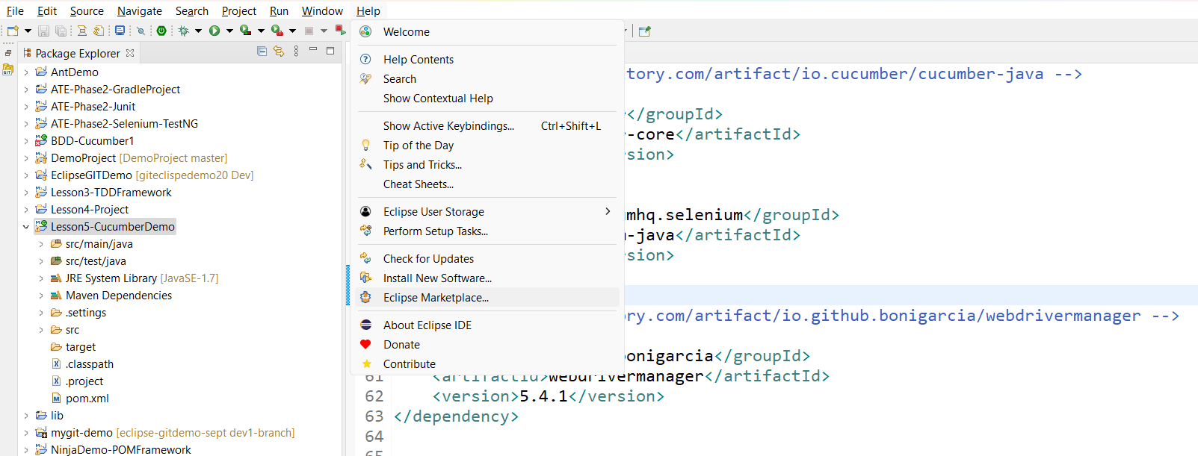

Go to Eclipse Market Place and search for cucumber plugin

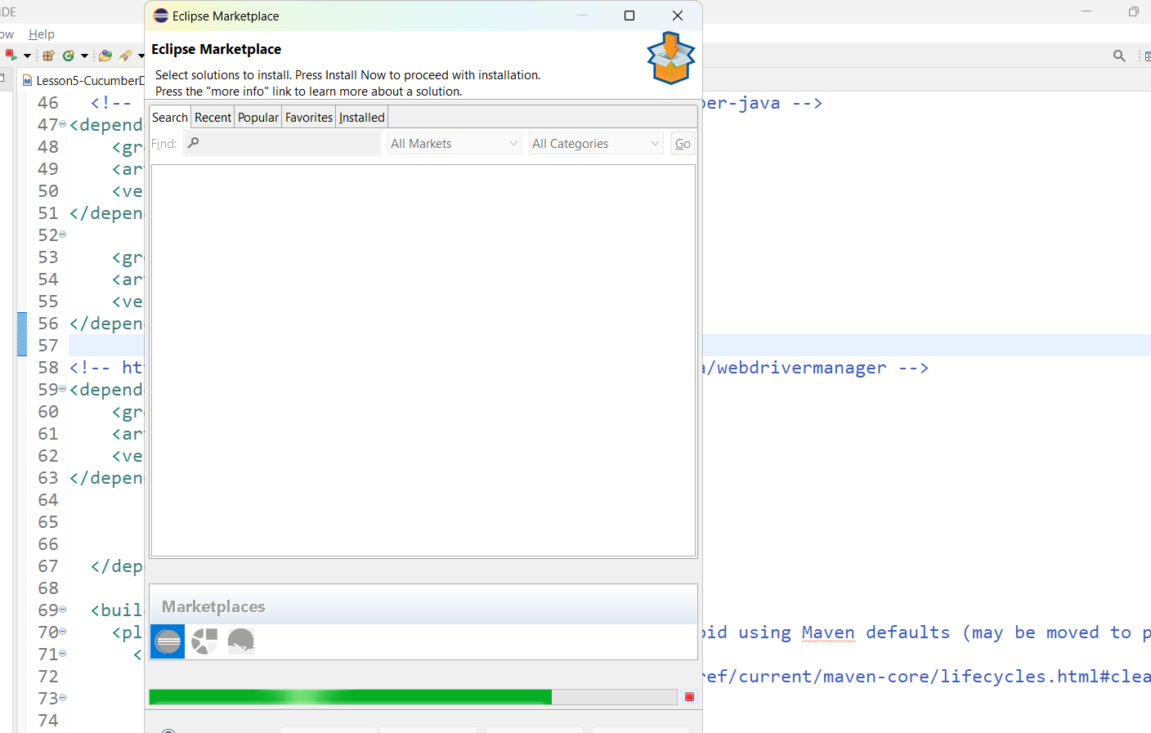

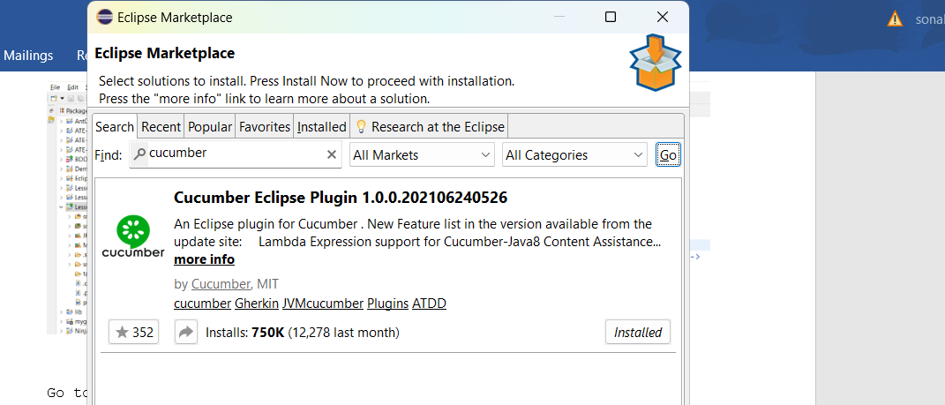

Click on install button to install the plugin.

Convert Maven project to Cucumber Project

Right click on the project 🡪 go to configure 🡪 click on convert to cucumber project

