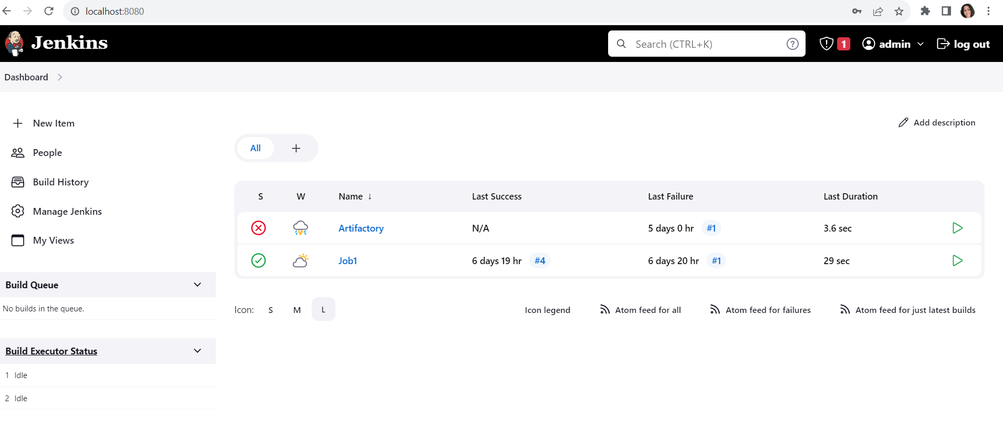

Download the code coverage plugin in Jenkins

Go to • [Dashboard](http://localhost:8080/)> [Manage Jenkins](http://localhost:8080/manage/) >[Plugins](http://localhost:8080/manage/pluginManager/) > Available Plugins > search for JACOCo

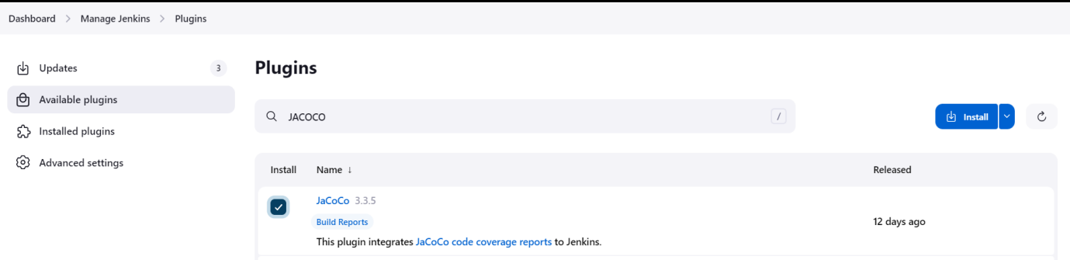

Click on Install button

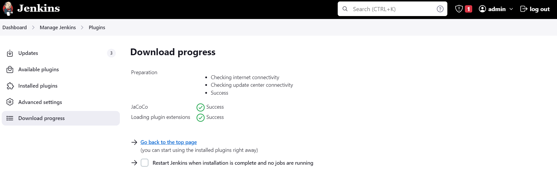

Now go and create a Freestyle job

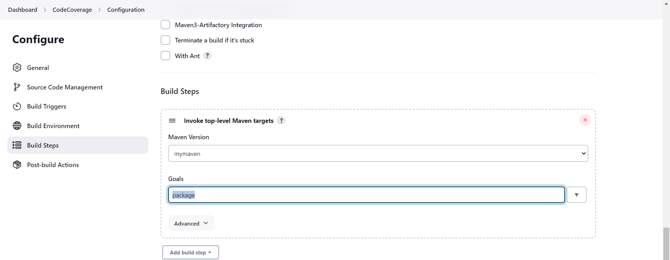

In port build actions > Select Record JACOCO coverage reports

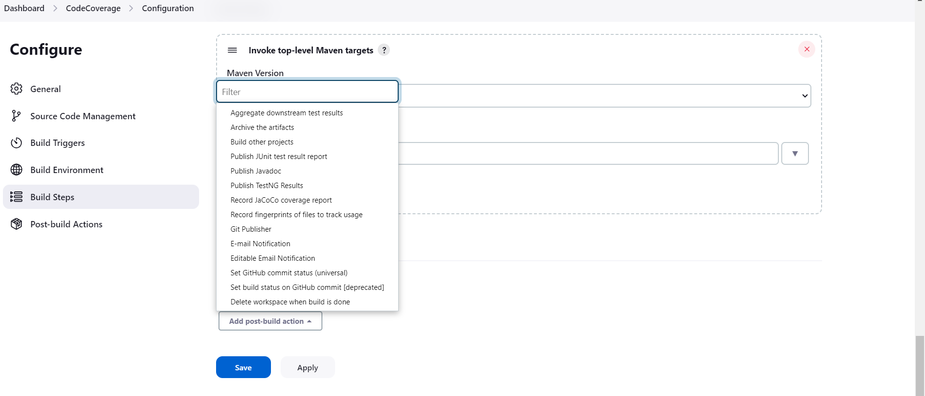

Execute the job

