File Search Assignment:--

Step 1:--

Menu Screen

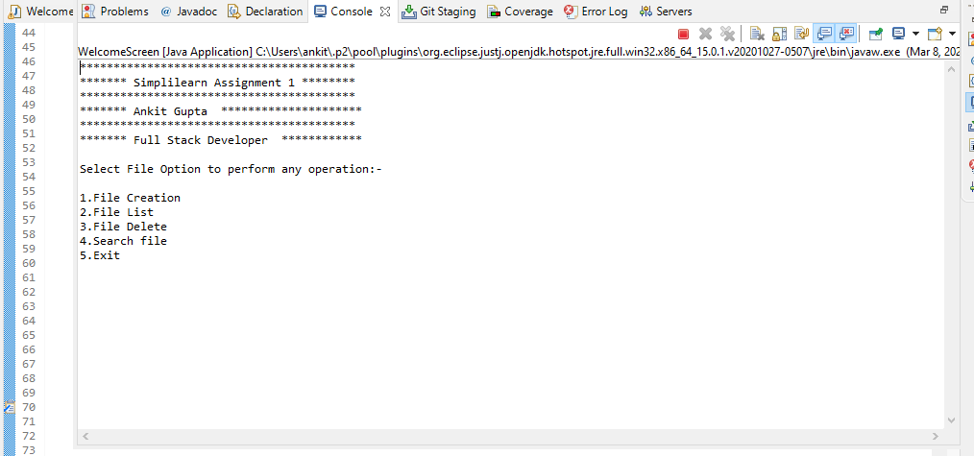

Select any Menu item

A .For File creation select 1

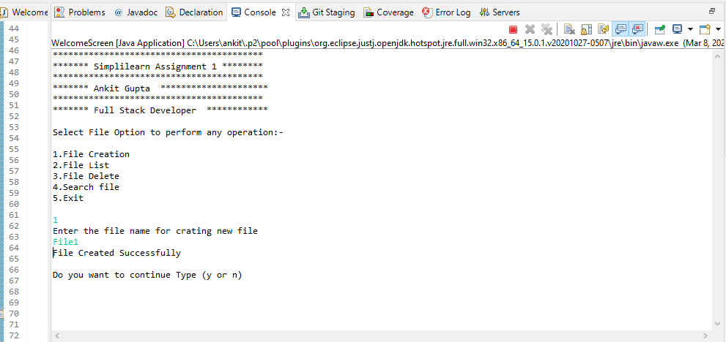

If you want to go with another menu option then click yes otherwise no.

After pressing yes

Select another menu option

Now we choose 2 for file list

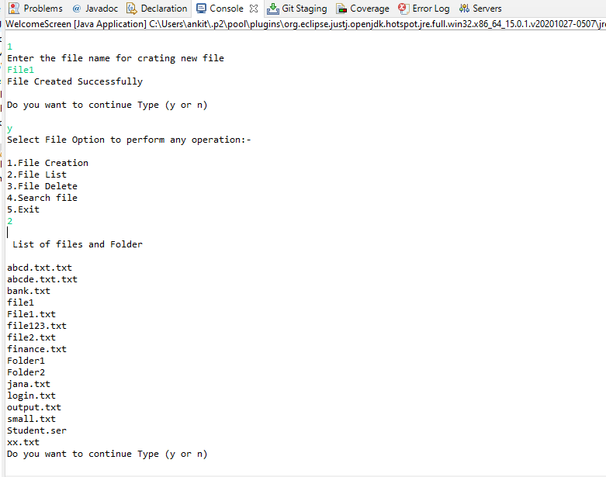

Again want to with another menu option then click Y for yes and N for no.

Now if you want to file search then choose menu option 4.

If File present in folder then you will get the output as file found

otherwise you will get the output file not found.

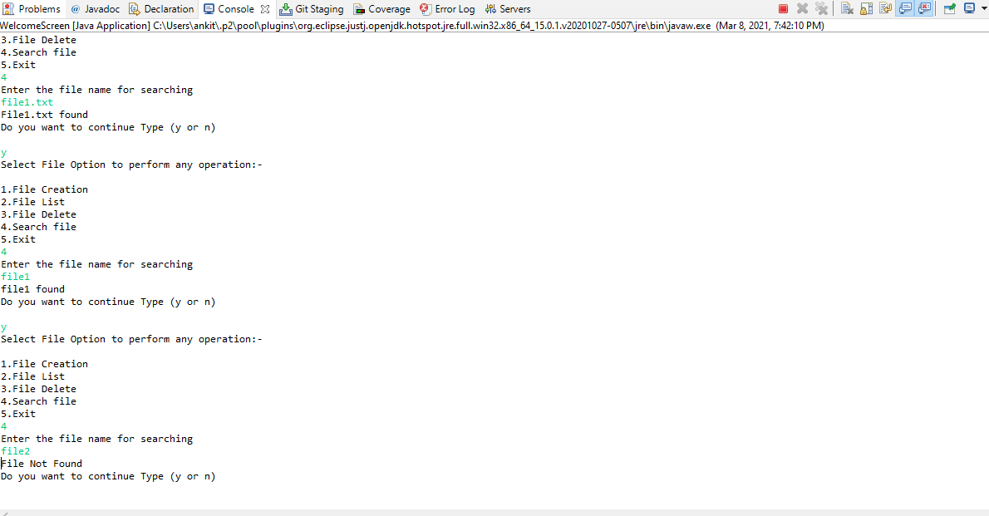

Now if you want to delete the file then go again the menu option

Then select the menu option 3 for deleting the file.

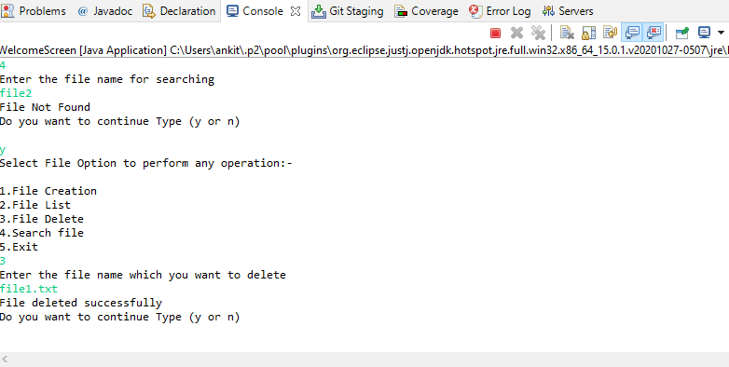

If you want to coming out from the program then choose menu option 5 to exit.

