**Locked Me Application Project**

Locked me application designed in Java programming language and contain the below following feature

**Generic feature of this application: --**

* Option to create a user specified file to the application
* Option to delete a user specified file from the application
* Option to search a user specified file from the application
* Option to show the list of all the file in the folder from the application

The user interface through application will be via a command line.

**Product Backlog of Locked Me .com**

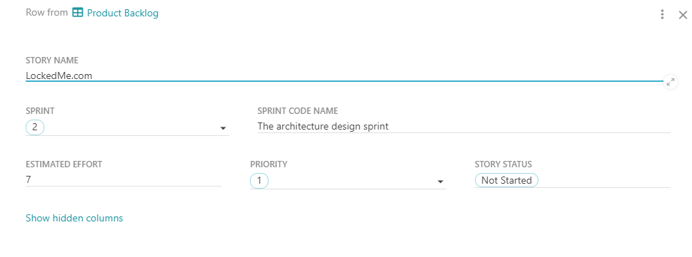

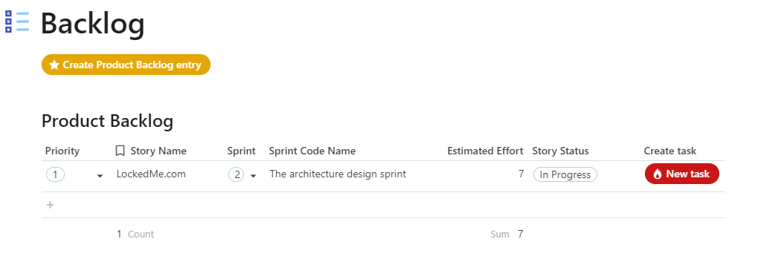

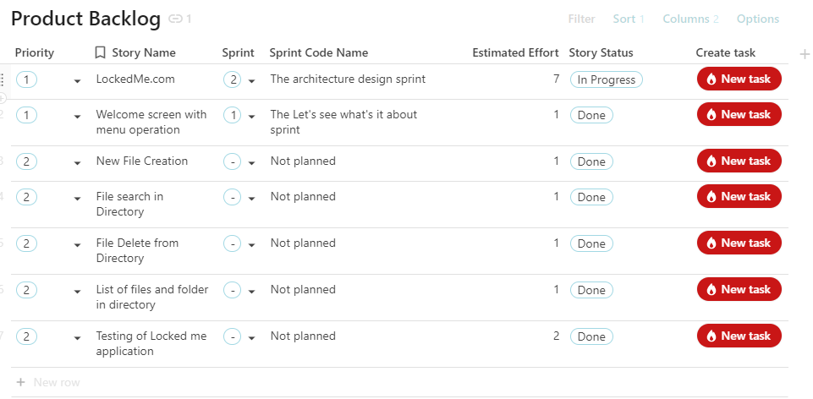

**Task Planning for Locked me .com**

