Team Pillow – CRASH! Project

**Data Visualizations**

The majority of the visuals included herein are derived from the 2015 **Fatality Analysis Reporting System (FARS**) data, which is managed by the **National Highway and Traffic Safety Administration (NHTSA)**. FARS specifically measures United States motor vehicle traffic accidents that result in at least one fatality within 30 days of the accident’s recorded date. If not noted, it can be assumed visualizations are counting accidents that resulted in fatalities.

The remaining visuals are derived from the **General Estimates System (GES)** put out by the **National Automotive Sampling System (NASS)**. Those will be called out specifically, as they include ALL national accidents, and are not limited to those resulting in human fatality.

**Relationships to ‘Person’ variables**

***Questions:*** *What type of drivers are more likely to cause or be in fatal crashes? Impaired (under influence alcohol), distracted, or drowsy drivers?*

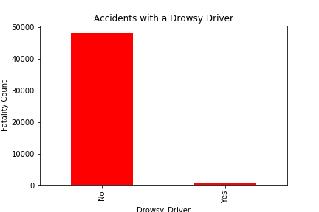 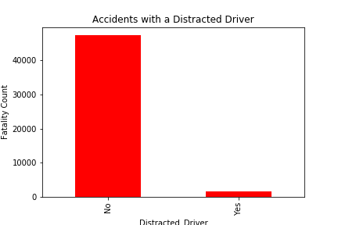

**Relationships to ‘Accident’ variables**

***Questions:*** *How often does speeding play a factor in fatal crashes? Are accidents with car roll-overs more likely to result in fatalities? What types of crashes are most common single-car, multiple car pile ups? Is there a type of vehicle that’s more commonly in accidents?*

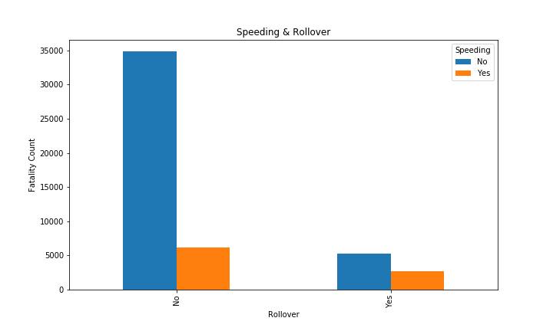 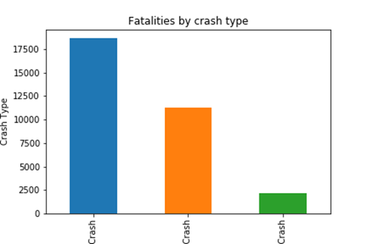

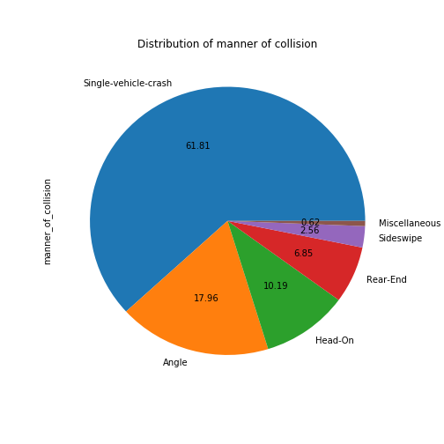 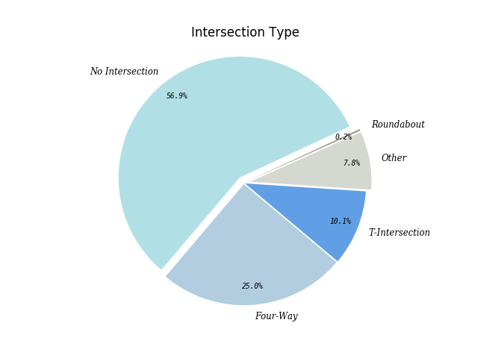

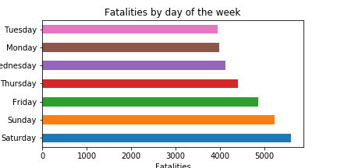**Relationship to TIMING – When was it??**

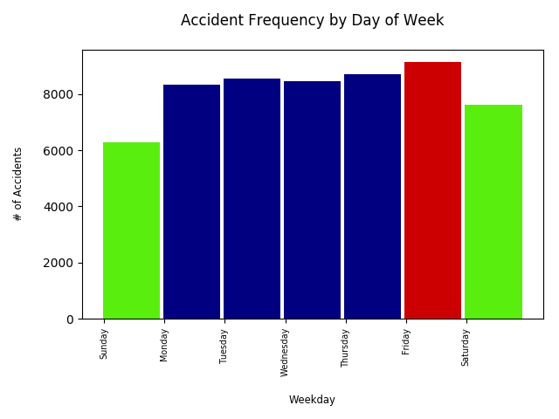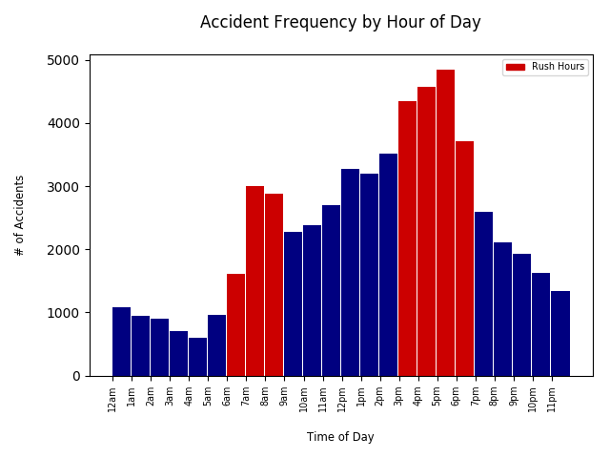 Above image is GES (all accidents including non-fatalities) Compare FARS (fatal crashes) above to GES (all accidents) below

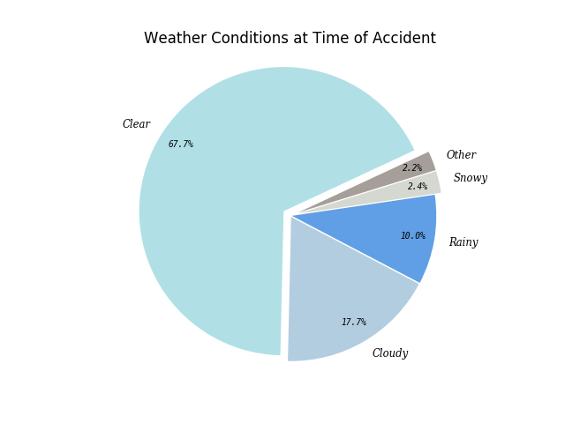

Above image is GES (all accidents including non-fatalities)

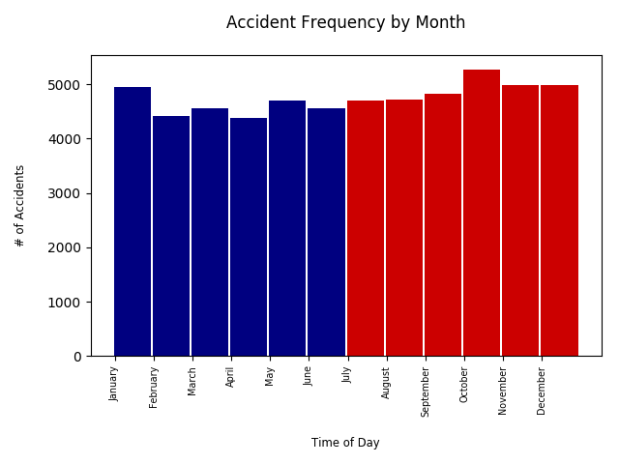

Compare GES data by month of year

(all accidents in US)

To FARS data by month of year

(fatal crashes only)

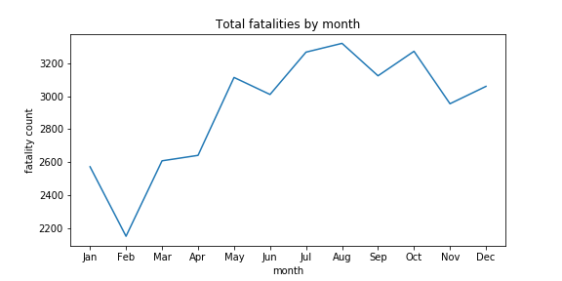

**CRASH Location Visuals**

***Question:*** *Where do fatal accidents occur most frequently geographically? Are urban areas more dangerous than rural? Does climate impact the frequency significantly? Does a winter season cause more accidents; or might it be related to fewer accidents due to fewer drivers on the road, more cautious/slow driving?*

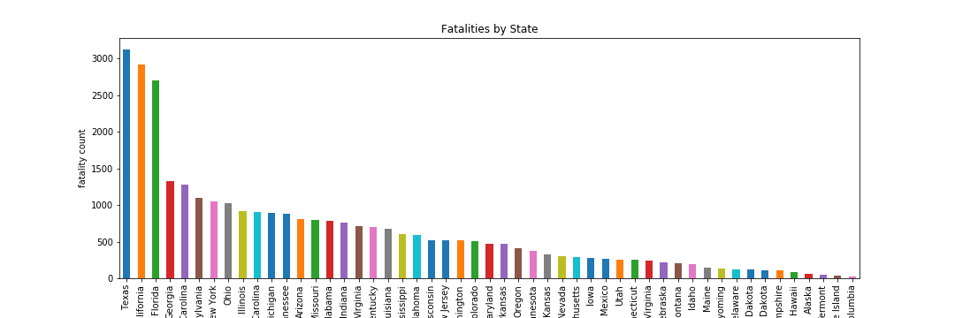

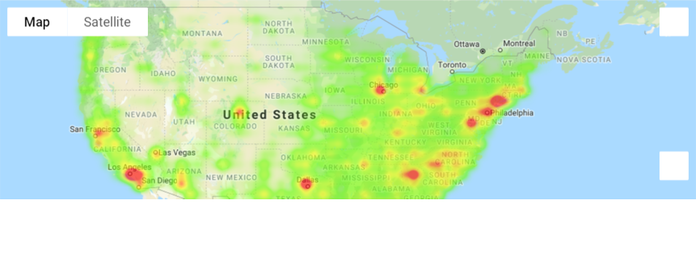 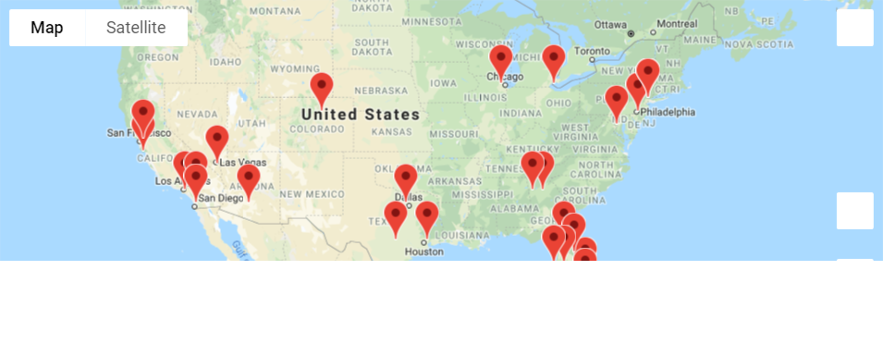

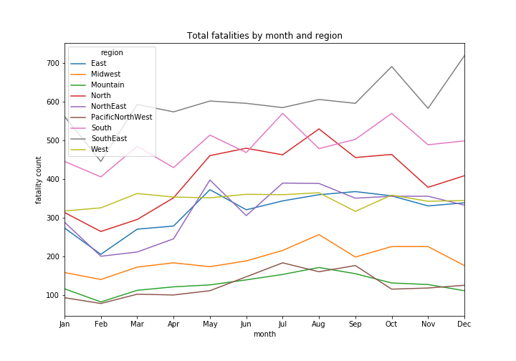Top 25 Geographic Areas

MOST Fatal Crashes (2015)

