**Project CRASH! ~ Team Pillow** (will soften the blow)

Andrew Hartman, Melissa Mielke, Jamie Reetz, Chris Rieck, Rahul Ughade,

During the team’s initial brainstorming session, when we chose motor vehicle crashes as our subject of interest, we discussed the causes of traffic accidents that are pro minent in the media and that have been driving legislation over the past decade: drunk/impaired driving, distractions (“don’t text and drive”), and seat belt usage (“Click it or Ticket”). We were interested in investigating the ACTUAL impact these known causes had, with the knowledge that media can sensationalize; we also defined additional variables of interest that weren’t as well known. Specifically, relationships related to time of day/week/year, inclement weather conditions, and geographic and traffic location of the accident. The majority of the findings herein are investigating those less publicized variables. This write up includes some conclusions we were able to draw, mitigating factors or confounding variables that may have skewed our findings, additional questions that came out of our analysis. These questions would lead to further iterations of exploration, analysis, and conclusions, time permitting.

**CRASH! Study - Conclusions**

**Category #1:** Attributes of the PERSON(S) involved in the accident—includes both intrinsic characteristics (i.e. age group) or circumstantial (i.e. impaired/not)

***Questions:*** *What type of issue affecting drivers are most likely to increase the likelihood of accidents and resulting fatalities? While we knew alcohol/drug impairment would be significant, we were curious if distracted/drowsy driving factors were on the rise and even in the same ballpark as substance use impairment.*

*Do individuals on both ends of the age spectrum—younger (new) drivers and elderly drivers—get into more accidents than experienced drivers without aging impairments?*

*When accidents resulting in fatalities occur, who are most often the casualties? We expected that drivers would have the highest rate of mortality, due to the frequency of accidents that we found were single-car, single-driver. Other person types that could be a measured fatality were: pedestrians, bicyclists, passengers.*

**Conclusions:** The majority of fatal accidents did not involve distracted or drowsy individuals. Of these components, distracted driving was the bigger issue in the year measured (2015). We did see that distracted driving has been trending toward more prevalent over the past two decades (since the onset of cellular phone use while driving. As expected, alcohol impairment was a SIGNIFICANT factor, being a confirmed factor in almost 1/4 of fatal crashes. This measure, however, is certainly lower than reality as over 1/3 of fatal crashes either specifically did not test for impairment (~25%) or that variable was unknown (~11%). Another factor that likely shows a skewed (lower) impairment percentage is that alcohol is often the only substance tested for. The FARS/GES data does not have a data point for blood testing for any other illicit substances.

Across the three years we investigated, the age trends were consistent. The age group getting into the highest number of accidents consistently was the 25-34 year age group. We found this interesting, as standard car insurance rates drop at age 26 so, logically, we would assume the younger range of 16-24 would have the highest rate of accidents. We did not have the data for the total make-up of insured drivers on the road during the years explored. This would have allowed us to control for the percentage of the whole that each age group comprised. This type of control would have been helpful in normalizing any person-centered attribute.

***Person-Related Visuals:***

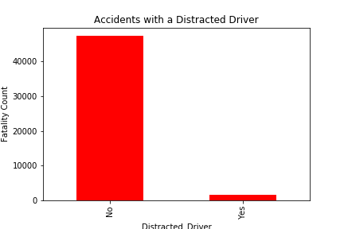 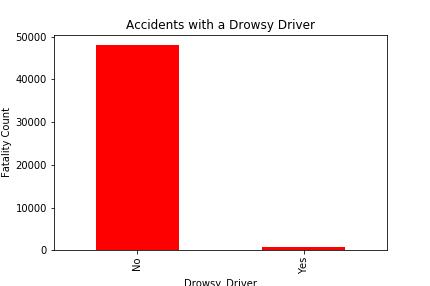

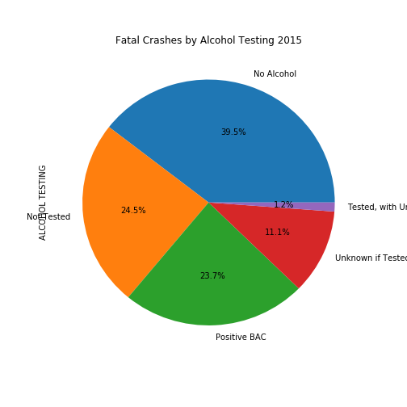 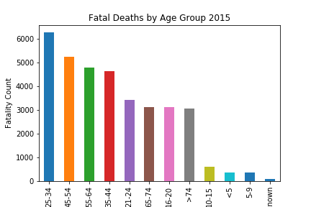

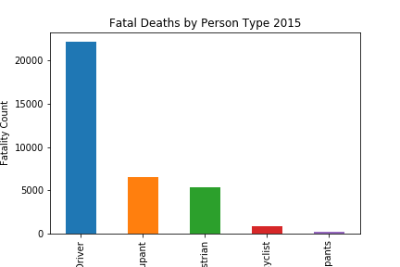

**Category:** General attributes of the **ACCIDENT** or collision itself.

***Questions:*** *How often does speeding play a factor in fatal crashes? Is there a relationship between speeding and the likelihood of a rollover (which often results in fatalities)? What types of crashes are most common single-car, multiple car pile ups? Is there a type of vehicle that’s more commonly in accidents? Are accidents more likely to occur in intersections and, if so, which type of accidents are the most dangerous.*

**Conclusions:** The majority of crashes involve one-car, one-passenger accidents. Again, this is probably because the majority of cars on the road are generally one-person cars (hence, the push for car-pooling). Two car crashes were second, followed by multi-car accidents. Almost half of the rollover accidents had speeding vehicles involved, whereas it was a much smaller percentage of the non-rollover accidents. Speeding, as we’d expect increases the likelihood of rolling over.

Across the years we investigated, age trends were consistent. The group with the highest number of fatal accidents consistently across years was the 25-34 year age group. We found this interesting, as standard car insurance rates drop at age 26 so, logically, we assumed the youngest drivers (16-24) would have the highest fatality rate. This may be due to the fact we did not have data describing the person make-up of insured drivers on the road during the time explored. This would have allowed us to control for the percentage of the whole that each age group comprised. This type of control would have been helpful in normalizing any other person-centered relationships as well (i.e. race/gender)..

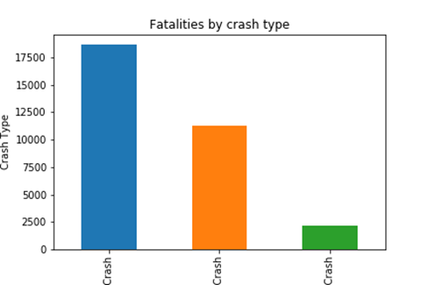 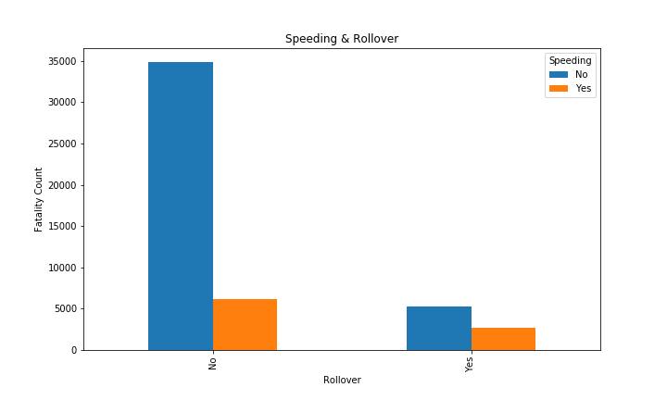

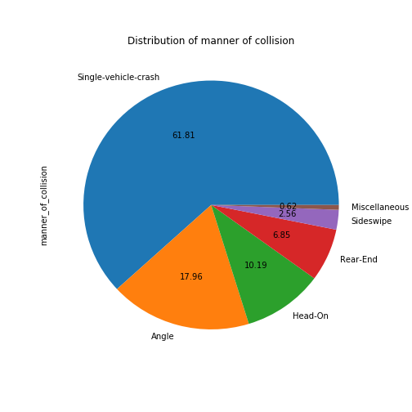 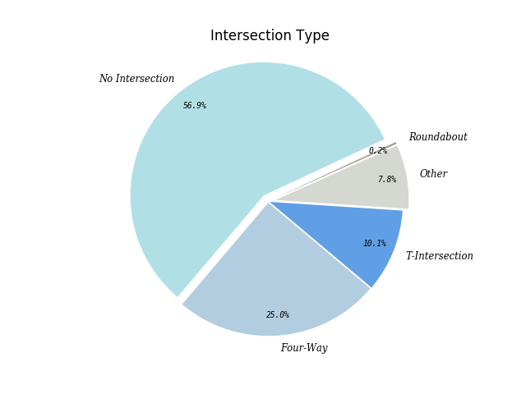

**Relationship to TIMING – When was it??**

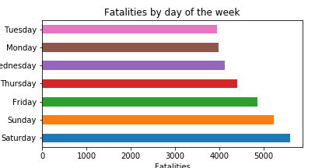

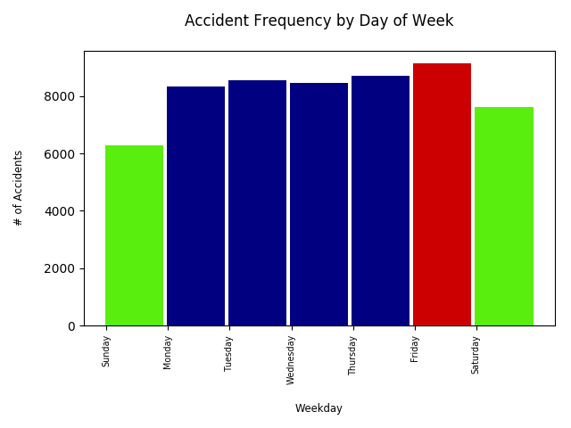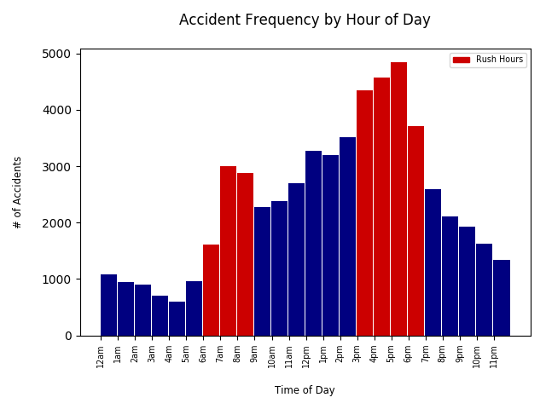 Above image is GES (all accidents including non-fatalities) Compare FARS (fatal crashes) above to GES (all accidents) below

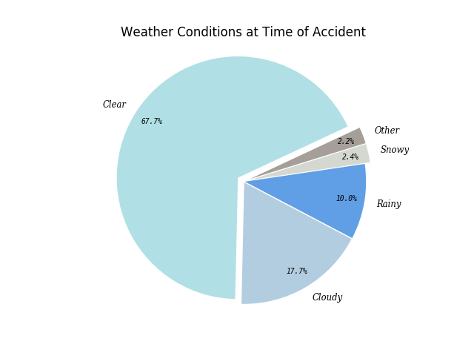

Above image is GES (all accidents including non-fatalities)

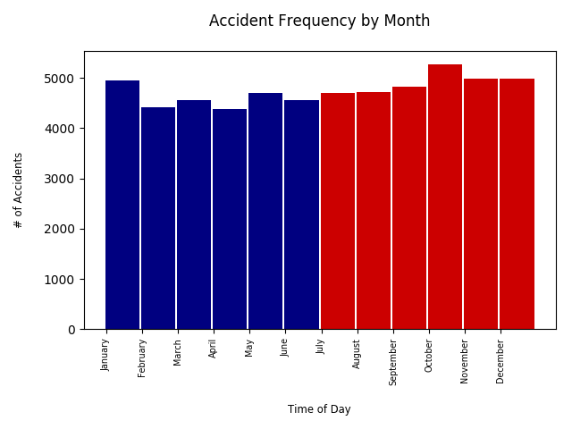

Compare GES data by month of year

(all accidents in US)

To FARS data by month of year

(fatal crashes only)

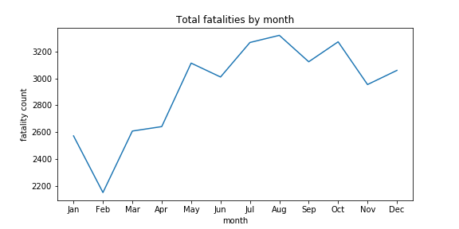

**CRASH Location Visuals**

***Question:*** *Where do fatal accidents occur most frequently geographically? Are urban areas more dangerous than rural? Does climate impact the frequency significantly? Does a winter season cause more accidents; or might it be related to fewer accidents due to fewer drivers on the road, more cautious/slow driving?*

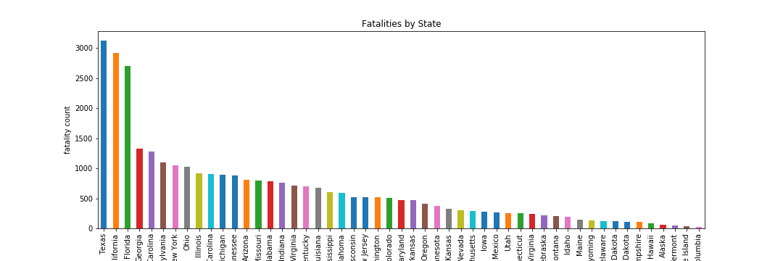

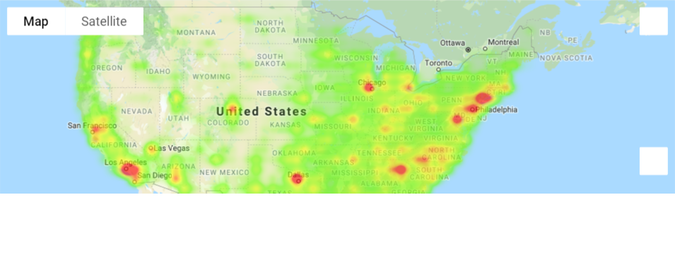 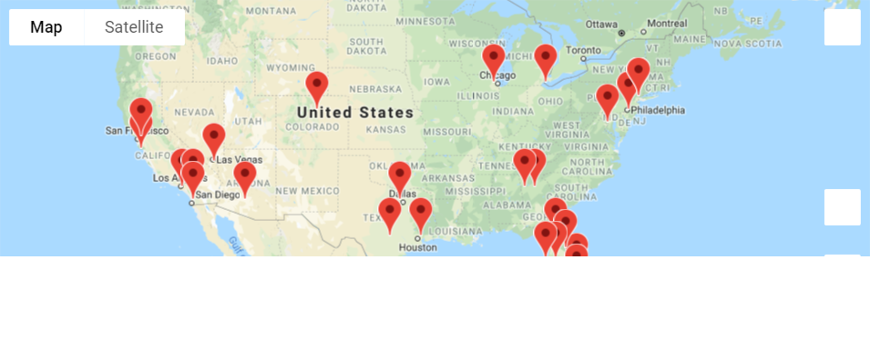

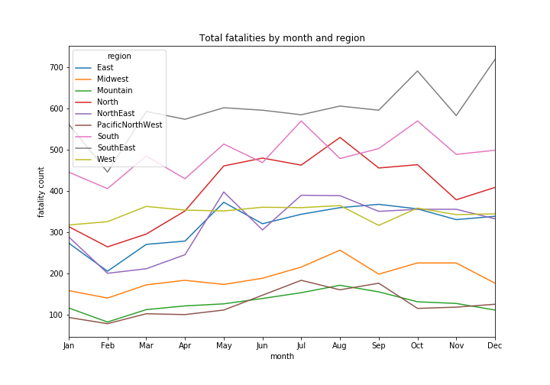Top 25 Geographic Areas

MOST Fatal Crashes (2015)

