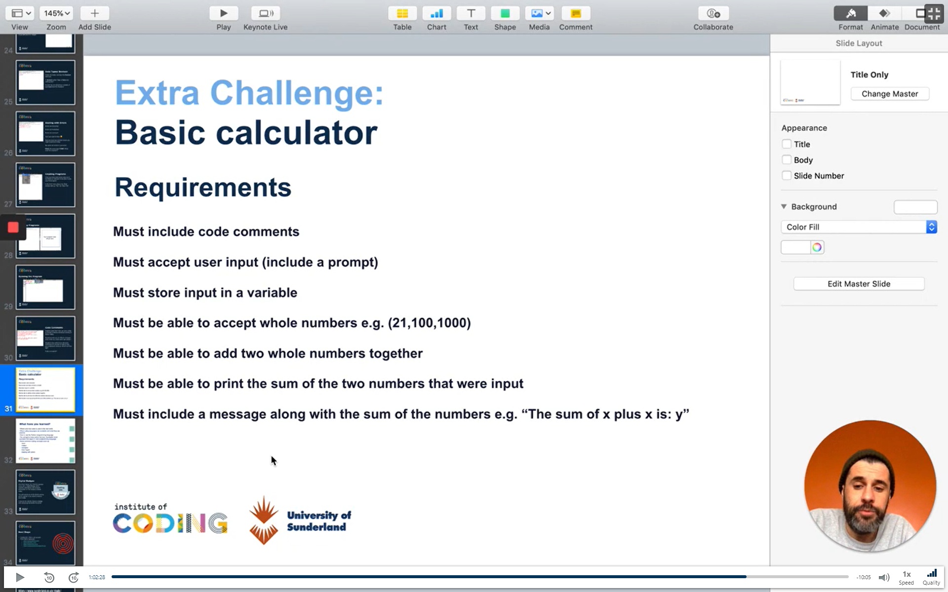

Must include code comments:

# single line comments

Must accept user input (include a prompt)

Input(“”: )

Must store the input inside a variable

How to store the output of input in a variable

Must be able to accept whole numbers (21, 100,1000)

Data Type Integer

Must be able to add two whole numbers together

2+2

Must be able to print out the sum of the two numbers that were input

Print(var1 + var2)

Must include a message along with the sum of the numbers e.g. “the sum of x plus x is: y”

Result:

#Basic Calculator - Must include code comments

#Must accept user input (include a prompt)

addNum1 = input("What is the first number?: ")

addNum2 = input ("What is the second number to add? ")

#Must store the input inside a variable

equals = int(addNum1) + int(addNum2)

#Must be able to accept whole numbers (21, 100,1000)

  #Data Type Integer

#Must be able to add two whole numbers together

  #2+2 operator

#Must be able to print out the sum of the two numbers that were input

#Must include a message along with the sum of the numbers e.g. “the sum of x plus x is: y”

print ("The sum of " + str(addNum1) + " plus " + str(addNum2) + " is: " + str(equals))

