**My CV Website**

**By**

**Andrew Howe**

**10322179**

**Web Development Assignment 1**

**Git Repository:**

<https://github.com/ajhowe31/csy1018-assign1/tree/master/htdocs5>

**submission date. 15TH Jan 2017**

In the Beginning

I began the process of creating my CV website by looking at the kind of sites that other people are using for their CV’s on the internet. I found that most sites were using a beautiful picture as their homepage background with most of the information required displayed on top of the background image on their homepage. As the assignment brief stated that I had to include an index.html, a bio.html, a cv.html and a contact.html, displaying all my information in this way would not be possible for me.

Below is a link to a website that displays five beautifully made CV websites that show the emphasis on displaying most of the information on the homepage. Although these pages do have links to separate pages, they don’t have visible navigation bars, which is something I wanted to incorporate into my site.

<https://code.tutsplus.com/articles/5-examples-of-beautiful-resumecv-web-templates--net-8895>

**Designs:**

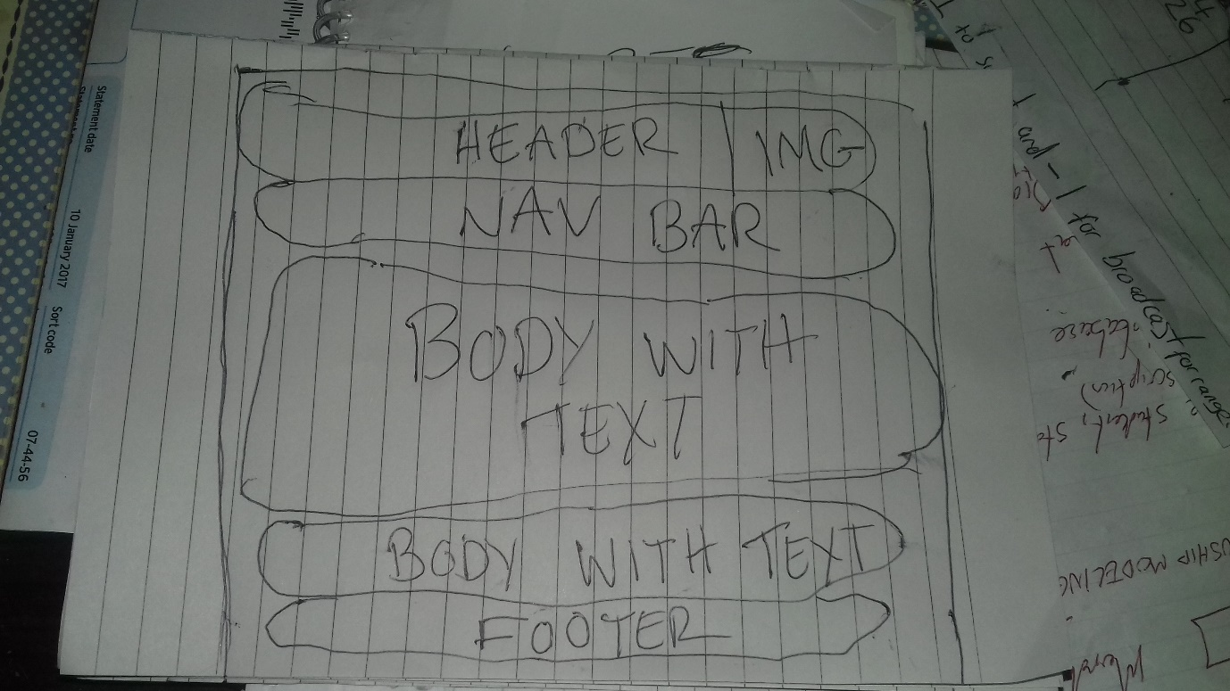

The drawing above is the original design I was going to go with. However, once I completed the design I was not happy with it and so started from scratch and came up with a completely new design despite this design taking me the best part of three weeks to complete. The website I completed for this design was committed to git hub on the 11th of December 2016 is available for viewing through the following link:

<https://github.com/ajhowe31/csy1018-assign1/commits/master>

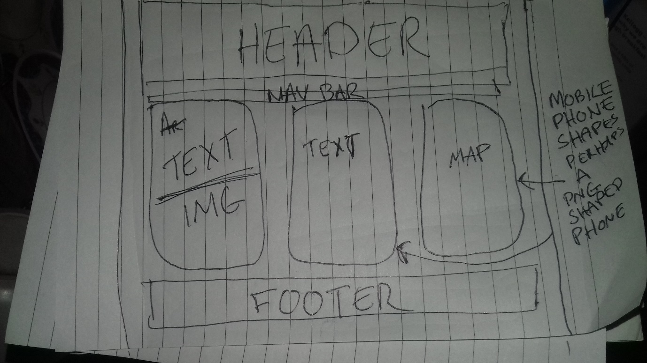

Above is my second and final design that I have now completed and will be submitting for the assignment. I decided to use flex box to create three separate blocks and then to fill them with the information required in the form of images and text. I originally wanted to shape the individual boxes in the shape of mobile phones but later decided against this. I made several git hub commits during the design of this idea and they are available for viewing via my git repository.

<https://github.com/ajhowe31/csy1018-assign1/commits/master>

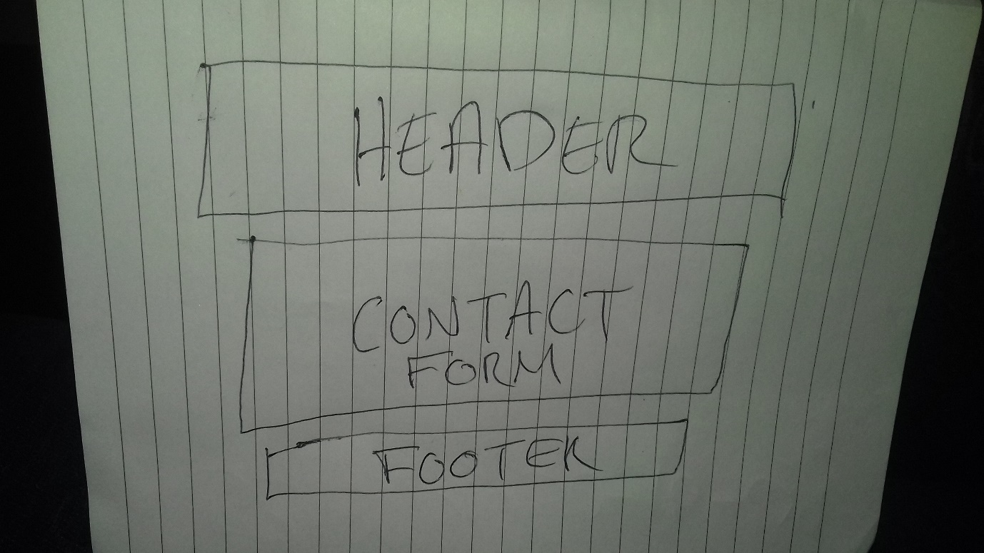

Above is an image of the design I sketched for my contact form page. It is a very simple design, although with something like a contact form is quite limiting in the way you can design it. In my final design however I did incorporate a picture of a phone an added some icons to try and make it look slightly more interesting.

I have not shown designs for all the separate pages on my site as I decided to keep the same design across all pages on the site but by adding different images and text they all still have their own theme. Keeping the same designs across all pages adds a sense of belonging and collectively to the whole site and it is possible to add individual elements of unique design to each page whilst keeping to the original design.

Before and during the construction of this website I spent many hours watching videos and reading articles about web design on the internet. I found them extremely helpful and have used some of them to help with the design of my own website. I have always been careful not to directly copy any of these sites, but have used some for inspiration and a guiding hand at times when I was stuck.

Below is a list of the sites I found to be extremely helpful in the design and construction of my own website.

The first video I have listed a since been removed for reasons I do not know. However, I found this video extremely helpful so I will just describe what the video was about as it is no longer available for viewing. The video consisted of seven separate one hour videos explaining the fundamentals of HTML5 and CSS3. In fact, the actual video title was called fundamentals of HTML5 and CSS3. Although I did not watch all seven hour episodes I did watch three hour episodes which I found extremely useful. The video did not really contribute to my actual design, more it provided a broader knowledge of concepts associated with HTML5 and CSS3.

<https://www.youtube.com/watch?v=4Oggpc9gl5g>

The second video I found the most helpful, it really gave me an understanding of how to use flex box in the design of my website which I found invaluable as flex box methods played a huge part in the design and construction of my website. This video is part of a series of eleven made purely about flex box alone.

The video is called: CSS Flexbox Tutorial #1-11 and is available at: <https://www.youtube.com/watch?v=2plKBskaKfY>

I found a host of other videos inspiring and useful for a variety of reasons although the two mentioned above helped me the most. I will list all the videos that I watched that helped me with the design and construction of my website below.

Responsive Web Design Tutorial #5 - Media Queries available at: <https://www.youtube.com/watch?v=5xzaGSYd7jM>

Google Fonts with HTML and CSS 2016 available at: <https://www.youtube.com/watch?v=1S3ga5Or5ec>

I found this following video useful for adding animation. I did use animation in first design, although not so much in my final design.

CSS Animation Tutorial #2 – Transforms available at:

<https://www.youtube.com/watch?v=PH35-BDak0M>

CSS Header & Horizontal Navigation Menu available at:

<https://www.youtube.com/watch?v=rKUIRO3UqGA>

**IMAGES:**

I used three images on my site, all of which are copyright free and provided by <https://pixabay.com/>

The image of the man on my home/index page is available at:

<https://pixabay.com/en/man-person-avatar-face-head-156584/>

The image on my biography page is an image of me taken by a friend who has given permission for me to use it.

The image of the man playing football on my biography.html page is available at:

<https://pixabay.com/en/soccer-football-sports-man-guy-34248/>

The image of the telephone used on my contact.html page is available at:

<https://pixabay.com/en/cell-phone-portable-device-33648/>

**FONTS:** I used two fonts on my website, ‘Lusitana’ & ‘Cantarell’. Both these fonts are available at: <https://fonts.google.com/?query=cantarell>

**ICONS:** I used several icons on my webpage, all courtesy of Font Awesome and are available at: <http://fontawesome.io/icons/>

I used googles colour palette in the design of my fonts. Goggle lets you select two colours from its pallet and then matches other colours for you automatically. This is available at:

<https://www.materialpalette.com/>

**HOURS SPENT:** I have easily spent well more than 35 hours working on this project. I have created designs and then started from scratch again as my git hub commits will testify to.