NMRphasing: An R Package for 1D NMR Phase Error Correction

Aixiang Jiang [a,b,c] * and Robert Nadon[d] **

A Jiang

[a] Department of Epidemiology, Biostatistics, and Occupational Health, McGill University, Montreal, Quebec, Canada

[b] Department of Pathology and Laboratory Medicine, University of British Columbia, Vancouver, British Columbia, Canada

[c] British Columbia Cancer Centre for Lymphoid Cancer, Vancouver, British Columbia, Canada

R Nadon

[d] Department of Human Genetics, McGill University, Montreal, Quebec, Canada

*e-mail: aijiang@bccrc.ca

**email: robert.nadon@mcgill.ca

**Abstract**

Nuclear magnetic resonance (NMR) spectroscopy is widely employed to identify and quantify chemical compounds. However, the presence of phase errors in NMR data, where signal timing deviates from the true phase, requires correction to prevent significant distortions. Current methods, relying on a single simple linear regression model, face challenges in correcting nonlinear phase errors, resulting in residual phase errors. This limitation leads to residual phase distortions that can impact the accuracy of chemical compound identification and quantification. To address this challenge, we introduce the NMRphase R package, which incorporates innovative phase error correction methods capable of handling all types of phase errors while preserving existing correction techniques. While designed primarily for 1D NMR data, NMRphase can also be applied to 2D and 3D NMR data by processing one 1D NMR data file at a time.

**Introduction**

NMR, or Nuclear Magnetic Resonance, is a versatile scientific tool that leverages signals emitted by nuclei when placed within magnetic fields. Its significance spans various disciplines, including chemistry, physics, biology, biochemistry, materials science, and medicine. Since its inception in the 1920s, NMR has given rise to diverse variants, such as Magnetic Resonance Imaging (MRI), MR Spectroscopic Imaging (MRSI), Magnetoencephalography (MEG), pharmacological MRI (phMRI), and functional MRI (fMRI).

These applications, while intricate, share a common foundation: the detection and analysis of electromagnetic signals emitted by atomic nuclei, including protons. When a radiofrequency (RF) field is applied, protons within the sample become excited, absorbing RF radiation. This absorbed energy briefly elevates the protons to a higher energy state and increases their rotation speed. Subsequently, as the RF field deactivates, the protons relax, returning to a lower energy state, and emit electromagnetic radiation as a resonance signal. This resonance signal is essentially a time series of decaying waveforms recorded in NMR raw data, often referred to as NMR time domain data.

NMR signal analysis considers frequency, strength, and phase. Frequency is a measure of how often a waveform repeats its pattern within a given time frame. Strength indicates the maximum deviation of a waveform from its baseline or zero level. Phase describes the timing or position of a waveform relative to a reference point, indicating the shift in the waveform’s position along the time axis.

In order to separate signals from the same samples based on their frequencies, NMR time domain data are transformed into NMR frequency data usually through Fourier transformation(Fourier, 1822), where signals should be displayed as sharpened narrow symmetric peaks. Despite these advantages, when phase measurement errors exist, signal peaks are distorted, causing alterations in signal shape, peak height, and area, leading to inaccurate molecular identification and quantification. Therefore, phase errors must be corrected before any data analysis.

Current existing phase error correction methods rely on a linear model, almost always a simple linear model. The phase correction value (opposite in sign to the phase error) serves as an unobservable independent variable *y*, while a scaled frequency index acts as the dependent variable *x*(Binczyk et al., 2015; Craig & Marshall, 1988; Wang et al., 2009). An optimization process identifies the optimal intercept and slope for the phase error correction model. This model is then applied to the entire spectrum, making phase error correction at each point(Binczyk et al., 2015; Chen et al., 2002; Ernst, 1969).

However, a single simple linear model applied to an entire sample's NMR data is insufficient for handling non-linear phase errors. This limitation leads to remaining phase errors and necessitates labor-intensive manual correction. Additionally, the effectiveness of existing methods depends on the optimization function. Various functions prioritize specific signal aspects, influencing phase estimates and downstream analysis. While entropy-based functions(Chen et al., 2002) demonstrate superior performance compared to other methods(Brown et al., 1989; Craig & Marshall, 1988), no single current function can optimally address all phase errors, leaving room for improvement.

In this NMRphasing R package (https://cran.r-project.org/web/packages/NMRphasing/index.html), we propose novel approaches to correct phase errors in NMR spectroscopy, addressing non-linear phase errors, and create a new optimization function.

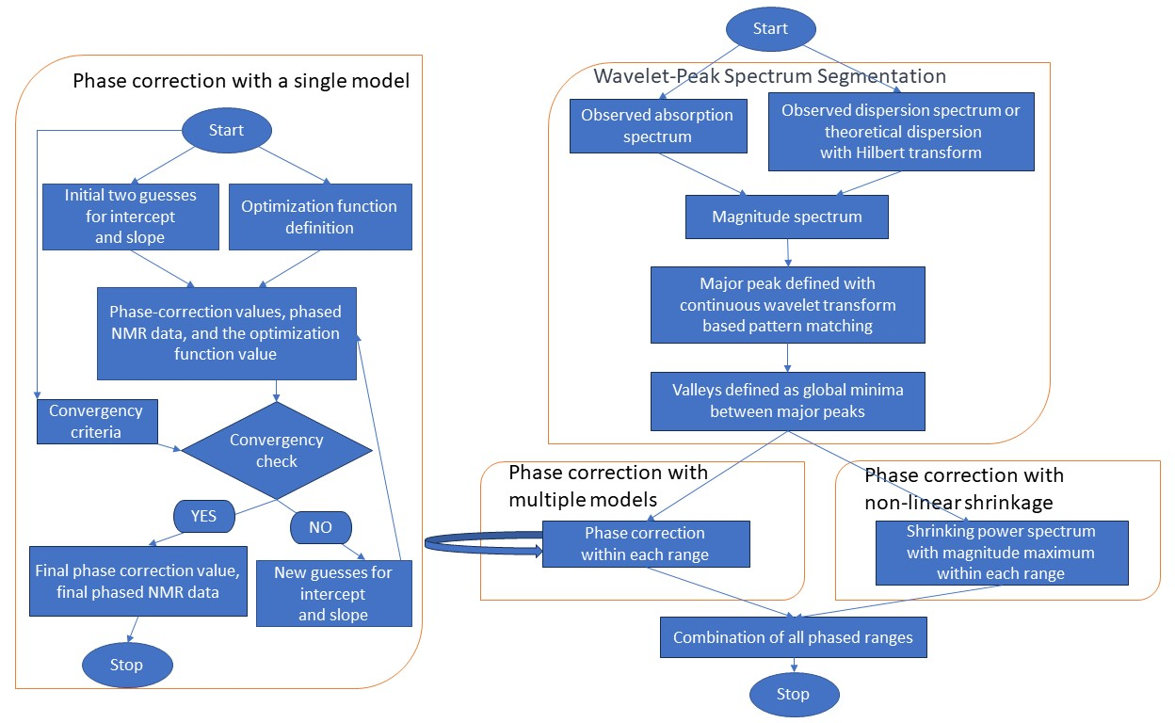Figure 1:Three phase error correction approaches in NMRphasing R package

Methods

NMRphasing offers nine phase error correction methods, comprising three existing methods and six new ones. These methods fall into three categories: phase error correction with a single simple model, phase error correction with multiple models, and non-linear shrinkage. The workflows for these three approaches are illustrated in Figure 1.

**Phase error correction with a single simple model**

When processing phase error correction with a single simple model for a spectrum, the model can be represented as follows:

$$y=a+bx$$

Here, *y* signifies a phase correction value for an individual data point, reflecting the phase error in the opposite direction. *a* serves as an intercept for correcting the global phase error, also known as the zero-order phase error, while *b* acts as a slope for addressing the frequency-dependent linear phase error, commonly referred to as the first-order phase error. The variable *x* represents the frequency value, ppm value, or the index for a data point.

Since *y* is not observable, an optimization search process is required to estimate *a* and *b*. To accomplish this, as illustrated in the left panel of Figure 1, we initiate the process with two initial guesses for the slope and intercept necessitating an optimization function. In the current implementation of NMRphasing, five optimization functions are available, asshown in the following:

• **Absolute area minimization (AAM)**

This method is based on the concept that a phase error free absorption spectrum, corresponding to the real part of NMR frequency domain data, should have the minimum integral of absolute intensity values among all possible absorption spectra with different phase errors(de Brouwer, 2009; Džakula, 2000). The optimization objective function is given by:

$$\left(\hat{a},\hat{b}\right)=\underset{\left(a,b\right)}{argmin}{\sum_{k=1}^{N}{\left|A_{k}^{'}\right|}}$$

Here, $\hat{a}$ and $\hat{b}$ represent the values of *a* and *b* that minimize the sum, and N is the number of terms in the summation. *A′k* is the absorption value at the k-th data point with the adjusted phase in the summation.

• **Entropy minimization with penalty (EMP)**

This method is employed to determine optimal parameters that not only achieve minimal entropy but also penalize negative signals that should not be present in a phase error free absorption spectrum. Entropy, in this context, is defined as the negative summation of the absolute intensity multiplied by the logarithm of the absolute intensity(Binczyk et al., 2015). The penalty term, introduced to penalize negative values, involves the square of negative values(de Brouwer, 2009). The optimization objective function is given by:

$\left(\hat{a},\hat{b}\right)=\underset{\left(a,b\right)}{argmin}{(-\sum_{k=1}^{N}{\left|A_{k}^{'}\right|*\ln\left|A_{k}^{'}\right|}}$ $+\sum_{k=1}^{N}{{(A_{k}^{'}*I(A_{k}^{'}<0))}^{2}})$

Here, the notations are the same as for AAM. Additionally, $I(A_{k}^{'}<0)$ is an indicator function that equals 1 when *A′k* < 0 and 0 otherwise. The formula combines two summations with logarithmic and quadratic terms, respectively.

• **Dispersion summation minimization (DSM)**

This method is to minimize the integral of the dispersion spectrum(Binczyk et al., 2015). The optimization objective function is given by:

$$\left(\hat{a},\hat{b}\right)=\underset{(a,b)}{argmin}{\sum_{k=1}^{N}{D_{k}^{'}}}$$

*D′k* denotes the dispersion value at the k-th data point with the adjusted phase in the summation.

• **Absolute dispersion summation minimization (ADSM)**

This method is founded on the premise that the absolute integral of the dispersion spectrum, representing the imaginary part of NMR frequency domain data, should approximate zero in the absence of phase errors (Chen et al., 2002; Ernst, 1969; Jiang, 2024). The optimization objective function is given by:

$$\left(\hat{a},\hat{b}\right)=\underset{(a,b)}{argmin}{|\sum_{k=1}^{N}{D_{k}^{'}|}}$$

*D′k* denotes the dispersion value at the k-th data point with the adjusted phase in the summation

• **Delta absolute net minimization (DANM)**

This represents our new method that takes into account both absolute and net areas. While minimizing the absolute area, the objective is also to maximize the net area for an absorption spectrum that effectively minimizes negative values. This approach aims to reduce the difference between the absolute area under a curve and the net area under a curve. The optimization objective function is given by:

$$\left(\hat{a},\hat{b}\right)=\underset{(a,b)}{argmin}{(\sum_{k=1}^{N}{\left|A_{k}^{'}\right|}}-\sum_{k=1}^{N}{A_{k}^{'}})$$

Here, $A_{k}^{'}$ represents the absorption value at the k-th data point.

After introducing the optimization functions provided by the NMRphasing R package, let's delve back into the application of a single model for phase error correction, as depicted in the left panel of Figure 1.

Once the first initial intercept and slope are determined, the phase correction value for each data point, *yk*, can be calculated using the simple linear model introduced earlier. Additionally, the absorption and dispersion values at the k-th data point of the new phased NMR data, ${A^{'}}_{k}$ and ${D^{'}}_{k}$, can be obtained with the following equations:

${A^{'}}_{k}=$ $A_{k}\cos{{(y}_{k })}-D_{k}\sin{{(y}_{k})}$

${D^{'}}_{k}=$ $A_{k_{l}}\sin{{(y}_{k })}+D_{k}\cos{{(y}_{k})}$

Here, *Ak* represents the original or previous absorption value, and *Dk* represents the original or previous dispersion value at the k-th data point.

Subsequently, the initial optimization function value for the entire spectrum is calculated using a chosen optimization function listed above. The process is then repeated with the selection of the second initial intercept and slope. By comparing the two optimization values, the one deemed either smaller (for a minimization function) or larger (for a maximization function) is chosen as the current final optimization value.

Following this, predefined convergence criteria, such as if the difference between two versions of the function value is smaller than a given cutoff or after running more than a specified number of iterations, are used to assess the current optimization function value. If the criteria are satisfied, the last version of *a* and *b* values are considered the final phase correction parameters, which are then employed to generate the final phase-corrected NMR data. If the criteria are not met, a new iteration begins with a new guess for *a* and *b*, repeating the process until the predefined criteria are satisfied.

The optimization process is conducted through the “optim” function(Bélisle, 1992) in the “stats” R package.

**Phase error correction with multiple models**

The approach for phase error correction with multiple models involves segmenting a spectrum into peak ranges and applying a simple regression model within each range, as illustrated in the middle part of Figure 1.

As both observed absorption and dispersion spectra may be influenced by phase errors, we utilize the corresponding magnitude spectrum as a guide for segmentation. To achieve this, we first calculate the magnitude (M) spectrum, defined as the square root of the sum of the squared absorption and dispersion values for each data point:

$$M= \sqrt{A^{2}+ D^{2}}$$

If the dispersion spectrum is unavailable, the Hilbert transformation can be employed to derive the theoretical dispersion spectrum from the absorption spectrum. However, it is important to note that this will be less accurate than observed dispersion, making it preferable to use both observed absorption and dispersion data.

Once the magnitude spectrum is obtained, major peak locations are identified using continuous wavelet transform-based pattern matching through the “peakDetectionCWT” function in the “MassSpecWavelet” R package(Du et al., 2006). Subsequently, the dividing lines between peak ranges, referred to as valleys, are defined as the locations of the global minima between two adjacent identified major peaks. Each peak range might contain one major peak with or without other peaks.

Following spectrum segmentation, phase error correction is applied within each peak range using a single model, as described in the previous section, "Phase Error Correction with a Single Simple Model." The phased peak ranges are then merged into a complete phase spectrum.

**Phase error correction with non-linear shrinkage**

Non-linear shrinkage also requires spectrum segmentation, as discussed in the section "Phase Error Correction with Multiple Models." However, after spectrum segmentation, no regression model or optimization is necessary. Instead, shrinkage is applied within each peak range as illustrated in the right part of Figure 1.

While absorption and dispersion intensities might be distorted due to phase errors, magnitude is not affected by phase, let alone phase errors. A simple proof is as follows:

$$A=Mcosθ$$

$$D=Msinθ$$

$$M= \sqrt{A^{2}+ D^{2} }$$

$$= \sqrt{{(Mcosθ)}^{2}+ {(Msinθ)}^{2} }$$

$$= \sqrt{M^{2} (\cos^{2}θ+ \sin^{2}θ)}$$

Since $\cos^{2}θ+ \sin^{2}θ≡1$, the magnitude intensity *M* is unrelated to phase θ, and free of phase errors. Therefore, the power of magnitude, $P= M^{2}$, is also unrelated to phase θ, and free of phase errors.

Furthermore, the full width at half maximum (FWHM) is the same between a power peak and its corresponding phase error free absorption peak(Marshall & Verdun, 1990), and peak height is the same between a magnitude peak and its corresponding phase error free absorption peak since $M ≥ A.$

Putting all of this together, our new approach to achieving a phased absorption spectrum is to use the following formula to shrink power intensity to be phase error free absorption intensity at the k-th data point within a peak range:

$${A'}_{k}=P_{k}*\frac{max⁡(\vec{M})}{max⁡(\vec{P})}$$

The derived phase error free absorption peak ranges are then merged into a complete phase spectrum.

**Overview of NMRphasing**

The NMRphasing R package includes 26 functions, divided into two categories: 12 functions designed for user accessibility and 14 functions intended for developers. Of the 12 accessible functions, 11 are grouped into three distinct categories, each implementing a unique phase error correction strategy. The 12th function acts as a wrapper, enabling users to call any of the preceding nine functions by specifying the appropriate method parameter.

The 12 functions are as follows:

**Phase correction with a single phase correction model (SPC)**

• SPC_AAM: A single model minimizing absolute area.

• SPC_EMP: A single model minimizing entropy with a negative peak penalty.

• SPC_DSM: A single model minimizing dispersion summation/area.

• SPC_ADSM: A single model minimizing absolute dispersion summation/area.

• SPC_DANM: A single model minimizing absolute and net area difference.

**Phase correction with multiple phase correction models (MPC)**

• MPC_AAM: Multiple linear phase correction models with absolute area minimization.

• MPC_EMP: Multiple linear phase correction models that minimize entropy with a negative peak penalty.

• MPC_DSM: Multiple linear phase correction models with dispersion summation/area minimization.

• MPC_ADSM: Multiple linear phase correction models with absolute dispersion summation/area minimization.

• MPC_DANM: Multiple linear phase correction models with delta net area minimization.

**Phase error free spectrum developed with non-linear shrinkage (NLS)**

• NLS: Non-linear intensity shrinkage.

**Wrap-up function**

• NMRphasing: A wrap-up function capable of calling each of the above nine functions.

**Examples of R code**

NMRphasing is available on CRAN (https://cran.r-project.org/web/packages/NMRphasing/) and GitHub (https://github.com/ajiangsfu/NMRphasing). Install it using one of the following methods:

Install from CRAN:

**install**.packages("NMRphasing")

or install from GitHub:

devtools :: install_github(repo = "ajiangsfu/NMRphasing",force = TRUE)

Note: If you don't have old versions of NMRphasing, remove force = TRUE.

Then you can load the library and example data embedded in NMRphasing with the following code:

**library**(NMRphasing)  
**data**("fdat", package = "NMRphasing")

Use the following to investigate example data structure:

**str**(fdat)

'data.frame': 5891 obs. of 2 variables:  
$ frequency_domain: cplx -252643-294983i -221414-311592i -189411-330984i ...

$ ppm : num 4 4 4 4 4 ...

This is a partial of a true NMR spectrum with two columns. The 1st column is a complex vector of observed NMR data (real: absorption, imaginary: dispersion). The 2nd column is ppm (parts per million), indicating the relative frequency position within the magnetic field.

The following are examples of R code to run all nine phase error correction methods in two different ways: either by directly calling a method function or by obtaining the same results with the wrap-up function.

**NLS**

nlsres1 = NLS(specdat = fdat$frequency_domain)

or:

nlsres2 = NMRphasing(specDatIn = fdat$frequency_domain, **method** = "**NLS**")

The default setting for ‘withBC’ is TRUE, which tests for baseline bias based on spline regression on the lowess line. If the maximum of adjusted squared r is greater than 0.2, baseline correction is performed with modified polynomial fitting.

If you set ‘withBC’ as FALSE, then no baseline bias will be tested and corrected. The example code is:

Nlsres3 = NMRphasing(specDatIn = fdat$frequency_domain, method = "NLS", withBC = FALSE)

**SPC_AAM**

saam1 = SPC_AAM(specdat = fdat$frequency_domain)

or:

saam2 = NMRphasing(specDatIn = fdat$frequency_domain, **method** = "**SPC_AAM**")

**MPC_AAM**

maam1 = MPC_AAM(specdat = fdat$frequency_domain)

or:

maam2 = NMRphasing(specDatIn = fdat$frequency_domain, **method** = "**MPC_AAM**")

**SPC_EMP**

semp1 = SPC_EMP(specdat = fdat$frequency_domain)

or:

semp2 = NMRphasing(specDatIn = fdat$frequency_domain, **method** = "**SPC_EMP**")

**MPC_EMP**

memp1 = MPC_EMP(specdat = fdat$frequency_domain)

or:

memp2 = NMRphasing(specDatIn = fdat$frequency_domain, **method** = "**MPC_EMP**")

**SPC_DANM**

sdanm1 = SPC_DANM(specdat = fdat$frequency_domain)

or:

sdanm2 = NMRphasing(specDatIn = fdat$frequency_domain, **method** = "**SPC_DANM**")

**MPC_DANM**

mdanm1 = MPC_DANM(specdat = fdat$frequency_domain)

or:

mdanm2 = NMRphasing(specDatIn = fdat$frequency_domain, **method** = "**MPC_DANM**")

**SPC_DSM**

sdsm1 = SPC_DSM(specdat = fdat$frequency_domain)

or:

sdsm2 = NMRphasing(specDatIn =fdat$frequency_domain, **method** = "**SPC_DSM**")

**MPC_DSM**

mdsm1 = MPC_DSM(specdat = fdat$frequency_domain)

or:

mdsm2 = NMRphasing(specDatIn = fdat$frequency_domain, **method** = "**MPC_DSM**")

**SPC_ADSM**

sadsm1 = SPC_ADSM(specdat = fdat$frequency_domain)

or:

sadsm2 = NMRphasing(specDatIn =fdat$frequency_domain, **method** = "**SPC_ADSM**")

**MPC_ADSM**

madsm1 = MPC_ADSM(specdat = fdat$frequency_domain)

or:

madsm2 = NMRphasing(specDatIn = fdat$frequency_domain, **method** = "**MPC_ADSM**")

Although the NMR input data in all the above examples are in complex format, the “NMRphasing” wrap-up function can handle other NMR data formats as well:

1) A data matrix or a data frame with two columns of spectrum data, where the first column is for the absorption spectrum, and the second column is for the dispersion spectrum.

2) A vector of the absorption spectrum; in this case, the parameter "absorptionOnly" should be set as TRUE, and it's important to note that the dispersion spectrum is transformed with the Hilbert transform, which is not as accurate as true observed data. Therefore, it is recommended to use both observed absorption and dispersion data for the NMRphasing R package.

The phased absorption spectra from the above examples can be combined and displayed with the original non-phased spectrum using the following R code:

fdat = cbind(**fdat**,Re(**fdat**$frequency_domain),nlsres1, saam1, maam1, semp1, memp1,  
 sdanm1, mdanm1, sdsm1, mdsm1, sadsm1, madsm1)  
library(**ggpubr**)  
plots = lapply(3:12, function(**i**){  
 ggplot(**fdat**, aes(**x** = ppm, y = fdat[,i])) +  
 geom_line() + theme_bw() +  
 labs(**y** = "Absorption") +  
 theme(**panel**.grid.major = element_blank(),   
 panel.grid.minor = element_blank(),  
 panel.background = element_blank(),

axis.line = element_line(  
 **colour** = "black"),  
 axis.title.x = element_text(**size** = 7),   
 axis.title.y = element_text(**size** = 7),  
 axis.text = element_text(**size** = 6))  
})  
ggarrange(**plotlist** = plots, nrow = 5, ncol=2,  
 labels = c("A", "B", "C", "D", "E", "F", "G", "H", "I", "J", "K", "L"),  
 vjust = 1)  
ggsave("PhaseCorrection.jpeg", width = 8, height = 9, dpi = 600)

ggsave("PhaseCorrection.pdf", width = 8, height = 9)

The output of the example code is displayed in Figure 2. In this small NMR data example, the original data appears problematic (Figure 2A), indicating the need for phase error correction. NLS performs very well in phase error correction (Figure 2B). SPC_AAM does a poor job on phase correction (Figure 2C), but MPC_AAM performs better, although some phase errors remain in the small peak ranges (Figure 2D). SPC_EMP performs well, although there is a slight distortion in the biggest peak close to 4 ppm (Figure 2E). MPC_EMP seems to perform adequately, but the middle three significant peaks show a jump in the bottom part (Figure 2F). Both SPC_DANM and MPC_DANM perform quite well (Figures 2G-H). SPC_DSM performs poorly (Figure 2I), similar to SPC_AAM (Figure 2C). However, even with multiple models, DSM, specifically MPC_DSM, cannot correct phase errors for any peaks (Figure 2J), while MPC_AAM can at least correct phase errors for the prominent peaks (Figure 2D). Nevertheless, MPC_DSM is still slightly better than SPC_DSM. When we switch from DSM to ADSM, both SPC_ADSM and MPC_ADSM perform significantly better than SPC_DSM and MPC_DSM, respectively.

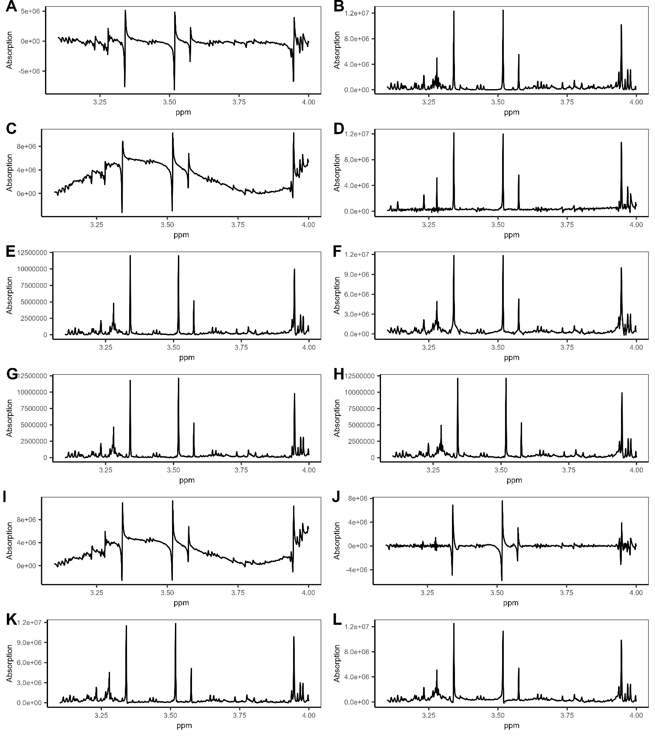Figure 2: Comparison of different phase error correction methods. A: original example data; B: NLS; C: SPC_AAM; D: MPC_AAM; E: SPC_EMP; F: MPC_EMP; G: SPC_DANM; H: MPC_DANM; I: SPC_DSM; J: MPC_DSM, K: SPC_ADSM; L: MPC_DSM.

**Conclusions**

In this application note, we introduce our new R package, "NMRphasing," specifically designed for phase error correction for 1D NMR data. This package comprises nine distinct phase error correction methods, categorized into three groups: non-linear shrinkage, a single linear model, and multiple linear models.

Our innovative non-linear shrinkage approach, NLS, directly derives a phase error free absorption spectrum from phase error free power and magnitude spectra, employing different shrinkage coefficients for distinct peak ranges.

The traditional single phase correction model, SPC, utilizes a pre-defined optimization function to seek estimates of linear model parameters (intercept and slope). This model is then employed to correct phase errors across the entire spectrum. Within this package, we implement five optimization functions (AAM, ADSM, DANM, DSM, EMP).

Our approach with multiple phase correction models, MPC, segments a spectrum into peak ranges and applies a linear model to correct phase errors within each range. The same five optimization functions are implemented for multiple models as for a single model.

We provide example code for each of these nine methods in two ways: either by directly calling the method function or invoking it from a wrap-up function, offering users alternative choices.

Using a partial real-world NMR spectrum, we present the original spectrum alongside the phased spectra from the nine different methods. The results indicate that our three new methods—NLS, SPC_DANM, and MPC_DANM—perform the best, followed by SPC_EMP, SPC_ADSM, MPC_EMP, and MPC_ADSM, with MPC_AAM slightly behind. MPC_DSM, SPC_AAM, and SPC_DSM rank as the least effective.

From these observations, it is evident that NLS is the optimal choice. Overall, MPC outperforms SPC with the same optimization function. However, if an optimization function is sufficiently robust, SPC with this function can match the performance of MPC with the same function (e.g., DANM).

It's important to note that these observations are based on a single example dataset, and their general applicability to other NMR data may vary. Users are encouraged to apply all methods to their datasets for testing and decide which one suits their needs. If testing all methods is challenging, we recommend using the NLS method for phase error correction.

While designed primarily for 1D NMR data, NMRphasing can also be applied to 2D and 3D NMR data by processing one 1D NMR data file at a time.

**References**

Bélisle, C. J. P. (1992). Convergence theorems for a class of simulated annealing algorithms on ℝd. *Journal of Applied Probability*, *29*(4), 885–895. Cambridge Core. https://doi.org/10.2307/3214721

Binczyk, F., Tarnawski, R., & Polanska, J. (2015). Strategies for optimizing the phase correction algorithms in Nuclear Magnetic Resonance spectroscopy. *Biomedical Engineering Online*, *14 Suppl 2*(Suppl 2), S5. https://doi.org/10.1186/1475-925X-14-S2-S5

Brown, D. E., Campbell, T. W., & Moore, R. N. (1989). Automated phase correction of FT NMR spectra by baseline optimization. *Journal of Magnetic Resonance (1969)*, *85*(1), 15–23. https://doi.org/10.1016/0022-2364(89)90315-6

Chen, L., Weng, Z., Goh, L., & Garland, M. (2002). An efficient algorithm for automatic phase correction of NMR spectra based on entropy minimization. *Journal of Magnetic Resonance*, *158*(1), 164–168. https://doi.org/10.1016/S1090-7807(02)00069-1

Craig, E. C., & Marshall, A. G. (1988). Automated Phase Correction of Ft Nmr-Spectra by Means of Phase Measurement Based on Dispersion Versus Absorption Relation (Dispa). *Journal of Magnetic Resonance*, *76*(3), 458–475. https://doi.org/10.1016/0022-2364(88)90350-2

de Brouwer, H. (2009). Evaluation of algorithms for automated phase correction of NMR spectra. *Journal of Magnetic Resonance*, *201*(2), 230–238. https://doi.org/10.1016/j.jmr.2009.09.017

Du, P., Kibbe, W. A., & Lin, S. M. (2006). Improved peak detection in mass spectrum by incorporating continuous wavelet transform-based pattern matching. *Bioinformatics (Oxford, England)*, *22*(17), 2059–2065. https://doi.org/10.1093/bioinformatics/btl355

Džakula, Ž. (2000). Phase Angle Measurement from Peak Areas (PAMPAS). *Journal of Magnetic Resonance*, *146*(1), 20–32. https://doi.org/10.1006/jmre.2000.2123

Ernst, R. R. (1969). Numerical Hilbert Transform and Automatic Phase Correction in Magnetic Resonance Spectroscopyt. *Journal of Magnetic Resonance*, *1*, 7–26.

Fourier, J.-B.-J. (1822). *Théorie analytique de la chaleur*. F. Didot.

Jiang, A. (2024). Phase Error Correction in Magnetic Resonance: A Review of Models, Optimization Functions, and Optimizers in Traditional Statistics and Neural Networks. *Preprints*. https://doi.org/10.20944/preprints202409.2252.v1

Marshall, A. G., & Verdun, F. R. (1990). *Fourier transforms in NMR, optical, and mass spectrometry: A user’s handbook*. Elsevier.

Wang, T., Shao, K., Chu, Q., Ren, Y., Mu, Y., Qu, L., He, J., Jin, C., & Xia, B. (2009). Automics: An integrated platform for NMR-based metabonomics spectral processing and data analysis. *BMC Bioinformatics*, *10*, 83. https://doi.org/10.1186/1471-2105-10-83