NMRphasing
Aixiang Jiang
2021-06-21

NMRphasing
NMRphasing is an R package for NMR data phase error correction. Although this is targeting on 1D NMR data, it can be applied to 2D and 3D NMR data when a 1D NMR data file is phased at a time.

I. NMRphasing installation
First of all, please make sure that you have R package MassSpecWavelet that NMRphasing depends on. Example code to install MassSpecWavelet is:
if (!requireNamespace(“BiocManager”, quietly = TRUE)) install.packages(“BiocManager”) BiocManager::install(“MassSpecWavelet”)
Now, let’s install NMRphasing from Github
devtools :: install_github(repo = "ajiangsfu/NMRphasing",force = TRUE)
## if you do not have old versions of NMRphasing, please remove force = TRUE

II. Data format
The input data format should be in one of the four formats: 1) a vector of absorption spectrum 2) a complex vector 3) a data matrix with two columns of spectrum data, the 1st column is for absorption spectrum, and 2nd column is for dispersion spectrum 4) a data frame with two columns of spectrum data, the 1st column is for absorption spectrum, and 2nd column is for dispersion spectrum
An example data from our multiple metabolite spike-in experiment can be loaded after you install NMRphasing.
library(NMRphasing)
load(system.file("extdata", "fdat.rda", package = "NMRphasing"))
str(fdat)
## 'data.frame': 131072 obs. of 2 variables:
## $ frequency_domain: cplx -4049+252i -4338-148i -4573-216i ...
## $ ppm : num 14.8 14.8 14.8 14.8 14.8 ...
Here, fdat$frequency_domain is the data for the following illustration, which is a complex vector.
## the following three lines are trying to avoid any possible conflict to the original data, and do not occupy extra space
psout = fdat
rm(fdat)
gc()
## used (Mb) gc trigger (Mb) max used (Mb)
## Ncells 604341 32.3 1251192 66.9 992130 53.0
## Vcells 1498180 11.5 8388608 64.0 2206382 16.9
## in order to make comparison, absorption part can be extracted
psout$Observed_Absorption = Re(psout$frequency_domain)
library(ggpubr)
## Loading required package: ggplot2
## Warning: package 'ggplot2' was built under R version 4.0.4
p1 = ggplot(psout, aes(x = ppm, y = Observed_Absorption)) +
geom_line() + theme_bw() + labs(y = "Observed Absorption") +
theme(panel.grid.major = element_blank(), panel.grid.minor = element_blank(),
panel.background = element_blank(), axis.line = element_line(colour = "black"))
p1
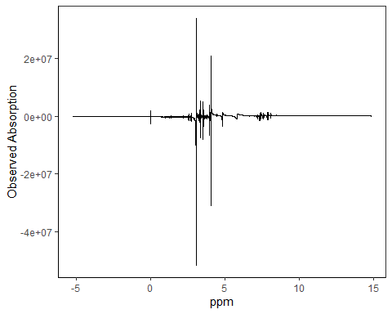
The observed absorption spectrum without phase error correction looks very bad.

III. Example code
There are currently seven NMR phase error correction methods implemented in this package, they are:“SPC_DAOM”,“NLS”, “MPC_DAOM”, “MPC_EMP”, “SPC_EMP”, “SPC_AAM”, and “SPC_DSM”.

1. SPC_DAOM
This is to use the traditional single linear model approach for phase error correction but with our new optimization function to minimize difference between absolute area and ordinary area.
psout$Phased_Absoprtion = NMRphasing(specDatIn = psout$frequency_domain, method = "SPC_DAOM")
### this step might take a couple of minutes
p2 = ggplot(psout, aes(x = ppm, y = Phased_Absoprtion)) +
geom_line() + theme_bw() + labs(y = "Phased Absoprtion") +
theme(panel.grid.major = element_blank(), panel.grid.minor = element_blank(),
panel.background = element_blank(), axis.line = element_line(colour = "black"))
ggarrange(plotlist = list(p1,p2),labels = c("Before","After"),nrow = 2, ncol=1)
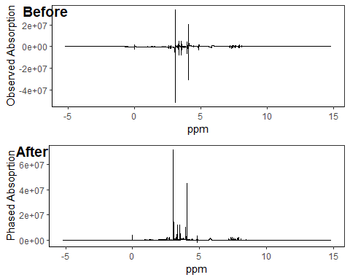

2. NLS
This is our new shrinkage method, which is the fastest phase error correction method since it does not involve any optimization step.
psout$Phased_Absoprtion = NMRphasing(specDatIn = psout$frequency_domain, method = "NLS")
## this is the default method, therefore, the method setting can be ignored
p2 = ggplot(psout, aes(x = ppm, y = Phased_Absoprtion)) +
geom_line() + theme_bw() + labs(y = "Phased Absoprtion") +
theme(panel.grid.major = element_blank(), panel.grid.minor = element_blank(),
panel.background = element_blank(), axis.line = element_line(colour = "black"))
ggarrange(plotlist = list(p1,p2),labels = c("Before","After"),nrow = 2, ncol=1)
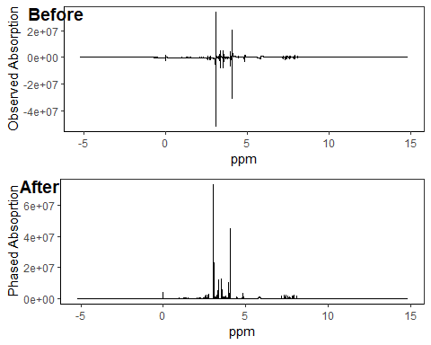

3. MPC_DAOM
This is ti use our new multiple linear model approach for phase error correction with our new optimization function to minimize difference between absolute area and ordinal area.
psout$Phased_Absoprtion = NMRphasing(specDatIn = psout$frequency_domain, method = "MPC_DAOM")
## this step might take a couple of minutes
p2 = ggplot(psout, aes(x = ppm, y = Phased_Absoprtion)) +
geom_line() + theme_bw() + labs(y = "Phased Absoprtion") +
theme(panel.grid.major = element_blank(), panel.grid.minor = element_blank(),
panel.background = element_blank(), axis.line = element_line(colour = "black"))
ggarrange(plotlist = list(p1,p2),labels = c("Before","After"),nrow = 2, ncol=1)
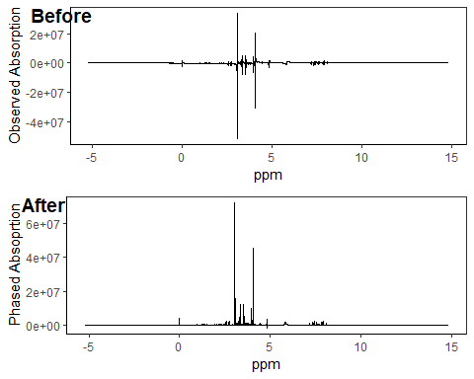

4. MPC_EMP
This is to apply our new multiple linear model approach for phase error correction based on an existing optimization function: entropy minimization with negative peak penalty.
psout$Phased_Absoprtion = NMRphasing(specDatIn = psout$frequency_domain, method = "MPC_EMP")
## this step might take a couple of minutes
p2 = ggplot(psout, aes(x = ppm, y = Phased_Absoprtion)) +
geom_line() + theme_bw() + labs(y = "Phased Absoprtion") +
theme(panel.grid.major = element_blank(), panel.grid.minor = element_blank(),
panel.background = element_blank(), axis.line = element_line(colour = "black"))
ggarrange(plotlist = list(p1,p2),labels = c("Before","After"),nrow = 2, ncol=1)
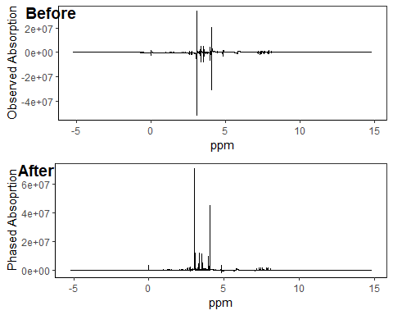

5. SPC_EMP
This is an old phase error correction method based on the traditional single model approach targeting on an existing optimization function: entropy minimization with negative peak penalty.
psout$Phased_Absoprtion = NMRphasing(specDatIn = psout$frequency_domain, method = "SPC_EMP")
## this step might take a couple of minutes
p2 = ggplot(psout, aes(x = ppm, y = Phased_Absoprtion)) +
geom_line() + theme_bw() + labs(y = "Phased Absoprtion") +
theme(panel.grid.major = element_blank(), panel.grid.minor = element_blank(),
panel.background = element_blank(), axis.line = element_line(colour = "black"))
ggarrange(plotlist = list(p1,p2),labels = c("Before","After"),nrow = 2, ncol=1)
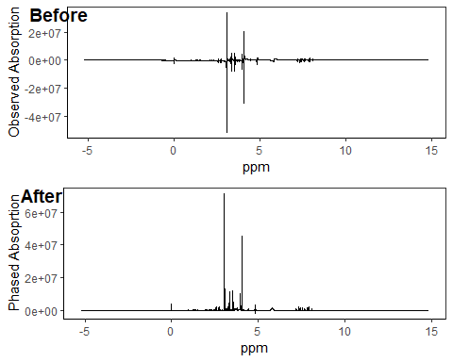

6. SPC_AAM
This is an old phase error correction method based on the traditional single model approach with an existing optimization function: absolute area minimization.
psout$Phased_Absoprtion = NMRphasing(specDatIn = psout$frequency_domain, method = "SPC_AAM")
## this step might take a couple of minutes
p2 = ggplot(psout, aes(x = ppm, y = Phased_Absoprtion)) +
geom_line() + theme_bw() + labs(y = "Phased Absoprtion") +
theme(panel.grid.major = element_blank(), panel.grid.minor = element_blank(),
panel.background = element_blank(), axis.line = element_line(colour = "black"))
ggarrange(plotlist = list(p1,p2),labels = c("Before","After"),nrow = 2, ncol=1)
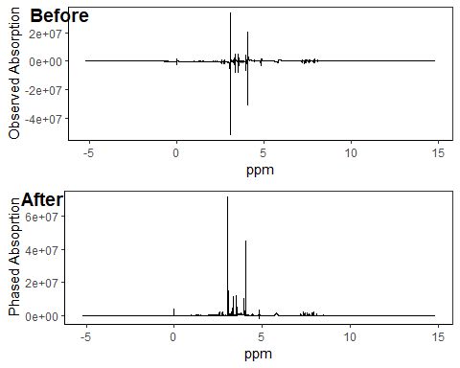

7. SPC_DSM
This is an old phase error correction method based on the traditional single model approach with an existing optimization function: dispersion summation minimization.
psout$Phased_Absoprtion = NMRphasing(specDatIn = psout$frequency_domain, method = "SPC_DSM")
## this step might take a couple of minutes
p2 = ggplot(psout, aes(x = ppm, y = Phased_Absoprtion)) +
geom_line() + theme_bw() + labs(y = "Phased Absoprtion") +
theme(panel.grid.major = element_blank(), panel.grid.minor = element_blank(),
panel.background = element_blank(), axis.line = element_line(colour = "black"))
ggarrange(plotlist = list(p1,p2),labels = c("Before","After"),nrow = 2, ncol=1)
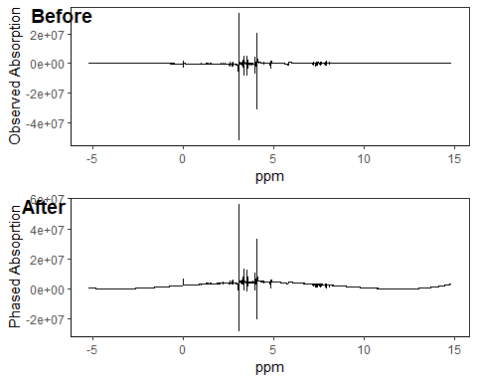 SPC_DSM performs the worst on phase error correction based on our example data.
Side note: with a single CPU, it takes about 10 minutes to process all R code.

IV. NMRphasing R package general information
Version: 0.0.2
Author: Aixiang Jiang
Maintainer: Aixiang Jiang aijiang@bccrc.ca aixiang.jiang@pathology.ubc.ca
Depends: R (>= 4.0), baseline, splines, MassSpecWavelet
Suggests: knitr
VignetteBuilder: knitr

